MEETING OF THE WORKING GROUPS 1 AND 2 OEA/Ser.L/XIX.VI.1
OF THE XX INTER-AMERICAN CONFERENCE CIMT-21/GT1-GT2/doc.8/23
OF MINISTERS OF LABOR 12 September 2023
September 21 – 22, 2023 Original: Spanish
Washington, D.C.

REPORT OF THE INTER-AMERICAN NETWORK FOR LABOR ADMINISTRATION (RIAL)
FOR THE PERIOD 2006 TO SEPTEMBER 2023

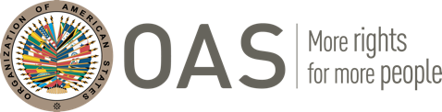

REPORT OF THE
INTER-AMERICAN NETWORK FOR LABOR ADMINISTRATION (RIAL)
FOR THE PERIOD 2006 TO SEPTEMBER 2023

CONTENTS
- Introduction ……………………………………………………………………………………… 1
- Outputs – RIAL in numbers and products ………………………………………… 2
- Outcomes – RIAL’s Impact and concrete results………………………………. 3
- Activities…………………………………………………………………………………………… 13
- Lessons learned ………………………………………………………………………………… 25
- Note on Funding………………………………………………………………………………… 27

APPENDICES
Appendix 1: Summary of the Hemispheric Workshops…………………………… 28
Appendix 2: List of activities of the RIAL Cooperation Fund………………… 35

I. INTRODUCTION

The Inter-American Network for Labor Administration (RIAL) is the cooperation and technical assistance mechanism of the Inter-American Conference of Ministers of Labor (IACML). It was created by the region’s Ministries of Labor, following the XV IACML in 2005, in order to strengthen their human and institutional capacities through an integrating mechanism for dissemination of knowledge and experiences.

The RIAL functions as a system made up of the following complementary and mutually reinforcing tools: Portfolio of Programs, Hemispheric Workshops, technical studies, bilateral cooperation activities, newsletters, web pages and, virtual forums and webinars.

The OAS Executive Secretariat for Integral Development (SEDI) is responsible for the coordination and operation of the RIAL, in its capacity as the Technical Secretariat of the IACML, while its priorities and actions are set by the IACML itself. It is now funded through a Fund for voluntary contributions from all its members. In the period 2006-2010, it was funded primarily by the Canadian Labour Program, whose contributions made it possible to establish the Fund and to carry out most of the activities described in this document. It has also received financial contributions from the Ministries of Labor of Argentina, Bahamas, Barbados, Belize, Bolivia, Brazil, Canada, Colombia, Chile, Ecuador, El Salvador, Grenada, Guyana, Jamaica, Mexico, Panama, Paraguay, Peru, Dominican Republic, St. Kitts and Nevis, Suriname, Trinidad and Tobago, and the United States, to this date.

II. OUTPUTS – RIAL in numbers and products

From its formal creation in May 2006 thru September 2023, the following are RIAL’s main accomplishments in number of people, organizations involved, and products delivered.

RIAL in numbers:

- 1887 government officials have been trained on priority labor administration issues through hemispheric workshops and bilateral cooperation activities.
- 1589 officials from Ministries of Labor have been trained on priority labor administration issues through hemispheric workshops and bilateral cooperation activities.
- +4700 public officials have been indirectly trained.
- 177 workers’ and employers’ representatives have been trained.
- 17 international agencies (ILO, IDB, PAHO, WAPES, IACHR, CARICOM, IDB, etc.) are involved with the RIAL.
- 27 research centers and NGOs are involved with RIAL activities.
- All OAS member states have participated in RIAL activities through their Ministries of Labor.

RIAL products:

- 27 hemispheric exchange workshops completed and one in planning on priority labor administration topics. Twenty-two (22) Ministries of Labor were represented in each workshop on average, along with workers, employers, and heads of international organizations.
- 130 completed bilateral cooperation activities (on-site visits or experts’ visits) that have allowed for direct technical assistance between Ministries through the RIAL and the development of specific products within each Ministry. Of these 130 activities, 16 have been carried out virtually.
- 200 updated programs, which are part of the online Portfolio of Programs from the Ministries of Labor and, as such, constitute cooperation offers.
- 1 new RIAL website: www.rialnet.org, recently published with improvements implemented directly from suggestions from the Ministries themselves, to make it more interactive and efficient.
- 6 technical studies completed: “Gender equality for Decent Work: Proposals for mainstreaming gender into labor and employment policies within the framework of the IACML” (2007), “The Institutionalization of a Gender Approach in the Ministries of Labor of the Americas” (2009), “Advancing the institutionalization of a gender approach in the Ministries of Labor of the Americas. Lessons learned, findings and recommendations from three Participatory Gender Audits” (2013), “Analysis of Bilateral and Multilateral Social Security Agreements as they relate to Pensions” (2015), and “The Coordination between Education and Labor in the Americas: Results of the Inter-Sectoral Workshop on Youth Employment” (2017), and “The Institutionalization of a Gender Approach in the Ministries of Labor of the Americas: Balance of a Decade” (2021).
- More than 230 newsflashes published every two weeks about RIAL’s activities, relevant events for the IACML, and any new and interesting information regarding the world of work.
- Creation of the RIAL/GENDER as the first specialized network of the RIAL, and holding of 7 virtual Dialogues, to strengthen the institutionalization of gender in the Ministries of Labor. An average of 27 Ministries have participated in each of the Dialogues, as well as representatives of workers, employers, and international organizations.
- 6 web seminars, four of them organized with PAHO, and ILO’s Regional Office for Latin America and the Caribbean about health in the workplace and youth employment, another one about Labor Inspections in Trinidad and Tobago, and one developed in 2019 along with the government, workers´ and employers´ representatives of Castilla and Leon, Spain, on their internationally recognized experience of Social Dialogue. These webinars allowed for the exchange of successful experiences and contributed to strengthening of labor administration in the region.
- 3 Gender Audits in partnership with the ILO, the first of its kind in Ministries of Labor in the region that resulted in diagnoses and action plans to strengthen gender institutionalization in each Ministry.
Additionally, in 2020, the RIAL published two specific products within the framework of the COVID-19 pandemic, demonstrating a great capacity for response and adaptation:
- Portfolio of Responses from Ministries of Labor to COVID-19, launched on April 1st, 2020, and permanently updated until July 2022. The Portfolio of Responses reached more than 490 measures taken by Ministries of Labor of all the countries in the region.
- Repository of Guidelines and Protocols for Deconfinement and return to work, launched in May 2020 and updated until December 2021, gathered more than 80 resources published by governments (both from OAS Member States and outside the OAS), international organizations, and organizations of workers and employers for a safe and orderly return to work that prioritizes the safety and health of workers.
Between 2022 and 2023, the RIAL launched two new information repositories:
- Portfolio of Telework laws and regulations, launched in July 2022 and permanently updated, gathers over 90 instruments implemented by the governments of the region regarding telework.
- Repository of Actions on Paid Domestic Work, launched in July 2023, and developed in conjunction with the governments of the Americas, showcases the actions that the Ministries of Labor of the region have implemented to dignify, formalize, and achieve the full exercise of rights in paid domestic work.

III. OUTCOMES – RIAL’s Impact and concrete results
Together, the outputs previously outlined, are aimed towards achieving the RIAL’s objective of building human and institutional capacities in the region’s Ministries of Labor. Institution-building is a complex and hard-to-measure concept but, for the purposes of the RIAL, it has been divided into the following components:
- Greater knowledge and tools in Ministries for the fulfillment of their functions.
- Development of new products, services, or programs.
- Creation of areas, offices, or units within Ministries.
- Review, modification and/or improvement of programs in execution.
- Design, modification and/or improvement of internal processes.
- Design or improvement of training activities for government officials.
- Reform of the regulatory or legislative framework.
- Enhanced capacity to identify cooperation priorities and needs.
- Greater communication and cooperation between each Ministry and its peers within the region.

After more than fifteen years of operation, it can be said that the RIAL has had a clear impact on these institution-building components, in some cases with impressive outcomes, as may be seen below. The outcomes were taken from final reports and follow-up surveys of RIAL bilateral cooperation activities, surveys of Hemispheric Workshop participants, and internal OAS records on their ongoing communications with ministries in the region.

RIAL’s Impact: Concrete Results

- Greater knowledge and tools in Ministries of Labor for the fulfillment of their functions

All of RIAL’s outputs are aimed at increasing knowledge within Ministries of Labor and providing them with additional tools to strengthen internal management. This knowledge translates to the development of new products, redefinition of internal processes, and the creation or strengthening of areas or units.

Several RIAL Hemispheric Workshop participants were consulted regarding the contributions that the information they received at our events had on their Ministries in the past. From those consulted, more than 90% considered that the information they received at our Workshops helped them improve their services about the topic discussed at the event, increase awareness about gender issues, and become more efficient in their respective countries.

Additionally, during the first months of the COVID-19 pandemic, several representatives of Ministries of Labor and organizations of workers and employers stressed that the information gathered in the Portfolio of Responses from Ministries of Labor to COVID-19 and the Repository of Guidelines and Protocols for Deconfinement was valuable when planning and adjusting their own responses.

- Development of new products, services, or programs

The RIAL facilitates new ideas within ministries for the development of products, services, or programs, whether by consulting the RIAL Portfolio, a source of information on interesting initiatives, or through their participation in Hemispheric Workshops or in bilateral cooperation activities. From these exchanges a decision may emerge to develop new initiatives or, if this decision has already been made, elements for their implementation may be drawn.

Almost 60% of RIAL bilateral cooperation activities documented resulted in the development of new products, services, or programs. Some important examples are:

- The “Manual to prevent and eradicate gender-based violence at work”, prepared by the Ministry of Labor of Uruguay and launched in March 2023, has lessons learned and recommendations from the Ministry of Labor of Argentina. This RIAL Cooperation included training actions, as well as detailed review and feedback of the contents of the Manual by experts from the Argentine Ministry.

- In 2022, the Network of Enterprises against Child Labor was created in Panama, incorporating elements and good practices from Argentina, whose similar Network was created in 2017. The RIAL Bilateral Cooperation allowed for the creation of this Network crystalized, by providing input and guidance to the Ministry of Labor of Panama from Argentina’s Ministry of Labor and members of the Network.

- Preparation of a Manual for the labor inclusion of people with disabilities in Guatemala, with the technical assistance of the Ministry of Labor of Ecuador, recognized for its good practices in this matter. The Manual, aimed at public and private institutions, is a practical tool with guidelines for the recruitment, hiring and inclusion processes of people with disabilities.

- Design of the Project to create a Leaders for Social Dialogue Training Program in Peru, retaking the lessons learned of the Trade Union Training Schools (Escuelas de formación sindical) of Chile, and including guidance on training modalities and curricular offer, among others. The Project, developed in 2021 with the participation of social actors and the assistance of Chile, seeks to develop the knowledge and capabilities of social actors as a means to strengthen social dialogue.

- Development and improvement of the program for returned Ecuadorian workers in 2019, as a result of technical assistance from Colombia on services for migrant populations.

- Design of a Pilot Plan for Implementation of Convention 189 on Domestic Work in Costa Rica in 2019, as a result of technical assistance from Uruguay, first country to ratify such Convention.

- The terms of reference for the establishment of the Disabilities Rights Tribunal in Jamaica in 2016 and 2017, as well as the communication strategy and the complaints procedures to comply with Jamaica’s Disabilities Act of 2014, were drafted including the lessons learned and the procedures in place in the United States. This was possible, after the Director of the Jamaica Council for Persons with Disabilities and other officers in charge of developing such instruments travelled to Washington to learn from the United States vast experience in enforcing the Americans with Disabilities Act (ADA) of 1990.

- Development of electronic declaration for employers in Peru to improve compliance with labor legislation, with lessons learned from Mexico’s experience.

- The first Municipal Child Labor Diagnostic in Guatemala was conducted in 2013 after receiving technical assistance from Ecuador on evaluating baselines and diagnostics on child labor, and having been able to learn from first-hand experience how municipal authorities work. The participants highlighted that before the exchange, they did not have enough resources to undertake this work.

- After the technical assistance received through an on-site visit from the Ministry of Labor of Guatemala, Paraguay designed a training and awareness programs for female domestic workers.

- The Public Employment Service of Panama (SERPE) finalized the installation of an employment unit at each training center of the National Institute of Vocational Training for Human Development (INADEH) to facilitate the hiring of graduates from the training courses that they have created. It also considered the creation of a Youth Employment Office as a result of the exchange of cooperation with the Ministry of Labor, Employment and Social Security of Argentina.

- The Occupational Health and Safety Administration (OSHA) of Trinidad and Tobago created a web page after receiving technical assistance from the United States Department of Labor. The web page can be used to distribute information and to maintain a permanent channel for interaction with the public. The Ministry of Labor of Trinidad and Tobago also developed brochures available in print and online on various topics regarding OSHA, and developed and implemented an awareness program to reach specific audiences throughout the country.

- The Ministry of Labor of Costa Rica made the decision to regionalize the conciliation service (presence of conciliators in regional offices) following a cooperation activity with Argentina wherein greater awareness was gained of the value of conciliation, and training and hiring processes were reviewed. The Argentine experience also served to improve conciliator training in Costa Rica.

- The recent establishment of the Job Training Center in the Ministry of Labor of El Salvador took account of the success of worker and employer education in the Ministry of Labor of the Dominican Republic, and some of its lessons learned were replicated.

- The Ministry of Labor, Employment and Social Security of Argentina is studying the possible implementation of a program similar to the Preventive Mediation Program of Canada, following an on-site visit to Canada.

- El Salvador’s Ministry of Labor launched its Gender Equality Seal after learning about Colombia’s experience with its own Equipares Seal and its mode of implementation. This included learning about the experience of private Colombian companies certified with the seal.

- Based on the Costa Rican experience, Guatemala developed a pilot program for the eradication of child labor in Guatemala City’s main food distribution center.

- Creation of areas, offices, or units within Ministries

To a lesser extent, the RIAL has contributed to creating areas or units within Ministries of Labor. Around 25% of RIAL bilateral cooperation activities report this as an outcome. These include:

- The consolidation of the Unit for Gender Equality in the Ministry of Labor and Social Welfare of El Salvador, which reviewed and improved the Ministry’s practices and procedures after an on-site visit from the Ministry of Labor, Employment and Social Security of Argentina and Colombia in 2012.

- The inclusion of a Medical Unit and Technical Unit in the Occupational Health and Safety Administration of Trinidad and Tobago after a bilateral cooperation with the United States.

- The creation of the Fundamental Rights Unit in the Ministry of Labor of Bolivia, after collaborating with Chile through the RIAL.

- The drive to increase the number of municipal employment offices run by the Ministry of Labor and Social Security of Costa Rica through a Framework Agreement with the Municipal Development Institute, signed after a visit to the Ministry of Labor, Employment and Social Security of Argentina.

- The establishment of a committee to develop an Inspection Program to guide the activities of the Department of Labor of Saint Lucia in that field, one of the lessons learned during cooperation with the United States.

- The creation of the Colombian Tripartite Commission on International Affairs after receiving technical and legal assistance from Brazil’s own Tripartite Commission.

*The efforts of RIAL since its origins to support the creation and consolidation of gender units in the Ministries, which are currently framed within the RIAL/GENDER created in 2022, are highlighted. It is also worth noting that the Inter-American Commission of Women (CIM), in collaboration with the RIAL, organized four subregional workshops (Caribbean, Central America, Andean Region, and Southern Cone) in 2010 to strengthen a gender-based approach in Ministries of Labor, which may include the creation of gender units. Some Ministries (El Salvador and Barbados mainly) have reported that following the workshop, they could advance in constituting a gender unit or focal point. These workshops are based on the achievements and recommendations of the RIAL study on “The Institutionalization of a Gender Approach in the Ministries of Labor of the Americas” and follow-up on the Gender Strategic Guidelines approved by the Inter-American Conference of Ministers of Labor (IACML) in 2007.

Additionally, the OAS and ILO partnered to develop “Participatory Gender Audits” in the Ministries of Labor of El Salvador, Barbados, and Peru, with financial support from Canada and in keeping with the efforts developed by the IACML and RIAL on gender issues. Audits have allowed comprehensive assessment of the situation in each Ministry regarding gender mainstreaming and the development of Plans of Action to strengthen their efforts, in particular units or areas responsible for gender. In the case of El Salvador, the Audit helped launch the Unit for Gender Equality.

- Review, modification, and improvement of programs in execution

A review of RIAL bilateral cooperation activities shows specific results in terms of program improvement, but RIAL’s workshops should also be taken into account in measuring program improvement. In fact, 70% of discussions during these workshops revolve around the outcomes and difficulties of, and lessons learned from, national programs. Additionally, most participants are program technical staff or coordinators. Although no rigorous follow-up to these workshops has been made, they may have led to reviews and modifications of programs in execution.

Some specific outputs of bilateral cooperation activities may be noted:

- In Ecuador, the Roadmap to strengthen the Advisory Council of the National System of Professional Qualifications was prepared, and proposals for improvement were identified for said System, after receiving direct technical assistance from the Ministry of Labor of Colombia on its National Qualifications System during 2022. Within the roadmap, actions to update legislation and design skills certification processes stand out, especially for people in human mobility.

- In Chile, a country that in the decade of the 2010s saw an increase in immigration flows, programs to assist migrant workers were expanded and the Labor Directorate’s Action Plan for Migration was strengthened after receiving technical assistance in 2017 from Costa Rica, a country with a long and recognized experience on the topic.

- The youth employment programs of St. Kitts and Nevis were reviewed and improved in 2017 after a cooperation mission in the United States, specifically on the components of apprenticeships, summer internships, and linking the Ministry with technical and vocational training institutions.

- Honduras efforts on identification and eradication of child labor in the agricultural sector were reviewed in the light of Colombia’s experience in this area in the coffee sector. The Child Labor Regulation, now called Protected Teenage Work Regulation, was amended.

- The strategy of communications and dissemination, as well as the implementation of the projects “Mi Primer Empleo” (My First Job) and “Empleo Joven” (Youth Employment) of Ecuador were improved in 2018 after adopting good practices from Panama’s “Programa de Apoyo a la Insercion Laboral-PAIL” (Labor Insertion Support Program).

- The Ministries of Labor of Barbados, Grenada, St. Kitts and Nevis and St. Lucia reported having improved and strengthened their youth employment strategies –in components such as internships, linking the productive sector with training institutions and promotional campaigns– after acquiring detailed knowledge of the youth employment initiatives in Jamaica during an on-site visit in 2018.

- The Ministry of Labor of Nicaragua, combining the best practices of the Ministry of Labor and Employment of Brazil with new institutional policies, strengthened their employment service (SEPEM) and their implementation of the “My First Job” (“Mi primer empleo”) program, increasing the placement of young graduates from universities and technical centers.

- The initiatives promoted by the Ministry of Labor of Costa Rica on working children and youth were reviewed and improved based on successful practices in Uruguay. In particular, the regulations for the registry of working adolescents were amended to include a medical report requirement and instruments such as the social and job assessment record of the working child or adolescent were improved.

- The More and Better Jobs for Youth Program of the Ministry of Labor, Employment and Social Security of Argentina was strengthened with new management elements and services following an on-site visit by its senior staff to the United States. Warranting mention are the regulations redesigned to allow for internships in the public and nongovernmental sector, improved management instruments, better relations with the private sector, and additional assistance provided to youth by the Secretariat of Employment.

- After San Vicente’s on-site visit to Canada in 2009, San Vicente improved its labor accidents data collection capacity and their health and occupational security policies.

- Design, modification and/or improvement of internal processes

This is one of the components of institutional strengthening where the RIAL’s impact is most clearly seen, specifically in its bilateral cooperation activities. In effect, about 55% of the cooperation activities which have been followed up have resulted in more efficient internal procedures, better-designed management tools and operational manuals, and more solid information and management systems, among others.

Some notable outcomes are described below:

- During 2022, the Ministry of Labor of Guatemala developed Guidelines for the inspection process and six forms/tools that will allow labor inspectors to identify and report cases of child labor, record adolescent labor, and identify signs of labor exploitation. The Guidelines and the forms to collect information were prepared with lessons learned from the Ministry of Labor of Argentina, whose experts reviewed and provided detailed feedback on each instrument.

- The implementation of the Occupational Safety and Health Act of Saint Vincent and the Grenadines, enacted in 2017, was defined in great measure after receiving technical assistance from Barbados in 2018. The experts from Barbados supported the elaboration of an Implementation Plan for the Act, which includes dispositions on labor inspection, inter-institutional cooperation, and the development of guidelines for worker and employer organizations.

- The regulation and design of procedures and instruments of the Registry of Labor Training and Training Institutions (REIFOCAL) of Paraguay was carried out based on the experience of the Registry of Training and Employment Institutions (REGICE) of Argentina.

- Manuals for users and administrators of Guatemala’s Public Employment Portal were developed, incorporating lessons learned from the experience of the Ministry of Labor, Employment and Social Security of Argentina.

- The Occupational Health and Safety Administration (OSHA) of Trinidad and Tobago finalized and implemented a multi-year strategic plan after receiving expert assistance from the United States Department of Labor. This plan guides the work plans of each of the inspection sub-units and focuses on initiatives and performance evaluations. Also developed and implemented was a performance evaluation system for inspectors and other Administration personnel.

- As part of a cooperation activity with the Ministry of Labor, Employment and Social Security of Argentina, the Ministry of Labor and Social Development of Panama began to strengthen their employment counseling services as part of their labor intermediation services. The Directorate General of Employment also consolidated a network based on complementarity, group cohesion, and management on the basis of results.

- The cooperation activity with the Ministry of Labor and Employment of Brazil enabled policies and actions to reorient and transform the Directorate General of Employment and Wages of the Ministry of Labor of Nicaragua’s strategic objectives. Some actions relate to the training process, the involvement of local actors, and the consolidation of a network of institutional work.

- The on-site visit from officials of the Ministry of Labor and Social Security of Costa Rica to their counterparts in Argentina helped to improve the skills of employment managers through training in the use of electronic job-search platforms, with the goal of standardizing procedures.

- The modernization of the Department of Social Organizations of the Ministry of Labor of Costa Rica was facilitated and strengthened through technical assistance from Mexico, specifically regarding the simplification of the social organizations registry, and computerization and design of oversight and monitoring tools, achieving greater efficiency and better service for users.

- Statistics development processes in the Ministry of Labor of Paraguay were streamlined and made more efficient and timely, better training was provided for statistics area officials, and that area was strengthened following assistance received from Argentina.

- The Occupational Health and Safety area of the Ministry of Labor of Guyana, following cooperation activities with Trinidad and Tobago and Barbados, made the following significant improvements: inspection kits were prepared as part of the inspectors' tools, the 4P model for evidence gathering implemented in Barbados was adopted, which enhanced investigations of workplace accidents and fatalities, and the use of scientific equipment and information systems in labor inspections was improved, resulting in increased efficiency in reporting.

- The procedures and structure of the Social Security Office of the Ministry of Justice and Labor of Paraguay, created in late 2008, and of the National Social Security System were strengthened following cooperation with Chile in March 2009.

- The restructuring of the data compilation system for labor statistics generation and the design of new indicators in Guatemala were based on training provided by Argentina.

- Occupational health and safety procedures of the Department of Labour of Saint Vincent and the Grenadines were developed using information and knowledge gained from seeing the Intervention Model of Canada. Among other issues, follow-up visits are part of inspectors training and forms used on inspection visits are currently being re-designed.

- ILO convention report preparation procedures were redefined in El Salvador following cooperation with Argentina to improve consultations with workers and employers.

- Proposed improvements to the organizational and functional structure of labor inspection in El Salvador, including the inspector career service, were developed based on the Dominican Republic model.

- Design or improvement of training activities for government officials

The RIAL contributes to Ministry training activities in two ways: (1) Directly, through visits by experts in bilateral cooperation activities which may include training activities; and (2) Indirectly, as advantage may be taken of the content of the Hemispheric Workshops and RIAL bilateral cooperation activities to improve Ministry training activities. Fifty-two percent of bilateral cooperation activities have had impact in the design or improvement of training exercises, which represents a very valuable multiplicative effect of cooperation.

Among direct contributions, the following activities warrant mention owing to their multiplier effect:

- Belize’s Labor and Employment officers and labor inspectors received comprehensive training on Occupational Safety and Health (OSH) from the Ministry of Labor of Barbados, via on-line sessions in 2022. Training included specific areas (ergonomics, chemical safety, hazards overview, among other), as well as OSH management approach and preparation for inspections at the workplaces.

- Labor inspectors from Guatemala improved their knowledge and capabilities on conciliation and conflict resolution after receiving training from Argentinian experts in 2018.

- As a result of an experts’ visit from Colombia to Ecuador in 2019, officers from both the Ministry of Labor and the Ministry of Foreign Affairs received training on services and measures to serve returned national workers.

- Labor inspectors from México received direct training and technical assistance from Argentinian experts regarding identification, prevention and eradication of child labor in 2019.

- Experts from the Ministry of Labor Relations of Ecuador, accompanied by representatives of the private sector and UNICEF, presented the Workshop “Transfer of a Public-Private Partnership Model for the eradication of child labor in Ecuador,” sponsored by the RIAL, to transfer Ecuador’s successful model of the Network of Businesses against Child Labor to Costa Rica.

- Experts of the Ministry of Labor of Manitoba, Canada provided a workshop for officials of the Ministry of Labor of Mexico on the design and implementation of the Safe Work program, aimed at the prevention of workplace accidents. The workshop was held in Mexico City and simultaneously transmitted by videoconference to Mexico’s 32 federal labor offices.

- Experts of Trinidad and Tobago provided training at the “Seminar on Occupational Health and Safety” to officers of the Ministry of Labor of Guyana and employer and worker associations.

- Experts of Argentina provided a training workshop on labor conciliation for Ministry of Labor officials of the Dominican Republic, mediators, prosecutors, employers, and workers.

- Canadian experts provided training to all Regional Directors of Labor of Chile on mediation, and presented the Federal Mediation and Counseling Service (FMCS) of Canada, including its structure, functioning, the challenges faced by the Service and the reforms introduced over time, with the goal of strengthening the labor mediation system in Chile.

Indirect effects include the following examples:

- As a result of a visit from experts followed by an on-site visit between the Ministry of Labor, Employment and Social Security of Argentina and the Ministry of Labor and Social Development of Panama, the latter has strengthened its training programs for officials of the Public Employment Service (SERPE) at the national level.

- The strengthening of permanent training programs of the Ministry of Labor and Social Development of Panama after visiting the Occupational Health and Safety Administration (OSHA) of the United States. This, through talks with Labor Inspectors, the development of information pamphlets, the design of a training program, lectures, and the participation of inspectors in OHS conferences are some of the fruits of cooperation activity.

- The redesign of training programs for labor inspectors in Panama, an outcome of the training assistance received from Brazil during and on-site visit that provided guidance on developing skills and attitudes that promote harmonious work relations.

Although practices in this area have not been documented, Ministries in their training activities could refer to the Hemispheric Workshops’ presentations and sound recordings, available at the OAS/RIAL website.

- Reform of the regulatory or legislative framework

The RIAL has shown clear results in internal Ministry of Labor management, but examples have also been found of its impact on regulatory or legislative framework reform. Although the negotiation of these reforms and their adoption transcends Ministries, RIAL impact may be seen in their conception, rationale, and preparation. Some very important cases have been identified:

  - The assistance that the Ministry of Labor and Employment Promotion of Peru received from the Ministry of Labor and Employment of Brazil in September 2013 contributed to the development of regulations pursuant to the General Law on Persons with Disabilities of Peru, issued in 2014, especially as it relates to the employment quota for persons with disabilities and monitoring compliance.

  - The formulation of a new National Plan for the Prevention and Progressive Eradication of Child Labor and the Protection of Adolescent Workers in Bolivia included lessons learned from the experience of Argentina.

  - The Ministry of Labor of Belize sent the National Health and Safety at Work bill to the Cabinet in 2010 after eight years of hard work. The Ministry also developed the National Labor Inspection Manual, aided by contributions of technical assistance from the Ministry of Labor of Trinidad and Tobago, among others.

  - Evaluation and development of a proposal to amend the rules that govern the Standing Committee and Departmental Subcommittees for Consensus on Salary Policies as spaces for social dialogue in Colombia, as part of the cooperation received from the Ministry of Labor and Employment of Brazil.

  - A bill drafted by the Ministry of Labor of Peru on mandatory payment through the financial system. Technical assistance from Argentina served to define proper mechanisms for the implementation of this law, provide the bill with additional technical support and greater soundness, and identify more benefits from this procedure than costs, the latter enabling the decision to draft this bill to be made. In July 2010, the bill had been approved by the congressional technical committees and was on the agenda for the Plenary.

  - A preliminary draft law prepared by the Ministry of Labor of the Dominican Republic to make mandatory individual labor conciliation with it prior to having recourse to the courts. This preliminary draft law is based on the experience of the Mandatory Labor Conciliation Service (SECLO) of Argentina. The Labor Advisory Council of the Dominican Republic approved the preliminary bill as drafted.

  - Barbados’ Labor Rights law was created after their on-site visit to Jamaica in 2013. This law is based on the experience and knowledge that Jamaica provided Barbados’ Ministry of Labor about its own labor rights law.

  - The knowledge that the Argentine Ministry of Labor shared with the Colombian Ministry of Labor was crucial for the development of Teleworking laws and the creation of the National Network for the Promotion of Teleworking in Colombia.

- Enhanced capacity to identify cooperation priorities and needs

The Technical Secretariat of the IACML consults all Ministries of Labor every two years, immediately following each Conference, on its cooperation priorities and needs. This exercise has been carried out every two years from 2005 to 2017 and it may be noted that for some countries, especially in the Caribbean, there is greater clarity in replies, and areas of cooperation are more specifically defined.

The RIAL calls for bilateral cooperation, enabling Ministries to present proposals to receive technical assistance from their peers in the region, have afforded international affairs areas and opportunity to consult other Ministry areas each year regarding their cooperation needs. This exercise facilitates the building of capacities for the identification of cooperation areas and for proposal preparation. In the twelve calls for proposals conducted, the quality of proposals for some countries has improved year by year, especially in those where the same officials responsible for cooperation matters have remained the RIAL focal point.

- Greater communication and cooperation between each Ministry and its peers within the region

The RIAL has provided wide-ranging opportunities for interaction among Ministries of Labor, in both their international affairs areas and technical areas. The RIAL Workshops and bilateral cooperation activities have enabled technical staff to meet, debate, and exchange experiences in their areas of specialization, in and of itself an outcome as regards greater communication, but the challenge remains for this interaction to continue and be maintained.

More than half of participants in bilateral cooperation activities report that they remain in communication with the ministry that provided them with technical assistance. Among them, there are also countries that have received additional follow-up technical assistance after their cooperation; some examples worth noting are:

  - After a RIAL Bilateral Cooperation in 2017, the Ministry of Labor of Paraguay received an additional technical assistance in 2019 from the Ministry of Labor of Argentina to strengthen the management of professional training centers administered by labor unions. On their final report, the Paraguayan delegation noted that further improvements in their workforce development services would be pursued in partnership with their Argentinian peers.

  - The Ministry of Labor and Social Security of Costa Rica received financial support from the Ministry of Labor, Employment, and Social Security of Argentina to participate in the Workshop on Public Employment Services that was held in Mexico City in 2011 after receiving technical assistance to strengthen municipal employment offices.

  - The Ministry of Labor of Colombia, after receiving assistance from the Ministry of Labor and Employment of Brazil, presented through RIAL’s Fourth Call a new application for bilateral cooperation in the areas of Decent Work and the Elimination of Child Labor. This proposal was selected and resulted in a visit in 2011 from officials of the Directorate of Labor Inspection, Monitoring, and Control of Colombia to Brazil.

  - The Ministry of Labor of the Bahamas, following technical cooperation on Occupational Health and Safety at the workplace with the United States Department of Labor, presented a proposal during RIAL’s Third Call. This proposal was selected and Bahamas received a group of experts from the Occupational Health and Safety Administration (OSHA) in 2011. Notably, the relationship between the two institutions has continued to strengthen due to mutual interest in this area.

  - The Ministry of Labor of Trinidad and Tobago presented a cooperation proposal through the RIAL on Occupational Health and Safety in the workplace with the United States Department of Labor. This activity took place in 2011 under the Fourth Call for proposals of the RIAL.

IV. ACTIVITIES

Below is a more detailed description of RIAL’s outputs and the activities undertaken to achieve them:

- Planning, organizing, and conducting twenty-seven (27) Hemispheric Workshops or seminars on priority areas defined by the Inter-American Conference of Ministers of Labor (IACML). These Workshops allow for the exchange and analysis of experiences, the holding of a technical dialogue among Ministries, employers, workers, international organizations, and civil society, and the identification of lessons learned and making of policy recommendations. They emphasize wider sub-regional participation and representation by Ministers of Labor (on average 22 per workshop). COSATE, CEATAL, and the ILO are present at all workshops, and the IDB, ECLAC, PAHO, and the World Bank have participated in several. The areas addressed by these workshops are set by the IACML authorities at their planning and monitoring meetings, following a survey conducted by SEDI/OAS to reveal the training needs of Ministries of Labor. Full information on each of these workshops, including presentations given, conclusions reached, and participants attending, can be found on the RIAL web page. A brief description of each one can be read in Appendix 1. Furthermore, progress has been made in holding dialogues and virtual seminars, as detailed in letters l) and p) of this section.

- Permanent consultation about and identification of programs undertaken by the region’s Ministries of Labor that have yielded positive results and are offered for horizontal cooperation. These programs are included in the RIAL Portfolio of Programs, which can be found online and which has a total of 200 registered programs to date. Programs are reviewed and updated permanently in consultation with the Ministries of Labor.

- RIAL’s Portfolio of Programs was launched in 2008, and redesigned in 2010 and 2017, to ensure it uses the latest and best technology available. The process of actualization and re-launching of 2017 included changing the technological platform used, revising the information categories, reforming the search system, and improving the Portfolio’s access, contents, and navigation structure. The portfolio is publicly accessible, but program updates can only be done by Ministries using confidential usernames and passwords. The Portfolio covers programs in all areas of labor administration, and are particularly concentrated in employment and labor (see Figure No. 1)

- Collection and systematization of ministerial programs in the RIAL Portfolio of Programs, online at www.rialnet.org. The Secretariat is providing personalized assistance to each Ministry to facilitate the uploading of their programs to the virtual platform.

Figure No. 1
Composition of the 200 programs currently registered in the Portfolio by area

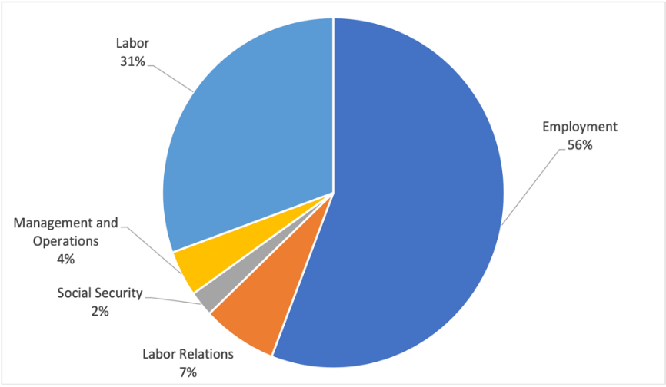

- Preparation, publication, and distribution the RIAL electronic Information Bulletin or “Newsflash”, which gives a bi-weekly look at Labor Administration in the Americas. Information is consolidated about cooperation activities, institutional changes, advancements in the sub regional and hemispheric labor and employment agendas, featured news from Ministries, events and publications. In addition to the electronic bulletins, some Information Bulletins have been printed, the last of which was on the occasion of the 50th Anniversary of the IACML. To date, more than 230 newsflashes have been produced and distributed. During the COVID-19 pandemic, the newsletters proved to be a valuable communication tool to inform the Ministries on the evolution of the labor situation worldwide, and share useful resources such as publications, reports, and the Portfolio of Responses from the Ministries of Labor to the COVID-19 pandemic itself. (See images of the Newsflash as Figure No. 2)

Figure No. 2
Images of the Newsflash

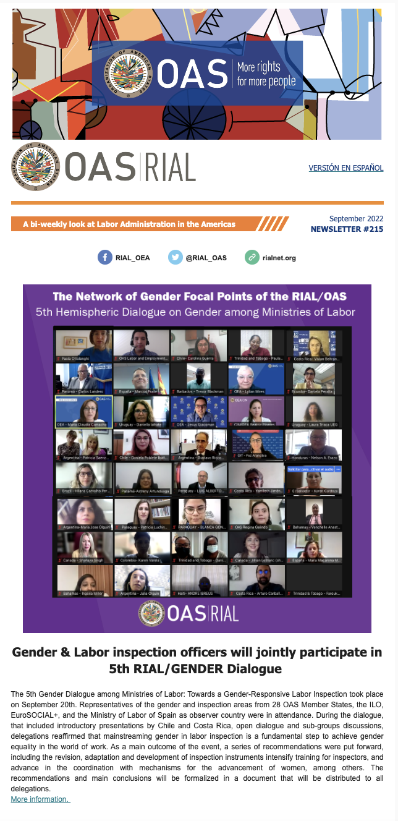
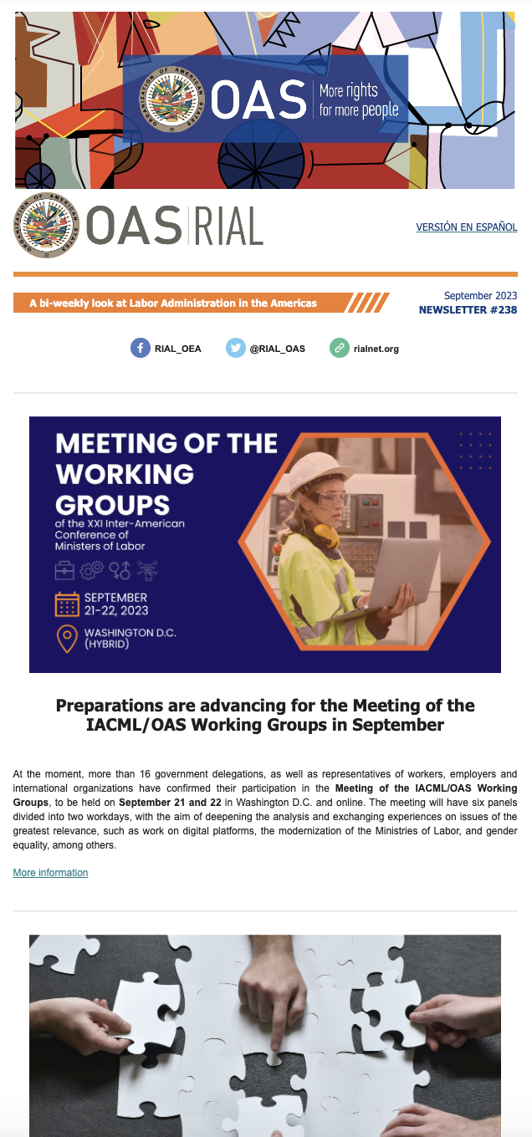

- Preparation, launch, and continuous updating of the RIAL web page: www.rialnet.org, which organizes and systematizes programs and activities. The website has been in constant revision to guarantee that its contents are up-to-date, and that the technological platform used is modern and agile, always in consultation with the Ministries of Labor. The web page contains complete and updated information on the Ministries and all RIAL activities (Workshops, bilateral cooperation, etc.), in addition, it has internal search engines to find information by country or by each of the labor administration topics, and is the access point to the different databases and repositories of the RIAL, including the Portfolio of Programs, the Portfolio of Telework laws and regulations, and the Repository of Actions on Paid Domestic Work.

Figure No.3
Image of RIAL’s Homepage
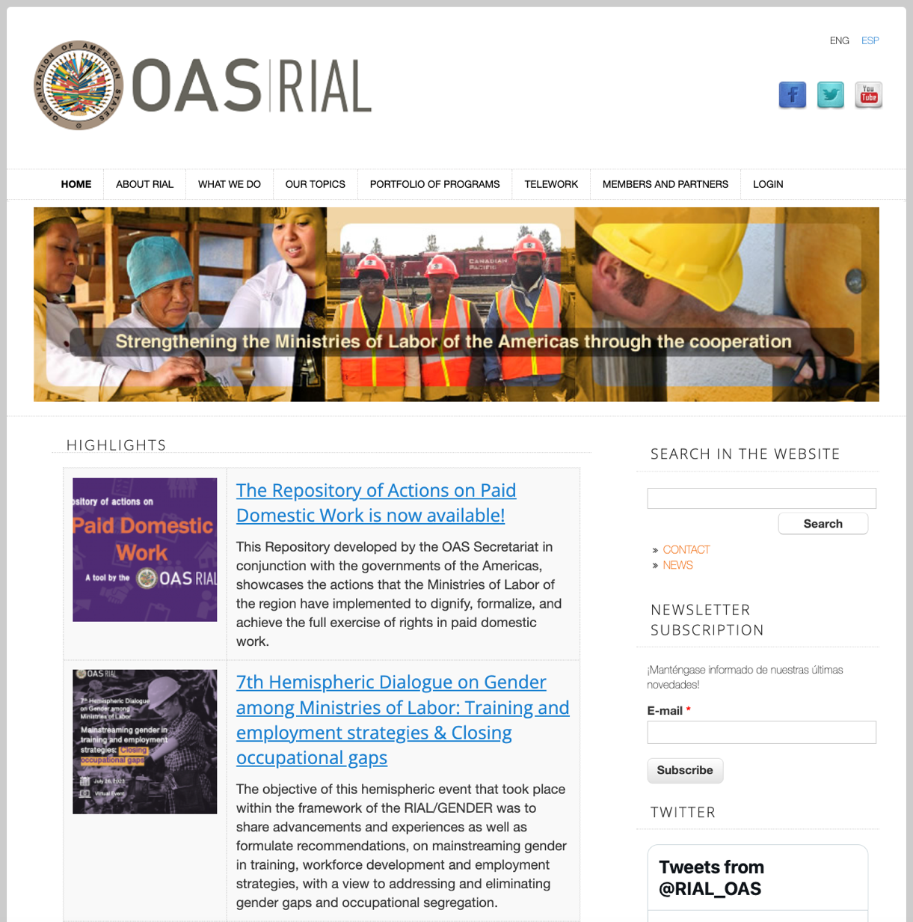

- Preparation of six RIAL technical studies and one in process: The first one, “Gender equality for Decent Work: Proposals for mainstreaming gender into labor and employment policies within the framework of the IACML” served as the basis for the document “Strategic Guidelines of XV IACML for Advancing Gender Equality and Non-discrimination within a Decent Work Framework”. These guidelines were adopted at the XV IACML, thus, the topic has continued to be addressed within the RIAL framework, in order to promote gender mainstreaming in labor and employment policies and in the operations of Ministries of Labor. In December 2007, IACML authorities approved the components of a RIAL Gender Project, based on the Strategic Guidelines, one of which was the preparation of the second study on “Institutionalization of a gender approach in the Ministries of Labor of the Americas”, distributed during the XVI IACML. In 2013 and as part of the follow-up to these Strategic Guidelines, a third study was completed that draws upon the Gender Audit experiences, which are detailed further in this report. This study is titled “Advancing the institutionalization of a gender approach in the Ministries of Labor of the Americas. Lessons learned, findings and recommendations from three Participatory Gender Audits.” In 2015, the study “Analysis of Bilateral and Multilateral Social Security Agreements as they relate to Pensions” was released, and it provides an updated outlook on these types of agreements and their operation. In 2017, the study “The Coordination between Education and Labor in the Americas: Results of the Inter-Sectoral Workshop on Youth Employment” was distributed during the XX IACML, responding to one of the emerging priorities of the Conference. At the XXI IACML in 2021, held virtually, the study “The Institutionalization of a Gender Approach in the Ministries of Labor of the Americas: Balance of a decade” was distributed, which took as a baseline the study of the same name published in 2009 and provides an updated overview on the advancements in this area. In addition, it proposes a series of recommendations and next steps to strengthen the institutionalization of a gender approach in the Ministries.

- Promotion of bilateral cooperation among Ministries of Labor identified and negotiated directly by them, with support from the Technical Secretariat. The RIAL operates through open calls for proposals and funds cooperation activities and technical assistance among Ministries of Labor, that can be: on-site visits or experts visits, depending on objectives pursued and the implementation site, or virtual cooperations (since 2020). The Ministries identify cooperation areas and initiatives or strengths of other Ministries through the Portfolio of Programs, the RIAL Hemispheric workshops, other regional or sub-regional events, and advice provided directly by the Technical Secretariat.

The bilateral cooperation and technical assistance activities funded by the RIAL make it possible to gain knowledge of a practice on-site or receive training from experts. The advisory services provided are direct and personalized and the contents of each activity are “tailor-made”, defined in keeping with the interests and needs of the participating Ministries.

- Launching sixteen (16) annual calls for proposals for bilateral cooperation through the RIAL, from 2007 to 2023, except for 2011, as a result of which 755 cooperation proposals were received, as is detailed in Table No. 2. Number of proposals selected per year has varied based on available financial resources in the RIAL Fund and according to the decisions of IACML authorities. See Appendix 2 for a full list of proposals selected.

Table No. 2

RIAL bilateral cooperation proposals and activities for each call for proposals

Call for proposals | Proposals received | Proposals selected | Activities carried out | On-going activities | Activities suspended or cancelled
1st - 2007 | 28 | 8 | 8 | 0 | 0
2nd - 2008 | 61 | 21 | 18 | 0 | 3
3rd - 2009 | 47 | 20 | 17 | 0 | 3
4th – 2010 | 53 | 17 | 16 | 0 | 1
5th – 2012 | 37 | 10 | 9 | 0 | 1
6th - 2013 | 63 | 8 | 7 | 0 | 1
7th - 2014 | 35 | 8 | 8 | 0 | 0
8th - 2015 | 64 | 8 | 7 | 0 | 1
9th – 2016 | 45 | 5 | 5 | 0 | 0
10th - 2017 | 41 | 5 | 4 | 0 | 1
11th – 2018 | 49 | 7 | 7 | 0 | 0
12th - 2019 | 47 | 8 | 8 | 0 | 0
13th – 2020 | 45 | 5 | 4 | 0 | 1
14ª - 2021 | 28 | 5 | 5 | 0 | 0
15ª - 2022 | 53 | 5 | 5 | 0 | 0
16ª - 2023 | 59 | 5 | 2 | 3 | 0
TOTAL | 755 | 145 | 130 | 3 | 12

The selection of bilateral cooperation activities to be carried out is based on the following criteria:

  - Relevance and timeliness of the cooperation (the rationale for the activity shows why the cooperation is needed at this time);
  - Clarity of objectives;
  - Clarity and relevance of participant profiles;
  - Explicit commitment by the parties involved;
  - Relevance of the subject matter to the IACML;
  - Priority accorded to proposals arising from activities of the RIAL and the IACML, and those with co-financing from the beneficiary institution.

In the first round of evaluation, each of the proposals received is graded based on these criteria and from a strictly technical standpoint. This grading puts special emphasis on the potential impact of the cooperation; that is, on proposals where a concrete result could be anticipated that would result in improved capacities and improvements in the operations of Ministries of Labor. Subsequently, it is verified that there is broad geographic representation among the most solid proposals, and special consideration is given to relatively less-developed countries.

The activities selected are canceled when they are not able to be held the year they were selected.

It is important to mention that the quality of the proposals has improved over time. In particular, the justifications are more solid, clearly showing what cooperation was required and why, and detailing the current situation within the Ministry in terms of the topic being addressed; furthermore, the stated objectives are in general more relevant and achievable. During the months that the Calls for proposals remained open, as well as in the submission of proposals, we were able to observe that communication and collaboration among various ministries had been strengthened.

During each Call, the Technical Secretariat holds a webinar or virtual seminar to provide guidance for formulating proposals and answer questions about the process, this practice began in the 7th Call and has had a positive impact on the quality of the proposals presented. This exercise also includes a match-making session where Ministries can identify potential partners to address their cooperation needs. Officials from more than twenty (20) Ministries of Labor have participated in each of the webinars, and more than 80% of them indicated that they felt better prepared to present proposals to the RIAL, according to follow-up surveys. Webinars are an excellent first step in the RIAL’s efforts to use more innovative technologies.

- Coordination and development of cooperation activities among Ministries of Labor under the aegis of bilateral cooperation in the RIAL. To date 130 cooperation activities have taken place, and 3 activities are underway and to be completed within 2023. Appendix 2 provides the complete list of activities selected and carried out or under planning during the sixteen calls, and many of their outcomes can be found in the RIAL Newsletters and are set out in Section II of this report.

In 2020, considering the challenges and mobility restrictions posed by the COVID-19 pandemic, bilateral cooperations began to be carried out virtually and under a new methodology to guarantee compliance with the stated objectives, as well as the development of a final product. The methodology includes at least 4 online cooperation sessions in a period of between 4 and 6 months of execution, the exchange of information and documents between the different sessions, the preparation of a final product (manual, work plan, program, etc.) throughout the exchange with direct technical assistance from the providing Ministry, and a dedicated webpage to follow each step of the cooperation. Virtual cooperations have shown very good results in terms of the outputs achieved and the participation of more people and actors than on-site cooperations.

Below, Table No. 3 shows the distribution by country of RIAL bilateral cooperation activities. Eighteen (18) Ministries have participated by providing assistance, with very important leadership from Argentina, and 28 Ministries have participated as recipients, for a total of 30 Ministries of Labor having participated in bilateral cooperation activities.

Table No. 3
Ministries of Labor participating in bilateral cooperation activities
(2007-2023)

Ministry of Labor |  | Providing |  | Requesting
 |  | Completed Activities | On-going Activities | Completed Activities | On-going Activities
1 | Argentina | 37 |  | 6
2 | Bahamas | - |  | 2
3 | Barbados | 4 |  | 4
4 | Belize | - |  | 3
5 | Bolivia | - |  | 4
6 | Brazil | 12 |  | 1
7 | Canada | 9 |  | -
8 | Chile | 8 |  | 4 | 1
9 | Colombia | 8 |  | 8 | 1
10 | Costa Rica | 4 |  | 8
11 | Dominican Republic | 2 |  | 6
12 | Ecuador | 3 |  | 9
13 | El Salvador | - |  | 6
14 | Guyana | - |  | 4
15 | Guatemala | 2 |  | 9
16 | Grenada | - |  | 1
17 | Honduras | - |  | 5
18 | Jamaica | 6 | 1 | 2
19 | Mexico | 6 |  | 7
20 | Nicaragua | - |  | 1
21 | Panama | 5 | 1 | 5
22 | Paraguay | 1 |  | 9
23 | Peru | 4 |  | 13
24 | St. Kitts and Nevis | - |  | 1 | 1
25 | St. Lucia | - |  | 3
26 | St. Vincent & Grenadines | - |  | 2
27 | Suriname | - |  | 1
28 | Trinidad & Tobago | 5 |  | 5
29 | United States | 10 |  | -
30 | Uruguay | 4 | 1 | 1
 | Total Activities | 130 | 3 | 130 | 3

- Follow-up on cooperation activities and identification of results. On finishing each cooperation activity, the participants from the requesting institution create a Final Report in which they the most important lessons learned and the practical successes of the providing Ministry, and interpret how they can be replicated or adopted in their country. Furthermore, steps to take are detailed; in other words, what their Ministry will do with the information and lessons gained. Six months after each activity, the requesting institution should complete a Follow-up Questionnaire which 1) indicates how the information received and subsequent contact with the providing institution have been shared; 2) specifies what has followed from the steps to take, which have been completed, which have not and the circumstances that would allow or prevent their completion; 3) indicates the concrete result that were produced after the cooperation activity (development of new products, creation of new units, etc.), and 4) provides suggestions and comments to improve the bilateral cooperation component of the RIAL.

Following up on activities allows for the identification of the RIAL’s results in terms of impact on institutional strengthening of Ministries of Labor, as is detailed in Section II of this Report.

- Creation of the Network of gender focal points, called RIAL/GENDER, in March 2022 as an express and organic decision of the gender units or areas in the Ministries of Labor. During 2020 and 2021, as an alternative to travel restrictions, the RIAL promoted virtual dialogues among the gender units of the Ministries to analyze and exchange experiences to strengthen said units and give them better tools to advise their Ministries on key issues, including teleworking policies. In each of these dialogues, the need and value of having an exclusive cooperation mechanism became evident. In response, RIAL/GENDER was created, whose purpose is to strengthen gender units or areas within the Ministries of Labor, as a means to contribute to achieving full equality in the world of work. The following products and results of this Network stand out:

  - Carrying out seven virtual gender dialogues between 2020 and 2023 on teleworking and co-responsibility for care, labor inspection with a gender perspective, paid domestic work, job placement and closing occupational gaps, among other topics. An average of 27 Ministries of Labor participated in each of them and resulted in the identification of lessons learned and policy recommendations.

  - Preparation of the founding document of the RIAL/GENDER with the participation of the gender focal points in the Ministries and definition of its annual work plan. Constitution of the first Coordinating Committee made up of the Ministries of Labor that lead the IACML and its Working Group 1: Argentina, Costa Rica, Chile and Trinidad and Tobago.

  - Preparation of the “Manual for Gender Units in the Ministries of Labor – ABC for its creation and operation”

  - Design, production and launch of the virtual Course on Gender Violence at Work on the Educational Portal of the Americas, launched in October 2021 in Spanish and in March 2022 in English. It has a duration of 10 weeks with synchronous and asynchronous activities and the permanent accompaniment of a tutor. Its contents were developed in competition with experts from the Inter-American Commission of Women (CIM) and are divided into 4 modules: 1) Conceptual framework of gender violence at work; 2) the role of the Ministries of Labor in the identification, prevention, attention, and punishment of gender violence; 3) good practices to prevent and address violence against women at work; and 4) conclusions and evaluation. 75 officials from 27 Ministries of Labor in the Americas have been trained.

  - Creation of the online Repository of Actions on Paid Domestic Work, described in letter u) of this section.

- Prior to the creation of the RIAL/GENDER, the execution of 3 Participatory Gender Audits in the Ministries of Labor of Barbados, El Salvador and Peru is highlighted. They took place between 2011 and 2013 in partnership with the ILO and with financial support from the Canadian Labor Program. These audits resulted in complete overviews and concrete action plans to strengthen gender institutionalization in each Ministry.

- The creation of a virtual library with institutional information about the Ministries of Labor (authorities, organization, responsibilities, and operating manuals) that is available on the RIAL web page.

- The creation of a Facebook page: www.facebook.com/RIALOEA, Twitter account @RIAL_OAS and LinkedIn profile to provide updated information on the activities of regional Ministries of Labor and, at the same time, make announcements to our followers on the movements of the RIAL. Additionally, there is ongoing monitoring of Ministries’ websites, along with those of relevant International Organizations.

- Undertake a series of Virtual Seminars (Webinars), beyond those used to provide information about the RIAL and those carried out within the framework of the RIAL/GENDER, to exchange experiences and analyze particular topics. Four webinars have been organized with PAHO and ILO on workers’ health. One webinar on labor inspection took place in 2015, particularly to showcase the experience of Trinidad and Tobago. In March 2019, the Technical Secretariat organized one webinar along with the government, workers’ and employers’ representatives of Castile and Leon, Spain, on their internationally recognized experience of Social Dialogue. This webinar was attended by officers from 17 OAS Member States.

- Publication of the “10 Years of the RIAL”, which outlines the strengths, achievements, and the
impact that the RIAL has had on the Ministries of Labor in the region.

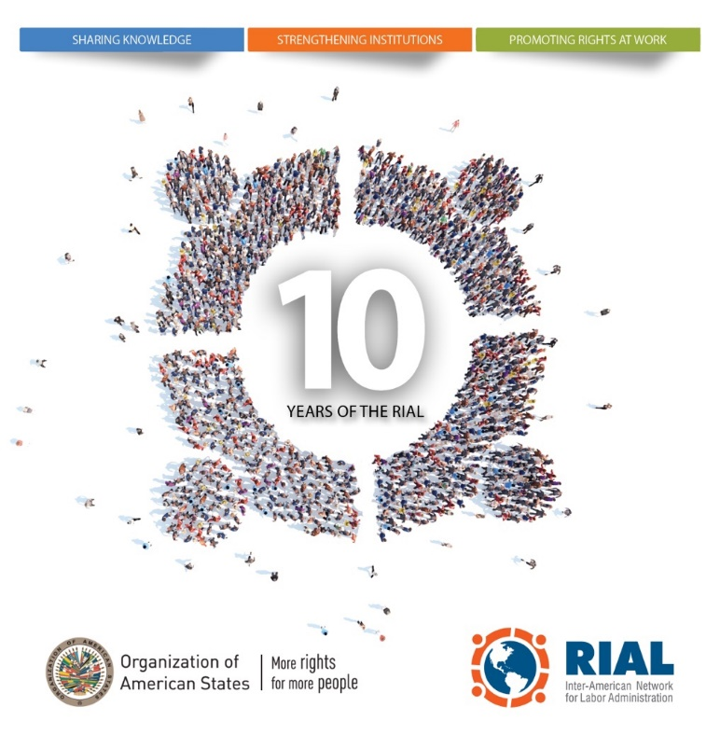

- Publication of the Portfolio of Responses from Ministries of Labor to COVID-19. On April 1st, 2020, as part of the response to the COVID-19 pandemic, the RIAL launched on its website the Portfolio of Responses from Ministries of Labor to COVID-19, which included information and direct links to actions taken by the labor administrations in the region to protect workers, employment, and income. This Portfolio was updated permanently until July 2022 and gathered almost 500 measures. It was a useful tool to monitor the situation at the regional level, identify lines of action of every country, and determine trends in the management of the crisis. For example, it was noted that a broad number of countries, after taking emergency measures regarding lockdowns and protecting jobs and employment, canalized their efforts to promote on-line training. A clear tendency of the Ministries’ efforts to digitalize their services during the pandemic, and strategies to attend the more vulnerable populations, among others, was also highlighted.

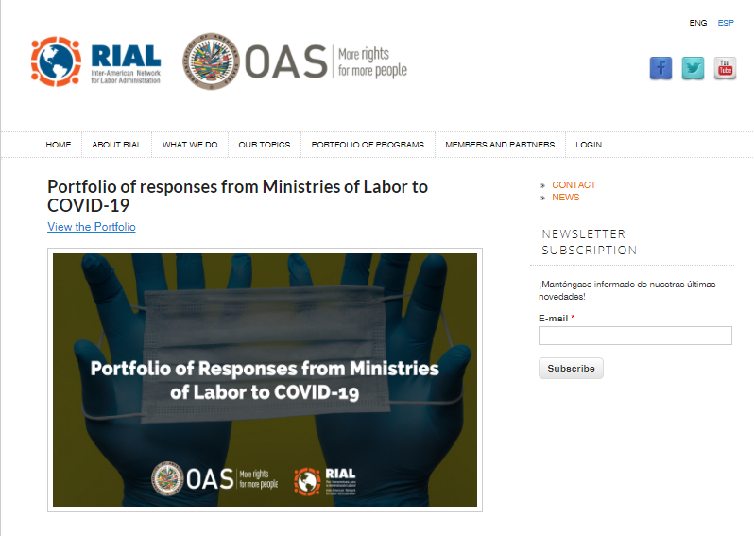

- Publication of the Repository of Guidelines and Protocols for Deconfinement and Return to Work. As a second product of the RIAL in the face of the COVID-19 pandemic, in May 2020 the “Repository of Guidelines and Protocols for Deconfinement and Return to Work” was published in the RIAL website. This tool was developed to provide Ministries of Labor of the Americas with information on the actions taken by countries outside the region to ease confinement measures, return to the workplace, and always ensure the safety and health of workers, considering those countries were at a different stage of the pandemic. In this regard, the Technical Secretariat made available resources published by governments outside the region, such as the European Union, Singapore, Germany and Australia, international organizations such as the ILO and the IDB, and workers’ and employers' organizations such as the IOE. As the OAS Ministries of Labor published their own deconfinement guidelines and Occupational Safety and Health protocols, they were also included. This Repository was updated until December 2021.

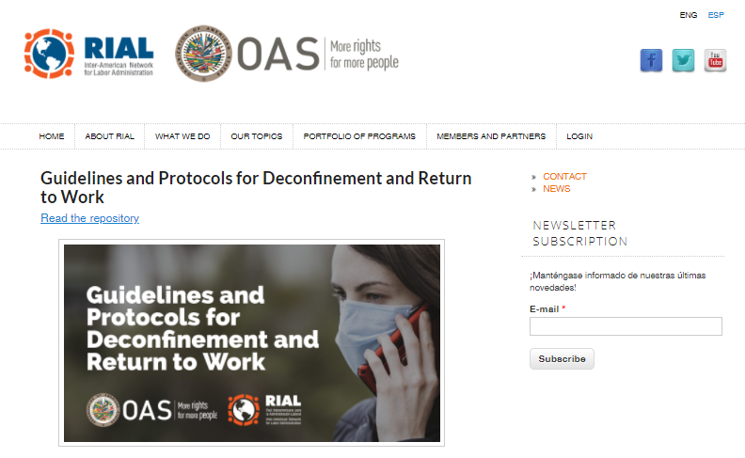

- Portfolio of Telework laws and regulations, launched in July 2022, gathers over 90 instruments implemented by the governments of the region regarding telework, with the objective of providing a useful tool for countries that are in the process of creating, designing or modifying their own, and may find elements to apply in their own national context.

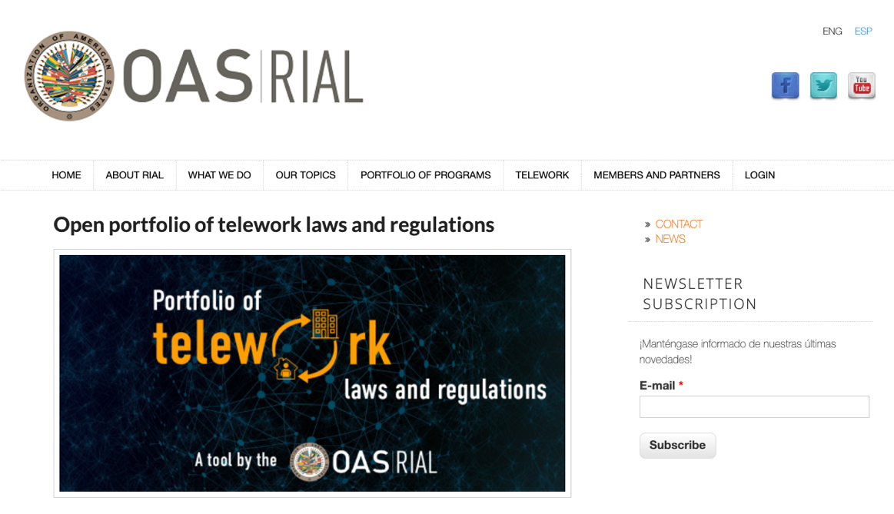

- Repository of Actions on Paid Domestic Work, launched in July 2023, and developed in conjunction with the governments of the Americas, showcases the actions that the Ministries of Labor of the region have implemented to dignify, formalize, and achieve the full exercise of rights in paid domestic work. The Repository contains information on legislation, policies, and strategies implemented, classified into five major areas of intervention: 1) Training and professionalization, 2) Dissemination and awareness raising, 3) Inspection, 4) Social security coverage, and 5) Alliances with social actors. This Repository is a direct outcome of the 6th virtual gender dialogue and the RIAL/GENDER.

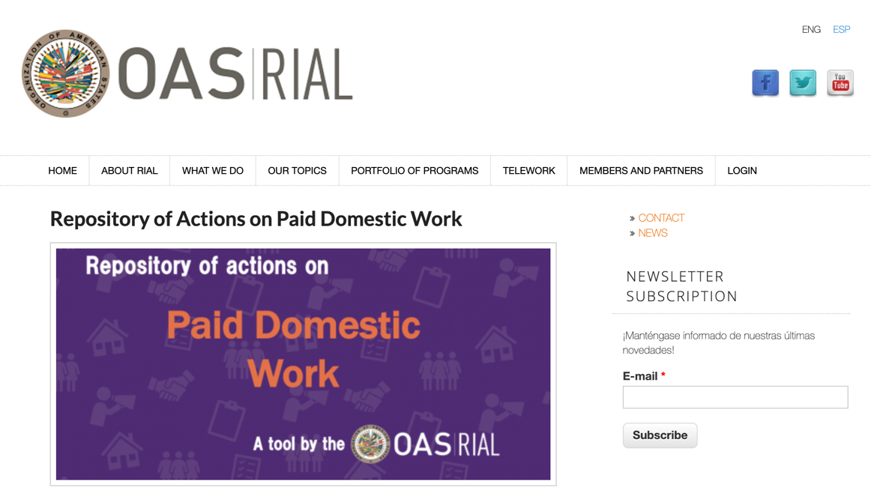

V. LESSONS LEARNED

Throughout the Inter-American Network for Labor Administration’s (RIAL) years of operation, the Technical Secretariat has identified some lessons learned that would facilitate better results in the Network’s operation and create a greater impact:

- Commitment and conviction: Commitment to cooperation and a conviction that it is a valuable tool for institutional strengthening are essential on the part of Ministries of Labor. This includes efforts on the part of Ministries to share initiatives of their institutions through RIAL that may be scattered throughout the region.

- Definition of priorities: The RIAL is a dynamic policy and action that was created by and for the Ministries of Labor. As a tool of the IACML, the RIAL must address the mandates contained in the Declarations and Plans of Action adopted by the Conference. Since the mandates refer to a wide array of subject areas, these years have confirmed the importance of the definition, by the IACML authorities at the biennial planning meeting, of the priority action areas and main activities of the RIAL. The authorities define these areas based on the ministerial mandates and the results of questionnaires sent to all Ministries regarding their cooperation needs and priorities. The areas and guidelines established at the planning meeting then enable the Technical Secretariat to operate the RIAL.

- Importance of the focal point: Ministries with a clearly defined person or area (focal point) to follow up on the RIAL make greater use of the Network and take much more advantage of its activities. On the other hand, in Ministries where there is no clear channel for communication with the OAS and/or a person or area responsible for the RIAL, there is less participation, and opportunities for cooperation and resources are lost. The RIAL focal points can ensure that their ministries take greater advantage of it if they: (1) are aware of the technical assistance priorities of their Ministries; (2) disseminate within all Ministry areas information about the RIAL (calls for proposals, workshops, portfolio, etc.) ; and (3) raise awareness among the different areas regarding the usefulness of cooperation in strengthening Ministry management and enhancing Ministry initiatives and programs. Generally, this lack of definition of a RIAL focal point is also where no area for international affairs exists and, moreover, seems to arise from lack of information on or interest in international cooperation.

- The role of offices for international affairs: In general, ministries’ offices for international affairs are the areas assigned to the RIAL. This is appropriate because they make use of the RIAL tools to deepen their cooperation ties and complement other initiatives being implemented at the level of sub regional blocs or under bilateral agreements.

- Participants’ profiles, the importance of including technical staff: The impact that can be achieved through Workshops and bilateral cooperation activities is closely linked to the participants’ profiles. Such activities can contribute effectively to Ministry institution-building (and leave installed capacity) if participants are technical personnel with broad experience and knowledge of the topic in question. Results will be still better if such personnel have authority to influence the formulation and implementation of policies and programs. In most cases, these requirements have been met.

- Relations with other agencies and the importance of incorporating expertise. Activities that are carried out in conjunction with other agencies from their planning stage show significant strength. This is the case, for example, of the studies on gender and the participatory gender audits conducted in conjunction with the ILO and the Inter-American Commission of Women (CIM). Mention may also be made of the workshops on Occupational Health and Safety (OHS) and Public Employment Services, planned and implemented in conjunction with the ILO, PAHO, and WAPES.

- Hemispheric workshops are a valuable opportunity for exchange. Workshops are of great value in raising awareness of different programs and strategies in a given area that are being implemented in the region, and have been evaluated very positively by participants. In general, they seem to be a “hotbed” for future bilateral cooperation activities in the framework of the RIAL.

- Preparation for Workshops: The quality of interventions during the Workshops is greater when the participants have prepared supporting documents that are based on the “Guiding Questions” elaborated by the Technical Secretariat. In addition, these documents enable us to have updated information about the initiatives in all of the countries on the relevant topic and they can serve as an excellent input for developing studies and recommendations.

- Bilateral cooperation within the RIAL has shown excellent results and certain conditions facilitate greater impact: In general, bilateral cooperation activities show valuable results because they facilitate direct exchange and because their content is defined in keeping with the priorities and needs of the beneficiary Ministry (tailored to its needs). It has been determined that these activities yield better results when: (1) they are carried out at an opportune time (for example, the country requesting cooperation is redefining a program or drafting a bill); (2) they address Ministry plans and priorities, i.e., the assistance is not fleeting and sporadic; and (3) they are planned from the outset by the technical teams that will participate in the on-site visit or experts’ visit. To that end, the RIAL focal points should create opportunities for this to take place and follow up on the process without creating interference. The RIAL shortens the challenges that are presented to the Ministries throughout the region and allows for an immediate and effective response to their needs.

- The strengths or shortcomings that are evident in proposals submitted for bilateral cooperation: The majority of the proposals received in the calls, particularly during the last call, are well developed and they include very clear justification and objectives; however, there are other proposals that are weak and this could be a reflection of the institutional weaknesses in the formulation of proposals in general, in the definition of priorities for technical assistance and/or in the identification of possible partners, through the RIAL itself or through bilateral or multilateral relationships.

- Final Reports on bilateral cooperation activities: These reports are key to understanding the results of the activities and their potential impact. Additionally, according to some of the participants, the elaboration of the reports can help in reflecting on the lessons of the experiences that they have observed and in defining how these lessons can be used to improve the management of the Ministry (the Secretariat requests that this analysis is included in the report).

- A need for recognition of the administrative capacity of focal points in planning activities: Some ministries have personnel and resources enabling them to administer several activities simultaneously and handle commitments with different agencies, but others do not. In the Technical Secretariat, we seek to schedule activities so that they do not exceed the administrative capacity of the focal points.

- The importance of regional dialogue and cooperation within the crisis: The COVID-19 pandemic proved the importance of regional dialogue and cooperation among labor administrations, by allowing the exchange of knowledge, experiences, challenges and lessons learned in designing and adjusting the responses to the crisis. In various regional and international dialogues, it has been recognized that labor international cooperation is an indispensable underpinning of the construction of a new and better normal.

VI. NOTE ON FUNDING

This report is complemented by the document “Financial Status of the RIAL”, which contains the state of contributions and expenditures up to date. The RIAL Voluntary Contribution Fund has received contributions since 2011 in an amount of approximately US $1,125 million; around $575,000 of those resources come from 20 countries, $100,000 from Trinidad & Tobago, $100,000 from the United States, and $353,000 from Canada.

Between 2006 and 2010, the vast majority of RIAL activities were financed through an important contribution from the Labour Program of Canada, which was solidified with the signature of four agreements with the OAS for a total of US $ 1.35 million. This financing covered the costs of activities as well as the RIAL’s basic operating costs.

The contributions made to RIAL have been complemented by financial and in-kind support from various Member States, partner international organizations and the General Secretariat of the OAS in terms of coordination and operation of the RIAL. Support from the OAS, which involves not only the Technical Secretariat headed by the OAS/SEDI, but National Offices and other administrative areas, is calculated at approximately $100,000 annually.

APPENDIX 1

Summary of RIAL Hemispheric Workshops

- Hemispheric Workshop on Occupational Health and Safety (OHS); San Salvador, El Salvador, May 16-17, 2006 (Second OHS Workshop under IACML, first one under RIAL): Inaugurated by the President of El Salvador, Elías Antonio Saca, this workshop was jointly organized by the OAS, PAHO, ILO, the Ministries of Labor of El Salvador and Canada, and Fundacersso, and thus provided an example of genuine and fruitful interagency coordination. The workshop brought together more than 80 OHS experts from more than 20 of the region’s Ministries of Labor, from OHS collaborating centers in Chile, Central America, Brazil, and Canada, from international agencies, and from COSATE and CEATAL. The workshop provided follow-up to the first IACML workshop on OHS held in 2004 in El Salvador. Its most important achievement was the adoption of strategic guidelines for three topics — occupational health and safety management systems, occupational health and safety information systems, and HIV in the workplace — which will serve to guide the work of governments, OHS centers, and international agencies on those issues, through actions at the national, subregional, and hemispheric levels.

- Seminar on Labor Intermediation and Labor Market Observatories: Opportunities and Challenges in the Hemisphere; Cocoyoc, Morelos, Mexico, November 7, 2006: Organized by Mexico’s Secretariat of Labor and Social Welfare (STPS) in its capacity as the pro tempore chair of XIV IACML, this workshop analyzed experiences with labor market observatories and employment services in Argentina, Chile, El Salvador, Mexico, the United States, and Europe, and was attended by representatives of the IDB, ILO, WAPES, OAS, COSATE, and CEATAL. In their exchanges, the participants emphasized the progress made by employment services in addressing demand and in the use of new technologies (ICTs). They also identified, as the main challenge facing those services, the need to respond to two new realities in the labor market: the expansion of the informal sector and increasing migratory flows.

- Workshop on Migrant Workers: Protection of Labor Rights and Labor Market Programs; Ottawa, Canada, November 28-29, 2006: This workshop was attended by representatives of 28 of the Hemisphere’s Ministries of Labor, the ILO, the Inter-American Commission on Human Rights (IACHR), the Organization of Eastern Caribbean States (OECS), the North-South Institute, the OAS, COSATE, and CEATAL. The event facilitated a dialogue and cooperation among the labor ministries on ways to promote the labor rights of migrant workers and on labor market programs, with emphasis on Canada’s program for temporary migrant workers. The workshop followed up on the relevant IACML and Summit mandates and on the Inter-American Program adopted by the OAS General Assembly in 2005.

- Workshop on Technical Assistance; San José, Costa Rica, May 8, 2007: This workshop was organized in response to a request made repeatedly by several IACML members regarding the need for greater awareness about technical assistance channels and priorities and for identifying the difficulties encountered by executing agencies in their dealings with donors; it was attended by representatives from 26 Ministries of Labor. At the event several donor countries and institutions (Canada, United States, AECI, IDB) and several technical assistance executing countries shared their experiences, and the participants received training on the basic components of successful proposals.

- Workshop on Labor Dimension of FTAs and Regional Integration Processes; Port-of-Spain, Trinidad and Tobago, July 10, 2007: This workshop, attended by representatives from 21 Ministries of Labor, studied two topics: (1) the specific labor provision components (chapters, side agreements, memoranda of understanding, declarations) that have been incorporated into various bilateral and multilateral free trade agreements, and (2) the labor provisions of various subregional integration processes and the progress they have made with them. The workshop heard presentations by representatives from several governments, COSATE, CEATAL, and CARICOM.

- Workshop on Social Dialogue and Social Cohesion; Montevideo, Uruguay, April 15, 2008: This workshop brought together technical specialists from the Ministries of Labor of 27 countries of the Americas, together with representatives from COSATE, CEATAL, and the ILO, to study the characteristics and challenges facing various social dialogue forums in the region, such as consultative councils, employment councils, economic and social forums, etc. The workshop lasted one day, during which the participants exchanged experiences and approaches and concluded that social dialogue is a key element in democratic governance and a basic tool for constructing inclusive societies and ensuring social justice. They concluded that social dialogue must be effective and institutionalized and must take place in conditions of constructive cooperation. The seminar’s presentations and discussion sessions were extremely rich in content and ideas.

- Seminar on Youth Employment; Rio de Janeiro, Brazil, May 20-21, 2008: This seminar was jointly organized by the Ministry of Labor and Employment of Brazil, the Department of Labor of the United States, and the OAS. It offered an excellent opportunity for exchanging experiences and analyzing key issues affecting youth employment in the Americas, particularly the need to forge alliances to create decent jobs for young people; the benefits of establishing comprehensive or integrated strategies, policies, and services; youth entrepreneurship initiatives as an alternative way to create decent work; and the importance of implementing labor inclusion strategies for at-risk youth. It was attended by technical representatives from 29 of the region’s Ministries of Labor, members of COSATE and CEATAL, representatives of international agencies such as the ILO, IDB, World Bank, and WAPES, and more than 10 nongovernmental organizations.

- Third Hemispheric Workshop on Occupational Health and Safety (OHS); Cusco, Peru, October 21-22, 2008: This Workshop provided follow-up to the two Hemispheric Workshops on OHS that took place in the IACML-RIAL framework in 2004 and 2006 in El Salvador. It was organized by the Ministry of Labor of Peru and the OAS, in close collaboration with PAHO and ILO. The main topics of the workshop were: Policies and strategies for the promotion of OHS, including the role of employers and workers; strengthening of schemes to prevent and control occupational hazards; and HIV-AIDS in the workplace. The Workshop was attended by OHS specialists and officers of 26 Ministries of Labor, representatives of COSATE and CEATAL, international agencies, experts and OHS collaborating centers. The document of Summary of discussions and lessons learned, produced at the end of the event, also contains some steps to follow.

- Workshop on Public Employment Services (PES), Panama City, Panama, December 10-11, 2008: This Workshop was jointly organized by the Ministry of Labor and Labor Development of Panama and the OAS, in partnership with the Ministry of Labor, Employment and Social Security of Argentina and the World Association of Public Employment Services (WAPES). It has three thematic panels, where the main the main tendencies of PES were discussed: 1) PES and Local Development: linkages with the productive environment to ensure access to quality and productive employment; 2) Articulation of PES with workforce development (training) systems and information systems; 3) PES’ approach to addressing vulnerable groups or persons with greater barriers to employment. The document of conclusions of the event reflects the richness of this Workshop that was attended by 25 Ministries of Labor, represented by their employment directors or officers with responsibilities on PES, members of COSATE and CEATAL, as well as representatives from ILO, WAPES and OAS.
- Workshop on Labor Migration and Labor Market Information Systems, Quebec City, Canada, February 24-25, 2009: During this Workshop, organized jointly by Human Resources and Skills Development Canada and the OAS, information was shared about the development of labor market information systems in the region, particularly in Canada, the importance of these systems in managing migration was analyzed and various dynamics between labor mobility, migration and labor markets in the context of the current economic crisis were discussed. Ministries of Labor from 22 countries were represented at the workshop, along with members of COSATE and CEATAL and specialists from ILO, IOM, OAS, the Inter-American Dialogue and the Inter-American Conference of Social Security, among others.

- Workshop on Successful Labor Inspection Models, Washington D.C., USA, May 19, 2009: This workshop made it possible to exchange information on the most crucial current labor inspection issues: 1) Steps taken to attain greater effectiveness, impact, and coverage of labor inspection; 2) Actions to ensure compliance with standards and improve working conditions; 3) Strategies for optimizing oversight and supervision and for combating corruption in labor inspections; and, 4) Challenges facing labor inspection in the current economic climate. The Workshop was organized by the Secretariat of Labor and Social Welfare (STPS) of Mexico and the OAS, and attended by 26 Labor Ministry delegations and representatives of COSATE, CEATAL, ILO and PAHO.

- Workshop on Gender Mainstreaming in the Ministries of Labor of the Americas, Buenos Aires, Argentina, July 21, 2009: This Workshop complies with one of the strategic guidelines adopted by the XV IACML in 2007 for moving forward with the incorporation of a gender perspective in the framework of the Conference. The main topic of the Workshop’s discussions was the preliminary version of the study “The Institutionalization of a Gender Approach in the Ministries of Labor of the Americas,” which was prepared in 2009 in close consultation with the Ministries and which also complies with the strategic guidelines. The event was attended by delegations from 25 ministries, most of which were represented by their highest authorities on gender. Also present were representatives from COSATE and CEATAL. Based on the preliminary study, the Workshop analyzed the progress made by ministries in this area and identified priority training needs.

- Workshop on the Labor Dimension of Globalization and the Free Trade Agreements: impacts and labor provisions, Santo Domingo, Dominican Republic, July 27, 2010 – Officials of 26 Ministries of Labor, COSATE and CEATAL representatives, and international experts of the European Union, ECLAC, the ILO and the OAS (from Trade and Labor areas), discussed the impacts of globalization on labor, the labor provisions contained in free trade agreements and integration processes, and the role of labor ministries in the negotiation of such provisions. One highlight of the event was a round-table of trade experts and negotiators who discussed labor provisions of FTAs.

- Seminar on Intersectoral Public Policies: Social Protection and Employment. Río de Janeiro, Brazil, November 30 to December 2, 2010 - This seminar was a joint activity of the Inter-American Network for Labor Administration (RIAL) and the Inter-American Social Protection Network (IASPN), and was co-organized by the Organization of American States (OAS), the Ministry of Labor and the Ministry of Social Development and Hunger Fight of Brazil. It was an opportunity to analyze innovations and progress with an intersectoral approach to social protection and employment generation. It brought together Ministries of Labor and Social Development of 25 member states of the Organization, and representatives of 10 international organizations, civil society, the private sector, IACML advisory bodies, and academia. In preparation for this event, a concept document was prepared, entitled “Social Protection and Employment Generation: Analysis of Experiences from Co-responsibility Transfer Programs.” This base document was prepared by the OAS, ECLAC, and the ILO and subsequently enriched with discussions during the event.

- Workshop “Decentralized Public Employment Services and their Linkage with the Business World – Inter-regional event”. Mexico City, March 16 to 18, 2011 - This workshop was an output of the productive interagency partnership among: the World Association of Public Employment Services (WAPES), the Ministry of Labor and Social Welfare (STPS) of Mexico, the Ministry of Labor, Employment and Social Security of Argentina and the OAS Department of Social Development and Employment. It was also an interregional event that brought together authorities and officials of the employment areas of 24 Ministries of Labor and Employment of countries of the Americas and Europe, representatives of employment services of 17 Mexican states, COSATE, CEATAL, Manpower, the ILO, the World Bank, the IDB, WAPES, and the OAS. The event facilitated effective and active exchange regarding decentralization of employment services, their contributions to local development strategies, and the challenges they face in achieving greater linkage with the private sector. It also identified recommendations as to how employment services could better address employer expectations and strengthen strategic partnerships with this sector.

- Seminar “Freedom of Association, collective bargaining and sustainable development in a context of economic crisis: Preservation of citizenship”. Washington, D.C., October 11, 2012. This event is an IACML response to a demand reiterated by COSATE. Given its theme, it was planned by the authorities of Working Group 1, the OAS and consultative organs. The objectives of the workshop were to stimulate the debate on freedom of association and collective bargaining in both, the public and private sector; Value the importance of freedom of association as a key component of democracy and guarantee of citizenship in a new model of development; Advance in Social Dialogue, strengthening the processes of collective bargaining as instruments to prevent and resolve social conflicts. Twenty-three Ministries of Labor participated, along with COSATE, CEATAL and the ILO.

- Workshop against Child Labor “Moving towards better horizons for children and adolescents in the Americas”. San José, Costa Rica, February 21-22, 2013. In this workshop, authorities from 24 Ministries of Labor of the region, employer and worker representatives (CEATAL and COSATE), ILO, IIN, UNICEF and civil society organizations shared experiences and presented recommendations from the Americas for the III Global Child Labor Conference to be held in Brazil in October 2013. The recommendations aim to overcome challenges and reinforce the fulfillment of the proposed goals in the Roadmap approved in the II Global Child Labor Conference in The Hague in 2010. This Workshop was guided by the 39th to 42nd mandates of the Declaration of San Salvador, which are found under the section “The scourge of child labor: an obstacle for the integral development of societies.”

- Workshop “Towards fairer labor conditions: promoting labor inclusion with equity”. Nassau, The Bahamas, April 16, 2013. The objective of this workshop was to identify key lessons learned and policy recommendations to promote labor inclusion of the most vulnerable populations, who have traditionally been marginalized or discriminated in the labor market. This meeting was attended by delegations from 22 Ministries of Labor of the Hemisphere, as well as employers’ representatives (CEATAL), the ILO, the Inter-American Commission on Human Rights and PAHO. It was approved by the authorities of the IACML as part of the 2012-2013 Calendar in keeping up with the mandates of the Declaration of San Salvador regarding equality and non-discrimination in the workplace, in particular articles 25, 27 and 34.

- Workshop “Social Dialogue for Formalization”. Bridgetown, Barbados, September 17, 2014. During this Workshop, delegates from 22 Ministries of Labor of the region, workers’ and employers’ representatives and specialists from ILO, PAHO and OAS, discussed “efforts to transition workers from informal to formal jobs and, in the framework of the Regional Programme for the Promotion of Formalization in Latin America and the Caribbean (FORLAC), consider strategies to achieve this goal”, in compliance with mandate 6,f of the Plan of Action of Medellin. The FORLAC program, as well as some strategies to increase formalization, including Colombia, Paraguay, Brazil, United States and Barbados, were showcased. During very active sub-group working sessions a set of “Recommendations to Address the Phenomenon of Informality” were approved, including recommendations related to social protection, labor inspection, registry and promotion of enterprises, hiring incentives, education and training.

- Workshop on social protection and employment “Toward an Intersectoral focus on social protection in the Americas: Labor, Social Development and Social Security". Mexico City, Mexico, December 10-12, 2014. This workshop brought together officials from Ministries of Labor, Ministries of Social Development and Social Security authorities from 21 countries in the region, along with representatives for workers’ and employers’, as well as experts from ECLAC, ILO, World Bank, Eurosocial and GIZ, with the objective of sharing and discussing experiences and challenges in intersectoral coordination in the area of social protection. It was organized jointly by the OAS, through its RIAL and IASPN networks, CISS and the Government of Mexico, through its Secretariats of Social Development (SEDESOL) and Labor and Social Welfare (STPS), with financial support from GIZ, attained through IASPN network. The event included presentations from various countries and international organizations, as well as an on-site visit to Tepoztlan, Morelos to witness the operation of the “Prospera” program. The document titled “Results of the Workshop” contains challenges, lessons learned and recommendations identified by participants during sub-groups discussions regarding intersectoral coordination in social protection and employment.

- Inter-sectoral Workshop on Youth Employment: Coordination between Education and Labor. Brasilia, Brazil, December 15-16, 2016. This was the first meeting at the level of the Americas that brought together ministries of education and labor. In attendance were officials from both ministries, 21 member states of the OAS, representatives of workers and employers, and specialists from the ILO, World Bank, OECD, OCDE, YABT, IOHE, Manpower, OIJ, and OAS, making for a true inter-sectoral dialogue. During the event, there was an exchange of the experiences being pursued by the Ministries of Labor and Education, with an attempt to highlight coordination-related components to promote youth employment. These strategies include professional training, vocational and technical education, skills certification, first-job programs, and employment services. The current challenges of the labor market, marked by rapid technological changes, the demand economy, and the fourth industrial revolution, as well as millennials’ expectations of a new work culture were consistently brought up during the event and were also recognized as being an additional pressure on the already urgent need to coordinate inter-sectoral policies. As a result of the Workshop, a series of challenges, lessons learned and policy recommendations were identified to achieve a better coordination between the education and labor sectors.

- Workshop “Labor Migration: Contributions from the Ministries of Labor of the Americas”. San Jose, Costa Rica, July 13-14, 2017. This workshop was co-organized by the OAS, ILO, and IOM, in a genuine interagency partnership. Migration Directors and officials responsible for attending to migrant workers in 20 Ministries of Labor, workers' and employers' representatives, subregional organizations, such as CARICOM and SISCA, as well as the Chairmanship of the OAS Committee on Migration Issues (CAM) attended the meeting. Following a regional consultation, the Workshop focused on two priority areas for Ministries of Labor, for which they bear direct responsibility: 1) the development of labor market information systems and the provision of relevant information for shaping a comprehensive migration policy; and 2) protection of the labor rights of migrant workers, including the role of labor inspection and tasks relating to awareness-raising and the dissemination of information. In wrapping up the workshop, and as the outcome of a participatory exercise, lessons learned and policy recommendations for labor migration management, especially within Ministries of Labor, were identified. A prominent recommendation was that Ministries of Labor continue to improve their labor inspection system, their strategies for labor formalization, and their information systems, but at the same time highlight and explicitly address the circumstances migrants face and their vulnerability. The Workshop also recognized that the Ministries' efforts need to be accompanied by regularization of migrants' status. There was a call for more extensive inter-sectoral – interagency – coordination among Ministries of Labor, Ministries of Foreign Affairs, and employment services, not only domestically but also among countries.

- Workshop “Strategies to improve compliance with Labor Legislation”. San Jose, Costa Rica, December 6-7, 2018. This workshop gathered representatives of 20 Ministries of Labor of the region, workers and employers to exchange of information and obtain first hand knowledge on strategies to improve compliance with labor legislation, especially in the fields of: 1) strengthening of labor inspection through innovative approaches and with special emphasis on protecting the rights of freedom of association and collective bargaining, 2) alternative resolution of individual and collective labor disputes; and 3) coordination between Ministries of Labor and other public instutions. The Workshop was organized by the OAS in collaboration with the ILO, sponsored by the Ministry of Labor and Social Security of Costa Rica and financed by the Government of Canada. As a result, a document was produced pointing out challenges, lessons learned and policy recommendations on the three topics of emphasis of the event.

- RIAL workshop "Skills for the future: Contributions from the Ministries of Education and Labor". Santiago, Chile, May 16-17, 2019. This event followed up on the dialogue between the Ministers of Labor and Education held at the IACML, and the Intersectoral Workshop on "Youth Employment: Articulation between education and labor" held in Brasilia in December 2016. It responded to mandates of the IACML and Inter-American Committee on Education (CIE), as well as to the joint Declaration from COSATE and CEATAL to the XX IACML. The event gathered technical officers from the Ministries of Education and/or Labor from 18 Member States, representatives from international organizations (IADB, ILO, ECLAC, World Bank and CAF), academic institutions, representatives from workers’ and employers’ organizations, and private sector, including Google, Telefonica Foundation, Nestle and Ford. The main outcome of the Workshop was the identification of lessons learned and policy reccommendations to strenghten the coordination between Ministries of Labor, Ministries of Education, and professional training institutions, develop skills for the future, address the skills gap, and allign the education and training offers to the current and future needs of the world of work. These lessons and recommendations are included in the Outcomes Document presented in the Tenth Inter-American Meeting of Ministers of Education (CIDI/RME/INF.2/19) in July 2019. Some recommendations worth highlighting are: strengthen training on socio-emotional skills, create an all-stakeholder ecosystem (individuals, governments, academic institutions, companies, international organizations, etc) to facilitate life-long learning, create and strengthen national qualification frameworks, improve teacher training, revalue technical and technological higher education, and strengthen dual vocational training and apprenticeships programs.

- Workshop "Social Dialogue for a Sustainable, Just and Equitable Recovery", Bogota, Colombia and on-line, July 12 and 13, 2022. The Workshop, hosted by the Ministry of Labor of Colombia, brought together representatives of Ministries of Labor, workers' and employers' organizations from 29 OAS Member States to exchange and analyze experiences on the functioning of social dialogue bodies during the pandemic, to identify elements or characteristics within social dialogue bodies that facilitate the achievement of agreements, and to develop recommendations to strengthen and institutionalize social dialogue bodies at the national level, as well as to consolidate the full exercise of freedom of association and collective bargaining. As a result of the Workshop, a document entitled "Recommendations and Results" was prepared which contains, among others, the most important elements or characteristics of social dialogue mechanisms; mention of the multiple purposes of social dialogue and its centrality in democracy, social justice and development; recommendations for strengthening institutionalized social dialogue, including the regulatory framework, training and culture of dialogue; as well as specific recommendations for the functioning of social dialogue bodies.

- Workshop "Social Dialogue for a rights-based transition from informal to formal employment”, Buenos Aires, Argentina and on-line, October 20 and 21, 2022. The Workshop, hosted by the Ministry of Labor of Argentina, was attended by 25 countries of the region through delegations of Ministries of Labor, representatives of workers and employers, the representation of Spain as an observer country of the OAS, and representatives of the ILO and PAHO. The general objective of the Workshop was to increase knowledge and strengthen the capacities of the Ministries of Labor with respect to strategies and policies related to social protection and the promotion of productivity that facilitate the transition to labor formalization through mechanisms based on social dialogue. Based on the discussions during the Workshop, a "Results and Recommendations" document was prepared, containing valuable elements of consensus on the relationship between informality, inequality, poverty and exclusion; the importance of social dialogue in the design and implementation of strategies for transition to formality; the causal relationship between informality and productivity; the need to address sectors with a high prevalence of informal employment in a differentiated manner (e.g. domestic work, self-employment); among others. The document also includes recommendations to improve the contribution of social protection and productivity promotion policies and strategies to the formalization of employment.

- Workshop “Towards a Stronger Coordination between Education and Labor in the Americas". Buenos Aires, Argentina and on-line, May 4 and 5, 2023. The Workshop is the third one of the RIAL gathering Ministries of Labor and Education of the region, and responded to mandates and work plans of the OAS ministerial processes on labor and education. It was hosted by the Ministries of Education and Labor of Argentina -Chairs of the CIE and IACML respectively- and gathered specialists from Ministries of Labor and/or Education from 27 countries of the region, representatives of workers and employers, ILO-CINTERFOR and other international organizations. As an output of the Workshop, a document of results was prepared, which contains lessons learned and recommendations to strengthen the education-labor coordination, including the need to have robust policy frameworks that guide coordination and intersectoral mechanisms that make it operational and that are based on social dialogue; generate gateways between educational systems and job training systems so that people can move between them and obtain recognition for their learning; improve and give greater emphasis to teacher training; strengthen labor market information systems that make it possible to anticipate training needs; revalue technical and vocational education; guide education and training towards skills development, and adopt a proactive approach in updating and improving skills, among others. The results document also includes recommendations to develop national qualifications frameworks (NQFs) and move towards a regional qualifications framework.

APPENDIX 2

Bilateral Cooperation Activities of the RIAL

First Call for proposals - 2007

 | Beneficiary Institution | Providing Institution | Thematic Area | Type of Activity | Date (2007)
1 | Dominican Republic | Argentina | Labor conciliation (Phase 1) | On-site | May 29-31
2 | Costa Rica | Argentina | Alternative resolution of labor conflicts | On-site | June 4-6
3 | Paraguay | Brazil | Re-organization of the ML of Paraguay | On-site | July 23-27
4 | Argentina | Brazil | Labor Inspection in maritime and fluvial activities | On-site | August 6-10
5 | Peru | Argentina | National Plan for Work Regularization (Phase 1) | Experts | August 6-10
6 | Trinidad and Tobago | United States | Occupational Health and Safety | On-site | Sept. 17-21
7 | Dominican Republic | Argentina | Labor conciliation (Phase 2) | Experts | October 1-5
8 | Peru | Argentina | National Plan for Work Regularization (Phase 2) | On-site | October 8-12

Second call for proposals – 2008

 | Beneficiary Institution | Providing Institution | Thematic Area | Type of Activity | Date
1 | Guyana | Trinidad and Tobago | Occupational Health and Safety (Phase 1) | On-site | June 23-27, 2008
2 | Guyana | Trinidad and Tobago | Occupational Health and Safety (Phase 2) | Experts | July 21-25, 2008
3 | El Salvador | Dominican Republic | Labor Inspection and International Labor Relations | On-site | July 28-Aug. 1, 2008
4 | Peru | Argentina | Payment of salaries through the banking system | On-site | Sept. 3-5, 2008
5 | Honduras | Argentina | Enterprise demography and employment dynamics | Experts | Sept. 22-26, 2008
6 | Costa Rica | Mexico | Social Organization registration | On-site | Oct. 27-31, 2008
7 | Panama | Brazil | Occupational Health and Safety | On-site | Oct. 28-31, 2008
8 | Costa Rica | Chile | Promotion of a culture of compliance through the web page | On-site | Nov. 10-12, 2008
9 | Ecuador | Argentina | Registry and labor statistics system | Experts | Nov. 17-21, 2008
10 | Bahamas | United States | Occupational Health and Safety | On-site | Dec. 8-12, 2008
11 | Bolivia | Chile | Gender equity | On-site | Dec. 9-12, 2008
12 | El Salvador | Argentina | Labor inspection and International relations | On-site | Dec. 15-19, 2008
13 | Bolivia | Chile | Strategic planning | On-site | Dec. 17-19, 2008
14 | Paraguay | Chile | Social Security System | On-site | March 24-26, 2009
15 | Argentina | Canada | Preventive Mediation Program | On-site | May 12-14, 2009
16 | Dominican Republic | Argentina | Decent Work National Programs | On-site | July 27-30, 2009
17 | Ecuador | Argentina | Public Employment Service | Experts | Sept. 30 –Oct. 2 and Nov. 23-27, 2009
18 | Dominican Republic | Costa Rica | Labor statistics | On-site | Nov. 24-26, 2009

Third call for proposals – 2009

 | Beneficiary Institution | Providing Institution | Thematic Area | Type of Activity | Date
1 | Belize | Jamaica | Public employment service | On-site | Sept. 7-11, 2009
2 | Colombia | Brazil | Social dialogue and freedom of association | On-site | Sept. 21-25, 2009
3 | Chile | United States | Improvement of the enforcement of labor laws / National Call Center | On-site | Sept. 21-Oct.1 2009
4 | Guyana | Barbados | Occupational Health and Safety | On-site | Oct. 5-9 , 2009
5 | Saint Vincent and the Grenadines | Canada | Occupational Health and Safety | On-site | Oct. 19-23, 2009
6 | Nicaragua | Brazil | Public employment system | On-site | Oct. 19-23, 2009
7 | Paraguay | Brazil | Public employment system | On-site | Oct. 19-23, 2009
8 | Ecuador | Peru | Certification and evaluation of labor competencies | Experts | Nov. 9-13, 2009
9 | Costa Rica | Uruguay | Enforcement of labor legislation regarding children and youth | On-site | Nov. 16-19, 2009
10 | Paraguay | Argentina | Labor statistics | On-site | Nov. 30- Dec.4, 2009
11 | Guatemala | Argentina | Strengthening of the Labor Statistics Unit in the Ministry of Labor | On-site | Nov. 30- Dec.4, 2009
12 | Argentina | United States | Youth employment services | On-site | Dec. 7-9, 2009
13 | Belize | Trinidad and Tobago | Occupational Health and Safety | On-site | Mar. 15-19, 2010
14 | Mexico | Canada | Occupational Health and Safety – Safe Work Program | Experts | Mar. 29-31, 2010
15 | Panama | Argentina | Public employment service | On-site | Sept. 20-24, 2010
16 | Peru | Chile | Employment service - new technologies | Experts | Dec. 16-17, 2010
17 | Bahamas | United States | Occupational Health and Safety | Experts | Jun. 27 – Jul.1, 2011

Fourth call for proposals – 2010
 | Beneficiary Institution | Providing Institution | Thematic Area | Type of Activity | Tentative Date
1 | Barbados | Trinidad and Tobago | Labor inspection | On-site | June 28 – July 2 2010
2 | Argentina | Colombia | Information management systems – E-government | On-site | June 12–16, 2010
3 | Chile | Argentina | Professional training and certification of labor competencies | On-site | June 14–16, 2010
4 | Brazil | Canada | Occupational Health and Safety in the maritime sector | On-site | Sept. 14-17, 2010
5 | Costa Rica | Argentina | Employment service network | On-site | Sept. 20-24, 2010
6 | Saint Lucia | United States | Labor inspection | On-site | Oct. 19-22, 2010
7 | Panama | United States | Occupational Health and Safety | On-site | Oct. 19-22, 2010
8 | Ecuador | Peru | Certification and evaluation of labor competencies | On-site | Nov.8-11, 2010
9 | Guyana | Barbados | Dispute resolution | On-site | Nov. 8-12, 2010
10 | Dominican Republic | Colombia | Follow-up, monitoring, and evaluation of plans, programs, and projects | On-site | Nov.29 – Dec.1, 2010
11 | Mexico | Brazil | Labor relations – Labor union register | On-site | Dec. 6-10. 2010
12 | Saint Lucia | Jamaica | Employment programs abroad | On-site | Feb.21-25, 2011
13 | Trinidad and Tobago | United States | Occupational Health and Safety | Experts | Mar. 14-18, 2011
14 | Colombia | Brazil | Labor inspection | On-site | April 4-8, 2011
15 | Paraguay | Argentina | Labor statistics | On-site | June 7-9, 2011
16 | Trinidad and Tobago | Argentina | Labor inspection | On-site | Jun.27 – Jul.1, 2011
Fifth call for proposals – 2012
CIDI03378E01

 | Beneficiary Institution | Providing Institution | Thematic Area | Type of Activity | Date
1 | Colombia | Argentina | Telework as an instrument to generate employment | On-site | August 12-17, 2012
2 | Guatemala | Argentina | Employment Service: Use of new technologies | On-site | Sept. 3 – 7, 2012
3 | Bolivia | Argentina | Child Labor | Experts | Sept. 17 – 21, 2012
4 | Argentina | Canada | Public Employment Service – Linkages with local employers and older persons | On-site | Sept. 24 – 28, 2012
5 | Trinidad & Tobago | Brazil | Youth Entrepreneurship: Incubators and non-financial cooperatives | On-site | Oct. 22 – 26, 2012
6 | Peru | Brazil | Methodology to design employment and wage indicators | On-site | Oct. 22 – 26, 2012
7 | Costa Rica | Argentina | Employment promotion: customer service | Experts | Dec. 3 – 7, 2012
8 | El Salvador | Argentina | Gender mainstreaming in the Ministry of Labor | On-site | Dec. 3 – 7, 2012
9 | Paraguay | Guatemala | Strengthening the Assistance Center for domestic workers | On-site | Nov. 26-30, 2012

Sixth call for proposals – 2013

 | Beneficiary Institution | Providing Institution | Thematic Area | Type of Activity | Date
1 | Guatemala | Ecuador | Eradication of Child Labor | On-site | July 29 – Aug. 2, 2013
2 | Mexico | Argentina | Unemployment benefit schemes | On-site | August 5-9, 2013
3 | Peru | Brazil | Protection of the rights of People with Disabilities | On-site | Sept. 2-6, 2013
4 | Honduras | Mexico | Trade union registration | On-site | Sept. 11-13, 2013
5 | Barbados | Jamaica | Labor legislation | On-site | Oct. 14-19, 2013
6 | Suriname | Trinidad & Tobago | Employment services | On-site | Oct. 16-19, 2013
7 | Colombia | Brazil | Social dialogue / Operation of Tripartite Commission on Int’l Relations | On-site | May 5-8, 2014

Seventh call for proposals – 2014

 | Beneficiary Institution | Providing Institution | Thematic Area | Type of Activity | Date
1 | Guatemala | Mexico | Control and oversight of labor inspection | On-site | July 29 – Aug. 1, 2014
2 | Paraguay | Argentina | Strategic planning - organization and functioning | On-site | Aug. 25-29, 2014
3 | Costa Rica | Ecuador | Public-private partnerships to fight child labor | Experts | Aug. 26-28, 2014
4 | Saint Lucia | Jamaica | Labor Market Information Systems | On-site | Sept. 8-12, 2014
5 | Ecuador | Panama | Eradication of child labor and protection of adolescent workers | On-site | Sept. 22-26, 2014
6 | Mexico  CIDI04683E01 | Argentina | Labor conciliation | On-site | Nov. 17-19, 2014
7 | Colombia | Guatemala | Prevention of domestic child labor in indigenous communities | On-site | Dec. 2-5, 2014
8 | Peru | Colombia | Conflict prevention and resolution | On-site | Oct. 21-23, 2014

Eighth call for proposals – 2015

 | Beneficiary Institution | Providing Institution | Thematic Area | Type of Activity | Date
1 | Guatemala | Costa Rica | Child Labor | On-site | August. 4-7, 2015
2 | Peru | Uruguay | Social Security for All Program | On-site | October. 19-23, 2015
4 | Chile | Canada | Alternate Dispute Resolution – mediation | Experts | October. 5-9, 2015
5 | El Salvador | Colombia | Gender Equity – Seal “Equipares” | On-site | July. 27-30, 2015
6 | Colombia | Argentina | MOL Human Resource Administration | On-site | November. 16-20, 2015
7 | Jamaica | Colombia | Labour Market Information System | On-site | October 5-8, 2015
8 | Mexico | Chile | Labor Inspection Professionalization – technical training school | On-site | October. 19-20, 2015

Ninth call for proposals – 2016

 | Beneficiary Institution | Providing Institution | Thematic Area | Type of Activity | Date
1 | Grenada | Jamaica | Labor Market Information Systems | On-site | July, 13-15
2 | Jamaica | United States | Disability Legislation and Enforcement | On-site | September, 6-8
3 | Honduras | Costa Rica | Minimum Wage Enforcement | On-site | September, 26-30
4 | Peru | México | Labor Observatory and Public Information System | On-site | September, 28-30
5 | Colombia | Dominican Republic | Youth Employment | On-site | October, 17-21

Tenth call for proposals – 2017

 | Beneficiary Institution | Providing Institution | Thematic area | Type of Activity | Date
1 | Paraguay | Argentina | Proffessional Training | On-site | August 30-31, 2017
2 | El Salvador | Uruguay | Working conditions - Domestic Work | Experts | October 23 – 26, 2017
3 | Chile | Costa Rica | Labor Migration | Experts | November 6 – 9, 2017
4 | St. Kitts y Nevis | Estados Unidos | Youth Employment | On-site | November 6 – 10, 2017

Eleventh call for proposals – 2018

 | Beneficiary Institution | Providing Institution | Thematic area | Type of Activity | Date
1 | Honduras | Colombia | Child Labor | On-site | August 27-31, 2018
2 | Ecuador | Panamá | Employment Services - Youth Employment | On-site | August 27–31, 2018
3 | Barbados | Jamaica | Youth Employment | On-site | September 10–14, 2018
4 | St. Vincent and the Grenadines | Barbados | Occupational Safety and Health | Experts | September 10–14, 2018
5 | México | Canadá | Occupational Safety and Health | On-site | November 7-9, 2018
6 | Perú | Argentina | Professional Training and Skill Certification | Experts | November 13-17, 2018
7 | Guatemala | Argentina | Individual and collective conflict resolution | Experts | November 26-30, 2018

Twelfth call for proposals – 2019

 | Beneficiary Institution | Providing Institution | Thematic area | Type of Activity | Date
1 | Barbados | Panamá | Labor Inspection | On-site | June 25 – 27, 2019
2 | Paraguay | Argentina | Professional Training and Skill Certification | On-site | August 26–30, 2019
3 | Costa Rica | Uruguay | Labor Inspection for Domestic Work | On-site | September 9–12, 2019
4 | Perú | México | Labor Inspection | Experts | September10–11, 2019
5 | México | Argentina | Labor Inspection for Child Labor | Experts | September 23-26, 2019
6 | Ecuador | Colombia | Labor Migration | Experts | October 16-17, 2019
7 | El Salvador | Argentina | Individual and Collective Conflict Resolution | Experts | November 11-15, 2019
8 | Honduras | Peru | Employment Services | On-site | Under planning

Thirteenth Call for Proposals – 2020

 | Beneficiary Institution | Providing Institution | Thematic area | Type of Activity | Date
1 | Bolivia | Colombia | Public Management – Monitoring and Development system | On-site | Under planning
2 | Belize | Barbados | Occupational Safety and Health | Experts | Under planning
3 | Guatemala | Ecuador | Labor Inclusion of people with disabilities | On-site | Under planning
4 | Panama | Chile | Labor inspection and occupational health in mining | On-site | Under planning
5 | Argentina | Canada | Social Security Systems | Experts | September 29th, and other dates to be determined, 2020  (Virtual)

Fourteenth Call for Proposals – 2021

 | Beneficiary Institution | Providing Institution | Thematic area | Type of Activity | Date
1 | Peru | Chile | Labor Relations - Trade Union Training | Virtual | July 14 - December 7, 2021
2 | Guatemala | Panama | Child labor - Prevention and eradication of child labor in sugarcane production | Virtual | July 16 - November 11, 2021
3 | Panama | Argentina | Child Labor - Business Network Against Child Labor | Virtual | July 19 – December 2, 2021
4 | Costa Rica | Peru | Child Labor - Seal of Good Practice in the Private Sector | Virtual | August 31 - November 19, 2021
5 | Trinidad and Tobago | Canada | Prevention and eradication of harassment and violence at work | Virtual | September 13, 2021 – April 27, 2022

Fifteenth Call for Proposals – 2022

 | Beneficiary Institution | Providing Institution | Thematic area | Type of Activity | Date
1 | Uruguay | Argentina | Gender-based violence and harassment in the workplace | Virtual | April 8 – October 11, 2022
2 | Guatemala | Argentina | Training of labor inspectors in the identification of labor exploitation | Virtual | April 8 – November 28, 2022
3 | Peru | Paraguay | Strengthening digital skills for employability | Virtual | May 17, 2022 – February 28, 2023
4 | Ecuador | Colombia | National System of Professional Qualifications | Virtual | May 20, 2022 – March 8, 2023
5 | Bolivia | Panama | Economic empowerment of women through cooperatives | Virtual | May 31, 2022 – January 17, 2023

Sixteenth Call for Proposals – 2023

 | Beneficiary Institution | Providing Institution | Thematic area | Type of Activity | Date
1 | Dominican Republic | Argentina | Child Labor | Virtual | May 11 – August 23, 2023
2 | Ecuador | Mexico | Public Employment Services – Labor reinsertion | Virtual | May 11 – August 29, 2023
3 | Chile | Panama | First Job "Aprender Haciendo" | Virtual | On-going
4 | San Kitts y Nevis | Jamaica | Research and Labor Statistics | Virtual | On-going
5 | Colombia | Uruguay | Formalization of paid domestic work | Virtual | On-going

CIDTR00443E01

