OAS/Ser.W
CIDI/INF. 504/22
25 May 2022
Original: Spanish

NOTE FROM THE PERMANENT MISSION OF THE ARGENTINE REPUBLIC TO THE OAS ANNOUNCING THAT, BECAUSE OF RESTRICTIONS NECESSITATED BY THE PANDEMIC, THE GOVERNMENT OF ITS COUNTRY WILL BE UNABLE TO HOST THE ELEVENTH INTER-AMERICAN MEETING OF MINISTERS OF EDUCATION AND PROPOSING THAT IT BE HELD AT THE HEADQUARTERS OF THE GENERAL SECRETARIAT

"2022 — The Malvinas are Argentine"
Permanent Mission of the

Argentine Republic
Organization of American States

OEA 097
The Permanent Mission of the Argentine Republic to the Organization of American States (OAS) presents its compliments to the Department of Human Development, Education, and Employment — Executive Secretariat for Integral Development — of the OAS (DDHEE/SEDI) and is pleased to refer to the Eleventh Inter-American Meeting of Ministers of Education.
In that regard, the Permanent Mission presents herewith a note from the National Directorate for International Cooperation of the Ministry of Education of Argentina (NO-2022-46783744-APNDNCI#ME) by which the Directorate wishes to inform the Executive Secretariat for Integral Development of the need for the Secretariat to convene the Eleventh Inter-American Meeting of Ministers of Education (2022) at OAS headquarters in Washington, in online format, and that it consider including this convocation as an agenda item for the next regular meeting of the Inter-American Council for Integral Development in May.
The Permanent Mission of the Argentine Republic to the Organization of American States presents to the Department of Human Development, Education, and Employment — Executive Secretariat for Integral Development — of the OAS (DDHEE/SEDI) the assurances of its highest consideration.
Attachment: NO-2022-46783744-APN-DNCl#ME
Washington, D.C., May 24, 2022
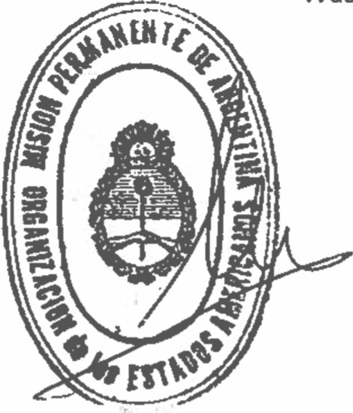
Department of Human Development, Education, and Employment (DDHEE)
Executive Secretariat for Integral Development (SEDI) Organization of American States (OAS)
Washington, D.C.

ATTACHMENT
Argentine Republic - National Executive
The Malvinas are Argentine

Note

Number: NO-2022-46783744-APN-DNCl#ME

CITY OF BUENOS AIRES
Wednesday, May 11, 2022

Reference: Convocation of the 2022 Inter-American Meeting of Ministers of Education

TO: Marina Nuria Mantecon Fumado (DAR#MRE),

Copy to: Maria del Pilar Toloza (DAR#MRE), Ariel Hernando Campero (DAR#MRE), IGNACIO BALARD (DNCI#ME),

Dear Mrs. Mantecon Fumado:

I am pleased to address you regarding the holding of the Inter-American Meeting of Ministers of Education within the framework of the OAS during 2022.
In this regard, we request that, through the Permanent Mission, you inform the Executive Secretariat for Integral Development of the need for it to convene the Eleventh Inter-American Meeting of Ministers of Education (2022) at OAS headquarters in Washington, in online format, considering above all the restrictions on travel and on-site meetings still necessitated by the pandemic.
The aim of this request is to avert alteration of the three-year calendar cycle of the Meeting of Ministers of Education and thereby continue with the preparatory and special meetings required by the ministerial process.
Our understanding is that including such convocation as an agenda item for the next CIDI meeting in May of this year will allow both the preparatory meeting and the ministerial meeting itself to be held in the course of 2022 without complications.
We await confirmation of the response from the OAS so as to proceed, within the framework of the Inter-American Committee on Education, with preparing the necessary documents to ensure compliance with the general guidelines for sectoral processes of the Organization.

Very truly yours,

Marina LARREA
National Director
National Directorate of International Cooperation
Ministry of Education

Link to original note: https://scm.oas.org/pdfs/2022/RMEMPARGENTINAOEA097.pdf

Link to original attachment: https://scm.oas.org/pdfs/2022/RMEMPARGENTINAANEXOOEA097.pdf

CIDRP03533S01

