INTER-AMERICAN AGENCY FOR OEA/Ser. W
COOPERATION AND DEVELOPMENT AICD/JD/doc.182/20 corr.1
MEETING OF THE MANAGEMENT BOARD 16 September 2020
Original: English

Executive Secretariat for Integral Development (SEDI)
Update on the OAS CooperaNet platform

(Prepared by the Secretariat, based on information on the CooperaNet Platform
as of September 10, 2020: https://www.oas.org/cooperanet)

As part of the Work Plan of the Inter-American Agency for Cooperation and Development (IACD) for the period 2020-2021, approved in June, 2020, the Management Board laid out 8 actions to strengthen cooperation in the framework of the OAS, which were revised taking into consideration the emerging challenges related to the COVID-19 pandemic. One of these actions is “Launching, populating, and promoting the CooperaNet Platform”, as Member States highlighted the high-potential / low-cost opportunity of creating an online hub for increased interaction and sharing of knowledge and experiences among Cooperation Authorities, particularly in a time as challenging as responding to and recovering from the pandemic.

To date, 22 Focal Points have been designated by Cooperation Authorities (65%), and 12 Member States (35%) have yet to designate a technical person to work directly with the Secretariat in this initiative.

As part of the efforts to implement the Work Plan, the Secretariat held a Technical Training for Focal Points at the end of July.
- July 29, 2020: Spanish training session.
- July 30, 2020: English training session.
- 53 participants from 20 Member States joined the training from Capitals and Permanent Missions.

The presentation was distributed in English and Spanish on July 31 as reference for Cooperation Authorities and Permanent Missions.

Cooperation Exchange:

There are currently 234 offers and needs published in the “Cooperation Exchange” section of CooperaNet. 124 offers were published by Peru (53%) at the end of 2019, and 102 offers were published by Argentina (43.6%) in April 2020. Both Focal Points used information available in the Cooperation Agencies “Cooperation Catalogue”. The 8 “Needs” that are currently featured come from programs in execution in the framework of the Development Cooperation Fund (DCF) by Bahamas, Barbados, Costa Rica, El Salvador, Honduras, Saint Kitts and Nevis, Saint Vincent and the Grenadines, and Uruguay.

“Offers” shared through CooperaNet may refer to a project in execution or concluded, representing a good practice based on institutional capacities, which could serve as an example to design cooperation projects or activities with other countries.

It is worth noting that the greatest challenge in this section is for Cooperation Authorities to identify their offers or good practices, which is a task that has already been undertaken by many countries and has been systematized in cooperation catalogues. In this regard, the Secretariat has been in contact with several Focal Points who have expressed interest in uploading information to CooperaNet but indicated that their catalogues are currently being updated and will do so as information becomes available.

Type
Offer - Member States | 226
Offer - Partners | 0
Needs - Member States | 8
Total | 234

Offering/Requesting Country | # | %
Argentina | 102 | 43.6%
Bahamas | 1 | 0.4%
Barbados | 1 | 0.4%
Costa Rica | 1 | 0.4%
El Salvador | 1 | 0.4%
Honduras | 1 | 0.4%
Peru | 124 | 53.0%
Saint Kitts and Nevis | 1 | 0.4%
Saint Vincent and the Grenadines | 1 | 0.4%
Uruguay | 1 | 0.4%
Total | 234 | 100.0%

As for the “Areas of Focus”, which are based on the mandates given by Member States to the OAS in the field of development, nearly 40% of shared Offers are in the area of “Sustainable Development and Environment”, including areas such as Disaster Risk Management, Responsible consumption and production, Clean Water and Sanitation, among others. 32% are in “Other” areas, such as Security, Justice and Human Rights, Innovation in Public Management, and Health.

Area of Focus | # | %
Education and Human Development | 15 | 5%
Economic Development and Competitiveness | 16 | 6%
Small and Medium Enterprises (SMEs) | 4 | 1%
Research and Development | 1 | 0%
Innovation and Technology | 10 | 4%
Sustainable Tourism Development | 13 | 5%
Sustainable Development and Environment | 107 | 39%
Social Development | 20 | 7%
Productive Employment | 0 | 0%
Culture | 0 | 0%
Other | 89 | 32%
Total | 275 | 100%

In terms of the SDGs, 25% of featured Offers are aligned with SDG 17: Partnerships for the Goals. It is worth noting that the total number of projects related to all SDGs is greater than the total number of projects, as one project may be simultaneously aligned with two or more Goals.

Sustainable Development Goal | # | %
Goal 01: No Poverty | 8 | 2%
Goal 02: Zero Hunger | 33 | 8%
Goal 03: Good Health and Well-Being | 13 | 3%
Goal 04: Quality Education | 16 | 4%
Goal 05: Gender Equality | 5 | 1%
Goal 06: Clean Water and Sanitation | 10 | 2%
Goal 07: Affordable and Clean Energy | 2 | 0%
Goal 08: Decent Work and Economic Growth | 19 | 4%
Goal 09: Industry, Innovation and Infrastructure | 18 | 4%
Goal 10: Reduced Inequalities | 11 | 3%
Goal 11: Sustainable Cities and Communities | 34 | 8%
Goal 12: Responsible Production and Consumption | 35 | 8%
Goal 13: Climate Action | 27 | 6%
Goal 14: Life Below Water | 26 | 6%
Goal 15: Life on Land | 20 | 5%
Goal 16: Peace, Justice and Strong Institutions | 40 | 9%
Goal 17: Partnerships for the Goals | 106 | 25%
Total | 423 | 100%

An “Open Call for COVID-19 Offers and Needs” announcement has been published on the Homepage and in the Cooperation Exchange section of the platform as part of the efforts to implement the IACD Work Plan. Yet, as Member States continue to face the many challenges brought forth by the pandemic, no specific responses have been submitted to date.

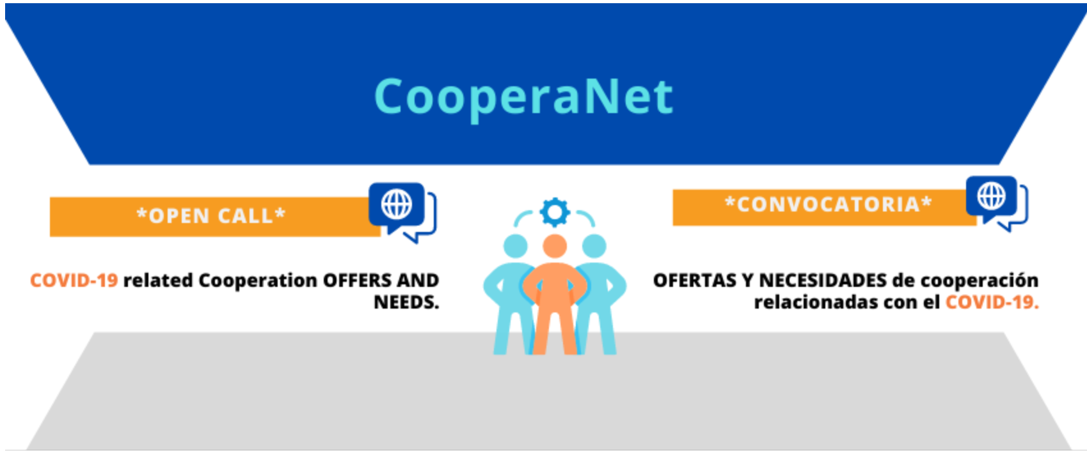

The Secretariat will continue to work with Member States Focal Points to support the process of populating CooperaNet, as to realize its underlying potential. To this end, a greater participation and involvement by Member States is encouraged.
CIDRP02980E01

