OEA/Ser.W
CIDI/doc. 328/21
28 September 2021
Original: English

Ministerial and High-Level Authorities Meetings in the framework of CIDI
New model
(Approved during the regular meeting held September 28, 2021)

Ministerial and High-Level Authorities Meetings
in the framework of CIDI
New model
Background:

The Executive Secretariat for Integral Development (OAS-SEDI) works with Member States to support, facilitate, and foster integral development through three specific lines of action: (1) Policy Dialogue; (2) Focused Programming; (3) Cooperation and Partnerships.

The OAS-SEDI works directly with Member States through the Inter-American Council for Integral Development (CIDI), an OAS body directly answerable to the General Assembly, with decision-making power in matters of partnership for integral development*. The CIDI is composed of all the Member States who meet in regular, special, specialized, or sectoral meetings, with the purpose of promoting cooperation among its member states for the furtherance of their integral development and, in particular, to help eliminate extreme poverty.

Twelve high-level specialized sectoral meetings are held in the context of development. Nine of these processes are within CIDI (labor, education, science and technology, culture, tourism, sustainable development, social development, cooperation, and ports) and three are outside of CIDI, but the OAS-SEDI acts as the technical secretariat (competitiveness, Micro, Small and Medium Enterprises, and energy). (See annex 1)

*“Partnership for development” in the context of the OAS:

The first “Strategic Plan for Partnership for Development” was adopted by the OAS General Assembly in 1997 and defined what continues to guide the way the OAS-SEDI approaches its work on development.

“Partnership for development embraces all member states, regardless of their levels of development. It entails abandoning the traditional aid-oriented approach and developing instead cooperation programs based on a partnership which, without attempting to impose models, would support the economic and social measures taken by countries, particularly those to combat poverty. It pays attention to horizontal and multilateral cooperation, and to the participation of communities, civil society, and the private sector in solving problems. This concept also means that limited OAS resources will be effectively targeted at the most pressing needs of the member states, especially those with smaller and more vulnerable economies.”

Doc: AG/RES. 1511 (XXVII-O/97)

In order to effectively undertake cooperation, CIDI established the Inter-American Agency for Cooperation and Development (IACD) as a subsidiary organ to promote, coordinate, manage, and facilitate the planning and execution of programs, projects, and "partnership for development activities" within the scope of the OAS Charter and in the framework of the Strategic Plan of the organization. The IACD is composed of a Management Board, consisting of 9 Member States, and the OAS-SEDI.

Purpose and Opportunities provided by Ministerial Meetings:

- Provide a forum for substantive public policy dialogue among member states on topics of hemispheric interest.
- Identify regional trends and priorities.
- Allow for the exchange of experiences and best practices on policy development and implementation.
- Identify opportunities for cooperation.
- Set the agenda for the OAS work to support member states in advancing such priorities.

Outcomes:

The results of the ministerial-level dialogue are traditionally reflected in two main outcome-documents:

- Political Declaration: Outlines the regional vision for advancing the topic in the Hemisphere, based on the subject matter of the meeting.
- Plan of Action: Establishes the concrete steps to fulfill the priorities identified in the declaration.

Challenges:

The current process does not define cooperation or partnerships action for implementation, leading to two main challenges:

- Low levels of participation at the highest-level indicate low engagement by Member States.
- The Meetings’ potential to drive sector-specific regional cooperation is not being fully realized.

Proposed Solutions:

Based on lessons learned and its extensive experience, the Secretariat proposes to revisit the current model to include five key updates:

- Process guided by a Steering Committee
- Partners engaged at an early stage.
- IACD engaged to bring-in cooperation authorities.
- Priorities and list of potential actions identified and discussed in CIDI.
- Commitments to be announced at Ministerial meetings.

Model Sequence:

- Consultations and Input from partners and similarly mandated institutions to begin the Process for selecting the theme.

  - This is a more deliberate effort to capture and document information from key actors in addition to member states to inform the Ministerial process.
  - The consultation should facilitate both the preparation for the next Ministerial, and follow-up to mandates emanating from the previous Ministerial.
  - Consultation to be had 18 months before the meeting.

- The Steering Committee, composed of the Troika, and Chairs or Vice chairs of existing Inter-American Committees approves theme.

  - The Steering Committee provides for neutrality and oversight of the process instead of dependence on one country and helps ensure continuity and coherence in all activities. The Committee is composed of the Troika (including the past, present and future Chairs of each Ministerial Meeting), the chairs and Vice Chairs of Inter-American Committees, and or Working Groups. It must provide for geographic/sub-regional representation.

- Secretariat puts forward a White Paper based on the discussions with the Steering Committee.

  - The White Paper is an informative document prepared by the Secretariat based on initial consultations (1) and discussions in the Steering Committee (2) and sets the contextual framework for the upcoming Ministerial Meeting.

- CIDI defines list of concrete proposals/ projects for action and garners support from Member States.

  - The areas of action and topics addressed in the White Paper form the basis for the topics to be discussed in CIDI. Each discussion in CIDI is used to define a list of concrete proposals/projects for action to begin the process of garnering support from member states and partners. Authorities in countries can participate virtually together with their Permanent Missions.

- The IACD Management Board to identify potential for cooperation.

  - Within the context of the Management Board of the Inter-American Agency for Cooperation and Development (MB/IACD), discuss the list of proposals with Cooperation Authorities to define potential for cooperation based on specific needs and interest.
  - Cooperation Authorities established in the 2020-2021 IACD Work Plan the following Prioritized Action: “Aligning Ministerial Processes with Cooperation”.

- The Secretariat shares list with partners to define potential for partnerships.

  - The Technical Secretariat also shares list (defined in step 4 by CIDI) with the private sector and other partners to define potential for partnerships, solutions, and proposals in preparation for the Ministerial.

- The Steering Committee presents Ministerial Agenda.

- Secretariat prepares draft outcome document, which is discussed by member states in a virtual Preparatory Meeting.

  - During virtual Preparatory Meetings, Member States discuss and finalize outcome documents: Declaration and Plan of Action.

- Ministerial Meeting (2-day in person): Ministers and partners to network, register Policy and announce offers of cooperation.

  - In person 2-day meeting:
- Day 1 Ministerial Dialogue / networking.
- Day 2: Dialogue with the private sector and other partners / Announce and approve commitments and offers of cooperation / sight visits ( optional)
  - Drive engagement at Highest level: commitments and offers that come from Ministers and partners (after deliberate and concerted efforts).
  - Support Networking: Pre-arrange bilateral meetings with other Member State Ministers and potential partners, reception, sight visits.
  - Bring in partners into dialogue.

- Secretariat finalizes Work Plan to implement proposals.

  - The Work Plan is intended to facilitate implementation and follow-up to Ministerial Meetings. It therefore should include prioritized actions, specific tasks, objectives, deliverables / indicators, expected results, a calendar of activities, and budget specifying the estimated cost and source(s) of funding and partnerships.

- Implementation: Secretariat, Member States, Partners.

  - Engagement and participation of Member States and Partners is crucial to support implementation and follow-up by the Secretariat.

Expected Outcomes:

- Improved levels of engagement and participation at the highest-level by Member States.
- Increased sector-specific regional cooperation.
- Increased multi-sectoral Partnerships responsive to needs.
- IACD aligned with Ministerial processes.
- CIDI engaged in substantive sectoral discussion/ action and cooperation.

Proposed Updated Ministerial Cycle:

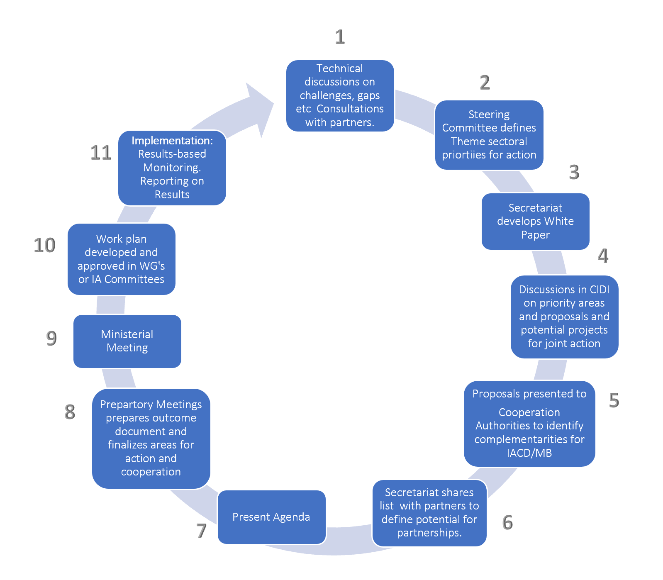

Annex 1: List of Sectoral Meetings in the Context of Development

Sectoral Meetings on: | Official Name
In the framework of the Inter-American Council for Integral Development (CIDI)
- Labor | Inter-American Conference of the Ministries of Labor (IACML)
- Education | Meeting of Ministers of Education
- Science and Technology | Meeting of Ministers and High Authorities of Science and Technology (REMCYT)
- Culture | Meeting of Ministers of Culture and Highest Appropriate Authorities
- Tourism | Inter-American Congress of Ministers and High-Level Authorities of Tourism
- Sustainable Development | Inter-American Meeting of Ministers and High-Level Authorities on Sustainable Development
- Social Development | Meeting of Ministers and High Authorities of Social Development
- Cooperation | Specialized CIDI Meeting of High Authorities on Cooperation
- Ports | Regular Meeting of the Inter-American Committee on Ports (CIP)
Other high-level meetings:
- Competitiveness | Inter-American Competitiveness Network (RIAC) Annual Meeting of Ministers, High-Level Authorities and Competitiveness Councils
- Micro, Small and Medium Enterprises | Inter-American Dialogue of High-Level Micro, Small and Medium Enterprises (MSMEs) Authorities
- Energy | Energy and Climate Partnership of the Americas (ECPA)

CIDI/CPD/doc. 208/21 rev.1
CIDRP03349E01

