OEA/Ser.W
CIDI/INF. 505/22
25 May 2022
Original: Spanish

NOTE FROM THE PERMANENT MISSION OF GUATEMALA TO THE OAS REQUESTING THE INCLUSION OF AN ITEM ON THE AGENDA OF THE REGULAR MEETING OF CIDI TO BE HELD ON MAY 31, 2022, AND SUBMITTING THE PRELIMINARY DRAFT AGENDA FOR THE NINTH INTER-AMERICAN MEETING OF MINISTERS OF CULTURE AND HIGHEST APPROPRIATE AUTHORITIES

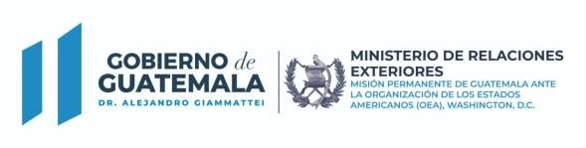
Ref. NV-OEA-M4-259-2022

The Permanent Mission of the Republic of Guatemala to the Organization of American States (OAS) presents its compliments to the honorable Chair of the Inter-American Council for Integral Development (CIDI), and is pleased to refer to Note Verbale OEA-M4-257-2022 confirming Guatemala’s offer to host the Ninth Inter-American Meeting of Ministers of Culture and Highest Appropriate Authorities in the city of Antigua Guatemala, Guatemala, on October 27 and 28, 2022.

In connection therewith, the Permanent Mission of the Republic of Guatemala to the Organization of American States (OAS) respectfully requests that at the next meeting of CIDI, to be held on May 31, 2022, an item be included in the agenda for the Ministry of Culture and Sport of Guatemala to present the following:

- Draft resolution convening the Ninth Inter-American Meeting of Ministers of Culture and Highest Appropriate Authorities, for the member states’ consideration and approval.

- Preliminary draft agenda for the Ninth Inter-American Meeting of Ministers of Culture and Highest Appropriate Authorities. Enclosed herewith, respectfully requesting its distribution to the member states.

These documents will be presented by the Vice Minister of Culture of Guatemala, Mr. Cristhian Neftalí Calderón Santizo, who will attend the meeting virtually.

The Permanent Mission of the Republic of Guatemala to the Organization of American States (OAS) avails itself of the opportunity to reassure the honorable Chair of the Inter-American Council for Integral Development (CIDI) of its highest consideration.

Washington, D.C., May 25, 2022
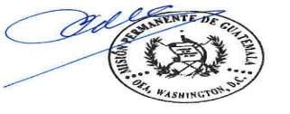

To the honorable
Chair of the Inter-American Council for Integral Development (CIDI)
CC. Executive Secretariat for Integral Development (SEDI)
Secretariat of the Inter-American Council for Integral Development (CIDI)
Washington, D.C.
Link to original note: http://scm.oas.org/pdfs/2022/RMCMPGUATEMALAM4259.pdf

1507 22nd Street NW Washington, D.C. 20037
Teléfonos: 00 1202-8334015 / 00 1202 833-4016 /17

DRAFT AGENDA
NINTH INTER-AMERICAN MEETING OF MINISTERS OF CULTURE
AND HIGHEST APPROPRIATE AUTHORITIES
October 27–28, 2022

“Technology, creativity, and innovation as an opportunity for
developing and strengthening culture”

- Consideration and formalization of agreements on the following points:

    - Election of the Chair
    - Composition of the Style Committee
    - Finalized meeting agenda
    - Agreement on the deadline for presenting proposals
    - Meeting duration
    - Other business

- Methodologies and policies for promoting the management and consumption of arts and literature

- Creative economies and industries

- Strengthening heritage and cultural expressions

- Election of authorities of the Inter-American Committee on Culture
- Consideration and approval of the Draft Declaration and Draft Plan of Action
- Other business

CIDRP03536E02

