OEA/Ser.W CIDI/INF. 511/22
26 August 2022
Original: English

NOTE FROM THE PERMANENT MISSION OF JAMAICA NFORMING OF THE DECISION
OF THE GOVERNMENT OF JAMAICA TO ASSUME THE CHAIRMANSHIP OF THE
INTER-AMERICAN COMMITTEE ON SCIENCE AND TECHNOLOGY (COMCYT)

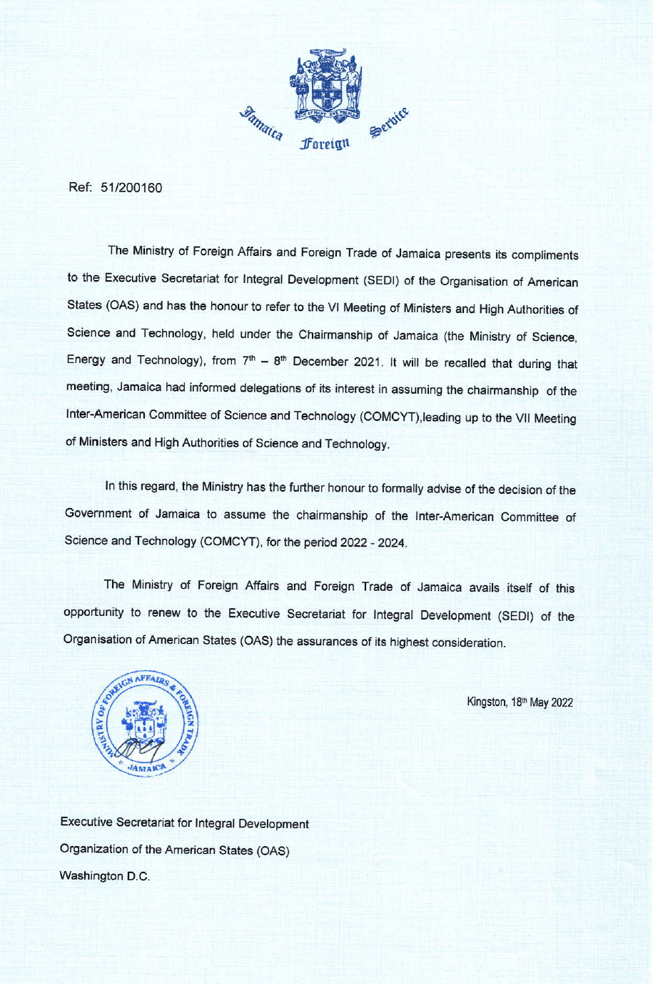
CIDRP03636E01

