COMMITTEE ON MIGRATION ISSUES OEA/Ser.W
CIDI/CAM/doc.77/20
25 February 2020
Original: English

GUESTS SPEAKERS BIOGRAPHIES

THEMATIC SESSION:

“RESPONSES BY THE INTERNATIONAL COMMUNITY IN THE HUMANITARIAN RESPONSE TO, AND SOCIAL INTEGRATION OF, MIGRANT POPULATIONS IN THE REGIONS”

(February 27, 2020)

- Lucca DALL’OGLIO
Chief of Mission
International Organization for Migration (IOM), Washington, D.C.

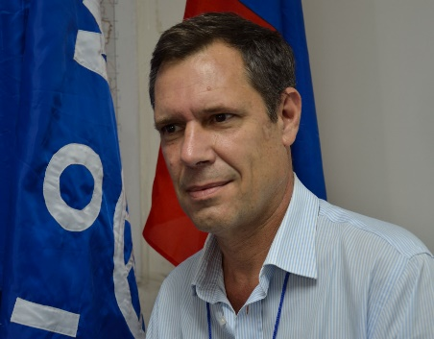
Mr. Luca Dall’Oglio was appointed Chief of Mission of the International Organization for Migration (IOM), Washington office in April 2012 and assumed responsibilities in October 2012. Prior to this assignment, he was Special Envoy of the Director General of the International Organization for Migration (IOM) for Haiti from January 2010 and assumed the functions of resident Chief of Mission in June 2010.

His preceding assignment was the Permanent Observer for the IOM to the United Nations in New York, a position he has held since late 2003.

A sociologist by training, Mr. Dall’Oglio has dedicated a large part of his career to issues related to population stabilization, post-crisis transition and recovery, with extensive field assignments in the Horn of Africa, Mozambique, Haiti, Guatemala and Kosovo.

He was also IOM’s regional representative in Washington D.C. and Rome.

Prior to IOM, he worked for UNESCO’s regional office for social sciences in Bangkok promoting teaching and research in the area of human rights, population, youth and migration.

Before joining the international civil service, Mr. Dall’Oglio conducted teaching and research activities with the University of Rome and national and international research organizations.

- Joaquim Tres
Principal Specialist, Migration Initiative, Inter-American Development Bank (IDB), Washington, D.C.

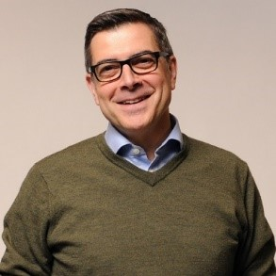
He is the Principal Specialist of the Migration Initiative of the Inter-American Development Bank (IDB) as Operation Coordinator. He also leads the Regional Public Goods Program.

He is a co-author of the IDB’s Economic Integration Strategy and has worked in economic and social development for over 20 years, including research, policy-making and development management; 15 years of field work in Latin America and the Caribbean.

Prior to joining the IDB, he worked at UNCTAD’s Trade and Development Report and the Spanish Development Cooperation (AECID) in Bolivia, Guatemala (incl. Belize), Mexico and Peru.

He is an MPhil graduate from the Institute of Development Studies (IDS), Sussex (UK), where he has served as a trustee. He also taught development economics at CIDOB, Institut Barcelona d´Estudis Internacionals (IBEI), where he also served in their Boards of Trustees.

- Paula Rossisco
Senior Social Development Specialist, World Bank

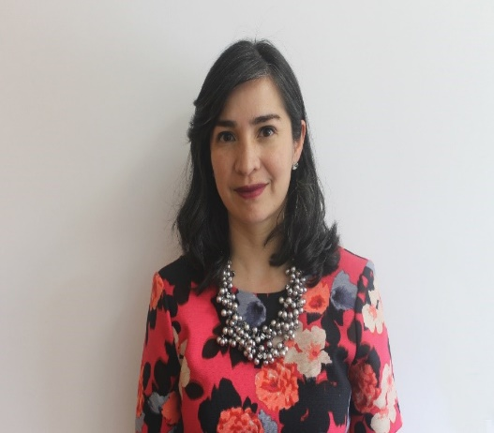
Paula Rossiasco is a Senior Social Development Specialist at the World Bank. She has more than fifteen years of experience in fragility, violence and conflict, working in the design and implementation of technical assistance and investment projects in numerous countries, as well as on sub-regional initiatives in Central, South America and Sub-Saharan Africa. She is the author/ co-author of multiple analytical pieces on conflict and forced displacement, and has co-lead the World Bank response efforts to complex situations including the Recovery and Peace Building Process in Northern Nigeria, and the response to the Venezuelan migration crisis in Colombia and Peru.

She is one of the main authors of the reports “Migration from Venezuela to Colombia: Short- and Medium-Term Impact and Response Strategy” (2018) and “An Opportunity for All: Venezuelan Migrants and Refugees and Peru's Development” (2019). Before working at the World Bank, Paula worked with other multi-lateral organizations, as a private consultant and for the Colombian Government.

Organization website | https://www.worldbank.org/
Twitter handle of the speaker | https://twitter.com/paularossiasco
Twitter handle of the organization | https://twitter.com/BancoMundialLAC
Facebook account of the organization | https://www.facebook.com/bancomundial/
Instagram account of the organization | https://www.instagram.com/bancomundial/
CIDRP02798E01

