INTER-AMERICAN AGENCY FOR OEA/Ser. W
COOPERATION AND DEVELOPMENT AICD/JD/doc.194/22 rev.2
MEETING OF THE MANAGEMENT BOARD 23 March 2022
Original: English

GUIDELINES: WORKING GROUPS OF THE INTER-AMERICAN AGENCY FOR COOPERATION AND DEVELOPMENT (IACD)

(Approved by the Management Board of the IACD on March 23, 2022)

BACKGROUND:

The Third Specialized Meeting of High-Level Authorities of Cooperation was held virtually on December 2 and 3, in two half-day sessions. As part of the outcomes of the meeting, three working groups were established in the framework of the Inter-American Agency for Cooperation and Development (IACD). The working groups were proposed by the Chair of the MB/IACD to make the work of the Agency more strategic and responsive to countries’ needs and increase their engagement.

As stated in Article 20 of the Rules of procedure of the MB/IACD: “The Management Board may establish working groups of a temporary nature when it deems necessary. The working groups shall consider, develop, examine, or study specific matters that the Board assigns to them and shall report their conclusions and recommendations to the Board. Working groups shall determine procedures for the performance of their functions.” This document seeks to provide guidance to Member States for the establishment and functioning of the Working Groups. Additional references may be found in the documents cited below.

For the Meeting of High-Level Authorities of Cooperation, the Secretariat prepared an informative document (CIDI/RECOOP-III/doc.6/21), which highlighted that while the work of CIDI and its Secretariat SEDI is concentrated on cooperation, more strategic direction is needed within the context of the IACD and specifically the Management Board (MB/IACD) to commensurate with its functions, as defined by member states. Specifically, Article 9 of the “Statutes of the IACD” (see reference documents below) establishes that the MB/IACD shall, among others (numbering corresponds to the Statutes):

- Issue strategies and guidelines for raising additional funds to finance partnership for development activities;
- Approve, within the framework of policies established by CIDI and for the purposes of enhancing resources, guidelines for the IACD to foster cooperative relations with Permanent Observers, other states, national and international organizations, and other entities and persons;
- Report on the activities of the IACD at least semi-annually to CIDI and, as appropriate, to other entities and persons.

ESTABLISHED WORKING GROUPS:

- Working Group 1: Aligning cooperation with CIDI Ministerial processes.
- Working Group 2: Fundraising to support partnership for development activities in the OAS/SEDI.
- Working Group 3: Position the IACD in the international development cooperation landscape

METHODOLOGY AND PROCEEDURES

Purpose: To bring together representatives of cooperation authorities to examine in greater depth the topics identified, facilitate information exchange, define a calendar of activities, provide periodic updates and report on conclusions, recommendations with a Plan of Action to the Board.

Duration of the mandate: The temporary Working Groups shall exist for at least one year since the first meeting of the MB/IACD (March 2022) and may be extended or dissolved by the Board as necessary.

Officers: The Working Groups will be open to participation from all Member States, comprised by Representatives of Cooperation Authorities, and led by a Chair and a Vice Chair elected by the Board.

Audience: Representatives of Cooperation Authorities. If appropriate, strategic partners relevant to the planning process may participate. These meetings will be open to all delegations.

Frequency and format of the meetings: A first meeting of each WG shall be held during the first semester of 2022 as part of the follow-up process to the Meeting of Cooperation Authorities. The meeting will be convened by the Chair of the MB/IACD.

Calendar of Meetings: Additional informal working groups meetings may be scheduled as needed to consider specific topics and examine proposals in greater depth.

Expected outcomes: A draft plan of action including recommended strategies and actions, timetable, and expected results. The Secretariat will assist the Working Groups with supporting and reference documents and if necessary, with the virtual platforms for these meetings.

Source of funding for this meeting: The meetings will be held virtually using the Technical Secretariat’s (SEDI/OEA) video conferencing resources. Additional resources to be defined.

SUGGESTED TOPICS FOR CONSIDERATION BY THE WORKING GROUPS:

WORKING GROUP 1: Aligning cooperation with CIDI Ministerial processes.

Some topics to be considered by the Working Group are as follows:
- What considerations must be made to make the new model operational for Cooperation Authorities?
- How can we ensure a more coordinated and sustainable engagement between Cooperation Authorities, represented through the MB/IACD, and Sectoral Authorities in the framework of the Ministerial process?
- What is a reasonable timeline to consult Cooperation Authorities in the new Ministerial Cycle? (see diagram as Annex 1).
- Ensure that the Management Board of the IACD is informed about the dates and content of ministerial processes.

WORKING GROUP 2: Fundraising to support partnership for development activities in the OAS/SEDI.

Aligned with the following prioritized actions in the 2020-2021 IACD Work Plan:
- Strengthening the Development Cooperation Fund (DCF).
- Establishing guidelines for engaging in Multi-stakeholder Partnerships.

Some topics to be considered by the Working Group are as follows:
- Issue strategies and guidelines for raising additional funds and channeling them through the DCF. (Refer to the Statutes of the DCF.)
- Develop the framework for the IACD to establish cooperative relations with Permanent Observers, other states, national and international organizations, and other entities, including the private sector.

WORKING GROUP 3: Position the IACD in the international development cooperation landscape

Aligned with the following prioritized actions in the 2020-2021 IACD Work Plan:
- Strengthening the working methods of the MB/IACD
- Seeking out complementarities with other regional and international cooperation schemes and institutions, including but not limited to the exchange of experiences and experts.

Some topics be considered by the Working Group are as follows:

- Issue guidelines and a methodology for reporting all OAS-SEDI cooperation activities, in line with other regional and global reporting efforts.
- Establish procedures to use the reports by the OAS General Secretariat and by Member States to share information on the work of the IACD.
- Consider including cooperation outcomes emanating from Ministerial processes, as one of the Organization’s greatest comparative advantages.
- What other actions can be taken to raise awareness and understanding of the work of the IACD? (capacity building, exchange of information and practices, among other actions).

REFERENCE DOCUMENTS:

- Final Report of the III Specialized CIDI Meeting of Cooperation Authorities, held on December 2-3, 2021 CIDI/RECOOP-III/doc.8/22 rev.1- ENG | ESP)

- Proposed Outcome: Meeting of High-level Authorities of Cooperation (CIDI/RECOOP-III/doc.6/21 ENG | ESP)

- Rules of Procedure of the MB/IACD (CIDI/doc.202/16 – ENG | ESP)

- Statutes of the Inter-American Agency for Cooperation and Development (CIDI/doc.293/20 rev.2 ENG | ESP)

- 2020-2021 IACD Work Plan: (AICD/JD/doc-177/20 rev. 2 - ESP - ENG)

- New Model for Ministerial and High-Level Authorities Meetings in the Framework of CIDI (CIDI/doc. 328/21: ENG | ESP)

- Annual Report of the Inter-American Council For Integral Development (CIDI), approved at the Fifty-First Regular Session of the OAS General Assembly held in 2021 (AG/DOC.5748 ENG| ESP). (The GA/OAS adopted, among others, the new model for CIDI Ministerials).

- Statutes of the OAS Development Cooperation Fund (OAS/DCF) and Provisions Regarding other Partnership for Development Resources (ENG – ESP)

Annex 1

Proposed Updated Ministerial Cycle:

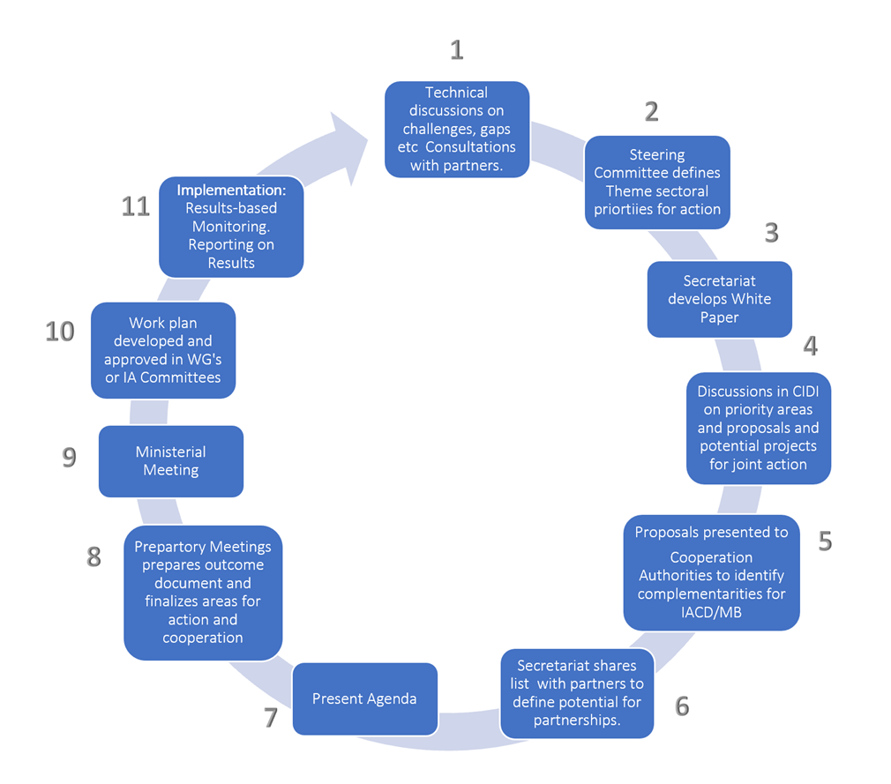
CIDRP03492E01

