FIFTY-FIRST REGULAR SESSION OEA/Ser.P
November 10 to 12, 2021 AG/INF. 737/21
Guatemala City, Guatemala 8 November 2021
Original: Spanish/English

DIALOGUE OF THE HEADS OF DELEGATION OF THE MEMBER STATES, THE SECRETARY GENERAL AND THE ASSISTANT SECRETARY GENERAL WITH THE
PERMANENT OBSERVERS

DRAFT AGENDA

November 10, 2021, 9:00 am - 11:45 am

DIALOGUE OF THE HEADS OF DELEGATION, THE SECRETARY GENERAL AND THE ASSISTANT SECRETARY GENERAL WITH THE PERMANENT OBSERVERS

The Strategic Counsel (SCODMR)/Department of External and Institutional Relations presents its compliments to your Permanent Missions, and in preparation for the Dialogue of the Heads of Delegation, the Secretary General and the Assistant Secretary General with the Permanent Observers, to be held on Wednesday, November 10, from 9:00 am to 11:45 am on the Kudo platform, please find attached the latest agenda and instructions for your connection.

Minister of Foreign Affairs of Guatemala H.E. Pedro Brolo will chair/moderate the dialogue.

Ministers, Vice Ministers, Permanent Representatives and other Heads of Delegation from Member States, as well as Vice Ministers and senior officials from the Permanent Observers will be participating (see flyer attached). Member States wishing to take floor are urged to inform the Department of External and Institutional Relations as soon as possible. We kindly ask all the speakers/participants to keep their remarks to four minutes. Please kindly confirm your presence and level of participation at GVergara@oas.org, with a copy to AEscobedo@oas.org.

Your Missions will be able to access the meeting in two ways:

- Duly accredited delegates whose e-mail addresses have been provided in their accreditation letters will receive an e-mail from KUDO (support@kudoway.com) requesting them to create a password to access the virtual rooms. Delegates wishing to participate with camera and microphone access in the Dialogue with the Permanent Observers may access the meeting with their password through the link they will receive from KUDO prior to the meeting or through the 51 GA web page at the following “DELEGATES LINK WITH PASSWORDS” http://www.oas.org/en/51ga/webcast.asp

- Through the OAS General Assembly web page: https://www.oas.org/en/51ga/webcast.asp

When accessing the GA web page, please click on "Dialogue with Permanent Observers", which will be visible in the main part of this site. There is also another access on this same page through the "Live Virtual Room" icon, which is located on the left side of the page, under the options menu.

Once you have logged in through that link, please enter your Kudo username and password. Please select the "Delegate Links With Password” option to access the camera and microphone.

For questions about the program, please contact via WhatsApp:

Gisela Vergara | (202) 255-8174
Andrea Escobedo | (202) 460-2301

For Kudo access questions:
Gloria Uribe | (301) 825-4993

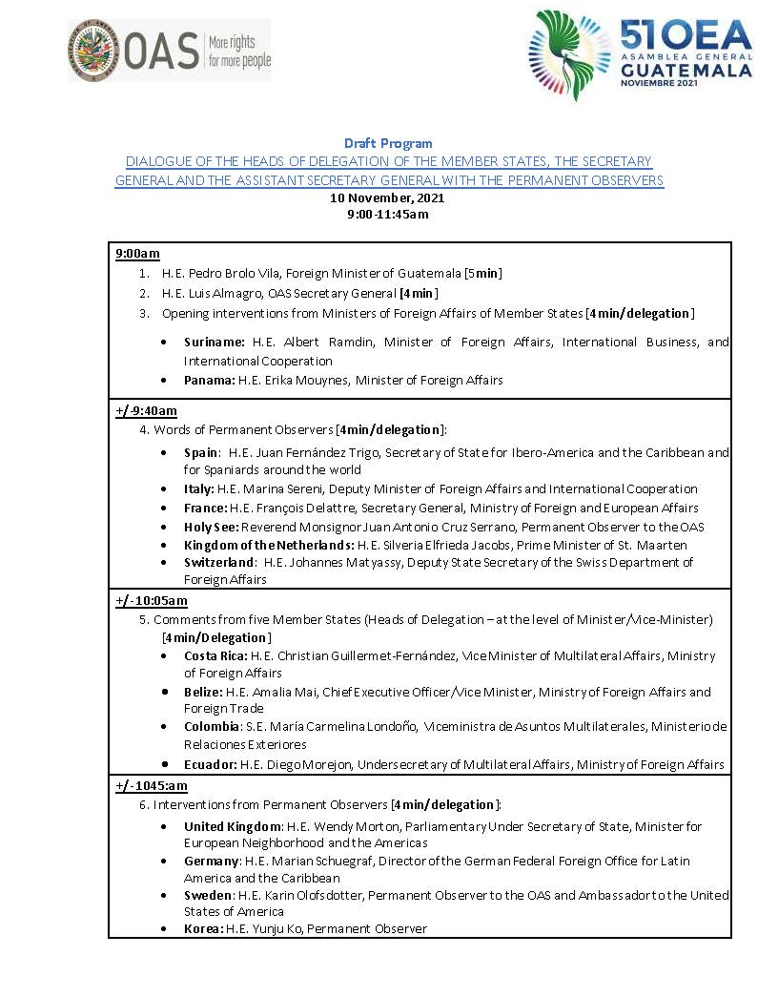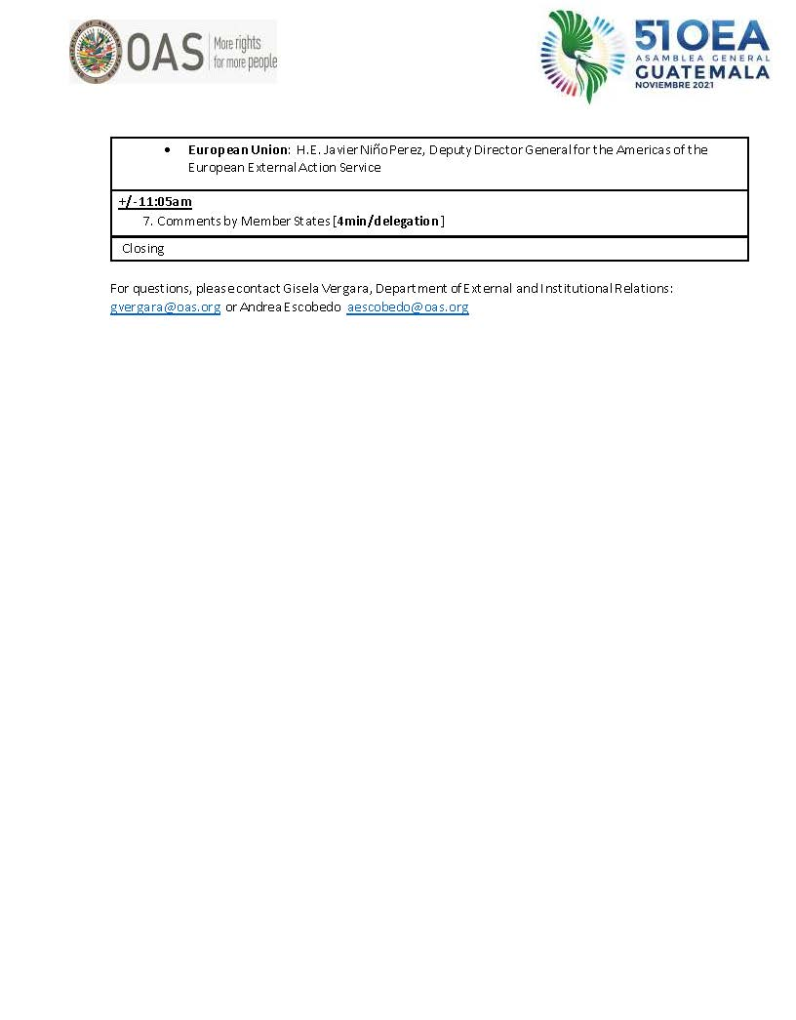
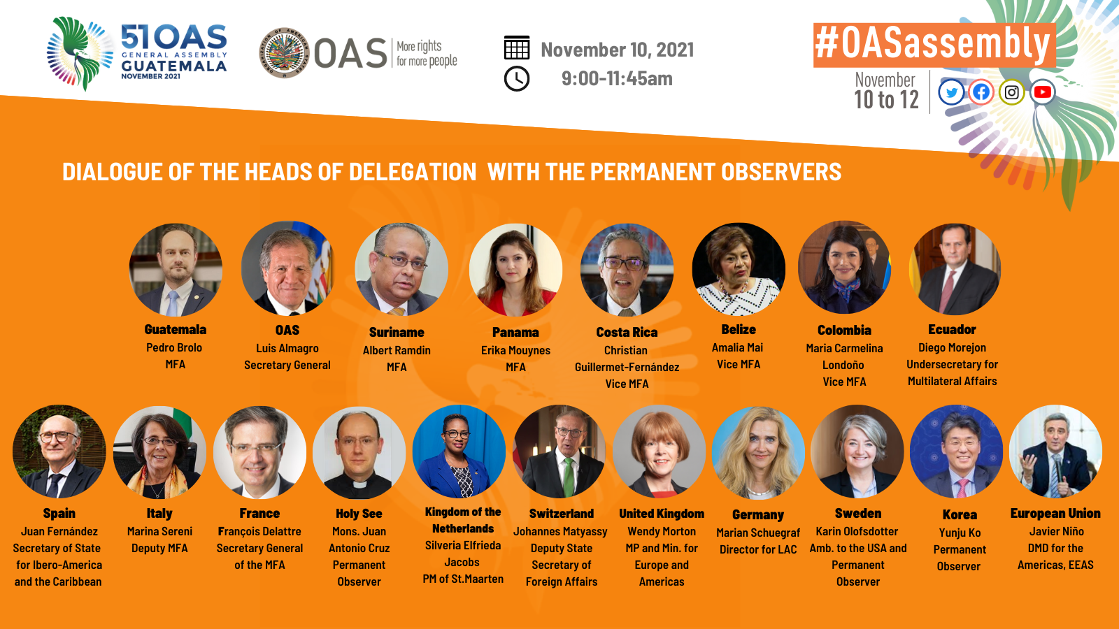
AG08397E01

