PERMANENT COUNCIL OF THE OEA/Ser.G
ORGANIZATION OF AMERICAN STATES CP/CAAP-2659/03
29 April 2003
COMMITTEE ON ADMINISTRATIVE AND Original: English
BUDGETARY AFFAIRS

REPORT OF THE CHAIR OF THE COMMITTEE ON ADMINISTRATIVE
AND BUDGETARY AFFAIRS ON THE AUTHORIZATION OF AN ADJUSTMENT
TO OBJECT 1, PERSONNEL COSTS FOR 2003

REPORT OF THE CHAIR OF THE COMMITTEE ON ADMINISTRATIVE
AND BUDGETARY AFFAIRS ON THE AUTHORIZATION OF AN ADJUSTMENT
TO OBJECT 1, PERSONNEL COSTS FOR 2003

By letter of April 8, 2003, the Secretary General advised the Chair of the Permanent Council of the impact on budgetary execution for fiscal year 2003 of the decision taken by the United Nations to increase salaries effective January 1, 2003, and to increase the post adjustment for staff in Washington, DC, effective April 1, 2003.

At the meeting of the Permanent Council, held on April 9, the Chair informed delegations that he had received the Secretary General’s communication and that it had been distributed to all missions as CP/doc. 3723/03, “Report of the Secretary General on Budgetary Execution process for Fiscal year 2003”. At that time, the Chair also indicated that the Council would benefit from a detailed study by the Committee on Administrative and Budgetary Affairs of the issues raised. This document was formally referred to the Committee by the Permanent Council on April 23, 2003./

In order to comply with statutory obligations toward the General Secretariat staff and to remain within the budgetary limits mandated by the General Assembly in resolution AG/RES. 1909 (XXXII/O/02), the Secretary General proposed certain measures that fall within his authority: (a) to suspend appointments to all Regular Fund posts not occupied as of April 1st 2003 and b) to suspend for a limited time the renewal of all short-term contracts financed by the Regular Fund; and expiring on June 30th 2003. The Secretary General also indicated that there were other measures that could be taken, but these were beyond his budgetary authority.

In view of the importance and urgency of the matter, the Chair and Vice Chair of the Committee on Administrative and Budgetary Affairs initiated discussions with the General Secretariat on the subject and drafted a resolution to address issues related to personnel costs for 2003.

This draft resolution (S/C) was initially discussed in the Ad Hoc Budget Working Group at an informal meeting held on April 15. Subsequently, the Chair of the Committee convened a meeting and continued consideration of a revised version of the above-mentioned draft resolution (S/C) in a formal meeting held on April 22, 2003.

From the discussions held in the meetings of the Committee on Administrative and Budgetary Affairs and its Working Group, it was clear that the Organization has a statutory obligation to maintain salary parity with the United Nations,^{2/} and that this requirement made it mandatory for the General Secretariat to implement the salary increases under reference as of the effective dates. It was also clear that the combined impact of the salary and post adjustment increments would bring the projected Object 1 to approximately $1,509,800 above the limit of $46,378,400, established by the General Assembly in AG/RES. 1909 (XXXII-O/02) the Budget Resolution for 2003.

It should be pointed out that during the deliberations, various delegations expressed concern about the impact of these measures for the 2003 budget as well as for the 2004 budget. In addition, delegations indicated that the functioning of the General Assembly and the Permanent Council should not be affected.

At its meeting held on April 28, 2003, the Committee was able to reach an agreement on all operative paragraphs of the draft resolution, which is attached to this report.

This resolution revises the Object 1 limitation in the 2003 Budget to $47,388,400 and instructs the Secretary General to take the following measures to finance the revised Object 1 appropriation as follows:

- Establish an immediate hiring freeze until December 31, 2003, against the vacant posts listed in Annex 1 of the resolution, financed by the Regular Fund, which should result in savings of $502,707

- Reduce 2003 appropriations of the Regular Fund in the following manner:
-Object 3 – Fellowships by $200,000;
-Object 4 – Travel by at least $300,000;
-Object 5 – Documents $ 50,000;
-Object 6 – Equipment and Supplies $120,000;
-Object 7 – Building Management and
Maintenance $ 50,000;
-Object 8 – Performance Contracts (CPRs)
by at least $250,000;
-Object 9 – Other costs by at least $ 40,000;

Total of at least $1,010,000

The Committee agreed further that none of the measures adopted should apply to performance contracts (CPRs), and other expenditures directly related to the functioning of the General Assembly. The Committee further agreed that, as feasible, precedence should be given to the funding of activities directly related to the Permanent Council and to already programmed Ministerial meetings of the OAS.

The draft resolution is attached to this report.

April 28, 2003

OEA/Ser.G
CP/doc. 3723/03
9 April 2003
Original: English

APPENDIX I

REPORT OF THE SECRETARY GENERAL ON BUDGETARY EXECUTION
PROCESS FOR FISCAL YEAR 2003

This document is being distributed to the permanent missions and
will be presented to the Permanent Council of the Organization.

http://scm.oas.org/pdfs/2003/CP11271A.pdf

Background:

In the Budget Resolution for 2003 (AG/RES. 1909 XXXII-0/02), the General Assembly established an absolute limit of $46,378,400 for object 1 expenditures (salaries) and an overall budget figure of US$76 Million for the Regular Fund. These figures included a provision of approximately $524,100 to cover expected salary increases due to cost of living adjustment for 2003, which are normally implemented in the second half of the year. The General Secretariat calculated that amount based on recent and historic information, available at the time of formulating the budget during December of 2001. (See Chart below)

Since the start of the year, the United Nations has made two surprise announcements effecting salary entitelments that together would substantially impact the 2003 appropriations. The first event began at the start of 2003 as a result of a decision taken by the General Assembly of the United Nations during the last days of 2002. Specifically, on 20 December 2002 by Resolution 57/285 , the General Assembly approved a Revised Basic Salary Scale for Staff in the Professional and Higher Categories effective 1st of January 2003. For the first time since salary parity was established in 1995, this scale reflects a differentiated increase with the purpose of addressing the low level of “the margin” at the upper grades of the salary scale.* This increase brought the grades P-4 to D-2 up to the margin level of 111 and the overall margin to 112.2. The grades P-1 to P-3 were already at 115 or above. The projected cost for the year of this salary increment is approximately US$ 880,000. This figure, by itself, not only will absorb the whole of the $524,100 provision made for cost of living adjustments that normally occur in the 2nd half of a year, but it would actually bring the projected Object 1 expenditures above the established limit by US$355,900.

Most recently, the United Nations announced on 31 March a raise of post adjustment (cost of living), effective April 1st, for the professional categories stationed in Washington DC of 5.1%, It should be noted that when cost-of-living increases are below 5% the appropriate UN committees consider them before arriving at a decision, but when the International Civil Service Commission determines that the actual cost of living has reached five or more percent, then increments are implemented automatically. It has been pointed out to us, informally, that the exceptional rise in cost of living for Washington DC is attributable to the steep increase in housing costs, particularly rentals, in the past year. As can be seen in the figures below, since the application of salary parity in July of 1995, such automatic increases occurred only once before in July of 2001:

INCREMENTS IN U.N. POST ADJUSTMENT MULTIPLIERS FOR WASHINGTON D.C.
DECEMBER 1st.1995 | 3.15%
MAY 1St.1999 | 1.46%
MAY 1St.2000 | 2.18%
MAY 1St.2001 | 3.96%
JULY 1st. 2001 | 5.54%
JULY 1st. 2002 | 3.15%

Note: The above changes in post adjustment have produced an average yearly increase in remuneration for professionals of 2.7% up to December 2002.

* Margin is the relation between UN salaries and those of the “Highest paying National Civil Service”. The United Nations compares salaries periodically in order to maintain the margin between 110 and 120, with a desirable midpoint of 115.
The 5.1% increase in post adjustment for salaries in the professional category, referred to above, adds approximately $1,153,800 to the projection of Object 1 for this year.

Proposed Solution:

The Organization has a statutory obligation to maintain salary parity with the United Nations, which obligates the General Secretariat to implement the referred salary increases as of the effective dates. The combined impact of the two salary increments would bring the projected Object 1 to approximately $1,509,800 above the limit of $46,378,400, established by the General Assembly in the above mentioned Budget Resolution for 2003.

In order to comply with statutory obligations towards the Staff of the General Secretariat and remain within the budgetary limits mandated by the General Assembly, explained above, the Secretary General has to:

- Suspend appointments to all regular fund posts not occupied as of April 1st 2003 (Annex A)
- Suspend the renewal of all short-term contracts for a limited time, financed by the regular fund, expiring on June 30th 2003. (Annex B)

As can be noted, alternative solutions to the above rest beyond the current budgetary authority of the Secretary General, but they are within the purview of the political bodies of the Organization. If it is decided that such measures are to be considered by the political bodies, then the General Secretariat would observe that decisions of the political bodies in this regard must take place quickly in order that alternatives remain viable.
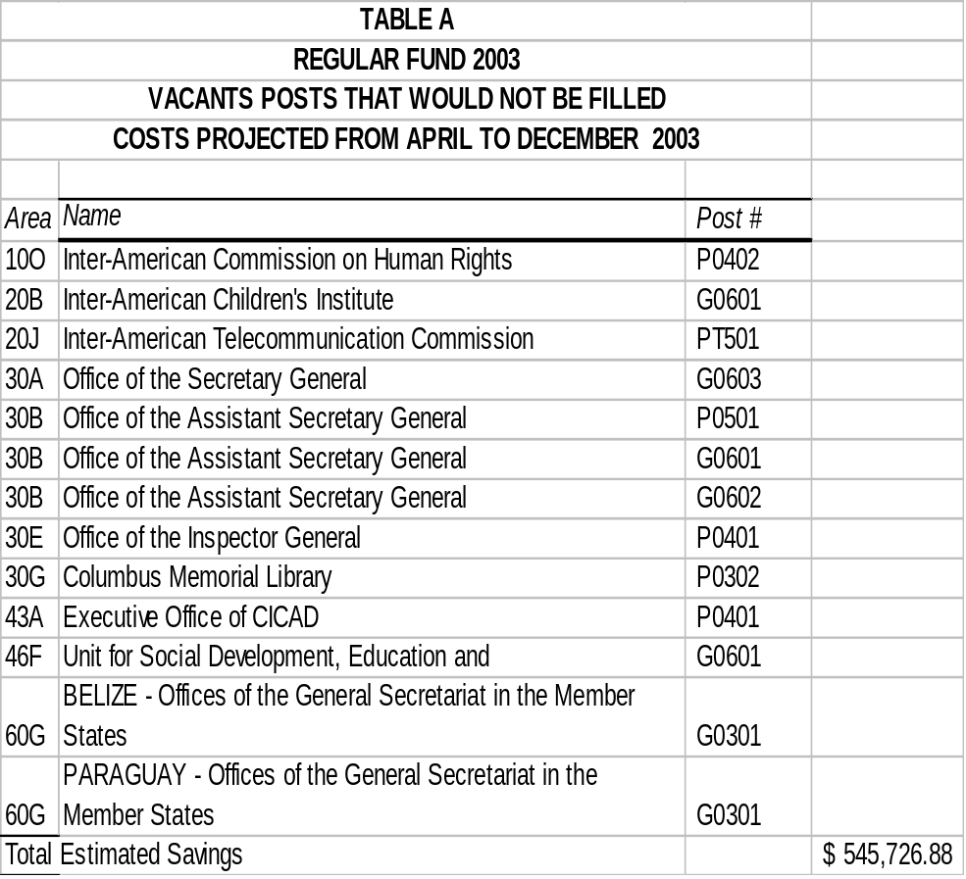
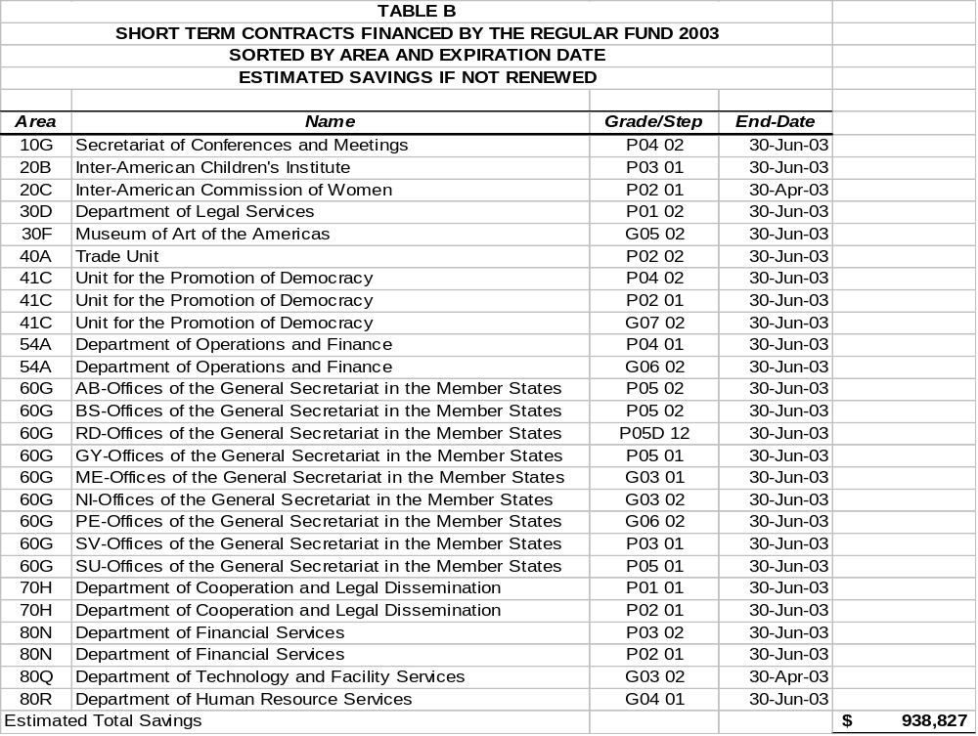
APPENDIX II

DRAFT RESOLUTION

AUTHORIZATION OF AN ADJUSTMENT TO Object 1
Personnel Costs FOR 2003

THE PERMANENT COUNCIL,

CONSIDERING:

That operative section III(A)(1)(a) of Resolution AG/RES.1909 (XXXII-O/02), the 2003 Program-Budget Resolution, authorizes the Secretary General “to adjust the personnel structure of the General Secretariat and to fill posts provided that total object 1 expenses for the year 2003 do not exceed US$46,378,400;”

That pursuant to the salary policy of parity with the United Nations set out in Article 40 of the General Standards Governing the Operations of the General Secretariat, the Secretary General has complied with his legal obligations to implement, effective January 1, 2003, unforeseen increases in the Secretariat’s net basic salaries and, effective April 1, 2003, higher than foreseen increases in the post adjustment for the Washington, D.C., headquarters professional staff;

RECOGNIZING that the $524,000 appropriation for a post adjustment planned for in the 2003 program-budget resolution AG/RES. 1909 (XXXII-O/02) was not sufficient to implement the above referenced increases, which amount to a total of US $1,512,700, and will cause the total of object 1 expenses for 2003 to exceed the above-mentioned US$46,378,400 limitation; and

BEARING IN MIND that pursuant to its authority under Article 91(b) of the Charter and Article 100 of the General Standards, the Permanent Council may approve special appropriations requested by the Secretary General “which he deems indispensable for dealing with situations unforeseen in the approved Program Budget…in the event the Permanent Council approves such special appropriations, it shall determine the source of their funding,”

RESOLVES:

  - To increase the appropriation under Object 1 of the 2003 Program-Budget by raising the amount stated in paragraph III(A)(1)(a) of Resolution AG/RES.1909 (XXXII-O/02) to US$47,388,400.

  - To instruct the Secretary General to take the following measures to finance the revised Object 1 appropriation as follows:

a. Establish an immediate hiring freeze until December 31, 2003, against the vacant posts listed in the Annex to this resolution, financed by the Regular Fund, which should result in savings of $502,707

b. Reduce 2003 appropriations of the Regular Fund in the following manner:
- Object 3 – Fellowships by $200,000;
- Object 4 – Travel by at least $300,000;
- Object 5 – Documents $ 50,000;
- Object 6 – Equipment and Supplies $120,000;
    - Object 7 – Building Management and
Maintenance $ 50,000;
- Object 8 – Performance Contracts (CPRs) by at least $250,000;
- Object 9 – Other costs by at least $ 40,000;
Total of at least $1,010,000
3. That none of the measures adopted in paragraph 2b, above, shall apply to performance contracts (CPRs), and other expenditures directly related to the functioning of the General Assembly, and, as feasible, give precedence in funding to activities directly related to the Permanent Council and already programmed Ministerial meetings of the OAS.

4. To request that the Secretary General, recognizing his authority to allocate resources to address mandates, achieve the reductions in paragraph 2b above while being guided by the principle of proportionality, bearing in mind operative paragraph 3 above.

http://scm.oas.org/pdfs/2003/CP11271B.pdf

0000.doc

. This report appears as annex 1. 2. Parity with United Nations was established in 1955, through resolution AG/RES. 1319 (XXV-O/95).
. CP/doc.3723/03 Report of the Secretary General on Budgetary Execution process for fiscal year 2003.
2. Parity with the United Nations was established in 1995, through resolution AG/RES. 1319 (XV-O/95).

