OEA/Ser.G
CP/doc. 4105/06
13 April 2006
Original: Spanish/English

ANNUAL REPORT OF ACTIVITIES BY THE ANTI-TRAFFICKING IN PERSONS SECTION
OF THE ORGANIZATION OF AMERICAN STATES

(April 2005 to March 2006)

[In accordance with resolution AG/RES. 2118 (XXXV-O/05)]

This document is being distributed to the permanent missions and
will be presented to the Permanent Council of the Organization.
http://scm.oas.org/pdfs/2006/CP16063e.pdf

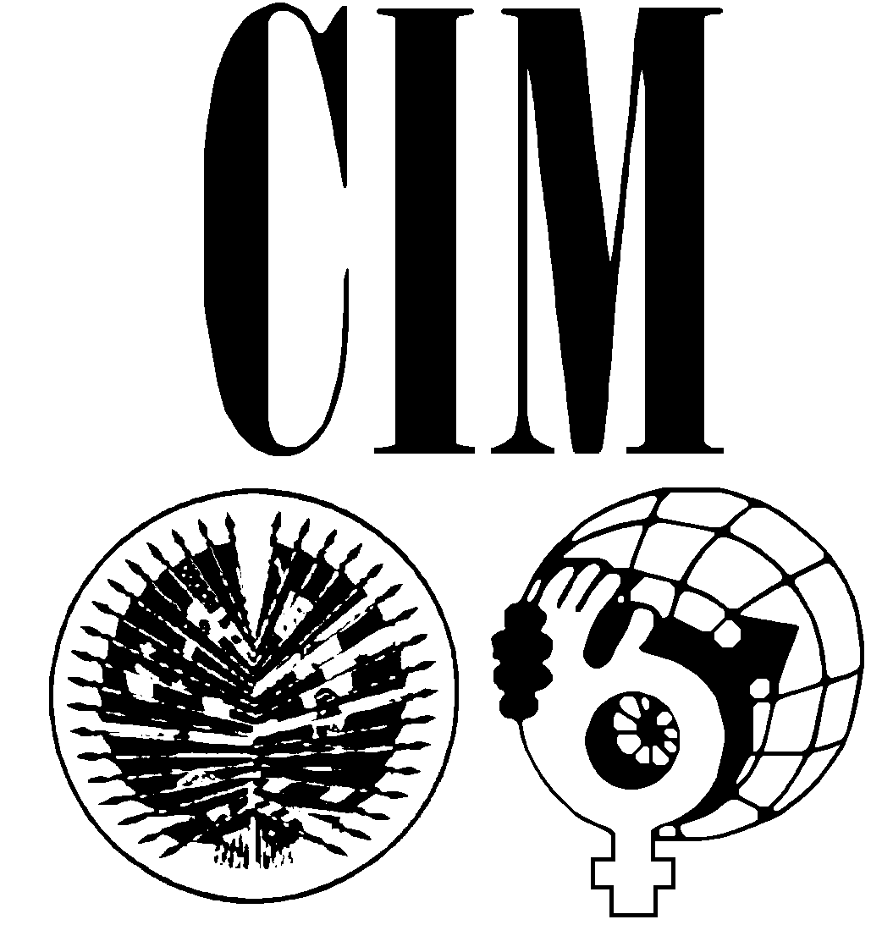
ORGANIZATION OF AMERICAN STATES
INTER-AMERICAN COMMISSION OF WOMEN

OEA/Ser.G
CP/doc.92/06
27 March 2006
Original: Spanish

ANNUAL REPORT OF ACTIVITIES BY
THE ANTI-TRAFFICKING IN PERSONS SECTION
OF THE ORGANIZATION OF AMERICAN STATES

April 2005 to March 2006

ANNUAL REPORT OF ACTIVITIES BY
THE ANTI-TRAFFICKING IN PERSONS SECTION
OF THE ORGANIZATION OF AMERICAN STATES

April 2005 to March 2006

The Inter-American Commission of Women (CIM), in recent years, and in spite of a shortage of funding, has made great efforts with research and training for fighting the phenomenon of trafficking in persons, including adolescents and children of both sexes. This initiative began in 1999 with the research project on Trafficking in Women and Children for Purposes of Sexual Exploitation in the Americas, which provided a broad panorama of the situation regarding human trafficking in the Americas and offered recommendations aimed at eradicating the practice. As a result of the CIM’s work, and with the financial support of the U.S. government, the unit for combating those crimes was set up within the CIM. This Section is responsible for coordinating the OAS’s efforts in combating human trafficking.

In fulfillment of General Assembly resolution AG/RES. 2118 (XXXV-O/05), “Fighting The Crime of Trafficking In Persons,” and the CIM’s resolution CIM/RES.225 (XXXI-O/02), “Fighting the Crime of Trafficking in Persons, Especially Women, Adolescents, and Children,” the Anti-Trafficking in Persons Section, as a part of the Inter-American Commission of Women, herewith submits its report of activities for the period April 2005 to March 2006.
During the period covered by this report, the CIM and the International Organization for Migration (IOM) continued to implement Phase II of the Anti-Trafficking in Persons Project in Mexico and Bolivia. In addition, with the aim of raising awareness about the scourge that is trafficking in human lives and ensuring that the topic is addressed at the hemispheric level, workshops and seminars for training and awareness-raising were organized in Belize (April), Peru (April), Bolivia (July and October), Ecuador (August), Guatemala (September and December), and Mexico (March, May, and October). These seminars targeted government representatives working in this area, lawyers, diplomats, police officers, immigration officials, nongovernmental organizations, teenagers, the mass media, etc. Of particular note was the Meeting of National Authorities on Trafficking in Persons, held on Isla Margarita in the Bolivarian Republic of Venezuela on March 14 to 17, 2006, under the aegis of resolution AG/RES. 2118 (XXXV-O/05).

BELIZE

In Belize City, in conjunction with the International Organization for Migration (IOM), the OAS/CIM organized a two-day training seminar on combating trafficking in persons on April 14-15, 2005. The seminar was attended by 60 representatives of Belize’s Trafficking in Persons Task Force, Department of Human Services, Department of Immigration and Nationality Services, the police, and the press. Also represented were the consulates and embassies of Mexico, China, and the United States. The main aim of the seminar was to provide training and strengthen cooperation among the country’s agencies, and it also addressed such key areas as best research practices, trafficking in human lives from China in the western hemisphere, a panel session on sexual tourism, and the mental consequences of trafficking in persons. This training seminar served to heighten public awareness about the problem of trafficking in persons in general and about the local context in particular.

BOLIVIA

The second training seminar on “Strategies to Combat the Trafficking of Children, Adolescents and Women” was held in the city of La Paz on July 13-15, 2005. The seminar was attended by more than 120 representatives of the government, academia, the press, experts from the ILO and the OAS, anti-corruption experts, regional financial institutions, and civil society from La Paz, Santa Cruz, Tarija, and Cochabamba. At the event, the researchers Aníbal Alvarado and Erick Roth presented the results of their Bolivian research project.

The Prevention of Trafficking of Women and Children Project was carried out in Bolivia, during October, in conjunction with the International Organization for Migration. This project involved a prevention campaign carried by the mass media, including television and radio, for which public service announcements were produced in the Spanish, Quechua, Aymara, and Guarani languages.

Between October 17 and 21, a series of seminars, focusing on different topics, were held in the cities of Trinidad, La Paz, and Cochabamba. La Paz hosted a seminar on “Training for Journalists from the Bolivian Media in Trafficking in Persons: Reporting and Spreading the News while Upholding Victims’ Rights,” at which communicators, journalists, and owners of media outlets (written press, radio, and television) involved with the topic or who had produced important work relating to it, were given training relating to trafficking in human lives. In Cochabamba the seminar focused on preventing the trafficking of children and adolescents from the most representative sectors of Bolivian society, and involved youth and children’s organizations and leaders at the local, departmental, and national levels. Finally, the seminar “Training for Government and Civil Society Authorities in Combating trafficking in Persons, Particularly Women” was held in the city of Trinidad. This seminar assisted departmental authorities from Beni, Pando, and Santa Cruz, along with representative sectors of civil society and women leaders.

MEXICO

The Anti-Human Trafficking Workshop for Media and the Entertainment Industry Seminar was held in Mexico in December 2005. This event helped professionals in the entertainment industry focus on the subject of human trafficking and, in particular, the situation of trafficking victims, in order to assist writers and editors in this field to incorporate realistic depictions of this scourge in their story lines. The result of this undertaking was heightened public awareness about the topic and increased prevention. As the entertainment industry more fully comprehends human trafficking and portrays its real nature, the general public will be better informed and persons potentially vulnerable to the crime will be forewarned about the phenomenon.

The meeting “Trafficking of Persons and the Commercial Sexual Exploitation of Minors,” organized by the executive committee the Inter-American Network of Parliamentarian Women, was held in the Mexican city of Puebla on March 1, 2006. The OAS Anti-Trafficking in Persons Section was represented by its Projects Director, Fernando García Robles, with his keynote address on “Trafficking in Persons: A Transnational Problem.” The conference brought together parliamentarians of both sexes, national and international nongovernmental organizations, the international community, and civil society in general. The OAS’s presence at this event was of great importance, since the draft Decree Law to Prevent and Punish Trafficking in Persons was then being studied by the Joint Congressional Committees on Justice, Human Rights, and Legislative Studies.

PERU

During January 2006, the OAS/CIM and the Peruvian Ministry of Foreign Affairs jointly sponsored a training seminar on trafficking in persons held in the city of Lima. Experts from Colombia, Chile, the Dominican Republic, Paraguay, Panama, and Japan participated in the event and discussed best practices and strategies for combating human trafficking in the hemisphere. More than a hundred Peruvian civil servants, members of Congress, police officers, immigration officials, NGOs, diplomats, and journalists attended the seminar, which took place at the headquarters of the Ministry of Foreign Affairs. In Peru, the OAS/CIM also met with officials from the “Disappeared Peruvians” project, which uses internet technology to build a database for locating disappeared persons. The OAS/CIM is working with this organization, which would like to present this project to all the countries of the hemisphere.

ECUADOR

On August 25 and 26, the Government of Ecuador and the OAS organized a training and awareness-raising seminar on trafficking in persons, held at the Supreme Court building in Quito. The OAS was assisted at this event by Ecuador’s Ministries of Foreign Affairs and of Labor and Employment. Other sponsors included the ILO, the American Bar Association’s Latin America and Caribbean Law Initiative, and the embassy of the United States in Quito. More than a hundred individuals attended this event, including a large number of officials from the Ecuadorian government. In addition to experts from Ecuador and the United States, the meeting included experts from Panama, Peru, and Colombia.

GUATEMALA

The OAS/CIM assisted the embassy of Sweden, the Swedish Development Institute, and the NGO Casa Alianza in organizing and hosting a two-day training seminar on combating human trafficking. The event was attended by experts from Sweden, the Organization of American States, Casa Alianza, and the Guatemala/Belize border. This seminar was attended by congresswomen from the Central American region, diplomats, journalists, police officers, immigration officials, civil society representatives, and members of Guatemala’s Foreign Service. The event also involved a screening of the motion picture Lilja-4-Ever, which portrays the injustices suffered by trafficking victims; the film was also showed in Guatemalan cinemas as part of a campaign to raise awareness about trafficking in persons.
In December 2005, the OAS organized a training and awareness seminar on trafficking in persons in Guatemala City. The seminar was hosted and jointly organized by the Guatemalan Ministry of Foreign Affairs, with assistance from PASCA-USAID. It was attended by officials and experts in combating human trafficking representing government agencies and NGOs from Belize, El Salvador, Mexico, Guatemala, Ecuador, Peru, Colombia, Nicaragua, and the United States. The participants and observers included police officers, immigration officials, workers from social services, the press and other media, and civil society organizations and NGOs. The training was intended to provide greater understanding and transparency regarding the crime of human trafficking in Guatemala and in the region.

OTHER ACTIVITIES AND SPECIFIC PROJECTS

HAITI

In Haiti, Mr. Apollos Laurore was appointed the OAS consultant responsible for working in conjunction with the anti-trafficking in persons unit of the Haitian National Police (PNH), known as the Minors’ Protection Brigade (Brigade de Protection des Mineurs, BPM). The OAS project aims to support the country in its efforts combating human trafficking and has the support of the Department of Foreign Affairs and International Trade of the Canadian government. The project will assist the professional training of the police, oversight of the international resources made available to the BPM, and the organization of activities in the area. In addition, the research project into trafficking in persons in Haiti has begun. This purpose of this project is to determine the impact of human trafficking in Haiti, provide an estimate of the number of trafficking victims, identify the operating methods of the traffickers, and provide information on the current context of human trafficking operations, both within the country and in international terms.

LATIN AMERICA – JAPAN

In September, at an event in Tokyo, Japan, our consultant Ms. Kaname Tsutsumi presented the report of the Organization of American States on Trafficking in Human Lives from Latin America and the Caribbean to Japan. This report indicates that every year, some 1,700 women from the Latin American region are victims of trafficking in human lives in Japan. Most of them are exploited by the Japanese sex trade. The study’s findings are based on an analysis of migration data and Japanese crime statistics, and they show that most of the victims come from Colombia, Bolivia, Brazil, Mexico, and Peru.

VENEZUELA

At its 35th regular session, held in Fort Lauderdale, the General Assembly of the Organization renewed the mandate of holding a Meeting of National Authorities on Trafficking in Persons in its resolution AG/RES. 2118 (XXXV-O/05) “Fighting The Crime Of Trafficking In Persons.” In turn, the OAS Permanent Council, meeting on August 25, 2005, adopted the resolution “Convocation of the Meeting of National Authorities on Trafficking in Persons,” CP/RES. 889 (1503/05), which was later reviewed at the sessions held on November 30, 2005, and January 24, 2006, and in which it was agreed that the meeting would take place on Isla Margarita in the Bolivarian Republic of Venezuela on March 14-17, 2006. The meeting on Isla Margarita was attended by national authorities from the member states, civil society, and international agencies including the IOM, the ILO, and the UNODC; it was also the first hemispheric forum at which the countries of the Americas met to discuss issues related to the implementation of legal instruments for tackling human trafficking, preventing the phenomenon, punishing traffickers, providing protection and victim assistance, and exchanging information, experiences, and international cooperation. One of the outcomes of this meeting was the production of a document containing its conclusions and recommendations, which will be presented at the REMJA VI meeting to be held on April 24-26 next in the Dominican Republic.

LAUNCH OF THE WEBPAGE: www.oas.org/atip

At the end of the second half of 2005, the Anti-Trafficking in Persons Section launched its webpage, publicizing the programs it has carried out on the topic, press articles, reports, events of interest, and a list of information related to trafficking collected from the member states. In January 2006, the Spanish-language version was made available to users.

PRESENTATIONS MADE AT INTERNATIONAL EVENTS
● At the Awareness and Training Seminar for Combating Trafficking in Persons, held in Lima, Peru, in April 2005, the Coordinator of the Anti-Trafficking in Persons Section presented a paper entitled “Trafficking in Persons: A Scourge at the Hemispheric Level.”
● The Mario Vargas Llosa International Foundation for Freedom invited the coordinator of the Anti-Trafficking in Persons Section to attend the Second Europe-America Atlantic Forum, which was held in Madrid, Spain, on July 13, 2005. The title of his speech was “A New Challenge: International Trafficking in Persons.”
● During the training seminar held in Quito, Ecuador, in August 2005, the Coordinator of the Anti-Trafficking in Persons Section gave a speech entitled “Challenges in Combating Trafficking in Persons.”
● During the series of Seminars on Migration and International Trafficking in Human Lives, the United Nations Population Fund and the United Nations University invited the Projects Director to speak on the topic of “Trafficking in Persons and Organized Crime: The Cases of Mexico and Bolivia”; United Nations, New York City, USA, October 18, 2005.
● First Latin American Congress of Police Security Forces for Disappeared Persons; Santiago, Chile, October 19-21, 2005. The Projects Director was invited by the Chilean Carabineros and Save the Children – Sweden to speak about “Trafficking in Human Lives in the Hemisphere.”
● The Projects Director was invited, with sponsorship from Save the Children – Sweden, to attend the launch of webpage of the Latin American Disappeared Persons Network; La Paz, Bolivia, November 25, 2005.
● Save the Children – Sweden and the Latin American Disappeared Persons Network invited the Projects Director to participate in drawing up the 2005-2010 strategic plan of the Inter-American Center Against Disappearances, Exploitation, and Trafficking in Persons (CIDETT); Lima, Peru, February 2-3, 2006.
● The Coordinator of the Anti-Trafficking in Persons Section presented a paper entitled “Aspects of the Crime of Trafficking in Persons and the Hemispheric Situation” at the meeting of the Committee on Transnational Crime; Washington, DC, USA, February 2006.
● CASALS Internacional and the Network of Parliamentarian Women invited the Projects Director to speak at the Conference on Trafficking in Persons and Commercial Sexual Exploitation of Children, held Puebla, Mexico, on March 1, 2006. Mr. Fernando García Robles speech was on “Trafficking in Persons: A Transnational Problem.”
● With the sponsorship of Save the Children – Sweden, the embassy of the United Kingdom, the ILO, and the NGO Raíces, the seminar “Illicit Trafficking in Persons: The Need for Legislation in Chile” was organized. The Projects Director was invited to attend and address the event. Santiago, Chile; March 30, 2006
● During the training seminar held in La Paz, Bolivia, on March 31, 2006, the Coordinator gave a speech entitled “Regional Panorama of the Struggle against Trafficking in Persons.”

FUTURE ACTIVITIES

The Anti-Trafficking in Persons Section will continue organizing and participating at the seminars that are to take place over the coming months. These are excellent opportunities for the OAS, civil society, and the member states to cooperate and to exchange information. We will also continue with the research projects. The projects under development include reports on trafficking in human lives in Puerto Rico and on trafficking of Chinese citizens in Latin America, and a project whereby the OAS, in conjunction with the American Bar Association’s Latin America and Caribbean Law Initiative, will work to create mechanisms so that trafficking victims in Latin America can receive free legal advice.

SUMMARY OF ACTIVITIES

● In conjunction with the International Organization for Migration (IOM), the OAS/CIM organized a training seminar on trafficking in human lives in Belize.

● The OAS/CIM and the Peruvian Ministry of Foreign Affairs jointly sponsored a training seminar on trafficking in persons in that country.

● Second training seminar: “Strategies to Combat the Trafficking of Children, Adolescents and Women,” in Bolivia.

● The OAS/CIM, in conjunction with the IOM, carried out the Project for Preventing Trafficking of Women and Children in Bolivia.

● A series of three seminars against trafficking in persons was held in the Bolivian cities of Trinidad, La Paz, and Cochabamba.

● A training and awareness seminar on trafficking in persons in Ecuador.

● A research project on trafficking in human lives from Latin America and the Caribbean to Japan.

● The appointment in Haiti of Mr. Apollos Laurore as the OAS consultant charged with working alongside the Anti-Trafficking in Persons Unit of the Haitian National Police (PNH).

● The anti-human trafficking workshop for media and the entertainment industry in Mexico.

● In Central America, the OAS/CIM worked with the Swedish embassy, the Swedish Institute, and the NGO Casa Alianza on organizing and carrying out a training seminar focusing on efforts against trafficking in human lives that was held in Guatemala.

● Launch of the Anti-Trafficking in Persons Section’s webpage, www.oas.org/atip.
input.doc

● The OAS/CIM, with support from USAID and the Ministry of Foreign Affairs of Guatemala, organized a training and awareness seminar on trafficking in persons in Guatemala City.

