SIXTH INTER-AMERICAN MEETING OEA/Ser.K/V.9.1
OF MINISTERS OF EDUCATION CIDI/RME/INF.1/09
August 12-14, 2009 5 August 2009
Quito, Ecuador Original: Spanish/English

RETHINKING SECONDARY EDUCATION:
SUGGESTIONS TO STIMULATE DISCUSSION

(Presented by the Technical Secretariat)

INDEX

ESSAY I SECONDARY EDUCATION IN THE AMERICAS NEW PERSPECTIVES, KEYS TO REFORM (Prepared by Ricardo Villanueva): 6

ESSAY II FROM CURRICULUM TO PRACTICE REMOVING STRUCTURAL AND CULTURAL OBSTACLES TO EFFECTIVE SECONDARY EDUCATION REFORM IN THE AMERICAS (Prepared by Dr. Bradley A.U Levinson and Carolina Casas) 25

ESSAY III: BETTER OPPORTUNITIES FOR THE YOUTH OF THE AMERICAS: RETHINKING SECONDARY EDUCATION IN THE CARIBBEAN (Prepared by Dr. Didacus Jules) 42

ESSAY IV CHALLENGES TO THE UNIVERSALIZATION OF SECONDARY EDUCATION
INPUTS FOR DEFINING EDUCATIONAL POLICIES (Prepared by Dr. Inés Dussel): 70

RETHINKING SECONDARY EDUCATION:
SUGGESTIONS TO STIMULATE DISCUSSION

(Presented by the Technical Secretariat)

Secondary education is a level that is currently generating a lot of questions and has sparked a search for answers in educational systems throughout the world. The serious challenges posed by grade repetition, school dropout, and poor academic achievement–in a context defined by the coexistence of an economic crisis with rapid change at all levels of society and with the impact of new information and communications technologies–give the impression that, in many instances, the educational system is not attuned to the reality of young people’s lives. Based on this evidence, the 34 member states of the Organization of American States (OAS) unanimously agreed that the Sixth Ministerial Meeting should focus on rethinking the purpose and objective of this educational level, defining an approach, and searching for innovative methods and content in order to meet the challenge of providing an educational response that would be both effective and appropriate for the development of young people and beneficial to the well-being of the countries.

In the spirit of contributing to this dialogue and to the development of proposals and policy actions, the Department of Education and Culture of the OAS (DEC) has provided the Ministers of Education with four essays written by experts in the field as supplementary material for their consideration. These essays reflect the opinion of their respective authors and provide meaningful approaches to addressing, from an overall perspective, some of the problems affecting secondary education in the region.

The first essay, “Secondary Education in the Americas: New Perspectives, Keys to Achieving Reform” was written by Ricardo Villanueva, of Peru; the second essay, “From Study Plan to Practice: Eliminating Structural and Cultural Barriers to Achieve an Effective Reform of Secondary Education,” by Dr. Bradley Levinson and Carolina Casas, of the United States; the third essay, “Better Opportunities for Young People in the Americas: Rethinking Secondary Education in the Caribbean,” by Dr. Didacus Jules, of Saint Lucia; and the fourth essay, “Challenges to Making Secondary Education Universal: Contributions to Defining Educational Policies,” by Dr. Ines Dussel of Argentina.

In line with their analytical approach, the authors address the main trends and problems faced by secondary education, discuss and examine a number of experiences dealing with change and/or reform, and, based on those, present a series of recommendations to improve secondary education including: clearly establishing the purpose of secondary education, pointing out possible educational paths, considering the importance of revamping the curriculum and the organizational structure of schools, and addressing the contradictions between the expectations of reform and the actual material and cultural resources available to meet those expectations. Recommendations regarding teachers tend to consider them as “agents of change” in the design, implementation, and evaluation of reforms and in the development of proposals to professionalize the teaching career, placing particular emphasis on reforming teacher training systems as well as in-service, skills development, and hiring systems.

The authors point out that implementation of these recommendations requires, in addition to strong political will, a systemic vision of the educational structure that encompasses the various educational levels, the productive sector, and the cultural environment. It also involves strategic increases in public spending and the allocation of financial resources to sustain change in the medium and long range. Coordination with social policies, especially those targeted at young people, and the contributing efforts of the various societal institutions and actors and their commitment to secondary education emerge as key elements in reducing the individual vulnerabilities of the different contexts, ensuring the inclusion of the less fortunate sectors of society, and improving the system as a whole.

Each of the four essays has its own dynamic and we think it is appropriate to highlight certain areas which the essays analyze in considerable detail in order to delve deeper into the subject matter. In the essay entitled “Secondary Education in the Americas: New Perspectives, Keys to Achieving Reform,” the author points out the need to effectively incorporate, and not simply to state, the needs, expectations, and interests of young people as part of a twofold process: to define the objectives of secondary education and to provide incentives to help keep students in school. The author also maintains that it is important to analyze education policies from an overall perspective that takes into account the social environment in which young people live in order to determine whether or not they have access to social networks and the necessary support to help them remain in school. This analysis is essential in devising mechanisms to ensure that young people are included and will continue to attend school.

With regard to the essay entitled “From Study Plan to Practice: Eliminating Structural and Cultural Barriers to Achieve an Effective Reform of Secondary Education,” the authors maintain that recent investments in innovation to achieve equality and to revamp study programs have not been followed by the structural reforms needed to guarantee their implementation. These reforms–most of which have to do with matters related to institutional organization and capacity, education, and teacher training and hiring and to the relationship between the state and civil society–demand a clear vision, the shaping of a consensus, and the political will to challenge many vested interests. On the other hand, the authors consider that it is important to define the purpose of secondary education. Given the multiplicity and ambiguity of purposes and the distinction between educating a student to join the productive sector and educating a student to continue on to higher education, the author proposes that the essential and inclusive purpose of secondary education ought to be a “comprehensive education to prepare a young person to exercise the rights and duties of a democratic citizen.”

With regard to the essay “Better Opportunities for Young People in the Americas: Rethinking Secondary Education in the Caribbean,” the author points out that the main challenge facing the Caribbean is rethinking secondary education within the framework of a larger transformation agenda driven by the demands of a new, knowledge-based global economy and with the participation and commitment of key players in education. At the same time, the author points out the important role that education can play in the development of young people and in the integration of social policy and proposes identifying a comprehensive framework to increase opportunities for young people in each sector, with education as the focal point. In the author’s opinion, implementation of this framework requires a multisectoral strategy that brings together the disparate and uncoordinated efforts being made to improve the social and educational situation of young people. In this transformation, the author points out, schools must be reinvented and go well beyond traditional schemes in order to encourage young people to exercise the rights of democratic citizenship and pursue entrepreneurial initiatives, based on an educational system aimed at teaching practical know-how and learning how to live together. The author indicates that secondary education in the Caribbean is well positioned to be the focal point in the implementation of a comprehensive, multisectoral, and integrated initiative for the development of young people.
In the essay entitled “Challenges to Making Secondary Education Universal: Contributions to Defining Educational Policies,” the author offers possible public policy alternatives that emerge from identifying four challenges faced by secondary education: (a) the expansion of coverage to make the secondary level universal; (b) improvements in the quality of education and learning; (c) revamping of the curriculum and the organizational structure to meet present-day demands; and (d) enhanced governmental capacity to act to guide change. On this last point, the author indicates that, given the redefinition of an “educational system,” it is necessary to bring back the role of the state to manage change, provide general guidelines, and encourage the formation of a forum for democratic discussion in which questions and policies regarding distributive justice may be formulated and discussed.

The essays suggest a number of possibilities for the design of reforms aimed at improving the quality, fairness, efficiency, and relevance of secondary education, but they also raise a number of underlying questions relating to the dilemmas policymakers usually confront in the process of making decisions that determine the future of young people and the development of society as a whole. The manner in which the working sessions of the ministerial meeting are structured offer a valuable opportunity to provide context, deliberate, and present possible answers to these and other questions.

As a contribution to the discussion, we offer the following questions grouped according to the need to guarantee an effective change in teaching methods, improve the retention of students in the system and their access to a diversified and quality education, and ensure the reform, expansion, strengthening, and financing of secondary education.

1. With regard to the conditions needed to guarantee an effective change in teaching methods within schools and educational institutions:
- What measures are needed for teachers and educational institutions to make a genuine transition from a frontal and discursive method of teaching requiring student memorization, to active and creative teaching that makes it possible for students to actually develop skills, reduces the fragmentation of areas and specialties, and allows for the development of research and community action projects, among other essential reforms?
- What are the avenues to overcoming the bureaucratic rigidity of educational system administration, the impact of that rigidity on the organizational culture of educational centers, the shortcomings in teacher training programs, and the resistance to training and reforms among a sector of the teacher corps?
- What strategies, mechanisms, and situations could be more effective in making the active and independent participation of students in the classroom and in school activities a genuine, significant, and motivational democratic experience within the schools?
- How can schools interact more openly and with fewer impediments with the social and cultural environment of young people and be able to take maximum advantage of the opportunities they offer students for access to valuable learning tools, such as their preference to acquire information through the Internet?
- What intersectoral actions (Education, Economy, Labor, Health, and Planning) are needed to implement a comprehensive system of continuing professional development for teachers, together with a system of incentives as well as better employment and living conditions?
2. With regard to retention of the students in the system and their access to a diversified and quality education that will guarantee them the knowledge, skills, and competence needed to pursue higher education or to enter the labor market:
- How to advance in the design and implementation of a flexible educational system, with different educational methods and paths that are not only coordinated but of equal quality?
- How to remedy the continuing lack of coordination between vocational training and advanced study of the humanities, and between technical competence and critical comprehension, within the framework of a comprehensive vision of the educational system?
- How to make progress in identifying the minimum quality requirements that can be replicated throughout the region and take into account the dynamics of regional integration, migration flows among countries, and the creation of interconnected labor markets?
- What mechanisms would benefit the social mobility of teachers and students, creating opportunities to enrich professional development and cultural learning among the peoples of the Americas?
- How to establish learning available to all, aimed at ensuring equal opportunity, while at the same time offering differentiated options that respond to social complexities without falling into discrimination, exclusion, or lower quality alternatives, which may increase the unequal stratification of educational systems?

- With regard to the reform, expansion, strengthening, and financing of secondary education:
    - How should the purpose and effectiveness of secondary education be refocused in light of positions–often times conflicting–which give priority to continuing on to higher education or the possibility of entering the labor market and the productive sector?
    - What strategies are needed to ensure that the interests, concerns, and expectations of the different social and educational actors are channeled through institutions and truly reflected in the new reform policies and in study plans in secondary education?
    - What measures are needed to have comprehensive educational information systems where information on academic achievement is related to data on progress made and difficulties in providing a quality education for all?
    - What kinds of social and policy agreements would allow for the fiscal, organizational, and regulatory changes needed to achieve a greater and more equitable allocation and distribution of resources, overcoming standardized plans and predetermined allocations based on historical public spending precedent?
    - How could private sector efforts and international cooperation be coordinated with the actions of the public sector in order to facilitate the implementation of various innovative initiatives instead of options that increase rather than decrease educational inequity?

Going back to what was expressed at the beginning of this brief introduction and, in particular, taking into consideration the relevance of the approach to reforms in secondary education, it is the dynamic of the debate and the possible consensus that emerges concerning the attributes of particular educational policies to reform secondary education that will make it possible to determine the courses of action to take regarding possible working principles to allow countries–through cooperation and joint efforts–to move forward together toward achieving the objective of quality secondary education that will provide young people with the opportunity to fully exercise their rights and responsibilities as citizens.

ESSAY I:
SECONDARY EDUCATION IN THE AMERICAS: NEW PERSPECTIVES, KEYS TO REFORM

(Prepared by Ricardo Villanueva)

1. What are the main trends and problems associated with secondary education in the Americas?

1.1 Efficiency and shortcomings in education: a panoramic overview

The relationship between youth and secondary education has undergone a complex transition in the past fifteen years. While the number of adolescents entering secondary school has increased in virtually all of the countries of the Americas, school completion rates have not been satisfactory in the context of a strategy for equal opportunities.

In fact, the baselines of social inclusion ranges for youth are relatively unequal. Poverty rates among youth in most Latin American countries have grown. Another source of concern is the existence of a youth population that is neither studying nor working. In 2005, 21% of youth from 15 to 24 years of age in 17 countries were marginalized from the two mechanisms for social integration and building civic mindedness with the greatest impact (ILO, 2006). A persistently elevated school repetition rate is one of the major underlying causes.

In the present decade, most countries in the region have continued to record high repetition rates in secondary school. A UNESCO study shows that 13 Latin American and Caribbean countries with comparable statistics have a student repetition rate of 9% of the total student enrollment. Of even greater concern is the difference in the advancement rates between students in urban and rural settings. A study of students in four Latin American countries (World Bank, 2007, p.52) shows that the curve indicating the percentage of students that advance to the next level after sixth grade—and throughout secondary school—falls off sharply in rural areas, while the downward curve is more gradual in urban areas. The average difference is around 30 percentage points, with the exception of Mexico, where the difference is evident but moderate.

Repetition is a serious problem, as it represents a direct decline in valuable resources for the country and for families (UNESCO, 2008). As the cited report indicates, it also has a negative effect on education records in general by reducing the probability of completion of studies. Throughout the school years, the cumulative effect of the inherent inefficiency of the system exacerbates the social differences affecting youth in schools. Data related to secondary education coverage in Latin America and the Caribbean are of particular concern. Retention rates in secondary education lower as age increases above fourteen years. The data from the UNESCO report shows that 23 countries have a descending curve in enrolment as age increases. The drop in net enrolment in the fifteen years of age group is on average 9 points or 78.5% and by sixteen years of age net enrolment drops to 62.3%. This data shows that the notable progress achieved in the flow of graduates at the primary level does not continue at the secondary level. In other words, a significant number of adolescents are exiting at this level and are not moving into alternative education programs.
A key aspect of effective secondary education is achievement in terms of the learning process. As a rule, measurement of learning achievements in secondary schools has not been developed extensively or systematically in the region. The level of educational achievement is a reflection of the ability to organize and mobilize the teaching resources of the educational community. Thus it does not involve the sum of the individual failures or successes of youth, but instead it is the critical indicator of the quality of the products or programs offered by the system, including learning parameters, instructional methods, and strategies proposed for the curriculum.

One plausible indicator for determining this critical information in the Americas is the test results of the Programme for International Student Assessment (PISA), which measures the achievement of competency in 15-year old students on the basis of a series of achievement standards. During the 2006 fiscal year, eight countries in the Americas participated. The results are illustrative, although somewhat disappointing.

As you can see from the performance outcome in mathematics and science, there is an enormous difference between the developing countries of the Americas and the average for OECD countries.

Table No.1. Percentage of students at levels 4 to 6 of the PISA mathematics proficiency scale:
Table No.2. Percentage of students at levels 4 to 6 of the PISA science proficiency scale:

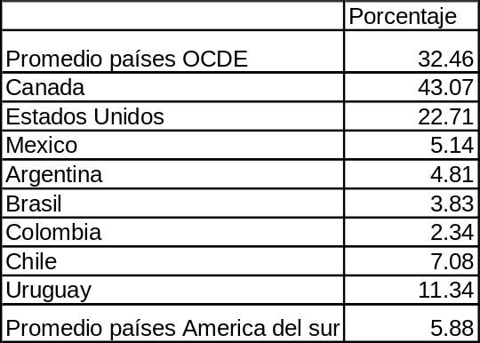
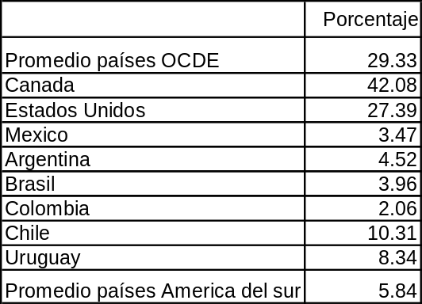

Source: OECD- PISA 2006

At a time when scientific and technological knowledge is critical for achieving the skills that make persons employable, the results of PISA 2006 reveal large variations in the levels of preparation between developed and developing countries, as reflected among the regions of relatively greater or lesser development in the Hemisphere. As Brunner (2008) indicated for the outcome of Chile, which can be extrapolated to all the secondary school systems in the region: “over half of the students have not developed the skills that will enable them to cope with life problems that involve the use of mathematics. Their mathematical reasoning applies only to very familiar contexts. They will be able to use routine procedures, following instructions, but will not be capable of proposing alternative solutions.”

It can be gleaned from these data that the prospects for youth with secondary school diplomas entering the labor market, which requires mastery of increasingly specialized and refined skills, are dim.

1.2. Equity and quality: the passive factors

Equity and quality of education in Latin America and the Caribbean are inextricably linked, since the difficulties encountered by the most vulnerable young people—in both urban and rural areas--in completing secondary school limit the opportunities needed to break the inter-generational poverty cycle. Low-quality schools produce graduates with limited abilities to break the vicious circle of exclusion. Due to quality differences, the secondary education offered is incapable of surmounting the factors that contribute to social stratification.

The social heterogeneity of youth is such that students entering secondary school may have divergent perspectives regarding their needs and how they can use their education in terms of their life project expectations. The disconnection apparent in secondary education vis-à-vis the training students need to adapt to the actual conditions of their cultural and work environment is a factor contributing to the loss of a systemic view of formal education.

This breach has given rise to an offering of various alternative circuits. Frequently, unrelated short-term technical and vocational training opportunities arise on the market or are offered by the government, but they do not necessarily solve the underlying problem, i.e., acquiring the competencies needed for successful and sustainable participation in the job market, in a context of advancement of the individual and the family.

In addition to the socio-economic level, family stability, appreciation for the educational capital of their children, and prior school experiences may play an extremely important role in decisions of youth to stay in secondary school. A review of household surveys (ILO, 2007) provides evidence supporting this. When it inquired into the reasons for school drop-out in the 14-19 year age group, family and/or economic problems were the primary reason given for students’ leaving school (34.7%), well ahead of the decision to go to work (17.6%). If we add to this last reason the impact of school failure (at 12.6%), the two together do not amount to the importance of family reasons.

Thus, it is essential to assess educational policies from a comprehensive standpoint, taking a 360 degree view of the environment of youth. In applying the same criterion used to evaluate social programs to reduce vulnerability, secondary education should ask to what extent does the educational institution take into account the heterogeneity of youth, or whether they all have the social and support networks needed to sustain their participation in school, or whether all the families have the same degree of commitment to education or even the same capacity to pay for the hidden costs of education. There is reason to believe that in a large part of the Hemisphere, these types of questions are not taken into consideration in designing course content and the educational processes, programs, and projects. Nor are these considerations included in training programs for secondary school teachers.

These factors are particularly apparent during the final years of secondary school. As their children reach the threshold age for contributing to the family income, families have to make a painful but inevitable cost-benefit analysis.

In this way, adolescents are subject to two pressures: On the one hand, they may value education, to the extent that their experiences and their immediate socio-economic surroundings provide them with indications that acquiring additional educational capital will yield a significant return for the personal and family effort involved in postponing their entry on the job market. On the other, however, families may find themselves compelled to move their children to the labor market in the context of a dynamic economy.

Qualitative research has shown that the expectations of youth regarding their educational success act as a factor in favor of completion (Benavides, 2008; Fernandez Cabezas et al). This is evident: high expectations of success can be a factor that reinforces the locus of control locus and can influence the decisions of their families. However, there are situations of economic insecurity or of variable family dynamics where their effect is not felt. For instance, premature sexual activity acts as a disruptor of expectations. Clearly the impact of early pregnancy among adolescents is a serious concern in this decade, and is frequently due to an insufficient or inadequate approach to sexuality, and generally to the vulnerability of the adolescent stage of life.

The support and guidance of the family nucleus is critical in rural parts of Latin America. Decisions regarding school attendance, joining the work force and participating in the economy are part of a family life cycle marked by a work ethic and the common good, values that are not lost when the younger members of the family migrate to urban areas to seek a better life. It is therefore essential to include families in the equation of policies to promote equity and quality in secondary education.

1.3 The emerging quality factors
“There are teachers who do not understand us (...), teachers who see things their own way and this is what we sometimes do not llike. It is important for them to understand us, we have a teacher who is a psychologist, he understands us, he talks to us, but as I said we only talk with a few teachers, not with the others.”
Gabriela (16 years old, San Juan de Miraflores, Lima)

In the Americas, based on the model for monitoring the Regional Educational Plan adopted by governments, more attention is being paid to the issue of relevance. Certain little-explored areas in skill development have been included in new designs for national curricula. In some cases, the emphasis on transmitting knowledge is being abandoned from curricula, and is giving way to students’ playing a key role in building knowledge and developing critical analysis. There are still defects in the design, as pointed out in the 2008 OREALC-UNESCO Report: there is less evidence of change regarding development of learning processes that link the analysis of information with decision making, and even less of this linkage with reflection on what was learned. These are key definitions for putting into practice learning to learn. There is an even greater distance separating the prescribed curriculum and the curriculum actually in use, the one that governs relations in classrooms on a daily basis.

In this context, there are three factors to define educational quality in secondary schools in the near future: a) the relationship with the opportunities and challenges involved in remodeling global production systems, in terms of new skill sets, that is established in the educational curriculum; in addition, the inherited problems of traditional inequities in our region, and especially in Latin America, which it should help to overcome; b) the capacity of teaching methods and strategies to respond to the significant cultural systems of adolescents; and c) the relationship established by the educational system with the emerging interests of youth, interests that arise from a new sensitivity regarding human relations and toward their environment and technology.

The governments of the Americas have taken important steps to enhance the link between the content of secondary education and real current needs. To this end, there have been a considerable number of reforms in recent years. On the one hand, the way in which people relate to markets, technology, and the media has substantially changed our concept of what skills we need to meet the new challenges of an integrated labor market and the national and global community. Youth have become aware that they need to acquire a series of both general and specific skills to respond to the fragmented labor market, with its constantly changing structure.

An emerging problem in the quality of education is access to the new technologies and development of the capacity to use them. The demand of students in this regard is reflected in one of the conclusions of the participatory assemblies of student leaders in Peru (2001), when they were asked about the new physiognomy of secondary education: “We need to be prepared in the field of cybernetics.... To learn how to decode and understand symbols and codes is a key requirement for becoming part of the information age.” The new skills included in the revised curriculum designs are going in the right direction. However, internet access and the contextualized use of online media in the educational process are still not present in most schools. Trends in development of employability in the near future will require youth to be computer-literate and to enhance their mastery of strategies for selection, use, and critical assessment of online sources of information, so that they can take advantage of the content of the global community and participate in an intercultural dialogue.

2. What is the basic objective of secondary education in this unstable scenario of the early 21st century?

Secondary education in the Americas is suffering from the blows of a series of stresses resulting from the transition process we are experiencing on a global level.

The speed of changes in the global economy, the impact of technologies on daily life, the enhanced expectations of the people to become part of the modern world and markets, the new sensitivities of the younger population, the tools it has available to it for the new socialization guidelines, and access to many sources of information in real time are all concurrent phenomena that have opened a series of cracks in the theories on which the secondary education of yesteryear was based. The scale of the transformation makes reality unattainable. In this situation, it is crucial to develop a different perspective for analysis.

Education has a systemic effect on societies. It can promote the necessary capacity to generate wealth, and at the same time create a social demand for the integration mechanisms of democratic society. From the standpoint of rights, education should try to respond to the individual, social, and culture diversity of students, and ensure comparable educational results, full participation, and the building of students’ individual identity (OREALC-UNESCO, 2008). This approach is inscribed in the Jomtien Declaration (1990), which establishes a link between the basic needs of education for all and the achievement of a better quality of life, and full participation and the development of new learning processes in accordance with individual needs and interests.

In this context, secondary education should be consistent with and support the human development processes of adolescents. It is not enough for education to contribute to the development of adolescents to be effective, but it must also re-examine the actual problems and potential of adolescents.

From this standpoint, the primary objective of secondary education is to provide learning experiences and activities that will provide all adolescents and young people with the knowledge, skills, values, and capabilities to develop the internal qualities needed for an active and enriching social life, so that they can be effective players who shape the events and results of their lives. It should also offer the basic and specific competencies needed to make solid decisions and employ useful tools when they become part of the working world and the value-added generation in their communities.

Partial, limited elements of this objective can be found in definitions of the region’s educational policies. There is a general trend in the Hemisphere to place greater emphasis on the vital needs and interests of adolescents. This new approach is seen in intergovernmental statements regarding the Regional Educational Project and—this is the major challenge—it has implications for the structures, study programs, teaching methods, time and administrative arrangements of the educational system. In synthesis, when our way of observing reality changes, everything else must change.

3. The current challenges of secondary education in the Americas

Youth have developed a special relationship with the new communication technologies. Online communication and information technology places tools and opportunities that were never available to any other generation within the reach of digital natives. An example is the existence of messenger services among members of virtual social networks, through which information and ideas can be exchanged and emotional support sought.

Adolescents and youth group together in communities that are based less on the geography of cities than on profiles of their personalities, tastes, and preferences. The stamp of their new language is informality. New communities are defined by life styles, group esthetics, occupations, customs, and ideological and spiritual leanings. The key role played by constructing one’s identity undeniably occupies a central place, since it provides the foundation for developing individual life projects.

Strong emotional and social ties are built in these networks. Inter-learning also occurs, in seeking elements of identity and in dealing with individual difficulties or ways of living together. Before a new universe of symbols and sensitivities erupted, schools and many parents had not yet developed response and adaptation strategies. It is not a matter of dealing with the traditional concept of a youth subculture. The force of cultural changes will reshape nations and will entail a loss of legitimacy of certain key, traditional elements of school culture, one of which is vertical authority. Recognition of diversity and of new and profound senses of identity are the agents for remodeling socialization in the near future.

In the coming years, education will face the need to readjust its organization, content, structure, and strategies to bring them into line with this new reality. In short, it will have to reinvent itself.

More specifically, we have identified the following challenges:

a. Place at the center of curricular reform the skills needed to develop human potential and talents inherent in heterogeneous cultures.

The accelerated pace of the emerging economies of Latin America shows that identification and creation of value added based on the training of human resources and the sustainable use of our region’s biodiversity is the road with the greatest potential to follow in the coming decades. There are only two ways to create value: development of technologies that expand the frontiers of productivity; and, development of human talent. This process has implications for the definition of objectives and the content of secondary education.

The relationship formed between the capacity to manage one’s own life project and creative thinking, and decision-making, is at the heart of the concept of employability. This concept, which should be the core of a specific part of the secondary school curriculum, involves thinking in terms of the development of a work ethic and an enterprising spirit among youth. These are both essential learning processes for building responsible economic relations, with creativity and initiative, in the context of globalization.

A growing awareness of adolescent sensitivities leads to the discovery of needs that have been left off the educational agenda. A key vector is ecological sensitivity. Adolescents show a natural interest in environmental problems, such as protection of forests and global warming. This reflects an interest in trying to rebuild the relationship between man and nature. This interest also represents an opportunity to develop heuristic thinking and systemic thinking abilities, which are critical to development of human potential linked to the concept of value added.

In the specific case of rural youth, the curriculum should be designed to ensure intensive contact with the cultural and productive reality of the rural environment, so that education will enable them to think, analyze, and assess problems and develop life projects, to measure their opportunities and resources, and to make decisions leading to the efficient use of family and environmental resources (including economic, material, technological, and human ones).

b. Ensure the inclusion of traditionally excluded youth groups and groups most vulnerable to dropping out of secondary school

Support students to remain in the system, pay attention to their needs, demand the time and resources to design specific projects and activities as part of institutional educational projects. To accomplish this, priority must be given to allocating specific resources to these geographical areas—urban pockets, rural areas, areas predominately inhabited by ethnic groups—that show strong patterns of student withdrawal.

Moreover, just as important as consideration of these factors common to systems is consideration of the heterogeneity of the socio-cultural surroundings that affect the life and options of adolescents. The success of inclusion policies is directly related to the flexibility of the educational institution (Croso, 2009), that should combine diversified study programs and management of time and school calendars on the basis of the local situation. This is also an argument for focusing on local policies and for favoring a leading role for sub national and local governments in the management of education systems.
c. Substantially increase the relevance of education by considering the natural strengths, languages and codes of social action that adolescents have and using these tools effectively in designing teaching strategies and procedures.

New knowledge that emerges as demands to interact in the information age can and needs to be brought into play. The current curriculum and the multiplication of a greater number of skills to be acquired give rise to a huge variety of subjects and a dilution of knowledge.

We are going through a period of transition: capacities that were valuable for a cumulative written environment, marked by slow processes centered on the role of the teacher as the source of knowledge and truth, have been partially replaced with skills that require a type of interactive, life-based treatment, that differs on the basis of the individuals who live in a totally different cultural world that is marked by an interest in autonomy and horizontal communication.

The world of the future is one in which graphic and visual inputs are the essence of language and acquisition of reality. The philosophy underlying visual-linguistic knowledge contains a portentous reflective capacity, which is no greater or less than the knowledge transmitted by texts, but it has a different complexity. It is important to develop new educational mechanisms that strategically use this language. Teaching methodologies based on audiovisual means make three requirements on education policies: a) the need to build digital support infrastructures in public education on a massive scale; b) training of resources based on new technologies, preferably with relevant local content; and c) development of teacher training programs that incorporate the elements of these media and the language they use.

Building communication bridges in secondary education will require skills to learn the axiology, interests, and codes of interaction of adolescent and youth culture. This analysis is fundamental for any attempt at interculturality in learning and education processes. It has implications for the processes of curriculum development, in the content of teaching and the design of educational work strategies. It also sheds light on a central theme of school culture: how to define the new learning environment.

d. Promote the development of new learning environments that favor the central role of adolescents in building relevant learning with adaptable and flexible strategies and resources.

The role of secondary school is to help youth to learn to develop in a complexity, not to reduce it or separate from it. In the words of a teacher, “you do not help them to see the world, you help them so that they can see it for themselves.” When we embrace this idea and all of its consequences, we understand that by the same token schools cannot control the environment of resources available for children or adolescents in the real world.

The shift from the receipt of information from the traditional media to internet-based media sources implies changes in teaching methods, especially in one sense: with the accelerated proliferation of sources, it is absolutely essential that young people learn to be measured and to establish guidelines for critical thinking in the use of information. The key role of teachers in establishing these guidelines—without prior discussion or as a premise to the learning experience—should be to allow adolescents to build their own capacity to manage flows of information using criteria of efficiency, relevance, and a search for the truth.

An emerging role of schools and teachers is to help students to build their own personal learning environments, environments that respond to their learning needs and their life projects. The information age has democratized access to knowledge and an enormous proportion of it is found on internet sites that are increasing at a remarkable speed. Adolescents make an effort to become computer literate, and schools should support this effort by bringing classrooms closer to the online world.

In the coming years, secondary education will need to organize the transition from the traditional educational environment with the teacher in the dominant role to new personalized environments that favor three aspects of active learning: promotion of self-teaching; learning by dialogue in interaction with fellow students; and, significant learning.

A virtual learning environment goes well beyond implementation of the school’s resource center. It entails the formation by the school of active relationships with education websites, interactive information resources, and the interaction among peers from various latitudes. Intercultural education can receive an enormous boost since the virtual environment can provide support for the active presence of different cultures in the classroom. The dialogue of cultures in a culturally heterogeneous hemisphere such as ours can be enriched and stimulated in this way.

To achieve this objective, it is essential to ensure coordination of efforts with the government and the private sector. In various countries in the Hemisphere, there are educational websites that have a large capacity for educational content and learning resources conducive to interaction. An initial key step is to provide for widespread access by the schools to these resources. Programs to this end should take steps to avoid imbalanced access, to make sure that the digital divide between urban and rural areas--a factor of inequity with a long- term impact—does not create even greater inequalities.

e. Integrate secondary education into articulated human development policies targeting adolescents and youth, so as to promote comprehensive intersectoral education opportunities focusing on the life cycle and to ensure the synergy of the strategies involved.

At the same time as a new focal point has arisen in education policies during this decade, various approaches to capacity development have emerged in an attempt to meet the needs and respond to the vulnerability of adolescents and youth facing a series of risk, and/or to ensure a better quality of life. Most of these interventions have come to the schools from the communities, and the focal point is the social life of youth.

Youth policies in Latin America tend to cover five areas: education; promotion of safe behavior; promotion of work; youth culture; and, information technologies. However, the connection between these offerings or programs and those of secondary education is fragmentary and too limited. Action plans targeting children and adolescents include important goals involving their problems, but they are still a long way from expressing shared approaches or intersectoral strategies. There is a great potential to include intersectoral programs that approach adolescents as human beings in their totality, based on their vital experiences.

We will elaborate further on this challenge later on, and examine a series of experiences and strategies that have been developed in recent years.

f. Restructure secondary education to include subsystems that meet the need for education for purposes of employability, with interfaces for exit from and re-entry into the system.

The objective of ensuring a coordination or linkage among groups of general and specific competencies, and of placing the concept of employability of the person at the center of the system has been hampered by various characteristics of secondary education that are part of its identity. Although at one time they were included in an effort to ensure universal training and contact with knowledge of scientific disciplines, they have turned into an abstract and cumulative approach to knowledge that is not consistent with the demand for capacities applicable to life.

In order to strengthen the capacity to respond to the demands of youth who live in economically insecure environments, flexibility must be introduced into the structure. Mechanisms must be created to provide them with the necessary capacity to meet their needs for sustenance and support of their families. Education exports need to reflect on this so that they can define the characteristics appropriate for the new institutions that are the providers of specific capacities, and the exit profiles, and how they should be defined. A technical training subsystem for employability is a solid option with advantages for responding to these needs. The subsystem could have effective and accessible arrangements for certification of skills, and quality standards as rigorous as needed, to ensure the competitiveness of the students graduating from this modality.

4. What are the most important debates on policy options for secondary education?

At present, achieving universal secondary education is a consensual goal of the various international organizations committed to educational progress in the Hemisphere. However, now that access to secondary education has been considerably expanded, and in view of the problems involved in unequal educational experiences, differences in internal efficiency, and especially the disappointing levels of educational achievements, options not only diverge, but are scattered over a wide range. An important debate initiated in the past two years has to do with the mechanisms needed to ensure inclusion of the youth most affected by social exclusion patterns.

The First Inter-Governmental Meeting of the Regional Education Project (2002) gave high priority to secondary education and to finding “a model more focused on the needs of the adolescents of today and the future.”

Following this approach, the second interministerial meeting adopted a focus on rights and equal opportunities. The following are some of the priorities for action established for PRE:
“- Building more inclusive education systems, and developing strategies to help break the poverty cycle.
- Developing intersectoral policies to deal with the causes of inequality within and outside the education system.”

These goals are consistent with the proposal of ECLAC/UNESCO (1992, pp.19-20) to make education an instrument to stimulate productive change with equity in Latin America, so that the education system will be brought closer into line with social needs and ensure universal access to modernization codes and foster capacity associated with creativity and innovation.

However, it has proven difficult to provide and maintain channels of access to secondary education for the most excluded groups. Although educational inclusion of the most vulnerable adolescents is on the agenda of policies in the region, there is a hard core of factors associated with inclusion that resists innovative measures. The most difficult exclusion to tackle is unquestionably the one associated with socio-economic vulnerability. Tedesco (2005) points to a real policy problem resulting from the attempt to resolve the demand for a substantial improvement in education conditions, while at the same time expanding significantly the inclusion of excluded groups, in a situation of severely limited resources. In fact, it is more difficult to expand access to educational services that have defined quality standards than to simply ensure expanded enrollment in secondary school, as was the case twenty years ago.

During the second half of the 90s and the early years of this decade, major subsidy and scholarship programs were implemented to help keep children in school. This was the case with Argentina, Brazil, and Mexico. These nation-wide programs produced positive results for a period of time. Then, some countries promoted strategies for linking schools with comprehensive local development programs to attack the causes of school drop-out. Some analysts say that the focused policies provided a partial, temporary remedy to inequalities (Jacinto, 2009).

The approach of one group of inclusion strategists is to improve instruction and to attenuate the difficulties that cause school failure. Jacinto and Terigi (2007) have described three types of strategies in this group. One refers to absenteeism and/or over-age students, another refers to teaching approaches and methods designed to make the academic regime more flexible and adapt it to reality, and finally, the third strategy is geared to compensation for learning by offering job training courses or vocational training as part of the curriculum. One strategy that can be included here involves programs with innovative methodologies for managing courses that have high failure rates. An example of this is the “Open Mind” pilot program in Chile.

Although these experiences are not widespread in their respective systems, they are indicative of progress towards making schools more flexible. However, when they operate within regular education programs, issues related to the subjectivity of teachers, the institutional culture, and teachers’ working conditions determine to a great extent the actual possibilities for inclusive social and educational practices (Krichesky, 2008).

A second policy option discussed by Jacinto (op. cit.) involves using alternative schooling models. It analyses the existence of modalities or variants in secondary education that would be more closely associated with the commonly accepted idea of adult education and that are related to a compensatory, second alternative function in both specialized literature and social imagery.

The third option involves raising the quality and value of education oriented to early occupational training, commonly known as “technical-occupational” education. Both Braslavsky (1995) and Jacinto (op.cit.) identify advantages in enhancing the value of education for work, giving it its own physiognomy. Both assume an inevitable shift towards the independence of technical schools and their consolidation as a subsystem. The latter author suggests that “delinking average education from occupational training would facilitate its restructuring, which could take on other organizational and administrative styles (...) and could ultimately eliminate the bureaucracy and enhance the flexibility of this education, which by its nature, must be much more adaptive than training involving the basic competencies.”

In various Latin American countries, cooperation agencies have decided to reorganize their occupational education centers. IDB was the primary cooperation agency involved in this effort in Latin America from 2000 to 2007. These programs do not generally involve the redesign of the system as a whole.

Although this option is conceptually clear, there are two risks related to it. The skills required by the new global work environment are difficult to acquire in job training courses that are oriented to a more compartmentalized specialization. As a rule, these jobs give priority to skills in handling technical instruments, and do not cover capacities providing for the effective exploration of activities that would allow for greater social mobility on the part of participants. For the most part, the technical training programs in our countries are based on a catalogue of jobs or activities for which it is relatively easy to find instructors, but that do not necessarily line up with emerging trends to increase the variety of skills and value added. If education is to be part of the equation for combating exclusion and the chronic stratification of education and work circuits, it is important to analyze carefully the rate of return of alternative technical school options. It is important not to close the door to higher education and lose the synergic link between broad-based education for personal development and the capacity for inclusion in the productive world. It is critical to correct the apparent dichotomy between the two. Insertion and mobility in the productive sector require a base of capacities that enables one to acquire specific skills.

The redesign of the technical and vocational education programs offered, as a precursor of the future rather than a prisoner of the past, makes sense in the context of a future strategic view of secondary education as a whole and its relationship with the global productive sector.

A second risk stems from the increased expectations of youth. For a growing percentage of youth, who have witnessed an increase in future challenges and observed the dynamic world economy, the value identified as success is related to a type of job that provides a sense of personal achievement. This subjective measurement of youth can provide a clue as to why in some countries, where there is an attractive offering of technical education programs, there has been a gradual decline in enrollment in technical and occupational schools in predominantly urban environments. Hence there is cause for concern that in innovation projects, the mechanisms needed to ensure coordination or a link with higher education are generally not taken into account.

4.1. ¿What conditions are needed to ensure coordination between education in general competencies and basic occupational training of youth?

The key question at issue is whether policies should be designed to provide a technically solid supply so that they could be easily, albeit temporarily, inserted in the market, or whether the purpose of secondary education as a whole needs to be strengthened. Our perspective assumes that the two aspects can and should be linked in the teaching project to build good citizenship.

There is a need to take the next step in transforming specific practices of educational institutions. Four essential conditions are: i. Definition of competence achievement standards for different segments of secondary schools, each one with specific objectives that go beyond the view of a single, uniform area, so as to facilitate preparation of relevant, quality study programs and profiles; ii. Evaluation of the process and impacts to validate programs for the reorganization of occupational and technical education institutions or pilot programs in this modality, so as to facilitate a standardized supply; iii. Expansion of the concept of learning environment to include aspects of the cultural and productive world of the community, to take advantage of the expertise of rural production methods and create value added, and also to include the tools for using the sources of knowledge and production models available online; and, iv. Promotion of the independence of schools to organize diversified programs and activities with content based on community development and local interests, so that students will have direct contact with local problems that can be discussed in the schools, with a focus on learning through investigation.

5. ¿How can education contribute to the personal and social development of youth?
Lessons based on experience

Most experiences analyzed in this paper fall within the field of innovations that include a focus on “life skills” in secondary education.

One of the approaches that has proven to be most versatile and effective in dealing with concerns over vulnerability and the emotional and social problems of adolescents is the one based on life skills. As part of education for life, these projects have the following objectives: to give students the tools to enable them to discover internal strengths that will make them successful in life. In other words, a capacity for resilience that will help them gain social skills, strengthen their identity, have a sense of purpose, and give rise to transcendence.

In the United States, the focus of the strategy has been on training teachers using innovative experiential plans, whereas the programs in Colombia, Peru, and Chile have been based on self-diagnosis of adolescents in the community on arriving in school. Among the internal resources that are strengthened are levels of self-esteem, assertiveness, and the locus of control of the person. Many projects include in their content healthy sexual attitudes or the negotiated settlement of conflicts with their peers. The processes included allow for “the adolescents themselves to be the ones who talk about their lives, bodies, and decisions, generating space to be heard and having an impact on authorities.” (Manuela Ramos, 2009)
One common element of the three projects analyzed in South America is the development of a degree of empowerment and advocacy or leadership among students in planning, conducting, and evaluating educational activities. One of the first visible effects is the capacity to articulate their emotions and an increase in the assertiveness of youth.

The scope of this approach in Spain has been significant since it was introduced in the Basque Country in 2004. The program of life skills has been one of the priority programs in various independent Spanish communities. The most significant changes achieved by the program are development of heretofore unknown practices in the teaching community: a) working groups among the teaching staff to develop curriculum projects related to knowledge and life skills; and, b) development of global and specific projects to respond to the needs of the student body and the aspirations of their families and communities.

The approach is a rich source of reform for methodologies. The educational work environment most used in the programs is cooperative workshops and flexible activities together with collective reflection. The number of educational resources with their own technology used in different countries is impressive.

One of the most important lessons of the programs is the validity of proposals that emphasize an education centered on multiple educational agents (Palma et al, 2002, p.54). This idea linked to the concept of Educating Society is put into practice by community agents who provide learning services to participating adolescents. Frequently the role of educators of peers is assumed by the students themselves, demonstrating a heretofore unsuspected potential to teachers: adolescents as facilitators of significant learning.

At their own initiative, rather than due to institutional promotion, some teachers have tried to channel these diverse strategies into a model organization of the curriculum in the area of tutoring and guidance. However, the diversity and depth of possible changes are most likely just beginning to be perceived.

6. Keys to secondary education policies:
The new concepts and opportunities proposed in education reforms for secondary education require specific measures to convert the new the secondary education, which is reluctant to make sudden changes and is a prisoners of its own inertia? This appears to be the most relevant question arising from a review of evident challenges and anticipated innovations.

Changes in education take time, and will be viable only on the basis of persistent, concerted action on timely, systemic measures and a capacity for management.

Some of the components clearly needed are indicated below.

- Include as priority learning areas in curriculum design and teacher training programs critical thinking skills, heuristic methods, capacity for scientific investigation and research, and life skills.

Providing accessible resources and clear strategies is a requisite for organizing new work sequences and practices in the classroom. Brazil’s program “Parameters in Action” is an example of how to put the curriculum content and objectives within the reach of all the teachers in the country and to inform them of the achievement indicators.

- Organize systems for monitoring, standardizing, and disseminating innovative experiences, especially those with strategies focusing on life skills, empowerment, leadership and advocacy skills, and resilience of adolescents.

Teachers learn by demonstrating results and ultimately, they need experiences to demonstrate how strategies can take form in learning units in classrooms, as do the educational leaders who disseminate them. A measure with a major impact is implementation of technical support and teacher monitoring programs on a local level, with a view to identifying good practices, performing research, and advising institutional educational projects designed to enhance the relevance of study plans by linking them with the cultural and productive environment.

- Introduce flexibility into the system, by establishing teacher support and management systems for distance secondary education models and education for work in rural settings and diversified programs.

The specific measure to be achieved is to transfer power and capacity to local management groups and establish education programs linked with the productive reality of the environment, which can diversify considerable portions of the curriculum depending on an assessment of the local or provincial situation.

These programs can facilitate construction of educational networks that could incorporate regular secondary schools and technical and vocational educational centers into a circuit, based on objectives consistent with local development goals. The building of these networks would in turn entail the formation of educational management groups with leadership and management capacity oriented to educational achievements.

- Arrange for an orderly transition to a new, flexible secondary structure with subsystems based on groups of specific skills, as part of a global educational project with provisions for exit and re-entry.

New proposals for post-secondary and higher education are arising in response to the challenge of employability. Expansion of educational opportunities in the context of an information society implies flexible educational systems and a convergence between classroom and distance education modalities, something that is already beginning to be seen in the specialized manpower training programs generated by the private sector. The message is clear: everything should be done to ensure that the transition from school to work takes the most direct route possible.

- Strengthen the educational policy management role of local governments and increase the financial support to towns with greater educational exclusion.

To succeed in getting secondary schools to deal with exclusion requires local governments, the main agent for local development, to take the lead. Through socio-economic assessment of the community, we can better understand the effects and factors such as child and adolescent labor and the economic insecurity of families that have an impact on exclusion. When schools are included in local development priorities, a capacity for intersectoral action can be built and resources can be mobilized at various levels of government. In Guatemala’s experience with the National Self-Management Program for Educational Development (PRONADE), local empowerment proved to be decisive in significantly increasing access to primary education in the most remote areas of the country inhabited by indigenous communities.

- Make rapid progress in building digital infrastructure that can be used in investigative learning environments and projects, and that foster an intercultural approach in secondary education.

The benefits and possible effects of new learning environments have been discussed extensively. This is probably the policy area that requires greater investment. One interesting strategy would link educational resource networks with strategic resource training plans that would involve local governments and the private sector, playing a role of corporate responsibility, as partners. These plans for innovation and technological development designed to enhance capacities for value added would provide for an optimum organization of resources and improved project financing terms. In addition, this is an area in which the private sector has unquestionable expertise and so it can play a role in outsourcing services, on the assumption that the outsourcing model is designed on the basis of benefits to schools and communities, and falls in the hands of efficient, accountable agents.

By way of conclusion

There are many problems and challenges facing secondary education. For the most part, this is due to the fact that the needs of adolescents and youth in the Hemisphere have been ignored. Yet they recreate culture outside the schools.

The system needs to evolve and many of the structures, standards, and routines of the past pose temporary obstacles to this progress. The mandate for educational institutions today is to develop the capacity to learn how to learn, as adolescents are already doing in the context of their own lives.

Thus, the system will have to try to learn from them.

References

ANEP-CODICEN (2007). Elementos para analizar la evolución reciente de la matrícula de educación secundaria. Montevideo.

BANCO MUNDIAL (2007). Ampliar oportunidades y construir competencias para los jóvenes. Una agenda para la educación secundaria. Bogotá: Banco Mundial.

BENAVIDES, Martín (2007). Para acercarse a los que se alejan. Exclusión, jóvenes y políticas públicas. Informe para RES-BID. Lima: Grade.

BRAVSLAVSKY, Cecilia. “La Educación Secundaria en el contexto de los cambios en los sistemas educativos latinoamericanos” en Revista Iberoamericana de Educación No. 9.

CEPAL (2007). Cohesión Social: Inclusión y Sentido de Pertenencia en América Latina y el Caribe. CEPAL/ AECI: Santiago de Chile: enero 2007.
CEPAL/ UNESCO (1992). Educación y conocimiento: eje de la transformación productiva con equidad. Santiago de Chile: Naciones Unidas.

CHACALTANA, Juan y Dennis SULMONT. “Políticas para la capacitación y los servicios de empleo”, en Economía y Sociedad No. 51. Lima, abril 2004

CONSEJO NACIONAL DE EDUCACIÓN (2006). Proyecto Educativo Nacional. Agenda de Políticas Educativas y Metas Prioritarias. Lima.

CROSO, Camilla. “Universalizar el acceso y completar la educación secundaria. Entre la meta social y la realidad latinoamericana” en: Debate No. 7. SITEAL: 2009. http://www.siteal.iipe-oei.org/debates/uti/download_attach.asp?

Departamento de Educación del Gobierno Vasco (s.f.). Programa de Educación en Conocimientos y Habilidades para la Vida.

HOPENHAYN, Martin y E. Ottone (1999), El gran eslabón. Buenos Aires: F.C.E.

Instituto de Estadísticas de la UNESCO (2006). Compendio Mundial de la Educación 2006. Montreal.

JACINTO, Claudia (2009). “Consideraciones sobre estrategias de inclusión con calidad en la escuela secundaria” en: Debate No. 7. SITEAL. http://www.siteal.iipe-oei.org/debates/uti/download_attach.asp?

KRICHESKY, Marcelo (2008). Adolescentes en la escuela. Acerca de la Inclusión: Brechas entre políticas y prácticas (ponencia). Encuentro de Escuelas. Fundación Compromiso.

Ministerio de Trabajo y Promoción del Empleo. Plan Nacional de Acción para la Promoción del Empleo Juvenil 2009 – 2011 (versión preliminar). Lima: Prejal, 2008

Movimiento Manuela Ramos. “Ser Jóvenes en el Perú” (suplemento periodístico) en Perú 21. Lima: junio 2009.

OECD Programme for International Student Assessment (2007). PISA 2006 Results. Tables, figures and online database.

OIT (2006) Panorama Laboral de América Latina. Lima: Lima: OIT.

OIT (2007) Trabajo Decente y Juventud: América Latina. Lima: OIT.

Orealc- UNESCO (2008). Situación de la Educación en América Latina y el Caribe: Garantizando la educación de calidad para todos. Santiago, agosto 2008

PALMA, Irma y otros (2002). Estrategias de prevención en salud sexual y reproductiva en jóvenes en América Latina y el Caribe: hacia una nueva síntesis de enfoques. México D.F.: Fondo de Población de Naciones Unidas.

SCHMELKES, Sylvia. “México: educación intercultural bilingüe destinada a los pueblos indígenas” en: Aulaintercultural. México. http://www.aulaintercultural.org/article.php3?id_article=973

TEDESCO, Juan Carlos (2005). Problemas y tendencias de la reforma en América Latina.

ESSAY II:
FROM CURRICULUM TO PRACTICE: REMOVING STRUCTURAL AND CULTURAL OBSTACLES TO EFFECTIVE SECONDARY EDUCATION REFORM IN THE AMERICAS

(Prepared by Dr. Bradley A.U Levinson and Carolina Casas²⁰)

Introduction: Framing the Problem

Few would question the growing importance of secondary education in the contemporary outlook. Now more than ever, amidst globalization, youth require sophisticated and engaging pedagogies that will enable them to navigate the social, moral, and technological complexity of the modern world, and to recapture a sense of excitement, purpose, and wonder in learning. Ideally, schools can provide youth with the tools to navigate this new landscape. Yet sadly, schools and school systems in our region still reflect the bureaucratic, state-building imperatives of an older age. With all too few exceptions, and often in spite of their own best efforts, schools attempt to instill standardized knowledge through authoritarian means.

Important steps have already been taken to address this legacy. Secondary education reforms across the Americas have asserted quality, equity, and relevance as their watchwords. Since the early 1990s, most countries have made some level of secondary education compulsory, especially through the age of 15, thereby expanding both public access and state responsibility for educational provision. More recent reforms make the entire secondary cycle mandatory in some countries, thereby signaling a change in the definition of the aims of secondary education, and the role it fulfills in the provision of equal opportunities. In most cases, moreover, new curriculum and new pedagogical guidelines have been re-focused around the interests and concerns of adolescents and youth. Following global trends, education reforms in the region have abandoned the behaviorist assumptions of the past and engaged constructivist pedagogies for meaningful learning. Student-centered and dialogical discussion, group inquiry projects, transversal themes, and competency-based learning objectives are the order of the day. Teachers, it is said, no longer merely teach a subject; they teach a whole person—the student—THROUGH their subject.

We view these developments as largely salutary. Yet despite these promising policy and curriculum trends, most observers would agree that secondary education reform is still far from achieving its goals of increasing student retention, raising academic achievement, challenging poverty and inequality, and educating youth to face the critical challenges of our times. Indeed, there is some evidence that such reforms have constituted little more than a symbolic shift in priorities. While important gains have been made in overall student enrollment, and some gains appear to have been made in the quality of student learning, overall the results of reform are disappointing at best. In short, there is a long and torturous road leading from reforms of curriculum and pedagogy to the practices of teaching and learning, and few survive the trip. Why is this the case?

In this essay we will argue that recent investments in equity innovations and in curriculum reform for relevance and quality have not been accompanied by the kinds of structural reforms necessary for effective implementation. To be sure, curriculum reform itself is not complete; policymakers must continue to reduce the proliferation of contents and seek greater thematic coherence for comprehension, application, and problem-solving. Yet most importantly, new curriculum must be accompanied by structural reforms and strategic increases in spending in order to make reform goals feasible. The structural reforms that we highlight here concern institutional organization and capacity, teacher preparation, training, and hiring, and the state-civil society relationship. Such structural reforms, which we detail below, will require clarity of vision, consensus-building, and the political will to challenge entrenched interests.

Before undertaking this analysis, a brief digression on the purposes of secondary education would seem to be in order. Indeed, we see part of the problem of secondary reform as a reflection of the ambiguity (or perhaps it is the multiplicity) of purpose that permeates policy discussions and documents about this level of schooling. As is well known, basic secondary education may either constitute the final stage of formal schooling for youth who will enter the labor market, or further preparation for advanced studies in the secondary and tertiary sectors. For some, then, secondary education must, above all, prepare youth effectively for productive economic life, while for others, it must prepare youth for advanced studies. While such goals are not inherently contradictory, they do represent differing emphases and orientations that find expression in teachers’ professional attitudes and practices.

To overcome this ambiguity, we propose an integral formation for exercising democratic citizenship as the overarching purpose of secondary schooling in the Americas. We believe that a focus on democratic citizenship can overcome the specious divide between vocational and advanced humanistic learning, between technical competence and critical understanding. Why must skills training for the job market preclude an education in critical discernment? Why must the development of, say, rhetorical skills for deliberation, or mediating skills for peaceful conflict resolution, preclude the cultivation and application of mechanical knowledge? We reject as false the often-tragic ideological distinction made between mental and manual labor.

Exercising democratic citizenship means much more than participating in electoral outcomes or even contributing to public deliberation. Democratic citizenship education includes the full panoply of knowledge, skills, and dispositions required for a human being to achieve his/her full potential as a member of a local, national, and global community. Such a conception requires the acquisition of advanced literacy and numeracy to effectively communicate across multiple social, disciplinary, and professional borders, and to contribute meaningfully to the economic development and prosperity of a society; as well as the acquisition of moral and cognitive dispositions for respectful deliberation, intercultural communication, critical discernment, and creative problem-solving.

To be sure, recent reforms in Argentina (2006), Mexico (2006), and Chile (2009) place citizenship formation at the heart of secondary education. Yet more can be done beyond curriculum. Education for democratic citizenship also requires constantly revisiting and redefining the meanings of quality, equity, and relevance. Quality must be defined broadly and inclusively, and measured through qualitative as well as quantitative indicators. Equity must be understood in terms of a commitment to education as a public good, bringing together different sectors of society and providing equal educational opportunities to all for reaching full potential. Relevance must be defined locally and contextually, while still allowing for expanding life-projects defined by students’ curiosity and aspirations to both self and societal improvement.
Finally, if democratic citizenship is the overarching purpose of secondary education, then the policy process for secondary education reform itself must embody some of the best qualities of democratic citizenship: transparency, full and equal participation, respectful deliberation and attention to diversity, and peaceful resolution of conflicts. As with democratic deliberation more generally, there can be no shortcuts to full and knowledgeable involvement of all interested parties. As democratic consciousness matures across the Americas, there can also be no going back: reform can no longer be imposed as a project of technocratic elites, or as a result of backroom agreements between the State, private capital, and international agencies. The gap between educational policy-making and the real conditions of policy implementation is unsustainable in the long run; overcoming it requires democratic efforts to meaningfully engage all educational actors.

Structural Obstacles to Reform Implementation and their Cultural Correlates

Generalization about secondary education reform across the Americas is difficult, to say the least. Indeed, depending on the national system, the very term “secondary education” can refer to the post-primary years ranging from year 6 through year 12 (ages 11-18), and distinct combinations thereof. We focus our comments and observations on the post-primary ages of 12-16. Moreover, we draw primarily on the extensive research experience of the first author in Mexico. For twenty years, Bradley Levinson has studied the Mexican secundaria, from the perspectives and experiences of its students (1999, 2001) to the efforts of its most accomplished administrators and policymakers (2004). The analysis of Mexico’s experience in secondary education reform has been supplemented by analysis of reform efforts in other Latin American countries, particularly Colombia (home country of the second author, Casas), Argentina, and Chile. Based on this work, we venture to highlight the following common structural problems:

- A still-centralized curriculum planning process which, despite decentralization reforms, lacks broad legitimacy and stakeholder buy-in, and which relies on inefficient “trickle-down” processes of information, socialization, and teacher training.
- The contradiction between competencies-based curricular reform for educational relevance and meaningful learning, and both the organizational culture of schools and standardized systems of school scheduling and assessment.
- A system of teacher training, both pre-service, and in-service, that is poorly articulated to national reform efforts, and that is largely isolated from the best content knowledge in the fields.
- The depreciation of teacher salaries and the de-professionalization of teaching, that – along with opaque systems of teacher hiring – force teachers to juggle too many jobs and students, decreases morale, and discourages high-achieving students from joining the ranks.
- An overly politicized and personalized system of regional supervision, and the lack of mid-level support structures to effectively bind policy-making intentions with policy implementation.
- A structure and practice of schooling that lags behind – and even undermines - the process of institutional democratization occurring in most countries in the hemisphere.

In addition to highlighting these structural problems, we also identify what we consider their “cultural correlates,” that is, attitudes, habits, and beliefs of educational practitioners that are deeply implicated in such structures. As students of the history of education reform point out (e.g., Tyack and Tobin, 1994), school-level cultures often persist in the face of continuing reform; such cultures constitute a kind of “deep grammar” of schooling, the sedimentation of earlier structures and discourses. Structural and cultural changes must be pursued simultaneously, for they are fully interdependent.

The persistence of centralized planning in curriculum reform

Though judged largely a success in most instances (e.g., Grindle, 2004), decentralization reforms of the 1990s in Latin American countries failed to alter the centralized habits of educational planning and curriculum reform. To be sure, curriculum planning was never a goal of the earlier decentralization efforts; while much educational administration and decision-making has been decentralized, national ministries of education still reserve the right to set policy and establish curriculum. The continued centralization of most planning and curriculum in national education ministries can be attributed to a number of causes, ranging from the traditional prerogatives of national integration and nation-state formation, to the concentration of technical capacity in capital cities and the need to assure minimal levels of quality for all students.

While there may still be good reasons for some measure of centralized curriculum planning, we see clear evidence of its drawbacks. Despite increased efforts to involve teachers and administrators in the testing and development of new curriculum, such efforts are usually perceived to fall short. Local educational actors rarely perceive their interests and concerns represented in the new policy and curriculum, and local environmental and cultural knowledge gets left aside. Moreover, the absence of a vital and recursive curriculum construction process at the local level de-professionalizes teachers, lowers their morale, and makes them feel like mere appendages of a hierarchical system. Finally, the concentration of curriculum planning in national ministries leads to deformations and inefficiencies in the implementation stage: Materials arrive late, if at all, while training sessions are conducted by those far removed from the curriculum planning process, who may have little knowledge of the curriculum logic itself, or the local context in which it is to be implemented.

The cultural correlates of centralized curriculum planning often include cynicism, mistrust, and apathy. With little to no involvement in the curriculum process, teachers and administrators assume little responsibility for implementing something that feels foreign to them, created by someone who “sits behind a desk in the capital,” as teachers are heard to say. Moreover, they are often not certain whether the reform will persist. Take the case of Mexico: Because Mexican educational policymaking has often been subject to the vicissitudes of the six-year presidential administrations known as sexenios, continuity has sometimes been difficult to achieve. Teachers that have been in schools for a number of years will note the grand rhetoric that accompanies the inauguration of a new sexenio; they observe the arrival and departure of educational reforms, and they see that very little changes in the end. Thus, they adopt an attitude of stoic resignation, aguante.

Mixed with this sense of powerlessness and resignation is often a more active critique of the duplicity of educational authorities. Many teachers have developed a profound suspicion of such authorities, viewing them as apologists for demagogic politicians and self-serving bureaucrats in a “country of lies” (Sefchovich, 2008). They see training programs as mere exercises in “simulation,” conducted to fulfill bureaucratic imperatives but lacking substance or seriousness. Likewise, they may see curriculum “consultations” as a symbolic form of participation that serves more to legitimate central planning than to meaningfully channel teachers’ ideas and concerns. Ultimately, this is a problem of trust that could take years to address, but any meaningful reform must begin now by involving teachers thoroughly, from the beginning.

Finally, we may also surmise that another strong cultural correlate of centralized planning is the persistence of teachers’ authoritarian attitudes and practices, which may lead to a reluctance or inability to adopt the new pedagogical focus of most secondary reform. One fall afternoon in 2002 Levinson was chatting with a regional pedagogical advisor (jefe de enseñanza) in the Mexican state of Morelos. On this occasion, he was asking the jefa de ensenañza, a sixty-something former history teacher who was now in charge of disseminating the new citizenship education program, “Formación Cívica y Ética,” what she thought of the way the subject was being taught in schools. She expressed some exasperation and said that many teachers were simply not grasping the new dialogical focus of the program. She described how some teachers were still relying too heavily on the textbook and dictating passages for their students to copy. In an irritated tone, she finished her lament: “Ya pasó el tiempo de los dictadores, pues” (The reign of the dictators is over, come on!). The word “dictator” in this phrase can refer either to a tyrannical political leader or to the type of teacher who dictates notes and generally leads an authoritarian classroom, where only one correct response is possible. Unfortunately, most teachers throughout the Americas continue to be dictators in their classrooms. Not only are they reproducing the teaching styles that they experienced in their own schooling, they are also reproducing the stance of passive obedience that they are encouraged to take as quasi-professionals in a hierarchical system of educational authority. As supposedly dutiful agents of curriculum reform, teachers may simply encourage in their own students the same uncritical relation to supposedly objective curricular knowledge passed down from on high that they themselves experience as system subordinates.

In addressing the structural obstacle of centralized educational planning and curriculum, we ask: How can we break the cycle of submission and cynicism by including teachers and other educational practitioners more fully in the curriculum planning process? What new educational actors or mechanisms—local school councils, regional citizens’ observatories—could be included to increase stakeholder buy-in and improve curriculum contextualization? How can we bridge the gap between the design of curricular reforms and the implementation of actual changes in the students’ educational experiences?

Engaged learning and organizational conditions for assessment: An exercise in contradiction?

For nearly twenty years now, there has been a virtual consensus that the rote, encyclopedic instructional techniques of the past no longer serve our students well (if they ever did, at that!). An implicit behaviorism has given way to various constructivisms. In language learning, for instance, curriculum and pedagogy has moved from phonetics, decontextualized grammar, and textual memorization to meaningful production and interpretation of whole words and texts; in citizenship education, curriculum and pedagogy has moved from the memorization of constitutional articles to animated dialogue and engaged problem-solving. The movement to define learning in terms of competencies (saber hacer) rather than mere cognitive knowledge (saber) is one manifestation of this trend. So, too, is the recognition that powerful learning best takes place in a caring community and a supportive environment, where youth can develop strong identities as learners who contribute to the collective good.

Over nearly the same period of time, we have witnessed the standards-based movement and the growth of accountability systems for student achievement, as well as entrance exams for middle (educación media) and higher education. The standards and accountability movements grew over concerns about uneven educational quality across schools, poor teacher and school performance, and the lack of a substantive mechanism for aligning the different components of the educational system (i.e. teacher education, funding schemes, curriculum, assessment, and textbook production, among others). Largely influenced by administrative science, and heralded by business leaders concerned with the region’s lack of competitiveness, the push for standards has become increasingly common in recent executive educational reforms – as opposed to the more openly debated reforms that follow the legislative path.

The overlap of both of these movements, in school settings characterized by antiquated structures and practices, has led to unpredictable and unproductive forms of syncretism. The system’s demands on teachers, administrators, and students, to conform to what seem to be epistemically and philosophically dissonant expectations have created a situation in which strategically adaptive behavior rather than pedagogical reasoning prevails.

Among the older school structures and practices are schedules that severely fragment the school day and year, and place great emphasis on the recording of grades. Mexican scholars like Rafael Quiroz have been analyzing this problem of fragmentation for years (Quiroz, 1991, 1992, 1993, 1996; Weiss, Quiroz, and Santos del Real, 2005). In Mexico, the secondary school year is divided into 5 grading periods, for which teachers of every subject are required to submit grades for all of their students. After the 2006 reform, which sought to consolidate school subjects, students are still enrolled in some 10 distinct subjects of study, and the school day is typically divided into 7 50-minute periods for these subjects. Moreover, this fragmentation coexists with a bureaucratic infrastructure created to monitor student attendance and report their grades to the regional supervisor. Teachers and support personnel have to spend an inordinate amount of time on paperwork, and this takes away from time they might spend on more productive or engaging activities with the students. The “logic of evaluation,” as Rafael Quiroz calls it, often leads teachers to objectify knowledge and seek shortcuts for assessing learning. As one Mexican administrator put it to Levinson, “We experience a daily conflict between administrative needs and pedagogical needs, and it’s almost always the pedagogical needs that come out on the losing end.” There is evidence that such problems exist throughout the Americas.

Finally, in Mexico and elsewhere, local material conditions prohibit pedagogical innovation and inspire conformity. Crumbling classrooms, rigid school architecture, and the absence of computer technology militate against education for new competencies and for new applications of knowledge. To be sure, infrastructure development and computer connectivity have risen to the top of some reform agendas in Latin America; while these efforts are laudable, they are clearly not enough.

Needless to say, most teachers are living a contradiction. On the one hand, the new curriculum reform exhorts them to teach students real-life competencies, and to create a collegial learning community. On the other hand, the assessment and accountability structures, both new and old, force them into facile learning tasks, and “teaching to the test.” Short class periods allow for little continuity or depth in teaching, and high numbers of students who must be assigned grades on a frequent basis make the development of any sense of an inquiry community or intimacy between teacher and student nearly impossible. In addition, no systematic efforts have been made to educate teachers to plan and teach for developing competencies. The shift in curricular paradigms is deep enough that structured, sustained, and well-funded training strategies are indispensable for its success.

Amidst such contradictory conditions, we must ask: Are these movements and tendencies (competencies and standards) compatible? Can we prepare teachers and organize schools for meaningful competency-based learning if we also insist that students perform well on exams that continue to assess limited cognitive knowledge? Can we develop meaningful and engaged learning environments for students amidst short class periods, highly differentiated subject matter, onerous bureaucratic administrative requirements, and impoverished material conditions?

The ad hoc nature of teacher training

Most reform efforts in secondary education call attention to the centrality of teacher training (formación docente). At any given moment of reform, there is a tremendous challenge involved: How to create new programs for pre-service teacher training (formación inicial) that align with the reform, and, perhaps more importantly, how to create effective programs for in-service teachers’ professional development (formación continua, o actualización). We will address each of these in turn.

Historically, most teacher training in the Americas occurred in separate normal schools. Originally, these normal schools operated at the level of secondary or middle education (educación media), and they were oriented mainly to primary school teachers. Eventually, throughout most of the hemisphere, normal schools were re-calibrated at the level of higher education, requiring teacher candidates to have the equivalent of a high-school degree to begin their course of studies. Still, normal schools have typically maintained their separate institutional status, and they are often administered by a separate branch of the education ministry.

In those countries where a separate system of normal schools continues to be the dominant modality for pre-service teacher training, different structural problems persist. Communication and coordination between the administrative branch in charge of normal schools and the branch in charge of curriculum reform can be difficult, if not very deliberately addressed. Normal school professors, moreover, have little accountability for their performance, and little incentive for their own ongoing professional development. Often, it has been many years since they practiced teaching in a basic education classroom, and their exposure to the reform process may be only incidental.

In other countries, where multiple institutions for pre-service teacher education coexist, different but related problems have emerged. The variety of routes to teacher licensure has created differentiated hiring schemes and antagonistic subcultures. Moreover, differing levels of autonomy and independence from government regulation, along with different forms of ideological indoctrination, have fostered a multiplicity of stances vis-à-vis government-led education reforms. Young teachers may be socialized into political stances that hinder the possibility of dialogue or alignment with other administrative and philosophical orientations.

Finally, in the process of teacher education, parents, students, and civil society organizations are often shut out from participating. Citing their professional prerogatives, teacher educators eschew the grounded knowledge and expertise that such actors could contribute.

Meanwhile, in-service teacher education often suffers from problems of competence, access, legitimacy, and over-specialization. As with normal school systems, programs and systems for in-service development may also be run out of a different branch of the national ministry, with all of the attendant problems of coordination and communication this implies. Ultimately, much in-service education is delivered by “technical” teams in states or municipalities, or by unsupervised consultants and non-governmental organizations. There is little oversight or strict professional qualification for the demonstrated competence of such technicians. Moreover, in-service workshops are typically offered during a short session at the beginning of the school year, or on select professional development days throughout the school year. Some administrators are reluctant to release their teachers to participate in such workshops, and some teachers find excuses not to attend. There is little accountability in such matters, either for the administrator who discourages his teachers from participating, or for the teacher who opts not to attend. In cases where attendance is good, the low competence of the workshop providers may lead to a legitimacy problem, in which the aforementioned cynicism and apathy of teachers may find fruitful terrain. Finally, in-service workshops are often conducted according to subject-matter specialty. Even though reform efforts attempt to create a more holistic conception of secondary education, with emphasis on inter-disciplinary themes and competencies, in-service workshops rarely bring together teachers across their disciplines. This simply contributes to teachers’ overly strong specialization and identification with their strict subject matter.

Unexamined assumptions and wishful thinking pervade existing practices of in-service teacher education. Educational authorities seek to accomplish major educational transformations through one-time in-service trainings; such trainings may look good as policy indicators (e.g., “10,000 teachers were trained in…”), but they fail to generate robust capacities and transformative practices. There is also too great a reliance on “trickle down” models, which presume that a few teachers per school or district will faithfully and adequately reproduce the training they received. Finally, little accountability follows such training to provide incentive for its application; in many countries, teachers receive financial incentives to attend such trainings, but no measures are taken to ensure that the training has actually enhanced classroom practices.

Regarding the structural obstacles in teacher training, we must ask: How can pre-service teacher training and in-service teacher development be better coordinated with other dimensions of reform? How can new forms of accountability and quality control be built into the teacher education process? How can new and more imaginative formats for in-service teacher education be created? And when in-service teacher education is done well, how can we create incentives and assessments to ensure that teachers apply what they have learned?

Teacher hiring and the myth of collegiality

As with the curriculum and the organization of the school day, most systems of teacher hiring in our region are highly fragmented, with teachers occupying part-time positions across more than one school. Moreover, hiring is often highly personalized, subject to patron-client union relationships rather than professional training. Teachers with more experience, or better union connections, eventually occupy the choice positions at the “best” urban schools. All of these aspects of teacher hiring obstruct reform goals of effective, community-based learning, collegial lesson planning, and educational equity.

A recent census of Argentinean teachers found that seven out of ten secondary teachers work in at least two schools, and 30% work in three or more. In a similar situation, in Mexico, secondary teachers are hired by “hours,” not necessarily full-time positions. Many secondary teachers start off with just a few hours in a school, teaching a single subject to a single group of students. Often, they have acquired this position by serving for many years in school support positions (secretary, janitor), through personal connections to union representatives, or because they have bought or “inherited” the position, not because of their experience or the quality of their training. Once teachers acquire some hours, and begin accumulating more over the years, it is virtually impossible to lose them. Moreover, in order to paste together sufficient hours for a full-time position, teachers must often teach a number of disparate classes throughout the day, even at different schools within the same city or region. This gives rise to the phenomenon of so-called “taxicab teachers,” common throughout much of our region. It is not unusual for secundaria teachers of lesser subject areas (e.g., English-3 hours a week; Art—2 hours a week) to give 10 hours of the class to 5 different groups in the morning shift, 10 hours to five other groups in the afternoon shift, and yet another 10-20 hours in a different school altogether.

This same system of hourly hiring also accounts for the structural obstacles in creating a truly collegial, joint process of curriculum planning and teaching. Teachers come and go throughout the school day, often juggling several jobs, both in and out of schools. They are rarely paid for “planning hours” beyond their actual student contact hours in classrooms. Thus, the much-vaunted reform goal of teacher collaboration (trabajo colegiado) in lesson planning and teaching is dead on arrival. Such collaboration is one of the main goals of the 2006 reform in Mexico, with the “transversal” themes of environment, gender, and values supposedly at the heart of joint planning. Yet little of this is practically realized. Instead, the individualistic culture of teaching, often inculcated first in pre-service schools, is reinforced by the fragmented local structure of work contracts. All of this effectively prohibits collegial planning and reflection.

Teachers cannot be expected to innovate, conduct research, and develop context-relevant pedagogical content and pedagogical alternatives, if these activities are not remunerated fairly. Due to its developmental uniqueness, secondary education also requires a stronger bond between teachers and students, and tighter teacher teamwork and coordination. None of this is feasible unless teachers are able to stay in the school beyond their teaching hours and be purposively involved in the educational community. Rather than individual-based hiring practices, new team-building models should be developed that privilege teaching as a collective enterprise.

In the context of fragmented teacher hiring and employment, we must ask: How can teacher hiring practices be rationalized and regularized to permit more full-time employment in single schools? How can schools implement spaces and structures for making joint lesson planning feasible and accountable?

The reign of bureaucracy: Administration, supervision, and information systems

In the research literature on secondary education, perhaps the least is known about mid-level administrative actors known as “mandos medios”: state and region-level technical personnel, regional supervisors, and pedagogical advisors. It is clear that such actors are critical to the success of reform efforts, yet little is done to professionalize their qualifications, or to involve and train them in the reform implementation process. Moreover, long-standing legal and bureaucratic requirements, along with antiquated information systems, have not been touched by reform.

In many cases, state and region-level administrative personnel are political or union appointees who do not always have the qualifications or experience necessary for the job. In cases where supervisors and technical assistants may have years of administrative experience, it is often only as school principals. Throughout the region, there exist few dedicated training programs for such mid-level leadership. Rather, it is a matter of “on-the-job” training. Secretaries and underlings typically provide these administrators with most of the training they need, yet such workers are precisely the ones most adept at “making do” with the older systems of information-gathering and reporting.

In Mexico, the widely generalized figure of the “jefes de enseñanza” is a potentially powerful but currently under-utilized resource for reform efforts. The jefe de enseñanza is a kind of pedagogical advisor, defined by subject area, who is in charge of visiting, observing, and mentoring teachers of his/her subject within the region covered. But jefes are typically late-career teachers who come into their positions as a kind of pre-retirement perk after having served as school principals or statewide administrators. Many years may have passed since they taught in a classroom, and there is little accountability for their job performance. Moreover, much of their time, too, is spent fulfilling bureaucratic reporting requirements rather than in substantive pedagogical advising and training.

The cultural correlates of such a hierarchical, bureaucratic system include conformity, control, and routinization. Mid-level actors strive, above all, to fulfill (cumplir) administrative requirements, rather than provide vision and leadership. Such actors impose their will on underlings, and reinforce the chain of command to which they themselves are subjected.

A correlated structural problem that limits the system’s capacity to respond quickly and appropriately to the challenges it faces is the lack of strong information systems that go beyond payroll, enrollment, and testing data. Guaranteeing equal access to quality education requires all schools and educational jurisdictions to maintain quality-oriented, streamlined information systems that combine quantitative data (i.e. test scores, attrition rates, investment) with qualitative data that enable educational actors to make context-relevant decisions. Quality should be broadly defined to include criteria such as school atmosphere, democratization of internal processes, school-community integration, and student participation. To be fair, development of such comprehensive information systems is still incipient around the world, but the strong traditions of humanistic education and qualitative action-research that originated in our region could make the Americas a fertile ground for their generation. Moreover, information systems, and mid-level supervision and support structures ought to have a tighter coupling than they have had in the past. Seeing them as functionally separate components is costly, and gives room to haphazard reform, or even counter-reform. Rather, we see the development of supervisory and consultative support structures at the regional and district level as absolutely indispensable to effective reform implementation.

Amidst the stultifying bureaucratic regime sketched here, we must ask: How can the system of supervision and technical-pedagogical assistance in states and localities be professionalized and modernized to accompany reform efforts? How can information systems be updated, expanded, and utilized to drive the quality-oriented reforms? And who should be responsible and accountable for the realization of such changes?

The undemocratic school and the muted voice of the student

Most of the large-scale educational overhauls of the 1990s focused, in some way, on accompanying the democratization processes that swept across Latin America and the Caribbean. Educational discourse changed, and claims were made for a new school – and a new structure of schooling – that fostered the kind of political culture necessary for democracy to take hold, and to prevent authoritarian regressions. Some of the structural changes proposed in these reforms involved the creation or strengthening of participatory mechanisms for decision-making at the school level. Suddenly, there were experiments in “school-based management,” the creation of “social participation councils,” and the like. Collegiate bodies emerged that incorporated representation from teachers, parents, and, in some cases, the surrounding communities as well as the business sector. More rarely, students were included as well. The years that have followed have been marked by ongoing experimentation with functionally similar forms of school government (e.g., Mexico’s Programa de Escuelas de Calidad), which allegedly symbolize the democratization of schooling. The implementation, however, has been less effective and complete than policy pronouncements might indicate.

Throughout our region, secondary students continue to suffer from a common adult perception of them as half-formed and irresponsible persons, not capable of assuming leadership roles or asserting a voice about the conditions of their own schooling. The “discourse of adolescence” rules out secondary students as reasonable interlocutors in the policy process (Levinson, 1999, 2001; Stevick and Levinson, 2003; Tenti Fanfani, 2004). Meanwhile, the combination of a trend towards business-like managerialism, which attempts to reformat the everyday life of schools for efficiency, with the pervasive presence of traditional authoritarian and corrupt practices, makes real participation by students challenging, to say the least. Exercises in student government and other forms of student participation have largely failed across the continent, since the administrative and political will to make them work has been absent. With the exception of the Penguin movement in Chile in 2006, where mobilization unfolded beyond institutional mechanisms, little can be found in terms of successful student involvement in educational decision-making.

Because of young children’s lack of maturity, in primary education, some of these arrangements that presumably support student participation in educational decision-making can maintain a largely symbolic role, without many adverse consequences. Yet much more is at stake if the goal of implementing democratic methods and structures within schools fails in secondary education. For many students, this is the final stage of formal schooling, and thus the last opportunity for the educational system to develop in students the knowledge, skills, dispositions, and, most importantly, the experiences that could translate into active support and defense of democracy. Involving students in determining features of their own educational experience is the “final frontier” of democratizing the policy process, not to mention the best available practice in citizenship education.

A democratic secondary school fosters not only participation, but also intercultural recognition and communication. Quality must include evaluation of intercultural competencies, that is, predispositions and abilities to appreciate and communicate across differences of social origin, gender, and ethnicity. In concert with social policies designed to encourage participation and empowerment of previously disenfranchised members of society, schools must work to overcome the homogenizing, monocultural practices of the past. Only through meaningful intercultural practices can secondary schools be brought in line with the new pluricultural legal frameworks emerging across the Americas.

We suggest, finally, that democratizing the school would significantly improve levels of retention and secondary school completion. Students who are fully engaged in the process of learning, and fully invested in the life of the institution, are much less likely to leave school. To be sure, one of the primary reasons for attrition at the secondary level continues to be economic. Families living in poverty often cannot afford the opportunity costs to keep their children in school when such children could be contributing in small, but meaningful ways to the household economy. Still, Levinson’s and Martin’s (1994) work with Mexican students and families suggests that brute economic realities do not simply determine the level of school completion. Rather, there is often an active negotiation, even struggle, between children and their families about whether or not to continue their schooling. If students feel like they belong in school, that they can participate meaningfully and construct aspirations around continued schooling, then they are much more likely to succeed academically AND convince their parents to make the sacrifices necessary to support further schooling.

Thus, we end by asking: How can student participation be transformed into a meaningful experience of democracy in our structures of schooling? How can we challenge the discourse of adolescence and transcend the easy trap of grand policy pronouncements to make democracy in schools a tangible reality?

Recommendations and Conclusions

A number of concluding recommendations follow logically from the challenges and obstacles we have identified here. These recommendations require varying levels of resources and political will, and we have no illusions about how easy they might be to implement. Nevertheless, we insist that these are among the most critical initiatives to accompany the next generation of secondary education reforms in the Americas. As we’ve said earlier, there can be no shortcuts, and there can be no going back. Reforms that are only determined by, and therefore launched at, expedient political conjunctures, are ultimately doomed to failure.

--We recommend more effective mechanisms for channeling broad societal input into curriculum, especially from teachers and civil society groups; for adapting curriculum to regions and social groups; and for modifying curriculum progressively over time. For reform to take root and endure, it must be the result of a democratized policy dialogue (Levinson et al., 2009). Until now, the State, teachers’ unions, and international lending agencies have been the primary participants in such dialogue, with limited participation of teachers, parents, and students. With the maturing of civil society under democratization, and the creation of new citizens’ watchdog and stakeholder organizations (e.g., Observatorio Ciudadano de la Educación), the State must urgently abandon elite strategies of “expertise from above” for curriculum reform, and instead develop new means and channels for societal dialogue. Developing trust between governments and other educational actors, and promoting fluid, inclusive, and cooperative relationships based on transparency should be at the top of the educational agenda for the Americas.

In addition to curriculum reform per se, new mechanisms must also be created for ongoing reflexive curriculum modification and implementation. In Mexico, two important aspects of the 2006 reform could be held up as potential models: The creation for each subject in secundaria of the Inter-Institutional Consultative Councils (Consejos Consultivos Interinstitucionales), which bring together representatives from non-governmental organizations, different government ministries, and the academy to study the implementation of the curriculum and provide recommendations for modifying it; and the creation of a dynamic, reflexive process of Continuing Study (Seguimiento), which involves state-level authorities in conducting empirical research in schools to study how the reform is being implemented, and what problems are appearing there. While these two innovations seem promising, what remains unclear is whether and how their findings and recommendations might actually be incorporated into policy and further reform. Without specifying a process and timetable for vetting and incorporating suggested changes, such important innovations run the risk that we have already mentioned: they may be perceived as symbolic window dressing for decisions already made by national educational authorities, and thus generate more cynicism.

--In order to address and minimize the contradictions between constructivist pedagogies and both traditional and new standardized assessments, we recommend so-called “block scheduling” of 2-3 hour periods, to maximize possibilities for organizing in-depth group learning (This of course, implies a corresponding change in the practices of teacher hiring). We also recommend no more than two full grading periods per year, perhaps punctuated by more flexible and subject-specific evaluations of “tramos de aprendizaje,” as being proposed in Argentina.

Greater diversity and innovation in educational assessment are clearly necessary. Granted, decision-making at the national level often requires countrywide data, but that need should not dictate an exclusive marriage with standardized testing. Indeed, modeling national assessment tools after cross-national survey studies (PISA, TIMSS, IEA) potentially threatens the development of an ecology of approaches to assessment, and, consequently, the possibility of satisfying contextual requirements, not to mention the principles of competency-based education. Indeed, competencies-based curricula require creative forms of assessment that reinforce rather than undermine the cognitive and social goals that inspire them. As a possible move in the right direction, we salute the effort made by six Latin American countries to transcend the de facto limitations on standardized assessment that has privileged only a few areas of the curriculum (Math, Language, and Science) by virtue of their measurability, and work together towards the development of an assessment instrument for citizenship competencies. We hope, however, that the final result of this joint venture, if constructed as a conventional standardized survey, does not sacrifice vital qualitative and contextual elements of citizenship education.

--Without doubt, teacher training, teacher hiring, and teacher professionalization continue to be central challenges for effective secondary education reform. Teachers must be reconceived as absolutely essential to the design and execution of reform, rather than as an afterthought. As Torres (2000) suggests, they must become the “subjects of change” rather than the “agents of reform.”

There are a number of more specific recommendations we would make. First, we advocate reform of pre-service education systems. Preferably, pre-service teacher education would now be located in universities, as in the North American model. Teacher candidates would take content courses in the respective departments and faculties of the disciplines, but pursue studies of pedagogy and education in a separate department, with dynamic school-practicum relationships created. Where such a re-structuring is not feasible or desirable, we urge the reform of existing pre-service schools, with increased accountability for instructors’ level of knowledge and performance. For in-service teacher development, we recommend the creation of reform “institutes,” run by state education ministries or normal schools, consisting of specially trained professors and “master teachers” who have spent significant time in the classroom and fully understand the principles of reform.

Second, on issues of teacher hiring and performance: It is imperative to move toward the creation of full-time teaching positions, so that teachers can invest themselves in a particular institution and develop the security and commitment that go along with it (One promising development comes from Colombia: Decree 1850, of 2002, regulated the school day, making it mandatory for all teachers to have a 22 hr. academic assignment (teaching time), and 18 hrs. of planning, administrative and pedagogical work. Teachers must be physically present in the school at least 6 hrs a day). It would also be important to implement differentiated compensation packages (“hardship pay”) to incentivize experienced teachers’ service amongst neediest student populations; presently, in the absence of any other incentives, the more experienced and talented teachers tend to work in the “best” urban schools. A system of performance-based bonuses and professional development rewards should also be implemented to incentivize teachers’ ongoing improvement. Finally, teacher hiring must be rationalized and professionalized, with positions filled through meeting meritocratic criteria. In both promotion and hiring, care must be taken to measure performance and qualifications through a number of quantitative AND qualitative indicators, including character, motivation, knowledge of educational development, and parents’ assessment of their children’s learning. In Mexico, the application of a new competitive exam (concurso de oposición) for teacher placements is a step in the right direction; however, the exam has been rightly criticized for privileging content knowledge only, and leaving aside other important considerations in predicting teacher “quality.”

In order to increase collegiality and a culture of reflexivity in schools we recommend the creation of “critical friends groups,” like those of the U.S. National School Reform Faculty. Such groups observe one another’s classrooms and meet regularly to provide constructive critique; they thereby provide local networks of professional development support. We also recommend the creation of new “master teacher” positions in schools. Such teachers, promoted from within because of their proven effectiveness in the classroom, would be given significant release time from classroom teaching hours to serve as observers and peer mentors to their colleagues. The creation of such a new figure would go a long way toward breaking down the division between teachers and administrators, and toward providing a seasoned, credible, respected set of professional development “experts” in each school.

--In order to facilitate local institutional capacity and rationalize mid-level administrative procedures, we also recommend:

- The creation of higher salaries for top professionals to live and work in state and local education systems
- The development of information systems oriented toward quality rather than quantity of information—not just enrollment levels, “tracking” data, and test results, but also qualitative data on teacher and student performance.
- The resignification of supervisory work, and the development of leadership institutes, to train mid-level supervisors and pedagogical advisors for the kind of motivational and technical competency that reform efforts need in order to succeed.

A final note on teachers’ labor organizations

Because of the delicate politics involved, teachers’ professional organizations, or unions, are often the “elephant in the room” in discussions of education reform. Everyone sees the elephant, but nobody wants to talk about it. As is well known, teachers’ unions are powerful political actors in most of Latin America, and they control major political and administrative posts, especially in the education system. Most of the structural obstacles to effective education reform that we outline here are related, in one form or another, to the legacy of union power and its corporatist relationship to the State. Too often, union interests become the tail that “wags the dog” of education reform. In most cases, unions benefit from the status quo, which they have played a large role in creating. In other cases, though, the development of stronger unions could actually facilitate the enactment of the supplementary reforms we recommend here. We do not believe therefore that the power of unions must be “broken” in order to facilitate these reforms. We do believe, however, that unions must enter into a new kind of social contract with civil society and demonstrate that their actions are at least as concerned with improving the general educational welfare as they are with improving teachers’ benefits and conditions of work. Teachers’ unions must impose upon themselves further measures of democratization and professionalization; they must convince the broader society, as well as their own members, that they are committed to transparent reform. . If necessary, changes in union structure and practice must be imposed from outside, by a strong State. Moving teacher organizations away from the stagnant model of oppositional trade unions, and into the form of professional associations could be a positive step in this direction.

The State, meanwhile, must assure that any reform will respect existing labor agreements and not unduly damage teachers’ professional and economic standing. For instance, in cases where new curriculum requires the consolidation of existing subjects and/or the alteration of the weekly hours devoted to a subject, teachers should be offered retraining opportunities that would enable them to sustain their level of employment. Only in this way can trust between the State, unions, and civil society be restored, and the rationality of reform efforts be permitted to triumph over the vagaries of material and political interest.

References

Grindle, M. 2004. Against All Odds: The Contentious Politics of Education Reform. Princeton: Princeton University Press.

Hanushek, E. and L. Woessmann. 2009. Schooling, cognitive skills, and the Latin American growth dilemma. Working Paper 15066 of the National Bureau of Economic Research. Accessed at: http://edpro.stanford.edu/Hanushek/admin/pages/files/uploads/w15066.pdf on July 26, 2009.

Levinson, B.A.U. 2004. "Hopes and Challenges for the New Civic Education in Mexico: Toward a Democratic Citizen without Adjectives." International Journal of Educational Development 24(3): 269-282.

Levinson, B.A.U. 2001. We Are All Equal: Student Culture and Identity at a Mexican Secondary School, 1988-1998. Durham, NC: Duke University Press.

Levinson, B.A.U. 1999. “ ‘Una Etapa Siempre Difícil’: Concepts of Adolescence and Secondary Education in Mexico.” Comparative Education Review 43(2):129-16.

Levinson, B.A.U., M. Sutton, and T. Winstead. 2009. Education policy as a practice of power. Educational Policy.

Martin, C.J. 1994. Schooling in Mexico: Staying In or Dropping Out. London: Ashgate.

Ministerio de Educación. (2008). Educación Secundaria en Argentina. Retrieved 06 07, 2009, from Ministerio de Educación: http://www.me.gov.ar/doc_pdf/cfe_ed_secundaria.pdf

Ornelas, C. 2008. Política, poder, y pupitres: Crítica al nuevo federalismo educativo. Mexico City: Siglo XXI.

Programa de Promoción de la Reforma Educativa en América Latina y el Caribe (PREAL). 2005. “Cantidad sin Calidad.” Un Informe del Progreso Educativo en América Latina 2006. Accessed at: http://www.oei.es/quipu/Informe_preal2006.pdf , July 26, 2009.

Quiroz, R.. 1991. Obstáculos para la apropiación de los contenidos académicos en la escuela secundaria. Infancia y Aprendizaje 55, 45-58.
---. 1992. El tiempo cotidiano en la escuela secundaria. Nueva Antropología 12,42, 89-100.
---. 1993. La reforma curricular de la escuela secundaria en México. In: J. Labastida Martín, G. Valenti, and L. Villa, (Eds.) Educación, ciencia y tecnología: Los nuevos desafíos para América Latina. Universidad Nacional Autónoma de México, Mexico City, pp. 143-148.
---. 1996. Del plan de estudios a los aulas. In: Estatal de Educación Pública de Oaxaca (Ed.), La educación secundaria: cambios y perspectivas. IEEPO , Oaxaca, pp. 89-109.

Sefchovich, S. 2008. Pais de mentiras. Mexico City: Oceano.

Stevick, D. and B.A.U. Levinson. 2003. From Non-Compliance to Columbine: Capturing Student Perspectives to Understand Non-Compliance and Violence in Public Schools. Urban Review 35(4):323-349.

Tenti Fanfani, Emilio. 2004. La escuela y la educación de los sentimientos: Notas sobre la formación de los adolescentes. Revista Electrónica Iberoamericana sobre Calidad, Eficacia, y Cambio en Educación 2(1).

Torres, Rosa María. 2000. De agentes de la reforma a sujetos del cambio: La encrucijada docente en América Latina. Perspectivas 30(2):281-299.

Tyack, D. and W. Tobin (1994). "The "Grammar" of Schooling: Why has it been so hard to change?" American Educational Research Journal 31: 453-479.

Weiss, Eduardo, Quiroz, Rafael, and Annette Santos del Real. (2005). Expansión de la educación secundaria en México: Logros y dificultades en eficiencia, calidad y equidad. Paris: IIEP, UNESCO.

ESSAY III: BETTER OPPORTUNITIES FOR THE YOUTH OF THE AMERICAS: RETHINKING SECONDARY EDUCATION IN THE CARIBBEAN

(Prepared by Dr. Didacus Jules)

ACRONYMS

ALJ - Arthur Lok Jack School of Business
CARICOM - Caribbean Community
CDB - Caribbean Development Bank
CSEC - Caribbean Secondary Education Certificate
CXC - Caribbean Examinations Council
ECCB - Eastern Caribbean Central Bank
EFA - Education for All
ESDP - Education Sector Development Plan
ICT - Information and computer technologies
LAC - Latin America and the Caribbean
NGO - Non Governmental Organization
OECS - Organization of Eastern Caribbean States
OERU - OECS Education Reform Unit
PREAL - Partnership for Educational Revitalization in the Americas
SPEED - Strategic Plan for Educational Enhancement and Development
STD - Sexually Transmitted Diseases
UNESCO - United Nations Educational, Scientific and Cultural Organization
USE - Universal Secondary Education

ABSTRACT

The paper examines the problems experienced in secondary education in the context of the challenges facing by youth in the Caribbean today. It traces the evolution of Universal Secondary Education and argues that this milestone necessitates the re-thinking of secondary education in fundamental ways. The purpose of secondary education must be established (and it recommends the adoption of UNESCO’s imperatives for learning in the 21st Century as well as the CARICOM Ideal Caribbean Person as the philosophical basis of this re-purposing). Content, pedagogy and modes of evaluation of secondary education need to be re-designed if this form of education is to remain relevant.

The paper further argues that the debate on secondary education reform has tended to focus more on inputs than outcomes and that success has been measured more by increases in enrollment than the extent to which children learn.

Drawing on recent studies conducted on youth in the Caribbean, the dangers facing this significant demographic are highlighted and the growing levels of violence, poverty and inequality across the region make urgent intervention vital. The role of structural factors outside of education is posited as further exacerbating the problems experienced in schools.

The paper describes the features of the type of comprehensive framework necessary for simultaneously addressing youth development issues and the crisis of secondary education in the Caribbean and proposes a range of interventions to address the challenges.

- Introduction

  - General introduction

The Caribbean today faces unprecedented challenges at a time when uncertainty has become the dominant feature of life. Much that was taken for granted and a great deal of the social and economic progress achieved in the last three decades are at risk. What is clear about the current crisis is that the solutions that worked for the last thirty years will not necessarily take us through the next ten years and that new paradigms, which frame the challenges differently, view the opportunities futuristically and shape the solutions holistically are urgently needed.

The youth are in crisis and therefore the future is at risk. Whatever the changes that may be necessary, one unchanging reality is that our education systems will continue to be the single most vital mechanism for preparing youth for responsible adulthood, civic responsibility and economic participation. While the focus of this paper is on re-shaping secondary education, it must be understood that solutions it proposes takes account of the entire education system (especially basic education) and seek to create a more seamless and deliberate matrix with other institutions in society.

    - The necessity for Reform of Secondary Education

Confronted with a wide array of problems in education in general, secondary education assumes priority importance for several reasons:
- It is the dimension of education which has experienced the most dramatic demographic shift in the last ten years. The attainment of universal secondary education (USE) has resulted in a large increase in the number of students at that level;
- The transition to USE represents a tectonic shift for the education eco-system, the ramifications of which have not been fully conceptualized and digested
- Secondary education coverage spans the age cohorts at which youth are faced with adolescent life changes that are compounded by the rising tide of negative social tendencies (drugs, STDs, violence)
- The largest demographic of youth at risk are represented in this sector of education
- Secondary education represents the most vital arena of educational intervention if we are to avert the tipping point at which crime, violence and despair do not overwhelm these small societies.

The Caribbean enjoys a strong record of basic education provision and accomplishment. UNESCO reported in 2005 that primary school participation was over 95% with the exception of Haiti which has “the second-largest out-of-school population in the region – even after Brazil, which has 10 times more children”. The socio-educational situation in Haiti, in general poses a special challenge to the Caribbean as its secondary education population size makes up 68% of CARICOM’s secondary school population and consequently impacts on statistical descriptions of the region’s status.

It is necessary to identify some of the outstanding accomplishments of secondary education in the Caribbean. Attainment of universal secondary education has largely been accomplished in the last decade as governments in the region – spurred by the debate on education for all were seized with the urgency of full transition to secondary schooling.

A report card issued by Task Force on Education, Equity and Economic Competitiveness in Latin America in 2005 summarized that state of education in Latin America and the Caribbean as follows:

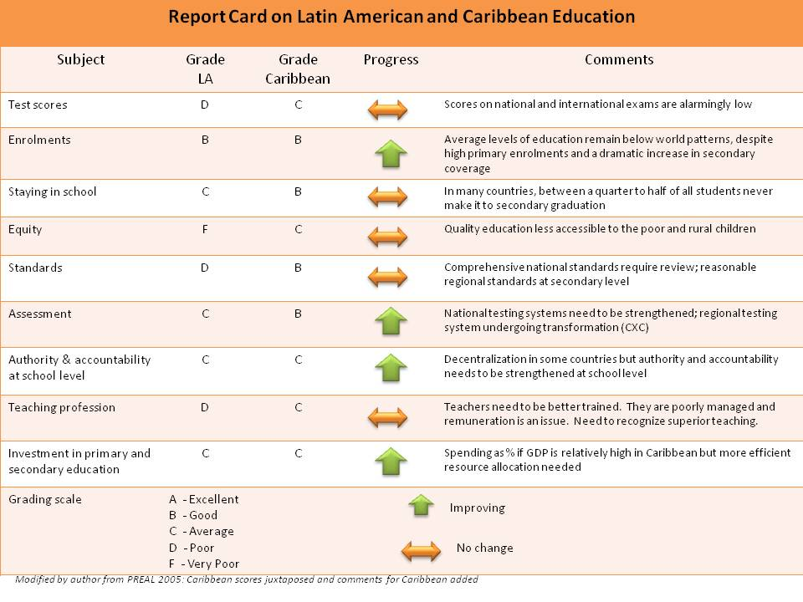

    - Main problems faced by secondary education in the Caribbean

Education systems in the Caribbean evolved from elitist colonial constructs and their evolution has generally followed an expansionist trajectory. It has been essentially about the widening and broadening of access to an existing structure with sporadic attention to issues of quality and relevance. Reform initiatives have not –until recently – raised fundamental questions about the purpose, content, and modalities of education in contemporary society. In few countries has there been any systemic attempt to articulate the developmental and aspirational agenda of the society with the purpose, function and delivery of education. The most ambitious efforts in recent times have included St. Lucia (ESDP, 1999), Grenada (SPEED, 2005) and Trinidad & Tobago (Vision 2020, 2006).

Several studies have identified the main problems affecting secondary education in the region. They include:

- Low levels of achievement:25-30% of secondary students do not acquire the basic cognitive skills to benefit from secondary education
- High levels of attrition (calculated at approximately 50% after age 15)
- Access and coverage of education especially for post secondary and tertiary education constitutes a bigger challenge since the attainment of USE
- Effectiveness of education particularly at the secondary level. Only a portion of the intake at secondary school actually gets to sit the Caribbean Secondary Education Certificate (CSEC) and only about 40% of that cohort obtains acceptable grades in the higher ranges. While overall performance in the CXC CSEC has shown improvement over time, serious weaknesses continue to manifest in core knowledge domains (English and Mathematics).

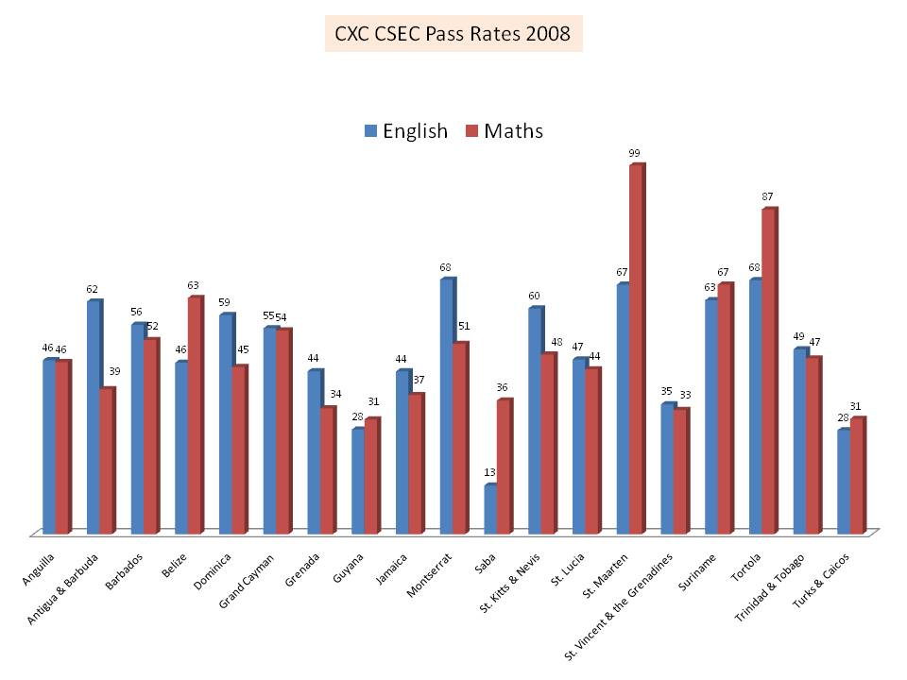

- The outcomes of secondary education (as measured by CXC examinations) need to be scrutinized. An analysis of students writing CXC (Caribbean Examinations Council) examinations in 2009 shows that only 20% of those taking English Language had registered for English Literature or for foreign languages; 40% sat pure science subjects, and 31% in information technology. After five years of secondary schooling, an insufficient proportion of the cohort register for literature, pure science, a foreign language or information technology – essential requirements for survival in the knowledge era..
- Equity issues are gaining prominence as the global economic situation adversely impacts the region and the incidence of poverty increases. Several studies have shown that children from the poorest quintiles fare least in the system. In the past decade, the increase in private schools – while adding diversity and providing centers of excellence in national environments - has contributed to a growing stratification of schools.
- Gender equity is becoming more textured and complicated. A recent (2009) World Bank-Commonwealth Secretariat Conference on “Keeping Boys Out of Risk” highlighted the under-participation and under-performance of boys while noting the structural factors contributing to this problem.

    - Main Challenges Faced by SE Reform

The main challenge impacting on secondary education reform in the Caribbean at this conjuncture is the need for a reconceptualization of secondary education. Bloom & Hobbes (2008) have shown how the economic transformation of the Eastern Caribbean increases the demand for skills, but the education system is not adequately preparing young people for the new opportunities being created.

In the last decade, the Caribbean (like Latin America) has significantly improved access to secondary education. The attainment of universal secondary education has brought issues of quality and the debate on the purpose of education to the fore. Now that secondary education is available to all, the following issues now arise:

- What are the fundamental goals of secondary education?
- What is the matrix of skills, competencies, and attitudes that secondary schooling should provide?
- How are differentials in learning pace and ability to be handled?

The entry of a larger and more diverse school population with a greater range of ability into the secondary education system necessitates that these challenges are addressed if quality is to be assured in that sector.

  - Empirical picture of Youth in the Caribbean

In this paper we adhere to the definition of youth utilized by the World Bank as persons between the ages of 10-24. Regional statistics show projected declines in the population aged 0-15 from about 45% of the total population in 1970 to about 25% by 2020.

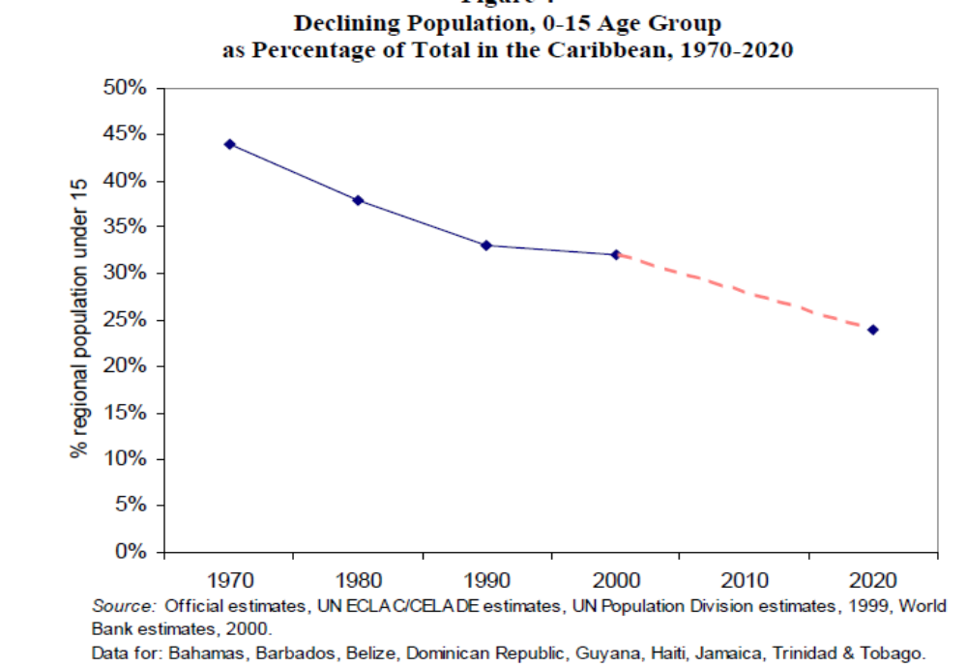

Conversely the population of over 16 year olds is projected to increase (dramatically in some countries):

“The size of the population 16 and over is projected to continue to increase ranging from 12% in Barbados to 119% in Belize. This situation poses enormous challenges, for the Region, first, in terms of provision of post–secondary level education and training and continuing education to ensure the competitiveness of the working population, and second, with respect to employment generation”

In light of the extremely adverse impact of the global economic recession, the challenge of this demographic is even greater. The 16-24 age cohort constitutes the most vibrant component of the population on the cusp of the world of work. The extent to which this cohort successfully completes secondary education will determine whether it constitutes a new, better skilled workforce or becomes a significant disaffected and socially disenfranchised grouping that will compound the crime situation.

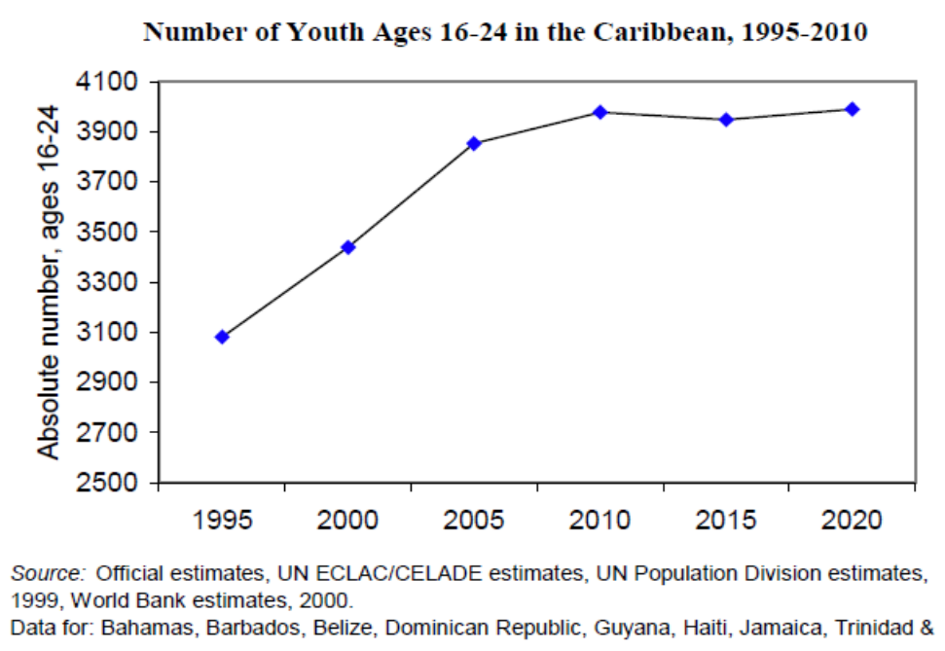

In the OECS countries, the services sector of the sub-regional economy has shown the greatest growth rate since 1980 and now account for almost four-fifths of the economy (Bloom & Hobbes 2008). Participation in a service economy is facilitated by a secondary level education. St. Bernard (2003) pointed to the “noteworthy association.. between exposure to secondary education and participation in clerical work or sales and services activities”

The Strategy for Poverty Reduction in the Borrowing Member Countries of the Caribbean Development Bank – on the other hand -, cites evidence from the Bahamas, Dominica, Jamaica and St. Kitts and Nevis suggesting that “male teenagers with secondary schooling are more likely to be unemployed than those with lower levels of schooling: and a study on Jamaica reported that young males are less likely than females to translate secondary education into labour market success. These labour market conditions help to discourage investment in education by young people and severely limit opportunities for youth employment and development, and together with some aspects of popular culture, are thought to promote behaviours that put Caribbean youth at risk of social and economic deprivations”

  - Relevant Debates on SE Reforms and their Evolution

The Caribbean Development Bank, the World Bank, UNESCO, and the OECS Education Reform Unit have made major contributions to the debate on secondary education reform in the region and studies carried out by these organizations have helped frame the issues.

The Education for All mandate that was fostered and promoted by the multilateral agencies represented a paradigm shift in education policy internationally. From its earliest postulation in Jomtien, the Caribbean region argued for the notion of basic education to be inclusive of secondary education since in virtually all countries of the region, provision for primary education was already universal. It was also argued that the emerging global service economy necessitated secondary education as the new benchmark for “basic” education.

Notwithstanding the philosophical consensus on universal secondary education as a developmental necessity for the Caribbean, there was much debate on the operational challenges and the modality of its implementation. There was resistance from various stakeholders to what they portrayed as rushed implementation of universal secondary education. The central issue in this discourse focused on quality considerations: that governments have been more concerned about inputs than outcomes; that success has been measured more by increases in enrolment rather than the extent to which children learn. Moreover accountability for student performance is weak and few systemic changes have been introduced to ensure this. The major demographic shift inherent in USE required that attention be also paid to other formative factors such as:
- Teacher preparation :preparation and upgrading of teachers for content mastery as well as pedagogic competence
- Content of secondary education: determination of core curriculum and
- Special needs: catering for students with low achievement records to provide the remediation necessary to ensure success

These considerations could not however be used to postpone what was an historical imperative. The future cannot be resisted, it can only be invented. The crisis of the current global conjuncture provides that opportunity to re-invent and to converge youth policy with secondary education.

  - Responsibilities of Key Stakeholders

Any effort at re-invention of education in the region must involve the creation of more participatory mechanisms for engagement of stakeholders. Education is an arena of social engineering that is too high stakes to be left solely to the state. Other key stakeholders must play a role in its governance, its processes of accountability, and its mechanisms of allocation to ensure equity, fairness and to share responsibility. In virtually all of the Caribbean, religious authorities have historically played a key role alongside the state in providing and managing education. There is therefore a precedent of shared authority: this needs to be broadened and deepened by engaging families, teachers, students, and the community (civic and business).

- Major Issues Affecting Youth in the Caribbean

  - Main Social and Educational Issues Affecting Caribbean Youth

Despite historical, political, cultural, and linguistic diversity, the negative outcomes observed among Caribbean youth are quite similar. These include early sexual initiation, HIV/AIDS, sexual and physical abuse, school leaving (dropout and exit), unemployment, crime and violence, substance abuse and drug dealing, and social exclusion

A major social issue is the growing and unacceptably high levels of poverty and inequality in the region. Thomas and Wint (2002) have noted the comparatively high income differentials between the richest 10% and the poorest 10% in Latin America and the Caribbean. The region’s ratios stood at 46 to 1 compared with 24 to 1 in Sub Saharan Africa and 15 to 1 in industrialized countries.

Poverty levels in the region
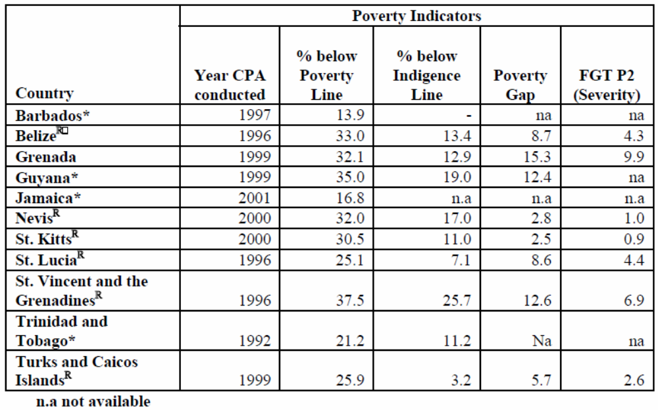
Source: Thomas and Wint 2002.

  - Trends and Projections

The social issues identified are growing in scope and complexity and increasingly the learning imperative in schools is being superseded by social dysfunctionalities. Schools are being impacted by early sexual initiation, deviant behaviour, domestic abuse, drug use, drug dealing and social inequity.

The levels of violence in the region have been increasing exponentially, largely fuelled by the increased demand for illicit drugs, and the victims of violence have principally been young persons (Franco 2005; Meeks 2009). In 2009, the reference below to Jamaica is true of almost every Caribbean country:

“Jamaica, already one of the most violent countries in the region, experienced a 50 percent increase in its murder rate from 2003 to 2004, largely a result of expanded gang and drug-related violence.”

While such manifestations have been the most notable, violence in society occurs at three levels: individual (e.g. domestic violence), societal (e.g. drug related killings, kidnapping, gang warfare) and structural/cultural levels (e.g. traditional institutional disciplinary modes). Attempts to address this phenomenon must therefore take these dimensions into account in order to move from a curative to a preventative approach.

  - Impact of these Issues on the Sustainability of Caribbean Society and Economy

Police records throughout the region show that most major crimes (murder, shooting, robbery, rape and break-ins) are committed by young persons between the ages of 16-30 years. Meeks (2009) cites Jamaica Constabulary figures which show that – over a three year period 2004-2006 –, almost 1,000 incidents of major crime were committed each year by 21-25 year olds with 16-20 year olds accounting for the second highest incident level (just under 800) for each of these years.

What the Caribbean is currently confronted with is not simply the escalating statistics of crime but the emergence of what Gordon Rohlehr calls a “Culture of Terminality”. This culture is a complex and potent brew of guns, drugs, money and violence: “Terminal people recognize guns and money as the dual bases for real power locally and internationally. Terminal men are involved in gangland executions, disemboweling, beheadings and scalpings!... The terminal man represents the end of society as one has known it”

When 16-20 year olds account for the second highest incidence of major crimes in the context of a spreading culture of terminality, the Caribbean is faced with an existential threat of the most urgent proportions that threatens the very survival of society. While empirical data to support this is scarce, Cunningham and Correia (2003) has provided some indications of the impact of these issues which are indicative of the trends:

- “A single cohort of adolescent mothers is estimated to cost society, in terms of forgone benefits from alternative uses of resources, more than US$2 million in St. Kitts and Nevis.
- School leavers in Guyana forgo hundreds of thousands of dollars in net earnings over their lifetimes, costing the state thousands of dollars in lost income.
- Youth crime and violence in St. Lucia generates more than US$3 million in lost benefits to society and US$7.7 million in lost benefits to private individuals annually.
- A 1 percent decrease in youth crime would increase tourist receipts by 4 percent in Jamaica and by 2.3 percent in the Bahamas.
- The financial loss to society due to AIDS deaths among those who contracted AIDS during adolescence ranges from 0.01 percent of gross domestic product (GDP) in Suriname and Antigua and Barbuda to 0.17 percent of GDP in the Bahamas in just the year 2000.
- If female youth unemployment were reduced to the level of adult unemployment, GDP would be higher by a range of 0.4 percent in Antigua and Barbuda and 2.9 percent in Jamaica.”

- Trends & Challenges in Secondary Education in the Caribbean

  - Summary historical trajectory of the emergence of USE in the Caribbean

Historically, performance levels in secondary education have been low. Over the thirty years since the Caribbean Examinations Council has offered the CSEC exam, an average of 52% of students entering have gained acceptable grades and the performance of boys in particular has been poor.

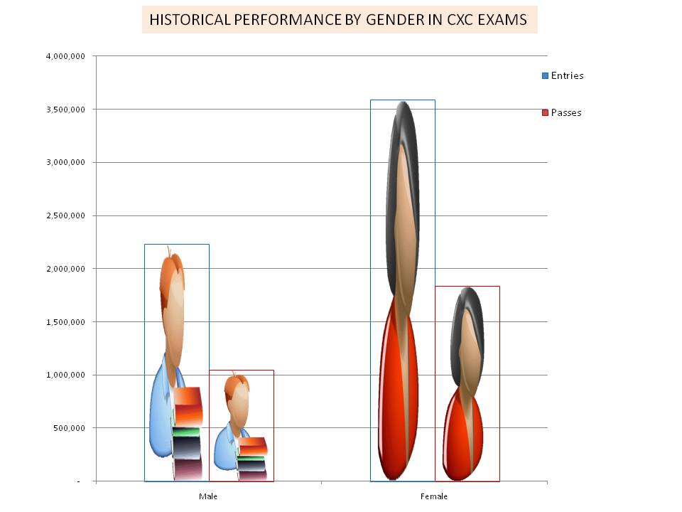
Source: CXC 2008

In the past few years, performance has incrementally improved but as the results for 2008 (represented in the graph below) indicate, this improvement has been borderlined. Acceptable or “passing” grades range from Grade I to Grade III.

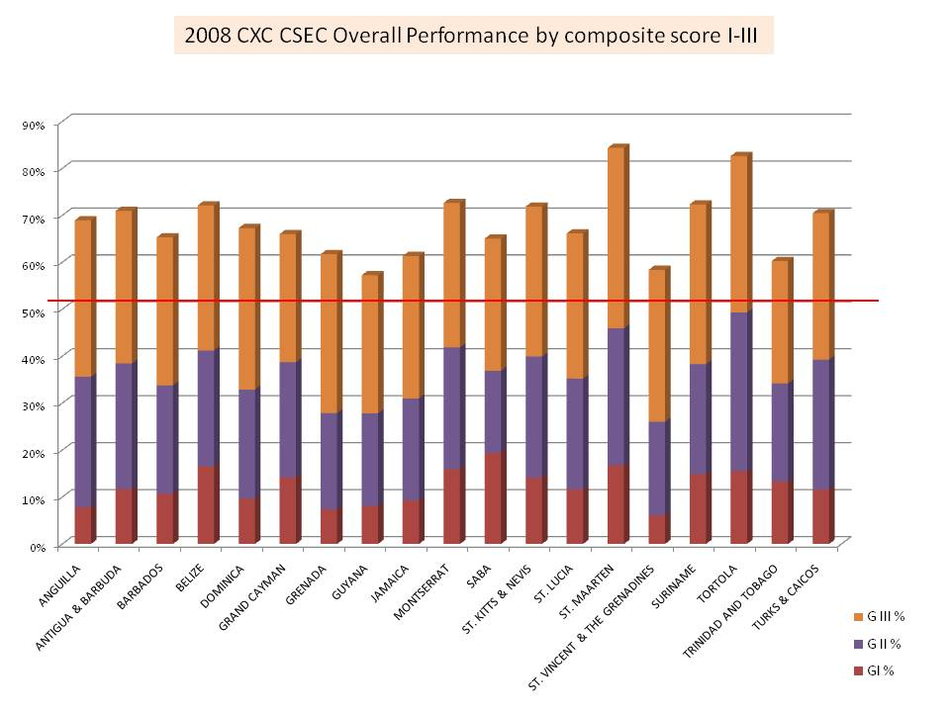
Source: CXC 2009

At first glance the statistics above look encouraging, but the reality is that Grade III, while considered to be a “passing” grade, represents borderline performance and the largest proportion of the acceptable grades are within this band. Improving achievement will require attention to this cohort in addition to those falling below the acceptable grade boundaries.

  - Challenges Posed by USE in the Region: Issues of Quality and Performance

    - Findings from Key Studies

Most of the studies done by multilateral and regional organizations on universal secondary education in the Caribbean highlight the following key concerns:

- Provision of quantity should not ignore the imperatives of quality
- Wider access necessitates a reconfiguration of the content and range of options in secondary education to cater for a more diverse mix of abilities and interests. In this context, the creation of opportunities for technical and vocational training, incorporation of the visual, theatrical and performing arts, availability of apprenticeships and work attachments
- The need to better define the early secondary curriculum (years 1 – 3 of the 5 year program) and articulate it with the regional standards embodied in the CXC CSEC.
- The need to address affective concerns – enabling students to handle conflict resolution, social relationships (esp. Gender sensitivity), self esteem, work ethics and the soft skills that enhance employability. Associated with this are recommendations for the provision of guidance and counselling services to secondary schools.
- Recognition of the value of supportive social and institutional networks that address adolescent issues in helping secondary schools provide for a more holistic educational experience.
- The importance of short term instructional improvement mechanisms such as remedial instruction to maintain or improve quality in the early transition stages to USE
- The strategic necessity of providing better quality inputs into an expanded secondary education sector more than just building more schools, is the need to train specialist teachers, provide adequate learning resource material/facilities (including libraries, laboratories and workshops)
- The importance of benchmarking to international standards, of tracking indicators and of the utilization of statistical indices to drive decision-making in educational planning
- Management capabilities were highlighted reflecting the need for a more sophisticated approach to school leadership (from creation of instructional departments to participatory management structures). Studies have also shown that the type of school including its form of management is one variable that is consistently related to educational achievement.
- Studies have shown that socio-economic status had a significant effect on CSEC performance.
- Engagement of parents and community resources to create a more positive enabling environment in the school and a more symbiotic relationship with the community.

  - Comparative view of issues in Secondary Education in the Caribbean and the rest of the hemisphere

Secondary education in the Caribbean shares some common ground with the experience in Latin America but it differs in some important respects. All of the issues referred to earlier arising from studies done in the Caribbean are generally shared with Latin America – they are best practice advisories. Gender patterns of participation and performance approximate in both contexts. Education systems in both environments tend to be highly centralized (despite some experimentation with decentralized models) with weak levels of school autonomy on vital questions of staffing, and budget and resource control.

Among the most significant areas of divergence between Latin America and the Caribbean include the following:

- While both regions experience unacceptably high levels of poverty, the inequality gaps are larger and more pronounced in the Latin American context. In the Caribbean, the more pronounced gaps are the income brackets (as opposed to racial or ethnic or geographic distinctions).
- The urban-rural divide is also more pronounced in the Latin American context. Urban schools in the Caribbean tend to be better resourced than their rural counterparts, but access to secondary education for rural residents is more available.
- National and regional standards have taken greater root in the Caribbean and at the secondary level, the CXC examinations have become the de facto standard (the Caribbean Secondary Education Certificate celebrates its 30th anniversary this year!).

  - Experiences in secondary education reform

Early secondary education reform in the Caribbean tended to be sector specific reform. Many of these efforts tended to be projects undertaken with donor funding from specific multilateral or bilateral agencies and concentrating on internal change in the sector.

Only in the last decade have new reform initiatives emerged which contextualize secondary education within a systemic transformation agenda either at the national level (as in the creation of national education sector reform plans in St. Lucia, Grenada, Trinidad & Tobago) or at the regional level – the OECS Education Reform Strategy. A central argument of this paper is the advantage of strategically contextualizing secondary education reforms with a broader transformation agenda, as it enables better articulation with other sectors of education and enables new synergies in education.

The graphic below summarises the elements of secondary education reform that are contained in the OECS Education Reform Strategy:

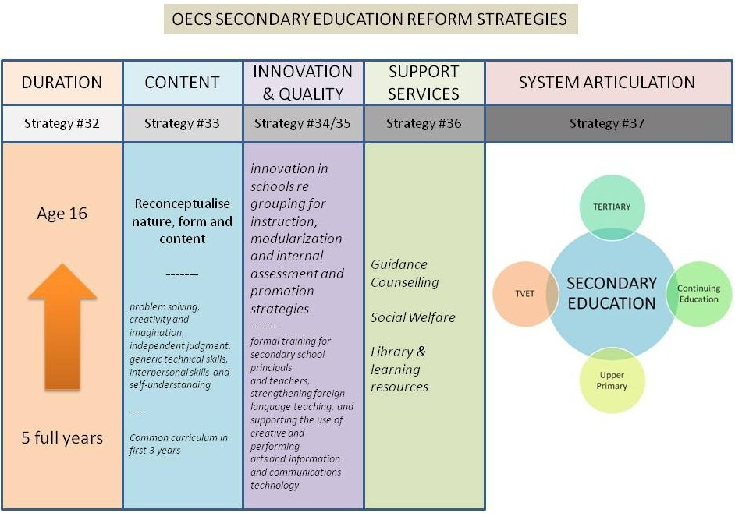

The OECS Education Reform Strategy contains several major recommendations related to the improvement of secondary education (Strategies 33-37). These range from ensuring that secondary level students receive a full 5 years of instruction to the reconceptualization of nature, form and content of secondary education. The changes in this aspect correspond to the UNESCO imperatives for learning in the 21st Century (incorporation of problem solving, critical thinking, creativity and judgement, generic technical skills, interpersonal skills and self understanding). The strategy also calls for and describes a range of innovations in secondary education necessary to modernize its content (ICT, foreign languages, modularization of curriculum) and to address social issues (guidance counselling and social welfare).

- Creating Opportunity for Youth

“Crime and violence will continue to thrive where rule of law is weak, economic opportunity is scarce, and education is poor. Therefore, effectively addressing crime requires a holistic, multi-sectoral approach that addresses its root social, political, and economic causes” – Adolfo Franco, USAID

The testimony of the USAID official to the US Congress cited above brings into focus the three most essential elements in creating opportunity in society: the rule of law, economic opportunity and good education. It also implies the justification for making the education system the focal point for multi-sectoral approaches to youth development.

  - Identification of Comprehensive Framework for Impacting Youth Opportunities in Every Sector with Education as the Focal Point

Many seminal recent studies (Cunningham & Correia 2003; St. Bernard 2003; Bloom & Hobbes 2008) have emphasized the importance of addressing deficiencies in the secondary education system in particular and the need to ensure higher levels of achievement as well as a more convergence between the requirements of the labor market and the outcomes of education. The encouragement of self employment options is also seen as vital to addressing this problem (a good example of which is the Youth Training & Employment Partnership Programme – YTEPP in Trinidad & Tobago).

Studies on youth (particularly those related to violence and youth at risk) have similarly called for integrated, multi-level, multi-sectoral interventions targeted at the underlying causes of these social dysfunctions. The scale of the problem has also necessitated a paradigm shift from interventions targeting individual cases of delinquency to interventions that also seek to change the social and economic environment. Secondary education can benefit from these findings because addressing its learning and social imperatives also requires integrated, multi-level and multi-sectoral interventions.

Drawing from the major studies done within the last five years, a comprehensive framework for addressing should have the following features:

- Treat the education system as a continuum: recognizing that difficulties and deficits at any level invariably are manifestations of earlier failings in the system. Addressing quality at secondary schools is not ultimately attainable if attention is not paid to learning fundamentals at primary school level.
- Differentiate the threat levels of at-risk youth: while there are many symptoms of risk, the underlying factors are common. A three tiered framework has been proposed (Barker & Fontes 1996) that defines a continuum of risk categories moving from primary to secondary to tertiary levels. Primary risk is a general exposure resulting from poverty and other social conditions. Secondary risk escalates the threat to more specific exposure while tertiary risk represents movement from being at risk to actually being impacted by adverse social situations.
- Incorporate the four interrelated levels of causality, impact, and intervention: individual, interpersonal, institutional and structural levels. Arising from an ecological framework for understanding violence developed for the Urban Peace Program by the World Bank, this facilitates the formulation of multi-layered interventions.
- Address the needs of youth holistically and within the context of their families, peers, schools and neighborhoods.
- Recognize gender and other social differentials during assessment, design, and evaluation
- Involve the participation of youth as well as their parents and families, from the early phases of the program onwards.
- Involve multi-agency collaborative approaches and obtain diversified support from public and private sector sources.

Schools can play a powerful protective role in the development of young persons and institutionally they can also function as important arenas of integration of social policy. The secondary education system in the Caribbean is well placed to be a focal point for the implementation of a comprehensive, integrated and multi-sectoral youth development initiative.

The main components of this initiative (which draws upon, synthesizes, and innovates from major recent studies) are described below:

KEY ACTIONS | INTERVENTIONS
Reform the Education System | - Define a coherent regional education reform strategy synthesizing the strategies already in place at the sub-regional and national levels
 | - Renewed attention to Learning Basics in primary education to eliminate inefficiencies at secondary level
 | - Reconceptualise secondary education to ensure equal attention to both cognitive and affective domains of learning
 | - Improve the quality of secondary education by mandating a core secondary well rounded curriculum that is inclusive of skills development, physical education and sports, ICT, citizenship.
 | - Support key reforms in secondary education by reform of regional examinations to reflect the new focus and to give value to non-traditional objectives
Strengthening the Affective Domain in Secondary Education | - Require secondary schools to engage students in civic initiatives and community development projects (learn responsibility by taking responsibility
 | - Establish democratic student governance structures in all secondary schools and engage them in taking responsibility for student achievement in all spheres
 | - Review the CARICOM Health & Family Life curriculum for secondary schools; embed this subject in the CXC CCSLC certification and include in core mid-secondary curriculum
 | - Train and re-orient teachers in student centered pedagogy
 | - Utilize student surveys as a means of soliciting and measuring student feedback on school performance and their engagement in the education process
 | - Incorporate the teaching of diversity, cross-cultural understanding with foreign language learning and the promotion of Caribbean unity and global citizenship

KEY ACTIONS | INTERVENTIONS
Maximize the protective effects of schools | - Encourage student led information and education campaigns on health, positive lifestyles & well being issues; drug, alcohol and substance abuse; violence and conflict resolution; sexual abuse.
 | - Offer customized programs to build self esteem and self efficacy (as part of a life skills program to at-risk students).
 | - Promote the formation of student interest clubs in the widest range of social, recreational, sporting, and other interests; require all secondary level students to be active members of at least three student clubs of their choice.
 | - Revitalization of traditional school organizations such as Scouts and Guides, Red Cross, Cadet Corps, School House Systems, Junior Achievers for positive forms of association.
Delivery of vital support services through schools | - Implementation of health promoting schools concept; the school as a focal point for preventative health education and practice (inoculation campaigns etc); access to vital medical care (e.g. dentists).
 | - Upgrading of public health care systems “by establishing new protocols, tools, and techniques for reaching youth and their families”.
 | - Provision of confidential access to Student Counselling Services.
 | - Encouragement of mentoring programs involving peer mentoring as well as by professionals and community leaders; support and incentives to effective programs and their institutionalization.
 | - Provision of school feeding in areas of poverty concentration and/or for students of disadvantaged backgrounds.
 | - Creation and maintenance of monitoring protocols for youth at-risk indicators to support targeted interventions.
Strengthening community and neighbourhood support structures for adolescents and their families | - Creation of competitive youth funds to finance NGO and community based youth initiatives
 | - Involvement of the local private sector in supporting (with appropriate incentives) youth development initiatives.
 | - Coordination with Ministries of Sports and national sporting associations to create competitions and events utilizing sport as a medium for constructive competitiveness and positive social values.
 | - Involvement of local and national clubs and associations in school projects and adoption (Lions, Kiwanis, Rotary as well as national sports associations).
 | - Establish community policing programs including involving Police in after school sports and homework clubs in at-risk communities.

KEY ACTIONS | INTERVENTIONS
Use of the media and social marketing to address key risk areas | - Engagement with media on sexual abuse and exploitation, early sexual initiation, corporal punishment and physical abuse, and substance abuse.
 | - Support to student led media (e.g. The Student Press in Trinidad & Tobago – an online student magazine) to convey positive youth values and highlight youth accomplishment.
 | - Utilization of existing social media especially in online and mobile technologies to create safe, positive cyber locations for youth expression.
 | - Use of theatre and performing arts programs in schools to strengthen student self expression and promotion of community outreach.
Reform and strengthening of legal, judicial and policing systems | - Review and harmonization of laws, strengthening of family courts, training of legal practitioners, modernizing of the courts, and use of alternative custodial sentences, increasing the control of weapons, and reforming the police.
 | - Mobilization of community activists in school truancy monitoring and alliance with electronic media to create environment of accountability by parents.
Making families and fathers a top public policy issue | - Creation of incentives to encourage parental accountability for their children; and particular attention to incentives to strengthen father’s rights and responsibilities.
 | - Teaching of parenting skills to at-risk parents through a variety of public education modalities.

  - Identification of Synergies from Integration of Approaches

A long history of standalone interventions seeking to address problems of youth at risk have failed to mitigate the dangers. Faced with a concatenation of problems, it is clear that only by integration of effort can we hope to get meaningful results.

Focussing on the school as a locus of concentrated action makes the challenge more manageable. Although the school is inextricably tied to the dynamic of the community; it is a sufficiently resilient eco-system to make such interventions feasible, possible and successful.

The graphic below (modified from a World Bank conceptualization of what makes for good education outcomes) provides a succinct map of the matrix of relationships that contribute to desirable outcomes:

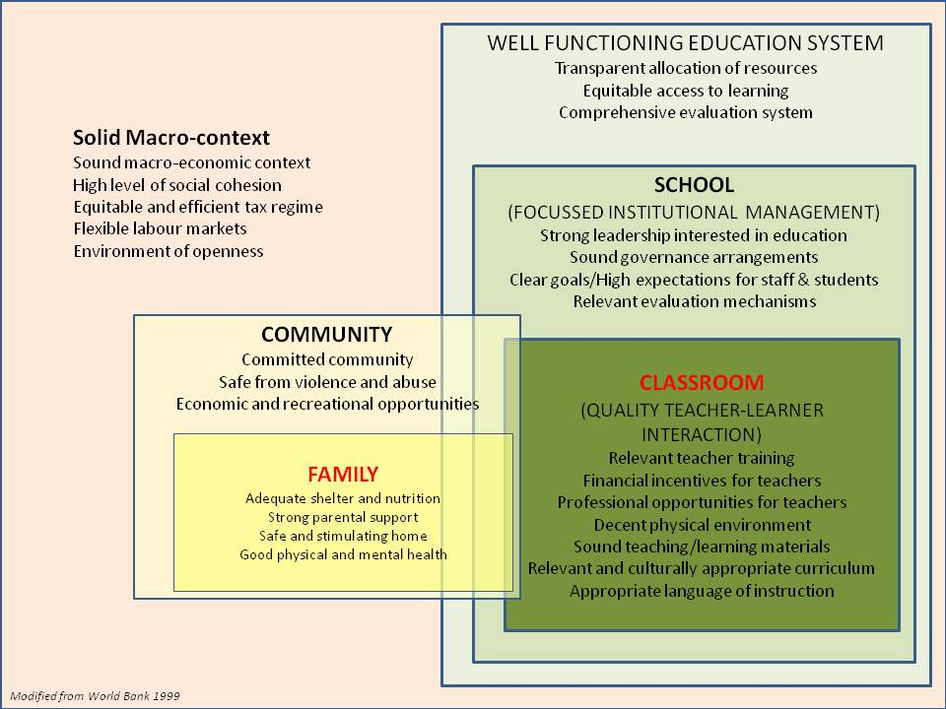

The central challenge in secondary education in the Caribbean today is that of simultaneously making learning at that level relevant to the demands of a new global knowledge economy while shaping new mindsets capable of affirmative responses to the social and cultural challenges of this new era.
In short, it is the challenge issued in UNESCO’s prescient definition of learning imperatives for the 21st Century: learning to learn, learning to do, learning to be and learning to live together.

  - Opportunities for Rationalizing Existing Programs

Too many youth and education initiatives focus on single issue concerns – e.g. the boys at risk issue. The most urgent need is for the articulation of a comprehensive strategy that weaves these disparate threads into a cohesive, multi-sectoral effort.

Integrating youth development with secondary education reform provides an opportunity to address the deficiencies of the education system in a comprehensive manner. Too often the rationale for new programs cite these deficiencies but their discourse appears to accept the persistence of these failures as an on-going feature of the education system, while put new mechanisms in place outside of the system to address the shortcomings. The education system (and in particular the secondary education sector) engages the largest demographic of youth and its shortcomings must be confronted in a transformative manner rather out of remedial necessity.

To accomplish this, our schools must reinvent themselves and they must step beyond the traditional mould and mobilize youth around civic engagement, democratic participation and entrepreneurial initiative; their pedagogy must also include learning to do and their focus must also include learning to live together. Youth clubs and organizations in schools and in community must converge so that they provide the continuum between the two necessary to give relevance to education and to add value to community service. Many elements of CXC’s new strategic thrust are aimed at enshrining these principles in a new assessment paradigm.

- Imperatives for Change

  - Outline of a minimum framework for action by regional governments

Given the projected increase in the working age youth population, St. Bernard (2003) warned that “increases in rates of unemployment could intensify if there are inadequate initiatives to increase the demand for labour to at least meet projected increases in the supply of youthful labour.” While Caribbean governments are generally preoccupied with generating higher employment in the economy, tacking the issue of youth unemployment must assume top priority in this effort. He further argued that female youth unemployment be given specific focus.

The continuing global economic crisis is threatening to reverse many social and economic gains achieved by the region. Average per capita GDP growth in the Caribbean during the period 2003-2008 has been 3% per annum – according to ECLAC; no similar growth period has been seen for 40 years. All of this progress now stands at risk. Since the crisis, unemployment has increased especially among the youth, job prospects for school leavers are increasingly remote, remittances from abroad have dramatically shrunk, 6 out of every 10 urban jobs are in the informal sector, low intensity conflict and violence have increased, with the spread of the drug trade.
.

It is this reality that constitutes the imperative for change and the recommendations made with respect to key actions and interventions should be considered to be the priority interventions required.

References

Armstrong. L.C, Jules, D. and Miller, E. (2000) Caribbean Education Strategy 2020. Washington D.C.: The World Bank

Bloom, A and Hobbes, C. School and Work in the Eastern Caribbean: Does the Education System Adequately Prepare Youth for the Global Economy? Washington: The World Bank.

Caribbean Development Bank (2001) Strategy for Poverty Reduction in the Borrowing Member Countries of the Caribbean Development Bank. Barbados: CDB

Cunningham, W. and Correia, M. (2003) “Caribbean Youth Development: Issues and Policy Directions”. Washington D.C.: The World Bank

Delors, J. (1996) “Learning: the Treasure Within”. Report to UNESCO of the International Commission on Education in the 21st Century. Paris: UNESCO.

di Gropello, E. (2003) “Monitoring Educational Performance in the Caribbean” Washington: World Bank.

Hinds, H. (2007) “Universal Secondary Education in the OECS: Policy and Access, Quality and Rewards” St. Lucia: OECS-OERU.

Jules, D., Miller, E., and Thomas L. (2000) Pillars for Partnership ad Progress: The OECS Education Reform Strategy 2010. St. Lucia: OECS

Jules, D. (2009) “Draft Concept Paper for the Development of a CARICOM Strategic Plan for Primary & Secondary Education Services in the CARICOM Single Market and Economy”. Trinidad: ALJ School of Business.

ILO (2007) Decent Work and Youth. Port-of Spain: ILO Regional Office for Latin America and the Caribbean.

Meeks, J. (2009) Caribbean Children’s Involvement in Gangs. Presentation at Teleconference on research activities, UWI Open Campus. At: http://www.open.uwi.edu/academics/Resources/Carib%20Children%20&%20gangs%20CSDR%20conf%2030jun09.pdf

Moser, C. and van Bronkhorst, B. (1999) Youth Violence in Latin America and the Caribbean: Costs, Causes, and Interventions. LCR Sustainable Development Working Paper No. 3. Urban Peace Program Series. Washington: World Bank

PREAL (2005) Quantity Without Quality. Report of the Task Force on Education, Equity and Economic Competitiveness in Latin America. Washington: PREAL

PREAL (2001) Lagging Behind: A Report Card on Education in Latin America. Report of the Task Force on Education, Equity and Economic Competitiveness in Latin America. Washington: PREAL

Rohlehr, G. (1993) Folk Research – Fossil or Living bone? FRC Bulletin Vol. 3 No 2 July – Dec 1993. St. Lucia: Folk Research Centre.

St. Bernard, G. (2003) Human Resources Development and Labor Market Challenges: Empowering Caribbean Youth. Trinidad: SALISES, UWI

Thomas, M. and Wint, E. (2002) Inequality and Poverty in the Eastern Caribbean. Paper presented at the ECCB Seventh Annual Development Conference. St. Kitts: Caribbean Development Bank.

UNESCO Institute for Statistics (2005) Children Out of School: Measuring Exclusion from Primary Education. Montreal: UNESCO.

World Bank (1993) Caribbean Region: Access, Quality, and Efficiency in Education. A World Bank Country Study. Washington: World Bank

World Bank (2000). Trinidad and Tobago: Youth and Social Development - An Integrated Approach for Social Inclusion. Report No. 20088-TR. Washington D.C.: The World Bank.

ESSAY IV:
CHALLENGES TO THE UNIVERSALIZATION OF SECONDARY EDUCATION:
INPUTS FOR DEFINING EDUCATIONAL POLICIES

(Prepared by Dr. Inés Dussel⁵²)

Secondary schooling is going through a period of change. This level of education is facing demands that are quite different from those of a few decades ago. It was traditionally designed to prepare students for higher education, but today secondary school is also required to educate students for the labor market and to teach them how to become participating citizens, or in other words to give them the skills they need to use the new information and communication technologies, as well as technical and scientific training and a knowledge of the global culture.

These demands are not only external, but they also come from within the educational institutions themselves. In recent decades, school enrollment has grown at an accelerated pace in most countries in the region, and especially in the most socially disadvantaged sectors. This has triggered greater demand for educational institutions to attend to social sectors with fewer material and cultural resources. In many countries of the Hemisphere, conditions within the schools have also deteriorated, due to the economic crisis and the reduction or stagnation of government spending. The result is that secondary schools today are facing other social demands that used to concern only primary schools or were not even felt at all by educational institutions. Many secondary school students need to receive meals, food supplements, or economic assistance scholarships, in the form of either money, study materials, or clothing, and they need social support due to various family situations, or to problems of drug addiction or conflicts with the law. There is no doubt that there has been a significant growth in recent years of the need for schools to become “social centers,” in addition to teaching institutions.

Moreover, we are also witnessing a cultural transformation of enormous proportions that affects secondary education, for two reasons. In the first place, there is a reordering of priorities in learning, that particularly affects the specialized fields that were traditionally the basis of the encyclopedic curriculum of secondary schools. The classification of knowledge inherited from the 19th and early 20th centuries is being challenged by the emergence of new areas and the trend toward an interdisciplinary approach, that threaten the stability of the traditional disciplines. We have also witnessed an overwhelming rise in the idea of collective intelligence as opposed to “expert knowledge,” spurred on by the new technologies. This new approach advocates cooperative building of knowledge in collective environments provided by the new technologies (with Wikipedia being one of the preferred examples). In the second place, relations between generations have undergone a profound change: youth no longer accept adult authority without question, and they want an education that is relevant to them and that takes into account their interests, while at the same time they demand consensual codes for living that give consideration to their opinions and perspective. At the same time, teachers vacillate between stubbornly clinging to old forms of teacher authority and adopting innovative methods that are still being tried out in efforts to develop new pedagogic links and norms for a democratic life. There is still a debate about teacher training for secondary education and whether to put more emphasis on contents or to emphasize teaching strategies to face these new challenges.

It is therefore not surprising that despite improvements in coverage and years of school attendance, secondary schools pose serious problems of inequality in the education they offer, in addition to poor quality, high repetition and drop-out rates, and problems of disinterestedness and apathy among students, and of uneasiness among teachers. It should be noted that these problems are worse in poorer sectors of the population, who have gradually begun attending secondary schools in fits and starts, with what an Argentine socialist calls “a low-intensity school experience.” Some analysts maintain that the processes of selection and social exclusion that used to occur upon admission to secondary school are now happening within educational institutions, as a result of this combination of social situations and precarious institutional conditions. It is also important to note, however, that there are interesting and successful secondary school programs that have managed to improve the education and learning conditions of the students, although few have succeeded in doing so on a large scale.

What can be done to improve quality and equity indicators in secondary schools, and to ensure that they function in tune with the times? What can we learn from their successful experiences to help redefine educational policies for all schools? In this paper, we will review four challenges to secondary education, and will suggest educational policy alternatives for each one. These challenges include the following: the expansion of coverage to achieve universal education at this level; an improvement in the quality of teaching and learning; a modification of the organizational and curricular structure, to bring it back into line with contemporary demands; and, an improvement in the government’s capacity to intervene to manage these changes.

1) Expansion of coverage to achieve universal secondary education

SITEAL’s 2009 data show certain stagnation in the rate of growth in secondary school attendance. There are highly significant variations among countries, with some reporting over 80% of the school-age population attending school (Argentina, Bolivia, Brazil and Chile) and others that slightly exceed 50% (Honduras and Guatemala). However, as a general trend, we can see the efforts made in the past 20 years to include poorer social sectors, and a slowdown in this growth among the structurally poor sectors.

The education policy strategies that have proven most effective in promoting the expansion of coverage among the poor are essentially socio-economic ones- especially scholarships granted to families to keep their children in school and to delay their entry on the job market. Among the best-known cases is Brazil’s experience with school subsidies through its Bolsa–Escola Program, Mexico’s Progresa/Oportunidades Program, Chile’s Presidential Scholarship (Beca Presidente de la República) and the High School for All (Licdeo para Todos) programs, and Argentina’s Student ScholarshipPprogram (Beca Estudiantil). Evaluations carried out in Mexico, Brazil, Argentina and Chile show a positive impact of these scholarships on enrollment, although they provide inconclusive data on improvements in retention and academic performance. Virtually all of them espouse the idea that keeping children in school is the “counter-contribution” that families should make, especially for children who receive scholarships. In some cases, a certain minimum school performance is also required in order for the benefits to continue. In these cases, there is a tension between the meritocracy criterion (the scholarship holders must prove their merits) and the criterion of a universal right that is not subject to be revoked due to poor academic performance

There are also scholarship programs for specific groups. In Chile, for instance, an indigenous scholarship program has been in place since 1991, for youth traditionally marginalized from the school system. A few years ago, Mexico instituted the Scholarship Program to Support Basic Education for Young Mothers and Pregnant Youth (PROMAJOVEN), to reduce the drop-out rate for this population group, primarily in the rural sector, and to extend their school attendance until they complete their studies.

Jacinto and Terigi (2007), in their lucid review of Latin American experiences with measures to deal with inequalities in secondary education, pointed out certain factors that should be taken into account in scholarship policies for secondary school students:

- as far as the recipients are concerned, criteria for providing scholarships could be defined by individual or by school, along with certain conditions for granting them (indices of social vulnerability, geographical or territorial criteria, and educational and social risks). Each of these criteria has advantages and disadvantages, depending on the political and cultural environment in the countries, and they are decisions that represent policy actions with lasting consequences.
- from a management standpoint, overly centralized experiences have not proven beneficial, since contact with the recipients is lost. There are experiences of management by local or district governments that run the risk of becoming tools for cronyism. There are also experiences in which the schools themselves manage scholarship programs, but are frequently overwhelmed by the heavy workload these programs entail. The authors recommend “a combination of centralized management, with evaluation and monitoring capacity, together with a certain degree of decentralization, accompanied by the necessary support.”
- with regard to integration with other social policies, there is a lack of coordination with other types of support for families and neighborhoods to improve their living conditions.
- Insofar as coordination with other pedagogic measures is concerned, most of the experiences in the region have not managed to achieve integration with other pedagogic initiatives to improve the school experience of these youth. Evaluation of the impact of the scholarships on the learning process and on the advancement rates of the students is lacking.

It is on this last aspect that we believe efforts should be focused in the next stage. It appears to be increasingly important to integrate the parallel policies being developed. The challenges facing secondary school education today have clear social and economic dimensions, but there are also pedagogic and institutional aspects of the school proposal that should be reviewed if we are to make progress in achieving universal secondary education. If socio-educational policies are developed without considering the necessary pedagogic transformations, we run the risk of repeating the pattern of improving access while increasing repetition and drop-out rates, which have remained unchanged in most countries of the region in the past decade. On the other hand, if we promote these pedagogic transformations without reflecting on the scholarship, social support, and assistance policies required to guarantee that certain social groups remain in school, these new school models will not reach the social sectors that need to be included.

2) Improving the quality of teaching and learning

Efforts to universalize secondary education were accompanied by a growing concern to improve the quality of educational processes and their results. In most countries of the region, ambitious reform programs have been developed with a view to redefining school content, changing attendance conditions, improving relations with families, and reducing the drop-out and repetition rates. In Chile, for instance, the “Liceo Para Todos” [“High School for All”] program was created to establish a common baseline of competencies for all students and to define clear performance goals that could be required and evaluated by the school system and the population. Following a quasi-market approach to education, with families demanding quality education, and on the basis of government-supported measures to support teachers and improve school infrastructure, the expectation was that quality could be improved in this way. One particularly important component of this strategy is the structuring of a Linear Plan of Action, an institutional project with four dimensions: teaching practices; students’ needs; school management; and, the relationship with the environment. The strategy of institutional plans has spread throughout the region, with disparate results. In some cases, they have managed to coordinate the interests of the schools in a common direction, and have enabled them to plan and coordinate the action of the different players. However, in others, they have become empty bureaucratic documents that do not produce the expected results. The difference seems to lie in the ways in which the management teams lead the effort and in their ability to bring together the different interests.

In the case of Brazil, many school districts have promoted extending school, including weekends, to create new opportunities for education and socialization. The change in curriculum entailed a de-specialization of secondary education, and the addition of more electives and expressive or creative subjects. In the case of Uruguay, the 1996 plan introduced an “open” area called Adolescent Space, to include reflection time for youth during the school day. There have been similar experiences in some Argentine provinces in the past three years (Buenos Aires and Entre Rios). The inclusion of new subjects in the curriculum have provided space for new technologies and for reflections on adolescence. So far, no studies have been conducted to analyze what traditions are beginning to take shape in these areas, or what are the dominant teacher profiles, or the working methods being used, since these are new disciplines and are not related to areas of knowledge defined by academic university circles.

Following the major curricular reforms, and the perception of the difficulty in achieving substantive changes, administrations have begun trying out more limited approaches, instead of opting for a curricular change as the primary vehicle for transforming secondary education. Jacinto and Terigi state that it is interesting to ask what changes can be brought about without substantively altering the curricular organization. They observe that “new components can be introduced in the curriculum that make it possible to include subjects that are not in current study plans and that open up new options for educating students.”

An interesting element is the adoption of decentralized strategies directed to improve the quality of education. Two examples include Argentina’s Proyectos Educativos Institucionales (Institutional Educational Projects) and Uruguay’s Proyectos Educativos Liceales (Liceales Educational Projects), which focus on supporting schools, develop their own work plans based on unified and consensual goals. In a recent work, Flavia Terigi indicates that this type of strategy for institutional change has its limits if there is no reform in the ways teachers are hired, in the fragmentation in their workload, and in their professional development base.
All these elements can present constraints on the commitment to general pedagogical objectives which go beyond the classroom subject assigned to each teacher.

Another strategy to improve quality has been standardized evaluations. On the one hand, various countries in the region have joined in international evaluations that compare their performance with that of other countries. This is the case of the Program for International Student Assessment (PISA), that evaluates the educational systems of the member countries of the Organization for Economic Cooperation and Development (OECD), by assessing the performance of students in the 15-year old range. In the last PISA survey in 2006, the student performance of the participating Latin American countries (Brazil, Chile, Uruguay, Uruguay, Mexico, Argentina, and Colombia) was in the lowest 35% in science, mathematics, and reading. All were statistically below the OECD average. In the case of Chile, with the highest ranking in science and language, it achieved a significant improvement in its performance over the previous test conducted in 2000.

On the other hand, some countries have established quality measurement systems that include national census assessments once a year or every two years. These assessments provide more accurate data on the performance of different regions, social groups, or schools. In addition to Chile, which has had the SIMCE (Education Quality Measurement System) since 1988, a measurement that is taken annually, another relevant case is Colombia. Although it has not been applied on a regular basis (there were years when it was used continuously, followed by five-year lapses in the evaluation), Colombia formed a culture more conducive to assessment of learning than other Latin American countries. The tests are samplings that take performance in language and mathematics. In recent years, knowledge and an understanding of civic values have also been included in these assessments, in an innovative initiative with little precedent in the region. In the Peruvian case, the Unit for Measurement of Educational Quality has been working since 1996 on a standard evaluation that reaches students and teachers, although the most important experience with this evaluation was developed at the primary level. Peru participated in the PISA tests in 2001 and is looking forward to integrating into the 2009 plan.

Other types of quality evaluations at the secondary level, though indirect, are applied through state exams that are also taken when students graduate, and are used to determine the level of competence in different subjects. Notably in the case of Colombia, the state exams help in the selection process for admission into schools of higher education, but they also provide information on the quality of the education received by Colombian youth. Most of the standardized assessment systems do not entail “penalties” for students with poor performance, except in some cases where their results are part of a grade average that is a requirement for admission to university (specifically, Brazil and Chile use this system, in addition to entrance tests).

The evaluations show that the greatest differences are still attributed to socio-economic variables and the mother’s level of schooling. However, institutional and pedagogic conditions also appear as significant factors, including the climate of the school, the teachers’ expectations, the management style of the administration, the availability of materials, and the teacher’s knowledge of the material.

To what extent do evaluations help improve quality? The issue is controversial, and there is no single answer. For those who defend their importance, they say that standardized evaluations tend to “exert upward pressure” on the system, by inducing schools to compete for better results. Their critics argue that they institute a speculative culture and displace the core of education by procedures for approving tests, thereby losing the focus on significant learning. They also maintain that standardized evaluations limit the concerns of schools, and generate pressure to focus exclusively on the material to be evaluated, at the expense of other valuable learning that is not covered by the tests.

In short, the strategies to improve the quality of teaching and learning have included everything from far-reaching programs to reform the curriculum and academic system to promotion of institutional projects and adoption of standardized tests. These strategies vary widely in scope, but the trend seems to be to combine global policies to guide all institutions with more open formats (like the institutional projects), that can be adapted to each school and that favor the creation of local proposals to mobilize the school community to adopt better educational practices.

3) Modification of the organizational and curricular structure of secondary schools

Secondary schools are organized in different ways in the various countries of the region, although most follow certain common lines: a graduated structure, with standard grades or school years; a curriculum organized on the basis of subjects or disciplines; training and appointment of teachers associated with a specialty (mathematics, history, geography, literature, etc.); and, frequently a highly fragmented time schedule, with an encyclopedic curriculum that is not conducive to sustained interaction in a field of knowledge. In some countries of the region, teachers give classes in different institutions, which creates a weak relationship with the school and little commitment to or knowledge of the groups of students in their classes.

As we stated initially, this institutional and teaching structure appears to be out of step with the demands and dynamics of our contemporary society and culture. In this section we will review a few strategies for adapting schools to these new dynamics.

- Inclusion of new information technologies

As one of the new fields of knowledge that is being added to school curricula, ICT provides an interesting space for analyzing how the old structure and the new dynamics interact. Most curricula have included technology courses in their design, and they are frequently oriented to teaching commercial computer programs. In the case of Mexico, the teaching of core subjects is being renovated by using new technologies, such as EMAT, Teaching Mathematics with Technology, and EFIT, Teaching Physics with Technology.

All of the countries are making efforts to provide schools with educational hardware and software, although the growth rate of the private sector is much higher than public investment, and the rate of growth of connectivity and ownership of personal computers is increasing every year for families, even in low-income sectors. These growth rates probably indicate that this is one area where complementary efforts by the public and private sector should be promoted, and discussion should take place on the content to be taught in the schools and on how to establish sustainable conditions for contracting, maintenance, and repair for administrations. In the case of the Province of Buenos Aires, Argentina, a new post was created in secondary schools, known as EMAT (Specialist in Audio-Visual Means and Technology); this is a person who placed in every institution to solve technical problems with the available equipment. We believe that this technical support will be increasingly needed in schools, requiring a revision of staffing charts to include these new profiles in schools.

Moreover, there is also noteworthy course content produced on the web. In the case of Peru, there is the notable experience of a youth website that seeks to promote sex education (www.puntoj.com.pe). The Network of Latin American Educational Web Sites (RELPE) has been taking a leading position and has commissioned the development of content for different groups, including production of video games for teaching social sciences to youth. These incipient experiences show that it is essential to accompany the equipment provided with the production of content appropriate for teaching purposes, that also take up the challenges inherent in new technologies on interactivity, and include the aspects of play, adventure, and exploration, elements that were not part of the traditional approach to education.

In a study done two years ago, a secondary school teacher in Corrientes Province, Argentina, stated: “The problem with technology is that the students know more than the teachers, they run circles around us. The other day they said to me: ‘This is an MP3 copier.’ And I asked: ‘Where do you put the CD?’ ‘No, teacher!’ they said.... I felt stupid. What is to stop them from using them if they know more than we do?” This example shows the enormous distance created by the new technology, that inspires insecurity and reticence, when we reflect on the knowledge that is being circulated and produced in these new conditions. One of the educational policy recommendations that can be made is the need to include these subjects in teacher training, with the course content based on the actual circumstances and conditions encountered by teachers in the schools. It would also seem necessary to go further than the “Microsoft Office” curriculum, as the Englishman David Buckingham calls it. Secondary schools should teach other more important and lasting material than mastery of commercial programs that will soon become outdated. They should instead allow the students to become experienced, clear-thinking users of the new media, who are aware of their potential as well as of their limits.

- Strategies for adapting schools to other vital demands and circumstances of adolescents

In this section we will present the strategies that foster changes in the academic system, attendance records, older students, and revision of course schedules. The experience of the City of Buenos Aires, Argentina stands out here. In 2005, it proposed a system called “Re-Entry Schools,” for youth who had interrupted their secondary school education and required more flexible conditions for their courses and the organization of their school work. The graduation system is by individual classes, and not by year or grade. Course subjects run for four quarters, and not annually, as is usual in secondary schools. Attendance is also recorded by subject or curricular unit, and not by the day, allowing students who work to have a more open and flexible schedule. There are optional workshops and institutional assistance or monitoring provided by tutors of the students. These schools have had significant success in retaining their students.

In the case of attendance systems, Jacinto and Terigi refer to the experience of Uruguayan high schools, that base advancement of students on their grades, and exclude the requirement that they attend a certain number of days a year. There are similar experiences in Brazilian schools, with the adoption of “soft” or flexible rules that make it possible to adapt to other circumstances of students.

Finally, there are also proposals to extend the school year. In the case of Chile, there is a single extended school system, with 1,621 annual teaching hours. There is a similar example in Uruguay, where the weekly work load is 38 teaching hours.

- Including courses on youth and assistance for youth

The demand to include space for reflection on youth experiences first arose in the 1990’s, when there was a major wave of reforms at that level. Traditional secondary schools were based on the core subjects and the curriculum, and it was very seldom considered important to take into account the characteristics of the students being taught. Today, however, when most of the cultural practices of youth are not part of what is being taught in the schools, according to Buckingham, it is critical to build bridges between youth culture and the school.

We referred earlier to the Uruguayan experience of including a course on “Adolescent Space,” as a space open to institutional definition. Most of the teachers hired were younger professionals of informal education, whose less academic experiences helped to renovate the teaching staff.

In the Argentine case, in 1999 Youth Activity Centers were organized in an increasing number of secondary schools, where alternative educational experiences were offered. The definition of each institution was also regarded as open space, with national financing that sought to introduce youth issues into the schools. For instance, art workshops were organized, in addition to workshops on sex education, technology, journalism, and the media. In 2003, a secondary school evaluation was conducted that showed that although these programs were highly valued by students as a way of expressing themselves and learning about other artistic and personal subjects, a significant part of the Youth Activity Centers remained outside the school agenda, and operated as an adjunct to the “official” life of the school.

Another program aimed at involving youth in the curriculum has been is place in Argentina, in the Province of Buenos Aires since 2007. It is meant to create a new course subject on “Building Citizenship.” Its objective is to “bring youth cultures into the school curriculum, on the premise that an educational proposal for adolescents should include their own practices.” The concept is that the curriculum should be defined together with the students themselves, and should focus on their ideas, interests, and knowledge. “Building Citizenship” covers the first three years of secondary school.

Another program for incorporating youth involves the organization of tutoring and assistance programs for students. It includes following their academic performance as well as assisting them with guidance in their social and emotional lives. In Mexico, as part of the secondary school reform, a Guidance and Tutoring program was established in the curriculum, to provide a comprehensive service to adolescents. In the case of Chile, there have also been experiences involving adult tutors in some regions, and the “Liceo Para Todos” program provides for tutoring among students, especially using as tutors the high academic achievement recipients of “President of the Republic” scholarships. These student tutors also take responsibility for the academic performance of their tutees. In Uruguay, there are also tutoring programs that are oriented more towards psychological and social guidance, with more formal initial evaluations and a follow-up with personalized intervention.

As highlighted above, one factor that limits incorporation of these new topics is the initial training of teachers from secondary schools that are trained with rigid subject classification (most of the times out-of-date regarding their subjects of specialty), and with little connection to concrete issues related to classrooms and youth. The in-service training moreover is often reduced to short courses that address isolated topics, whether focused on updating in academic discipline or specific problems related to classroom management. The most effective in-service training strategies with teachers are associated with their work at the school institution (on-going tutorials should be considered for current teachers), however, their elevated cost makes their scope difficult. It is recommendable to combine strategies for change in initial training of teachers at the secondary level, and to promote more interaction with real schools and with strategies that enhance in-service training that accompany teachers in their insertion to practice and that encourage teachers to remain open to continuous learning, in terms of updating knowledge, the use of new technologies, and new visions of society and nature.

In summary, strategies to reform the institutional and educational organization of secondary schools have taken various forms: incorporating new content (new information and communication technology, and youth problems); adding new staff, such as specialists in audiovisual and technology media, tutors to support and monitor students; and, adapting to new demands on the part of students attending secondary schools, who require more flexible attendance, advancement, and academic systems. Up to now, these latter experiences, that have shown promising signs of retaining and improving the learning of students, have been confined to pilot projects or programs limited to “at risk” population groups. A more systematic evaluation of their achievements and conditions for sustainability should be conducted, to determine if they could be made part of the school system as a whole.

4) Improvement in the capacity of the state to manage changes

In this last section, we will reflect on the capacity of education ministries and secretariats to manage and conduct education policies. After the wave of decentralization in the 1990’s, a good number of the central Latin American states were left with some powers to regulate and monitor the school system, but without direct management of schools. However, their management techniques did not always develop as necessary, and today there are still many obstacles remaining that hinder education systems from going in the desired direction.

In a recent study, PREAL pointed out that there are five major management problems in Ministries of Education: vertical policies that do not reach education centers; many programs and activities that have little impact; the fact that the processes and results expected of the schools have not been defined; weak supervisory systems; and, more general management problems linked to government bureaucracy.

The parallel action of various branches of Ministries is a factor pointed out in public management studies, and that is also reflected in the lack of coordination among education policies. The case of discrepancy between socio-educational policies and pedagogic and institutional policies referred to earlier is a good example of this. But a lack of coordination is also seen in different scholarship programs, or information systems of ministries, that are not always available for decision-making in other units or departments.

The proliferation of programs and projects is another issue for reconsideration. Although this was a useful strategy for introducing innovations during times of government stagnation, or in the case of teacher inflexibility, after two decades of project activism, it appears that this method for intervention has been more or less exhausted. The “special” program is perceived as a temporary experience, that will come and go in schools, and their ability to have an impact on the hard core of school life seems limited to the right occasion or persons capable of managing them. What are especially needed are systematic policies for assessment of the achievements and shortcomings of programs, that will lead to better decisions as to whether to continue or modify them.

It should also be noted that management problems are not related solely to the capacity of the ministries themselves. In the past two decades, there have been changes in the governance and integration of school systems that are evidence of more general transformations. A good part of western educational systems, based on democratic demands and rationales for more efficiency in the use of resources, have moved to decentralize management. The consequences of this transformation are unequal. A recent study on their impact in Argentinean secondary schools shows that, even though there is a positive general effect on students’ performance the poor sectors don’t receive these benefits. The emergence of locally and personally negotiated guidelines, to make up for the decline in the stronger vertical regulations of an earlier time, have created highly diverse institutional profiles in every educational institution. These profiles feature markedly different institutional visions, management styles, and capacities to mobilize “social capital.” The differences or similarities among institutions today are more random. There are schools attended by poor sectors with highly dynamic education programs, that offer an experience directly opposed to schools in the same neighborhood that are poorly run. Moreover, the organization of educational institutions is subject to negotiations, questioning, fluctuations, and mobility of students and families that were never experienced before.

In these circumstances, the very idea of an “educational system,” this key aspect that was regarded as part of something greater and more general with a specific orientation, seems to be undergoing a redefinition. Schools no longer identify so clearly with rigid top-down, vertical, centralized systems, although neither are they are part of more fluid networks coordinated on the basis of information flows. The prospect of systemic integration sometimes seems to fade in a situation where many activities and measures are not working towards a common vision, and the ideas and practices of the players appear limited by what the institution seems able to do. Units, whether involving individuals or institutions, seem to focus all the weight of decisions and responsibility on elections and results. This is not only misleading in terms of the real conditions for affecting these choices and results, but it also threatens to perpetuate inequalities in available social and economic capital.

In view of these tendencies, we believe that what is needed is to return to a certain systemic integration, although it cannot and should not involve rigidly structured and vertical systems. The state should recover its capacity to manage changes and provide general guidelines, among other reasons, in order to guarantee an arena for democratic discussion and for raising issues of the justice of distribution that only a common arena can entertain.

Throughout the document, several general recommendations have been made for secondary education policies, which we synthesize below:

RECOMMENDATIONS – SUMMARY

1) To expand coverage at the secondary level to achieve universal education, it appears to be necessary to integrate scholarship and socioeconomic support policies into pedagogic programs, which up until now have been developed separately in most countries. The challenges facing secondary school education today have clear social and economic dimensions, but there are also pedagogic and institutional aspects of the school proposal that should be reviewed if we are to make progress in achieving universal secondary education. If socio-educational policies are developed without considering the necessary pedagogic transformations, we run the risk of repeating the pattern of improving access while increasing repetition and drop-out rates, which have remained unchanged in most countries of the region in the past decade. On the other hand, if we promote these pedagogic transformations without reflecting on the scholarship, social support, and assistance policies required to guarantee that certain social groups remain in school, these new school models will not reach the social sectors that need to be included.

2) The strategies to improve the quality of teaching and learning have included everything from far-reaching programs to reform the curriculum and academic system to promotion of institutional projects and adoption of standardized tests. These strategies vary widely in scope and have different results. It appears to be necessary to have Global policies that guide all institutions (for example, changes in hiring procedure and teacher education); as well policies that promote a greater role for school institutions in the creation of local proposals to mobilize the school community to adopt better educational practices and greater accountability (through institutional projects).

3) We affirm the need to update the institutional and educational organization [of secondary education] to include newer forms of organizing knowledge and relations between generations. Education systems rely on a series of strategies that seek to incorporate new content (new information and communication technology, and youth problems); new staff (specialists in audiovisual and technology media, tutors to support and monitor students), and have adapted to new demands on the part of students attending secondary schools, who require more flexible attendance, advancement, and academic systems. Up to now, these latter experiences, that have shown promising signs of retaining and improving the learning of students, have been confined to pilot projects or programs limited to “at risk” population groups, and should be evaluated more systematically to consider their range/reach. At the same time, it becomes increasingly urgent to reform teacher education and training (structured, many times, in a rigid and outdated discipline classification and with little interaction with the concrete problems of the classroom and today’s youth) so that it bears more relation to the real practice of schools and strengthens teachers in their role as transmitters of an ever-changing culture.

4) Finally, it is necessary to set as an objective the improvement of the state’s technical capacity to execute these changes given the powerful centrifugal forces – some of them with democratic content and others, highly disorganized. It is advisable to keep systematic integration as an objective, which should not involve rigidly structured and vertical systems but should continue to affirm the will of an integrated society, among other reasons, in order to guarantee an arena for democratic discussion and for raising issues of the justice of distribution that only a common arena can entertain.

References

Andraca, A.M. de (2006). Programas de becas estudiantiles: experiencias latinoamericanas. Paris, IIPE-Unesco.

Braslavsky, C. (ed.) (2001). La educación secundaria. ¿Cambio o inmutabilidad? Análisis y debate de procesos europeos y latinoamericanos contemporáneos. Buenos Aires, Santillana.

Braslavsky, C.; Dussel, I, Scaliter, P. (2001). Los Formadores de Jóvenes en América Latina : desafíos, experiencias y propuestas para su formación y capacitación. Ginebra, BIE-UNESCO y ANEP-Uruguay.

Buckingham, D. (2007). Más allá de la tecnología. Buenos Aires, Manantial-

Dubet, F. (2004). “¿Mutaciones institucionales y/o liberalismo?”, en Tenti Fanfani, E. (org.) Gobernabilidad de los sistemas educativos en América Latina. Buenos Aires, IIPE-UNESCO.

Dussel, I., Brito, A., Núñez, P. (2007), Más allá de la crisis. Percepciones de docentes y alumnos sobre la escuela secundaria. Buenos Aires, Fundación Santillana.

Dussel, I. (1997). Curriculum, humanismo y democracia en la enseñanza media argentina, 1863-1916. Buenos Aires, Ediciones de la UBA/FLACSO.

Galiani, S., Gertler, P. y Schargrodsky, E. (2009). “Descentralización escolar: ayudando a los buenos a ser mejores, pero dejando a los pobres atrás”, en: Cueto. S. (ed.), Reformas pendientes en la educación secundaria. Santiago de Chile, PREAL.

Jacinto, C. y Terigi, F. (2007), ¿Qué hacer ante las desigualdades en la educación secundaria? Aportes de la experiencia latinoamericana. Buenos Aires, Santillana.

Jenkins, H., (2008). Convergence culture. La cultura de la convergencia de los medios de comunicación. Barcelona, Paidós.

Kessler, G. (2002). La experiencia escolar fragmentada. Estudiantes y docentes en la escuela media en Buenos Aires. Buenos Aires, IIPE-UNESCO.

Martín-Barbero, J. (2002). Jóvenes, comunicación e identidad. Pensar Iberoamérica. Revista de Cultura de la OEI No. 0, disponible en: http://www.oei.es/pensariberoamerica/ric00a03.htm (último acceso 06/25/2009)

OECD/OCDE (2004) Background OECD Papers: The Schooling Scenarios, Internacional Schooling for Tomorrow Forum, Toronto, Canada, Ontario Ministry of Education.

Pereyra, A. (2008). “Ingreso y abandono de la educación secundaria en América Latina”, Boletín SITEAL No. 2, disponible en: http://www.siteal.iipe-oei.org/modulos/boletinesV1/upload/7/boletin_02.pdf (último acceso 06/25/2009)

PREAL (2008), Desarrollo de la capacidad institucional y de gestión de los Ministerios de Educación en Centroamérica y República Dominicana, Documento PREAL No. 42, Noviembre.

Puiggrós, A. (2006). “Editorial”, Revista Anales de Educación Común No. 4, Agosto.

Tedesco, J.C. (2000). Educar en la sociedad del conocimiento. Buenos Aires, Fondo de Cultura Económica

Terigi, F. (2008). “Los cambios en el formato de la escuela secundaria argentina: por qué son necesarios, por qué son tan difíciles”, en: Revista Propuesta Educativa, Año 17, No. 29.

CIDI02637E01

Ricardo Villanueva, from Peru, has broad experience as an educational consultant in those areas related to management and evaluation of education projects.
The statistics extracted from the World Education Compendium (2006) include Argentina, Aruba, Belize, Brazil, Costa Rica, Dominica, Ecuador, Granada, Nicaragua, Panama, Peru, Uruguay, and Venezuela.
The study covers Ecuador, Mexico, Peru, and Dominican Republic.
At science level 4, students are able to deal effectively with situations and issues involving phenomena that require them to make inferences. They may select and incorporate explanations from different fields of science or technology and link these explanations with real life aspects.
The OREALC-UNESCO Regional Report is conclusive: “Education shortcomings are part of a social structure of systemic marginalization of certain population groups and, in this context, education is not only incapable of offsetting other social differences, but it is serving to reproduce them.”
The growing precariousness and insecurity of youth employment has two aspects: on the one hand, a reduction in real wages as a result of the restructuring of the labor market due to greater competitiveness; and, on the other, the difficulty for school graduates to acquire a range of skills that would serve to activate their strategies for work, either by starting their own business, or by entering the formal job market.
The expression refers to persons born during the information age, and who have become socialized at the time that internet-based technologies were proliferating.
According to Chacaltana and D. Sulmont (2004), employability is understood as the capacity to obtain and retain a job, the objective expectation that a person seeking work will find it, and, by extension, the series of qualities that enable an individual to be qualified to obtain and keep a job, and to adapt to its evolution.
Quoted in Dwyer (1995), p: 216.
A personal learning environment makes extensive use of online resources and organizes channels and sources of four information into four areas: i. Obtaining information; ii. Interaction, discussion, and collaborative analysis; iii. Production of one’s own knowledge; and iv. Storage and dissemination of information.
In Brazil, with the School Scholarship program of subsidies based on school enrollment, from 1997 to 2003, 60% of children from poor households who were previously not enrolled attended school.
This is the case with the Swiss Cooperation Agency and its Youth Job Training project (CAPLAB).
This attraction is based on different length courses, with differing entrance requirements, relatively flexible hours, and distinct exit profiles.
The high school program uses the methodology of socio-cultural development as an interactive working tool to stimulate and boost participation and integration processes, and cultural creativity and expression, creating bridges between the high school and the community. In theory, the institutional educational project that drives the curriculum in other Latin American countries should provide a frame of action for this approach.
The American Psychological Association systematized various pilot projects in the area of life skills in a training manual that promotes the use of the so-called “3 R’s” approach in secondary school: Reasoning, Resilience, and Responsibility.
In Colombia, the “Coexistence Model from the standpoint of Integral Prevention” project conducted by the Corporation without Borders in two communes of Medellin and the “Culture for Peace—Circles of Coexistence Methodology” project in Santuario, Antioquia, were reviewed .
In Peru, the project on “Helping to Improve the Sexual and Reproductive Health of Youth in Rural and Marginal Urban Areas”, which covers 50,000 students, was included.
Governments have established a procedure for accreditation of programs. Each program should include its conceptual framework, methodology, supports, evaluations, and expected results. In various communities, programs benefit from financing.
See PREAL (2005) for a sobering assessment of educational reform through 2006, with an emphasis on poor teacher training efforts and dubious cognitive gains. Hanushek and Woessmann (2009) make an intriguing, empirically substantiated argument about the relationship between low cognitive gains in education and low rates of economic growth in Latin America.
Censo Nacional de Docentes, 2004, cited in Ministerio de Educación (2008).
El Sistema Regional de Evaluation y Desarrollo de Competencias Ciudadanas (SREDECC). See: http://www.sredecc.org/index.php
Dr. Didacus Jules, from St. Lucia, is an expert in education in the Caribbean and is currently the Registrar for the Caribbean Examinations Council (CXC). Dr. Jules also holds a Ph.D. in Curriculum & Instruction and Educational Policy Studies from the University of Wisconsin-Madison (United States of America).
UNESCO Institute for Statistics (2005) Children Out of School: Measuring Exclusion from Primary Education. Pp. 25
World Bank Caribbean Education Strategy 2020
World Bank Caribbean Education Strategy 2020 p. xii
“Schools can help boys underachievement”, Commonwealth , May 7th , 2009 at http://www.thecommonwealth.org/news/34580/34581/191275/070509boysatrisk.htm
World Bank 2020 Strategy pp. 16
OECS comprises: Anguilla, Antigua & Barbuda, British Virgin Islands, Dominica, Grenada, Montserrat, St. Lucia, St. Kitts & Nevis, St. Vincent & the Grenadines
St. Bernard, G. (2003) Human Resources Development and Labor Market Challenges: Empowering Caribbean Youth. Trinidad: SALISES, UWI. Pps 8.
Strategy for Poverty Reduction in the Borrowing Member Countries of the Caribbean Development Bank. CDB 2001. Pp 4.
Cunningham, W. and Correia, M. (2003) “Caribbean Youth Development: Issues and Policy Directions”. Washington: World Bank Pps. xiv
Jules, D (2009) Global Realities and their Implications for Caribbean Education Systems. Address to the UWI Conference on Education. June 2009.
Testimony of Adolfo Franco, Assistant Administrator, Bureau for Latin America and the Caribbean, USAID Before the Committee on International Relations, US House of Representatives, Sub Committee on the Western Hemisphere, Wednesday April 20 2005. Gangs and Crime in Latin America. Pp. 5.
Rohlehr, G. (1993) Folk Research – Fossil or Living bone? FRC Bulletin Vol. 3 No 2 July – Dec 1993. St. Lucia: Folk Research Centre. Pp.27-28
Osuji 1987; Kutnick and Jules 1989 cited in World bank 1993. Pp 93.
Ibid.
The Reform of Secondary Education (ROSE) project in Jamaica funded by Government of Jamaica and the International Bank for Reconstruction and Development (IBRD) is one of the best known examples.
Cunningham & Correia (2003); Jules, D. (2009);
CXC’s new Strategic Plan outlines its intention to reshape its major exams to highlight the affective dimension and to give value to civic engagement, critical thinking and entrepreneurial expression
Cunningham & Correia (2003);
Moser & Bronkhorst (1999)
Cunningham & Correia (2003);
Moser & Bronkhorst (1999)
Moser & Bronkhorst (1999)
Cunningham & Correia (2003);
Cunningham & Correia (2003);
Includes the expansion of existing parenting programs such as the Roving Caregivers Program to better outreach to at-risk parents
Delors, J. (1996) Learning: the Treasure Within. Report to UNESCO of the International Commission on Education in the 21st Century
Barcena, A. (2008) Economic Outlook of Latin America and the Caribbean: Prospects 2008-2009. Washington: ECLAC.
OECD (2004) Background OECD Papers: The Schooling Scenarios, International Schooling for Tomorrow Forum, Toronto, Canada, Ontario Ministry of Education.
Martín-Barbero, J. (2002). Jóvenes, comunicación e identidad. Pensar Iberoamérica. Revista de Cultura de la OEI No. 0, disponible en: http://www.oei.es/pensariberoamerica/ric00a03.htm (último acceso 06/25/2009)
Tedesco, J.C. (2000). Educar en la sociedad del conocimiento. Buenos Aires, Fondo de Cultura Económica. Jenkins, H., Convergence culture. La cultura de la convergencia de los medios de comunicación. Barcelona, Paidós, 2008.
Braslavsky, C.; Dussel, I, Scaliter, P. (2001). Los Formadores de Jóvenes en América Latina: desafíos, experiencias y propuestas para su formación y capacitación. Ginebra, BIE-UNESCO y ANEP-Uruguay.
Kessler, G. (2002). La experiencia escolar fragmentada. Estudiantes y docentes en la escuela media en Buenos Aires, Buenos Aires, IIPE-UNESCO.
Pereyra, Ana, “Ingreso y abandono de la educación secundaria en América Latina”, SITEAL Bulletin No. 2, available at: http://www.siteal.iipe-oei.org/modulos/boletinesV1/upload/7/boletin_02.pdf (latest access 06/25/2009)
Andraca, A.M. de (2006). Programas de becas estudiantiles: experiencias latinoamericanas. Paris, IIPE-Unesco. The author indicates the existence of inconclusive data on the impact of the Scholarship’s Programs. One of the complicating issues is that in most of the cases economic support was supplemented with other strategies related to the distribution of resources and reorganization of schools which makes it difficult to isolate only one variable. Other aspects to consider are the general economic context and the contraction or expansion of the labor market: especially in the age group between 15 and 17 years. The pressure for early entry into the labor market competes with those efforts orientated to ensure their permanence at schools.
Jacinto, C. y Terigi, F., ¿Qué hacer ante las desigualdades en la educación secundaria? Aportes de la experiencia latinoamericana. Buenos Aires, Santillana, 2007.
Jacinto y Terigi, 2007, p. 154.
Pereyra, op.cit., who points out the exception of Chile, and Brazil and Peru to a lesser extent.
Jacinto and Terigi, op.cit. p. 65.
Idem, p. 61.
Terigi, F. (2008). “Los cambios en el formato de la escuela secundaria argentina: por qué son necesarios, por qué son tan difíciles”, in: Revista Propuesta Educativa, Year 17, No. 29.
Status of secondary education in Colombia. Document prepared by Corpoeducación to assist in determining policy guidelines for secondary education in 2003–2006. Available at: http://www.mineducacion.gov.co/1621/articles-85777_archivo_pdf3.pdf (latest access 06724/2009)
See the studies developed by the Latin American Laboratory for Quality Education Education, LLECE, of OREALC-UNESCO.
Terigi (2008), op.cit.
Dussel, I., Brito, A., Núñez, P., Más allá de la crisis. Percepciones de docentes y alumnos sobre la escuela secundaria. Buenos Aires, Fundación Santillana, 2007, p. 96.
Buckingham, D. Beyond Tecnology,. Buenos Aires, Manantial, 2007.
This is based on already cited work by Jacinto and Terigi (2007).
Jacinto and Terigi, op.cit., p. 107-108.
Braslavsky, C. (ed.), La educación secundaria. ¿Cambio o inmutabilidad? Análisis y debate de procesos europeos y latinoamericanos contemporáneos. Buenos Aires, Santillana, 2001.
An early exception was the proposed curriculum of Victor Mercante in the 1916 Saavedra Lamas Plan, that suggested using as a basis the psychology of puberty to define school subjects. The major change was the introduction of manual labor for all classes of society, in view of the fact that adolescence was a time of major hormonal changes and that manual labor “would keep them occupied.” See Dussel, I., Curriculum, Humanism, and Democracy in Argentine Secondary Education, 1863-1916, Buenos Aires, UBA/FLACSO Publications, 1997.
Minister Adriana Puiggrós, Editorial, Revista Anales de Educación Común No. 4, August 2006, p. 3
Information from the respective Ministries of Education and Jacinto and Terigi, op.cit., 116.
Cf. Braslavsky, Dussel y Scaliter (2001); Terigi (2008).
Desarrollo de la capacidad institucional y de gestión de los Ministerios de Educación en Centroamérica y República Dominicana, PREAL Document No. 42, November 2008.
For example, the studies of Nuria Cunill Grau.
Galiani, S., Gertler, P. y Schargrodsky, E. (2009). “Descentralización escolar: ayudando a los buenos a ser mejores, pero dejando a los pobres atrás”, in: Cueto. S. (ed.), Reformas pendientes en la educación secundaria, Santiago de Chile, PREAL.
Dubet, F., “Mutaciones institucionales y/o liberalismo”, in Tenti Fanfani, E. (org.) Gobernabilidad de los sistemas educativos en América Latina. Buenos Aires, IIPE-UNESCO, 2004.
I do not mean by this statement to deny the capacity or the desirabililty of individual and institutional decisions. But I want to alert people to the fact that they are overestimated, and that the policies of this pro-individualization movement tend to engender a lack of accountablity and responsibility.

