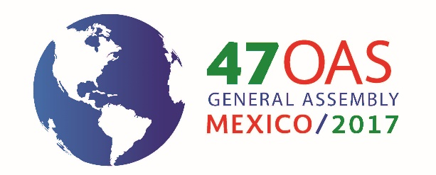

FORTY-SEVENTH REGULAR SESSION OF
THE GENERAL ASSEMBLY OF THE OAS
June 19 to 21, 2017
Cancun, Quintana Roo, Mexico

INFORMATION BULLETIN

The delegations may obtain the documents at the following web page:
www.oas.org/47ag
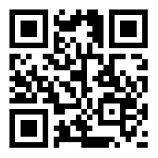

- Venue of the General Assembly
The forty-seventh regular session of the General Assembly of the Organization of American States (OAS) will be held from June 19 to 21, in the city of Cancun, Quintana Roo. The sessions will be held at the Moon Palace Arena Convention Center.
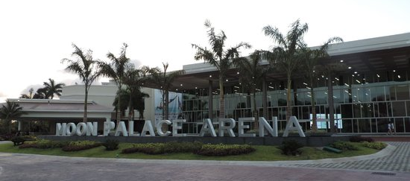
Carretera Cancún-Chetumal Km. 340, Cancun, Quintana Roo, Mexico. C.P.77500

- Office of the National Coordinator

His Excellency Luis Videgaray Caso
Minister of Foreign Affairs of the United Mexican States

Honorable Ms. Socorro Flores Liera
Ambassador, Deputy Secretary for Latin America and the Caribbean

Honorable Ms. Yanerit Morgan Sotomayor
Ambassador, Director General of Organizations and American Regional Mechanisms
National Coordinator

Honorable Mr. Roberto De Léon Huerta
Assistant Director General of Regional Mechanisms
Deputy National Coordinator

Honorable Ms. Agustina Sánchez Curiel
Deputy Director for the Ibero-American Conference, Organization, and Coordination
Coordinator of Logistics and Organization

- Accommodation
The Secretariat of Foreign Affairs of the United Mexican States, through the Office of the National Coordinator, has selected the following hotel for the heads of delegation and members of their official delegations. The hotel tariff covers all food, beverages, and taxes. Any additional costs are the responsibility of the guest.

Hotel | Room types | Web page
Hotel Moon Palace Cancún  Carretera Cancún-Chetumal Km. 340, Cancún, Quintana Roo, C.P. 77500  Sunrise lobby | Superior deluxe with garden view  Single room:  US$ 358 including taxes  Double room:  US$ 199 including taxes  All inclusive | https://www3.palaceresorts.com/NET/Formularios/Groups.aspx?gc=ASAMBL_002&sb=GRUPO&ag=ASAMBL_002

The Government of Mexico will cover solely and exclusively the cost of accommodation for 4 nights, June 18, 19, 20, and 21, 2017, for the heads of delegation of the OAS member states.

Should the delegates have any questions regarding their reservations, please contact the following persons:

Ms. Jessica Huerta
Reservations Supervisor
e-mail: jhuerta@palaceresorts.com

Ms. Virginia Avendaño
E-mail: vavendano@palaceresorts.com

The Office of the National Coordinator has also set aside additional rooms at the venue hotel for participating delegations, which should reserve using the “web page” link above.

Except for heads of delegation, each delegation member should pay his or her hotel bill directly, in accordance with usual hotel company procedures.

For confirmation of all hotel reservations, reservation requests must include a valid credit card number, the cardholder’s name, and the corresponding expiration date and security code.

The hotel reservations needed for each delegation must be made, without exception, by June 8. After that date, the Office of the National Coordinator cannot assume responsibility for room availability or the special rates negotiated with the venue hotel for the General Assembly session, and the block of rooms will be cancelled automatically.

- Dress code

Men: Long sleeve white guayabera shirt and dark pants.
Women: Light clothing. Depending on the weather, a shawl or wrap may be needed.

- Luggage identification

All delegations are requested to use the luggage identification tag to be provided in advance by the OAS in order to facilitate arrival and departure formalities in the city of Cancún.

- Entry and departure requirements

Information on visa requirements to enter Mexico may be obtained at the following link: https://47agoea.sre.gob.mx/index.php/visas.

- Reception at airport

The Government of Mexico will have officials at the Cancún, Quintana Roo International Airport to receive the official delegations.

- Transportation

The Government of Mexico will provide airport-hotel and hotel-airport transportation for the heads of delegation and official delegations of the OAS member states.

- Accreditation

The official delegations of the member states and of the permanent observer states, and special guests should forward their letters of accreditation in PDF format, by email only, to the following address:

Office of the General Assembly Secretariat
E-mail: oearegistroag@oas.org

- Registration of participants

Once the delegations have forwarded their letters of accreditation, they should register online using the following web page: http://www.oas.org/47ag

Beginning on June 16, 2017, identification cards will be issued at the Courtyard Marriott Hotel, Jaguar Room, continuously from 9:00 a.m. to 7:00 p.m.
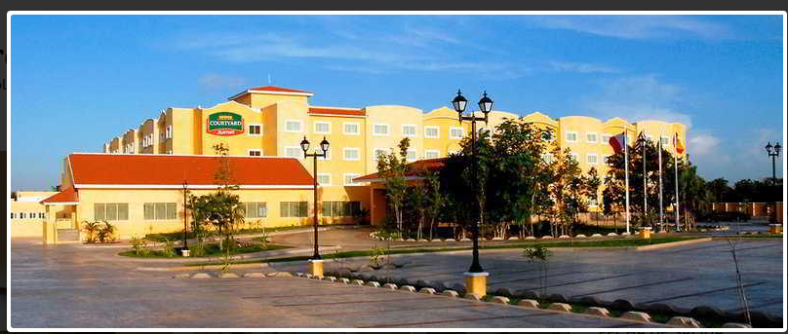

Blvd. Luis Donaldo Colosio Km. 12.5, Cancun, Quintana Roo, Mexico. C.P. 77560

For reasons of security, identification cards will be required for all General Assembly activities. Delegations and other participants are requested to provide a copy of their respective official credential at time of registration.

- Languages and working documents

The working sessions of the General Assembly session will be conducted in the four official languages of the Organization—Spanish, English, French, and Portuguese, with simultaneous interpretation available. To conserve resources, document printing will be limited and participants are asked to keep their documents during all sessions. The delegations are urged to obtain the General Assembly documents at the following website: http://www.oas.org/47ag

- Currency and exchange rate

Mexico’s currency is the peso. The average exchange rate is $20.00 pesos/US$1. This rate may vary. Foreign currency may be exchanged in hotels, at the airport, in banks, and in exchange bureaux. Most businesses accept credit and debit cards. However, it is recommended to carry some cash because some small businesses do not accept credit cards.

- Climate

Cancún is located on the east coast of the Hemisphere. The weather is influenced by warm sea currents, primarily the Gulf Stream. This creates a predominantly warm subtropical climate, with rain throughout the year, rain being more abundant in summer. Temperatures average 25.5º Celsius.

- Medical services

The Government of Mexico will provide emergency medical services. Any major medical costs will be covered by the party concerned.

- Time zone and area codes

Cancún City is in the Central Standard Time zone (UTC/GTM - 5 hours). The country code is 52, and Cancun’s city code is 998. For calls from outside Mexico to local landlines, dial + 52 998 + 7 digits (telephone number). For calls to cell phones, dial +52 (1) 998 and the 8 digits.

Within the city of Cancún, to call landlines, dial only the 7 digits of the number. For calls to a cell phone from a landline, dial the prefix (044) and the 10 digits of the number. For calls from one local cell phone to another, or to call by roaming, dial the prefix (045) and the 10 digits of the desired number.

- Taxes

All purchases, except food and medicine, in Mexico are subject to Value Added Tax (VAT) of 16%.

- Electrical current

The electrical current in Mexico is 110 volts and types A and B outlets are used.

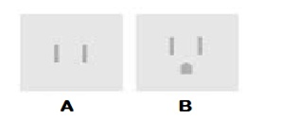

- Additional information

For any concern or request for information additional to that contained in this bulletin, please visit the following web page: https://47agoea.sre.gob.mx/.

