OEA/Ser.G
CP/INF. 8854/21
11 February 2021
Original: English

NOTE FROM THE PERMANENT MISSION OF TRINIDAD AND TOBAGO, IN ITS CAPACITY AS COORDINATOR OF THE CARICOM REGIONAL GROUPING OF OAS MEMBER STATES, REQUESTING THE INCLUSION OF THE ITEM “COMMEMORATION OF THE WORLD DAY OF SOCIAL JUSTICE” ON THE ORDER OF BUSINESS FOR A NEXT REGULAR MEETING OF THE PERMANENT COUNCIL

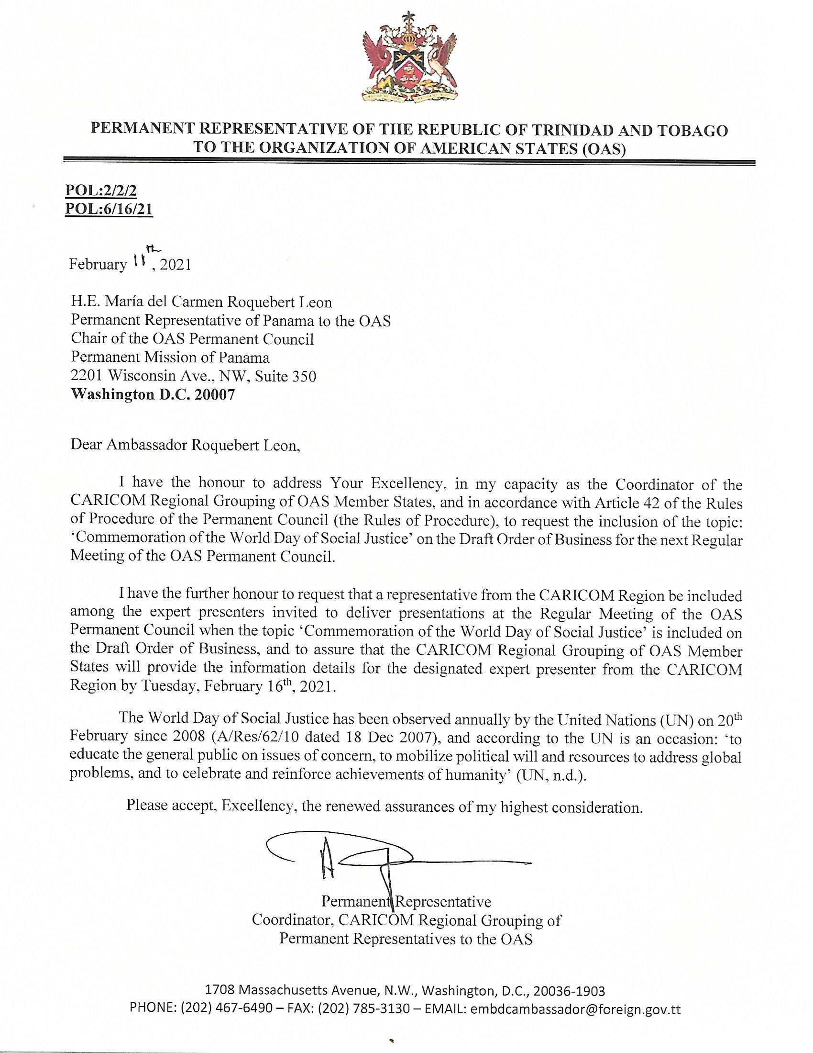
CP43454E01

