OAS/Ser.G
CP/INF. 8795/21 rev. 1
1 June 2021
Original: Spanish

NOTE FROM THE SECRETARY FOR ADMINISTRATION AND FINANCE SUBMITTING THE REVISED VERSION OF THE -DETAILED REPORT: FUNCTIONING AND COMPLIANCE OF THE COMPREHENSIVE STRATEGIC PLAN OF THE ORGANIZATION- IN ACCORDANCE WITH RESOLUTION CP/RES. 1121 (2209/19)
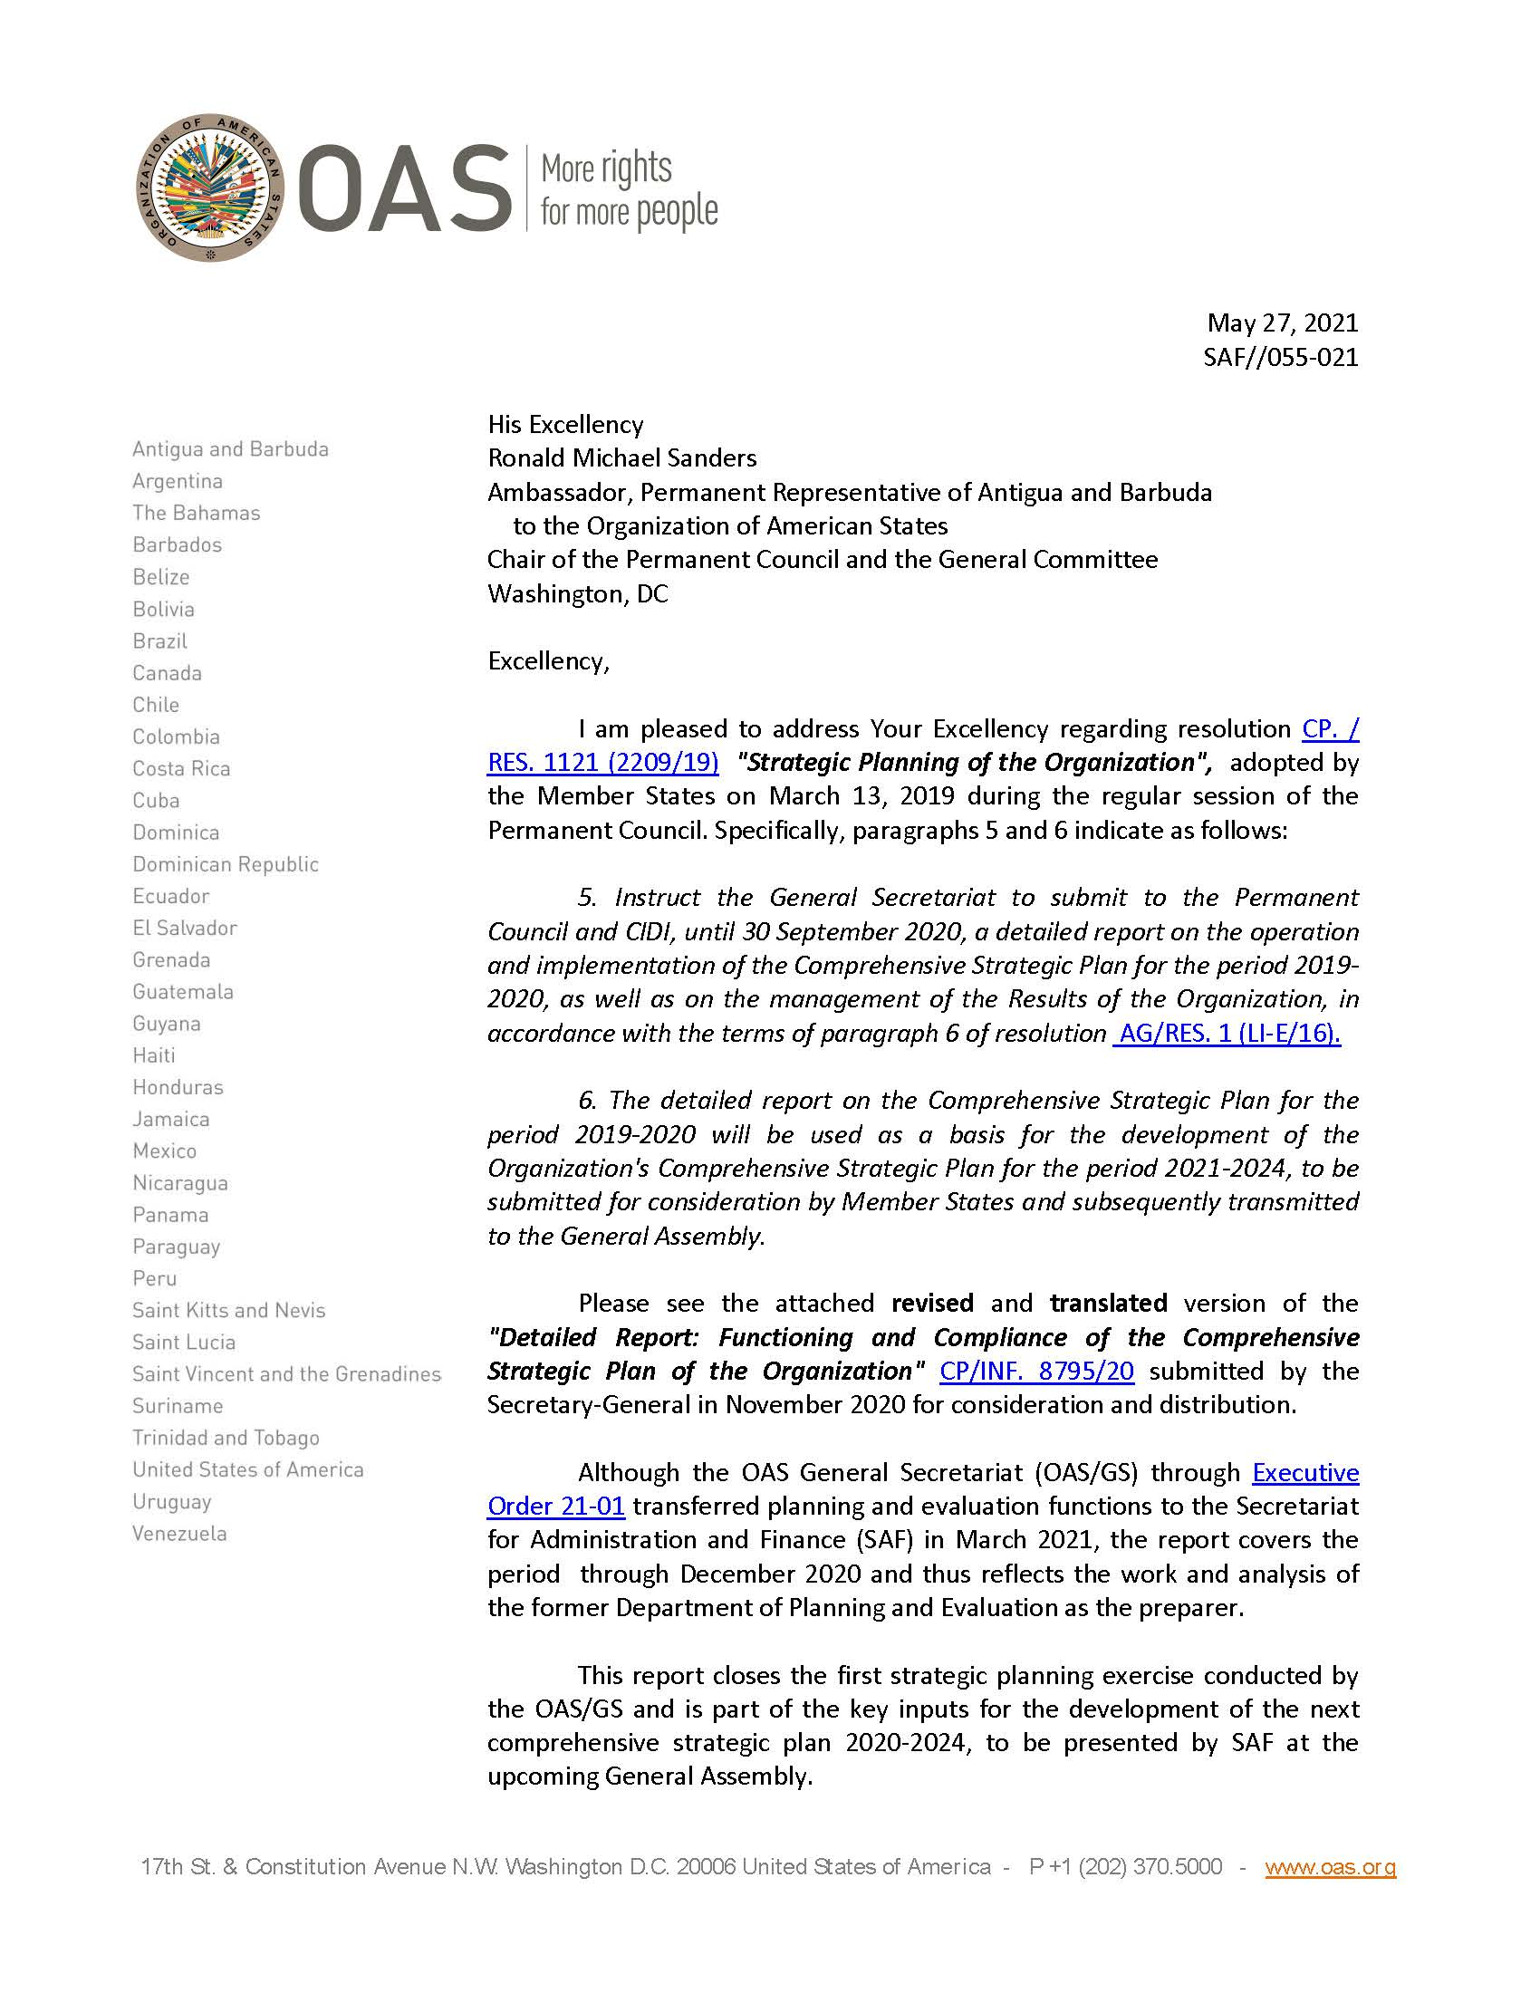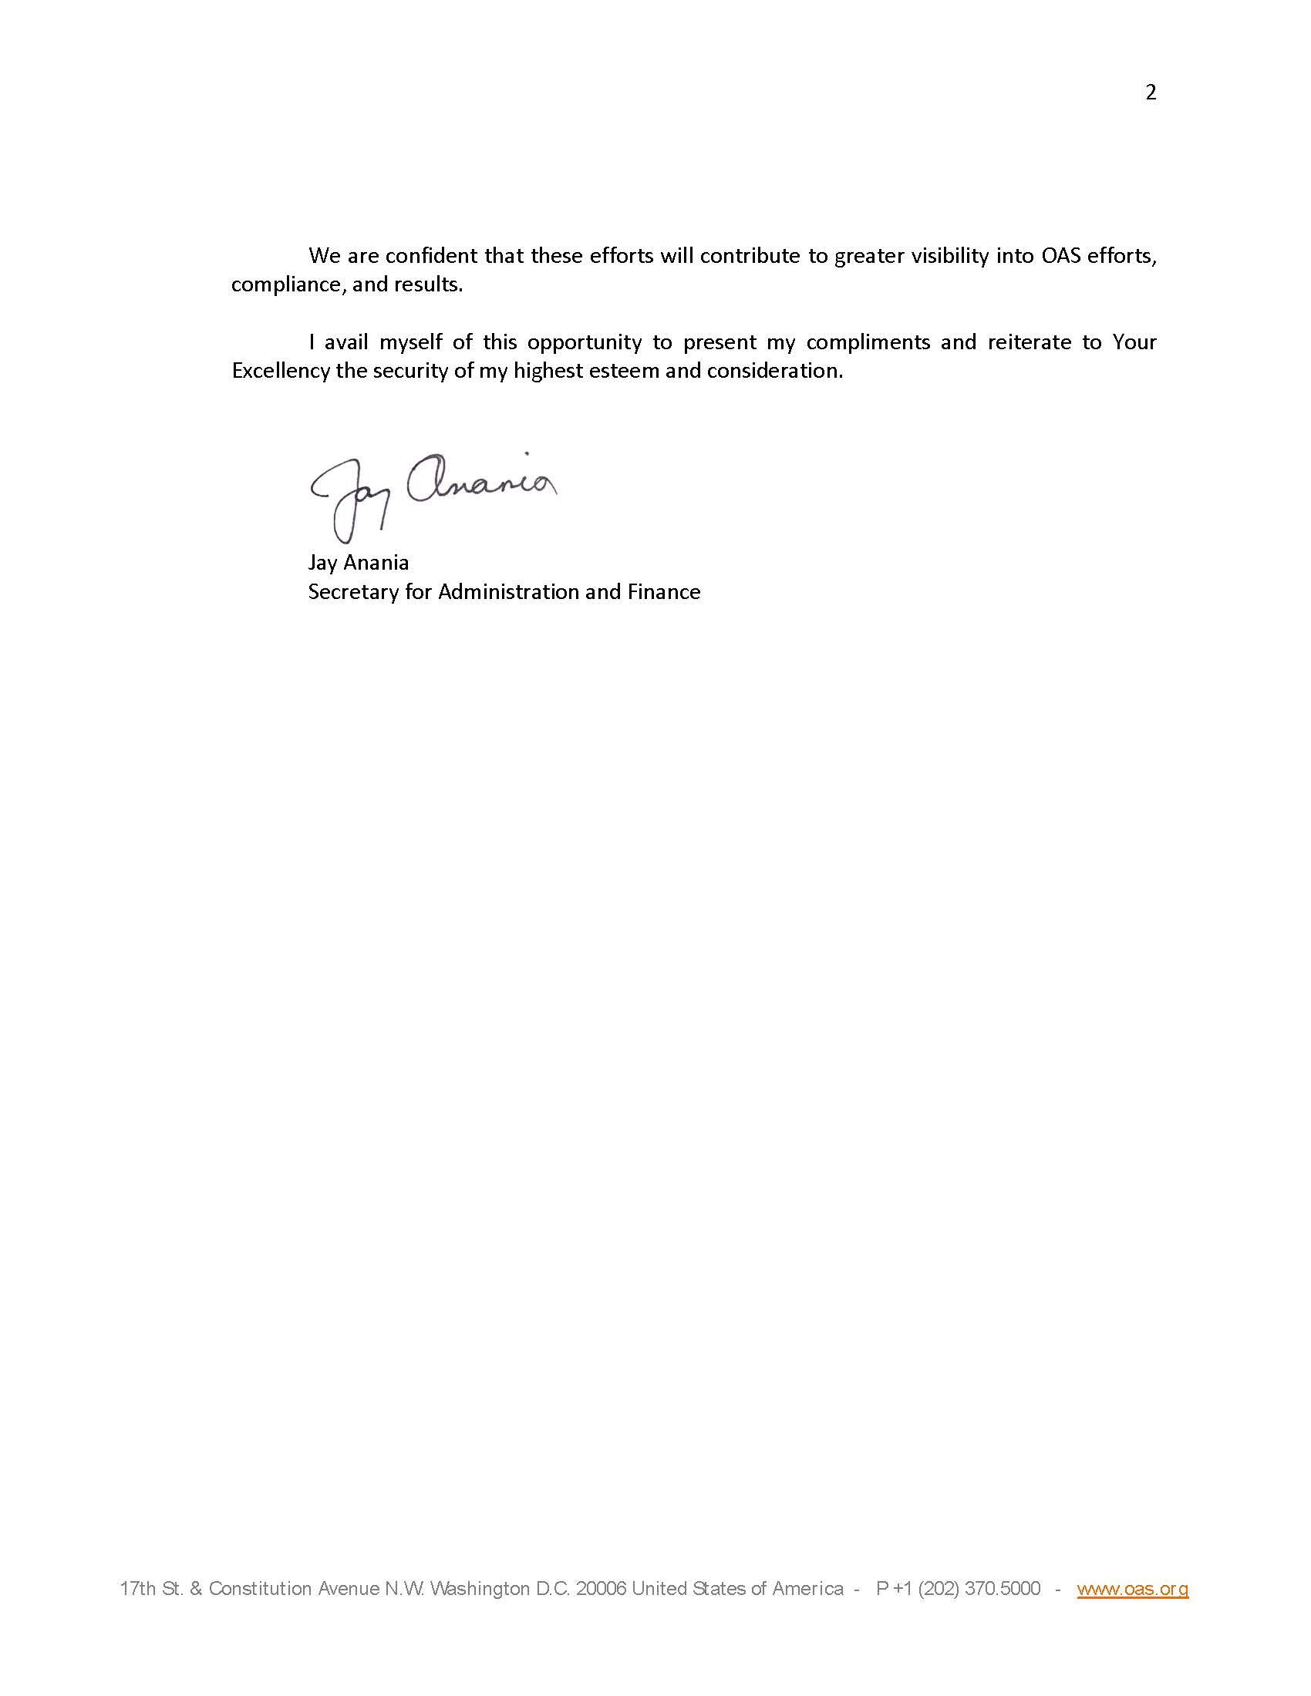

Report: link
CP44113E01

