OEA/Ser.G
CP/doc.4673/11
19 December 2011
Original: Spanish

NOTE OF THE SECRETARY GENERAL TO THE CHAIR OF THE PERMANENT COUNCIL PRESENTING “A STRATEGIC VISION OF THE OAS”
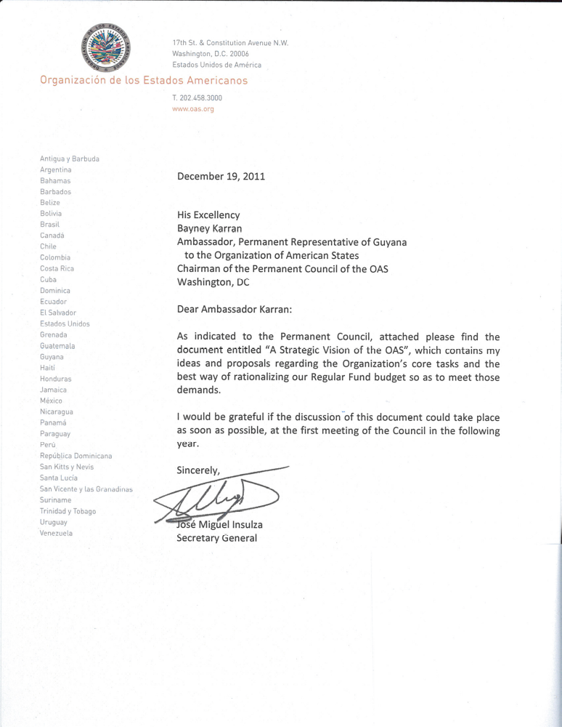

A STRATEGIC VISION OF THE OAS

INTRODUCTION

The perception that exists of the Organization of American States differs from country to country, as do the demands made upon it. There is, nevertheless, a common demand in all member states that we work more efficiently as the premier forum for discussions on the hemispheric issues that constitute the essence of the Organization: protection and advancement of democracy, promotion and protection of human rights, partnership for development among its members, and regional security.

Over the years a series of other tasks has been added to these core activities, compelling the OAS to dilute its efforts and give its attention to a huge variety of issues, without a common perception as to what the priorities of the member states, as a group, might be.

Inorganic growth of mandates and stagnation of budgetary resources have progressively eroded our capacity to respond efficiently to the demands arising from our core missions, leading to a sense of dissatisfaction—evident at the recent discussion on the budget—and renewed calls for a reduction in the number of mandates.

In response to this situation, the Secretary General offered to present to the member states a document containing proposals on how best to overcome this unsatisfactory state of affairs. This document makes good on that offer.

GENERAL CONSIDERATIONS

My proposals stem from the conviction that addressing this situation from a short-term perspective or re-attempting to reduce the hundreds of mandates that we have would be the wrong approach and would probably only worsen the problem. I firmly believe that we must return to a strategic vision that centers on the core missions of the OAS and relies on them to guide the use of the Organization’s resources and the contextual measures that need to be adopted immediately. I would also like to stress that to ensure success; a concerted effort will be needed between the member states and the General Secretariat. I will come to that aspect later.

If we return to giving strict priority to the core OAS missions, that would lead us to concrete measures that we could carry out efficiently and achieve the objectives that the member states have set. Today we have clear budgetary restrictions, many of them diagnosed in recent months. The assumption is that by concentrating on fundamentals, not only can we overcome the short-term situation, but also dispel many doubts about what role the OAS is destined to play in the hemispheric context.

The missions of the OAS are defined and elaborated on in the Charter and other basic documents, which serve as a guide in identifying and prioritizing the activities of its Council, General Secretariat, and other principal organs. Naturally, over the course of our history these missions have had various specific contents, shaped by the changing realities of our countries and regions, by the views of our countries' leaders as to the main challenges of each time, by the resources available to tackle them, or by perceived advantages in one content or another. However, it would be fair to say that currently there is consensus on our activities and basic documents as far as their core contents are concerned:

a) Preservation, strengthening, protection, and expansion of democracy, in particular on the basis of the mandates contained in the Charter of the OAS, the Inter-American Democratic Charter, the Inter-American Convention against Corruption, and a host of resolutions adopted in this regard, particularly since the 1980s.
At present, where the activities of the Secretariat are concerned, this objective includes follow-up on the mandates of our Democratic Charter; electoral observation missions; support for member states that wish to improve their electoral systems; the Mechanism for Follow-up on the Inter-American Convention against Corruption; crisis prevention and assistance; implementation of democratic-institution-building programs in member states, including programs on campaign finance, support for efficient governance, judicial facilitators, and civil identity; and priority for gender issues to ensure equal participation for citizens of both sexes in democratic government.
- Protection and promotion of human rights, particularly based on the mandates contained in the American Convention on Human Rights, the Protocol of San Salvador, the Convention of Belém do Pará on violence against women, the Convention on Discrimination against Persons with Disabilities, and other treaties in this area.

At this time, the endeavors of the Secretariat in this area include strengthening the inter-American human rights system and the work of the Inter-American Commission and Court; follow-up activities on the Convention of Belém do Pará (MESECVI); and efforts to combat all forms of discrimination against vulnerable groups: indigenous populations, people of African descent, migrants, and persons with disabilities.

- Preservation of peace and security throughout the hemisphere, especially based on the mandates of the Pact of Bogotá on Peaceful Settlement of Disputes and the provisions adopted by the Special Conference on Security held in Mexico City in 2003.

For the Secretariat this currently includes, as a priority, confronting threats from organized crime in all its forms. It also includes the work of our special missions in Colombia, Haiti, and the Adjacency Zone between Belize and Guatemala, as well as measures to promote peace. In addition, it includes our work with the Inter-American Defense Board, a subject I come to below.

- Integral development for all our member countries, especially based on the Charter of the OAS, the 1987 Protocol of Managua, and the yet-to-be-approved draft Social Charter.

At present this includes holding ministerial meetings and carrying out the mandates issued by our Summits of the Americas in the areas of education, environment, social protection, free trade, and competitiveness, in addition to management of our scholarships program and education portal.
These are, indubitably, the central tasks of the Organization of American States, as defined by its members and constantly reiterated by their highest-ranking officials at OAS meetings that they have attended. Consequently they are the tasks to which the Secretariat turns its attention daily.

However, these activities are carried out in parallel with others arising from mandates that have emerged at special conferences or that have been assigned to the OAS by other forums in which member states participate, even if, strictly speaking, they are not part of the structure of the Organization or, at any rate, report to the Permanent Council or the General Assembly. The main effect of this is to dissipate human and material resources, making the performance of tasks connected with the core missions less effective. It also reveals a lack of consistency among mandates whose priorities have not been determined.

BROAD OBJECT OF THE PROPOSALS

Faced with the above panorama, I would like to offer a number of proposals whose purpose is twofold. First, their aim is to give priority to the four fundamental tasks of the OAS; second, to highlight that their success will depend on a concerted effort between the member states and the General Secretariat in meeting the objectives set by the former.

These proposals seek to strengthen the capacities of the OAS in the areas where the countries recognize its contribution and where the Organization generates the most added value.

Two fundamental approaches are adopted to that end:

1. To allocate Regular Fund resources exclusively to carrying out our core tasks and, with respect to other activities that the member states might wish to entrust to the Organization, create specific funds in each instance to finance them.

2. To examine the content of each task to determine if the OAS is the organization best placed in the inter-American system to carry it out, and if not, identify potential opportunities for partnership with other agencies of the system in order to implement them, allocating our resources in a more efficient and rational manner.

SPECIFIC PROPOSALS

MANAGEMENT OF THE REGULAR AND SPECIFIC FUNDS

- We propose to coordinate with autonomous agencies that report to other political bodies in order to request their management to discharge the responsibilities that correspond to them.

This applies to the Inter-American Telecommunication Commission, whose members could be asked to defray the Commission's operating costs, as they already do in large measure. It also applies to the Inter-American Committee on Ports, for which a similar course of action is proposed.

The Inter-American Defense Board is something of a case apart since it has been brought into the OAS fold without the members having reached a clear determination as to its functions, its funding, and who it reports to. Notwithstanding the discussions that await us in the coming year on these topics, I believe that we could request the Defense Ministries of the Hemisphere, which actually design and steer the activities of the Inter-American Defense Board and its College, to create a special fund to finance it, thus disencumbering our Regular Fund of that cost.

The fourth case is that of the Inter-American Children's Institute, also run by a separate agency independent of the OAS. There it would be necessary to consolidate cuts that have already been made and maintain them going forward.
It would also be necessary to do away with the cash subsidies to the Pan American Development Foundation and the Trust for the Americas.

In the case of the Art Museum of the Americas, it is proposed that, following the presentation of a work plan, it be given six months to become self-financing, after which the subsidy that it receives through the Regular Fund would be cut.

These measures would provide a basis for reaching a determination on whether to finance activities with the Regular Fund or specific funds. That would make it possible to organize programs and projects as well as fund-seeking activities more efficiently, allowing us to use our relations with external donors to greater advantage.

B) In addition to the specific cases mentioned, it is planned to move toward the centralization of specific-fund management through country or program fund mechanisms (such as, the Canada Fund, Spain Fund, Human Rights Fund, Electoral Missions Fund). This would make it possible to ensure that activities financed with specific funds are aligned with the priorities of the Organization and that the assessment of its activities is results-driven.

C) As a complementary measure, we will accelerate the process of computerizing administrative processes in order to allow results-based management, improve internal controls for ensuring the security of processes, and eliminate redundant posts.

DECENTRALIZATION OF PROGRAMS

A review will be initiated of the Organization's programs to determine if it is advisable or necessary for them to continue to have their base of operations at OAS headquarters or if they could be relocated in member states, where they could be integrated with the OAS offices in those countries.

The decentralization process will include, inter alia:

a) Identification of programs apt to be decentralized based on criteria of a political (mandates, regional or national priority, strategic outlook), technical (homogeneity of processes, managerial solidity), and economic nature (scale, efficiency, and potential for in-kind contributions).

b) Identification of offices which, in addition to receiving political support and logistical assistance from the host country, might serve for the effective deployment of the program at the regional level.

c) Development and implementation of coordination and accountability mechanisms on all policy-related, technical, and administrative aspects.

d) Better allocation of human and material resources, with particular attention to a balance between local and international staff, including rotation mechanisms for the latter.

RATIONALIZATION OF SPECIALIZED MEETINGS

We propose a rationalization program for specialized meetings to be carried out under the following guidelines:

- Limit the amount of human and material resources contributed by the General Secretariat and strengthen the capacity of ministries and departments in member states to sustain the continuity of meetings. It is proposed that no activity last more than two days and that, if possible, they be held every three years. The MISPA and REMJA should be merged and convened every two years. As regards preparatory meetings, these should be confined to a single activity in the quarter immediately before the ministerial. All other preparatory meetings would be held by videoconference. The number of technical and professional experts who support the meeting should be reduced and any logistical support needed would have to be locally hired by the host country.

- Meetings of the political bodies of the Organization (General Assembly, Meetings of Consultation, Permanent Council and its committees, CIDI, CEPCIDI and IACHR) would be financed from the Regular Fund. All specialized meetings that are not part of that process and are scheduled to be held at headquarters would be financed with specific funds.

HUMAN RESOURCES POLICY

The core objective of the human resources policy will be the institutionalization of a merit-based career service in the Organization, with clearly defined ground rules and advancement mechanisms that encourage employees to strive for excellence in their work.

To that end, steps are being taken to reduce the number of positions of trust to a maximum of 8% of the Organization's total staff. This process will be completed by January 31, 2012, at the latest.

Within the framework of the 8% limit on trust positions as a proportion of staff financed by the Regular Fund, the Secretary General will give priority in assigning those positions to secretaries, the chiefs of staff of the Secretary General and the Assistant Secretary General, the Legal Advisor to the Secretary General, and a small number of advisers to the Secretary General and the Assistant Secretary General.

Second, we will review the Secretariat's staff hiring and promotion systems—observing vested rights—in order to correct imbalances in staff career opportunities caused by different hiring rules for different sources of financing. We will also complete implementation of the performance review mechanism.

QUOTAS

It is proposed, in first place, to introduce a rule whereby no country pays more than 49% of the contributions to the Regular Fund. This means that the current monetary share of the biggest contributor will be considered 49% of the overall budget and the remaining 51% will be financed with an increase in quotas from the other member countries. The plan is for this process to be carried out in five years.

In second place, it is proposed that the member countries agree on an automatic increase in quotas to meet the needs of the annual cost-of-living adjustment, which is set, as agreed, by the United Nations.

Third, it is proposed that the member countries agree to set a minimum quota for membership in the Organization and, furthermore, that the advance payment discount be eliminated, bearing in mind that, according to the standards of the Organization, quotas are due on the first day of the year for which they were set.

In this context, it is important to stress that prompt payment of quotas is essential for the Organization to function properly. Accordingly, continued efforts will be made to ensure that member countries are up-to-date in the payment of their dues.

POLITICAL DIALOGUE OF THE MEMBER STATES

As I noted at the beginning of this document, I am convinced that the process that we hope to institute will only be possible through concerted action between the member countries and the General Secretariat toward the objectives that our members set as priorities. I am sure it has been noted that most of the measures proposed will have to be implemented by the Secretariat. However, it is up to the member countries, in the exercise of their rights as members of the OAS, to determine its fate and identify the best ways to achieve the purposes for which they founded it. That is why I believe it is essential to underscore that, in my opinion, there is a pressing need for member countries to initiate a policy dialogue to prioritize mandates. It is simply not possible to address them all at once, and to continue in the current state of inertia only aggravates the problem. We need a clear decision from the countries to determine how existing mandates should be gradually met or even if some of them should not be implemented. Naturally the Secretariat would support this dialogue and provide all the information that might be needed; however, decisions of this type clearly belong to the political organs.
In this context, furthermore, the member countries will also have to make decisions on how to prioritize strategic partnerships within the American system, such as with the IDB and PAHO, as well as with the IICA, the Children's Institute, and other institutions and entities in the system, so that we can genuinely coordinate our activities and avoid costly and unnecessary overlaps.

In sum, the fate of the Organization is in the hands of its masters, as is only proper, which is why I propose that this dialogue be held as a matter of urgency, and that no time be wasted in tackling our current predicament and reaching decisions that will offer the OAS a future of greater dynamism and presence in the region's affairs.
0000.doc

