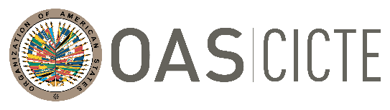
INTER-AMERICAN COMMITTEE AGAINST TERRORISM (CICTE)

TWENTY-SECOND REGULAR PERIOD OF SESSIONS OEA/Ser.L/X.2.22
July 27, 2022 CICTE/INF.6/22
Washington, D.C. 28 July 2022
VERBATIM

PRESENTATION BY MS. VELMA RICKETTS WALKER, CEO COMMISSIONER, JAMAICA CUSTOMS AGENCY, DURING ON THE SECOND PLENARY SESSION AT THE TWENTY -SECOND REGULAR PERIOD OF SESSION OF THE INTER-AMERICAN COMMITTEE AGAINST TERRORISM (CICTE)
JULY 27, 2022

Presentation by Ms. Velma Ricketts Walker: Link
CICTE01501T01
CICTE01501T01

