INTER-AMERICAN COMMITTEE AGAINST TERRORISM (CICTE)

TWENTY-FOURTH REGULAR PERIOD OF SESSIONS OEA/Ser.L/X.2.24
April 24-25, 2024 CICTE/INF. 4/24
Washington D.C. 24 April 2024
Original: Spanish

SUBMISSION OF NOMINATION FOR VICE CHAIR OF THE
INTER-AMERICAN COMMITTEE AGAINST TERRORISM (CICTE)

(Submitted by the Permanent Mission of Panama)

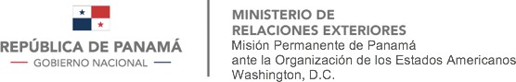

PANA-OAS-4-207

The Permanent Mission of Panama to the Organization of American States (OAS) presents its compliments to the Secretariat of the Inter-American Committee against Terrorism (CICTE), on the occasion of presenting the nomination of the Republic of Panama to the Vice-Presidency of the Inter-American Committee against Terrorism, during the elections that will take place during the Twenty-Fourth Regular Session of CICTE, on April 24 and 25, 2024 in Washington, D.C.
In this regard, the Permanent Mission of Panama to the OAS thanks the Secretariat of the Inter-American Committee against Terrorism for its good offices in circulating Panama's nomination among all Member States, hoping to have their support for the election.
The Permanent Mission of Panama to the Organization of American States takes this opportunity to reiterate to the Secretariat of the Inter-American Committee against Terrorism the assurances of its distinguished consideration.

Washington, D.C. April 24, 2024

To the Honorable

SECRETARY OF THE INTER-AMERICAN COMMITTEE AGAINST TERRORISM
Organization of American States Washington, D.C.
CICTE01714E01

