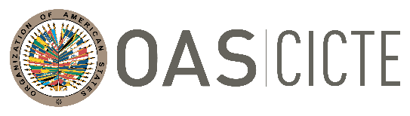
INTER-AMERICAN COMMITTEE AGAINST TERRORISM (CICTE)

TWENTY-SECOND REGULAR PERIOD OF SESSIONS OEA/Ser.L/X.2.22
July 27, 2022 CICTE/INF.4/22
Washington, D.C. 28 July 2022
VERBATIM

PRESENTATION BY MR. ROSS MUNN, ASSOCIATE DIRECTOR GENERAL MARITIME SAFETY AND SECURITY, TRANSPORT CANADA, DURING ON THE SECOND PLENARY SESSION AT THE TWENTY -SECOND REGULAR PERIOD OF SESSION OF THE INTER-AMERICAN COMMITTEE AGAINST TERRORISM (CICTE)
JULY 27, 2022

Presentation by Mr. Ross Munn: Link
CICTE01495T01

