OEA/Ser.G

CP/doc.6036/24 rev. 1

15 August 2024

Original: English

NOTE FROM THE PERMANENT MISSION OF THE UNITED STATES REQUESTING   
THAT A SPECIAL MEETING OF THE PERMANENT COUNCIL BE CONVENED ON FRIDAY, AUGUST 16, 2024, FOR THE SOLE PURPOSE OF CONSIDERING THE ATTACHED   
DRAFT RESOLUTION ON THE SITUATION IN VENEZUELA

(The attached draft resolution is the result of the negotiating session held on Tuesday, August 13, 2024, and edits subsequently received - It is presented on behalf of the United States and its co-sponsors, Antigua and Barbuda, Argentina, Canada, Chile, the Dominican Republic, Ecuador, Guatemala, Paraguay, Suriname, and Uruguay)

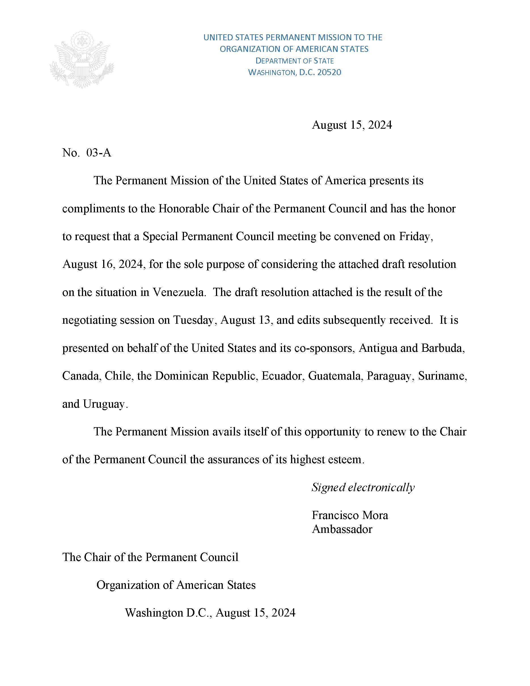

DRAFT RESOLUTION   
ON THE SITUATION IN VENEZUELA[1]/[2]/

(Presented by the United States and co-sponsored by Antigua and Barbuda, Argentina, Canada, Chile, the Dominican Republic, Ecuador, Guatemala, Paraguay, Suriname, and Uruguay)

(Edits added to the text resulting from the informal meeting held

on Tuesday, August 13, 2024)

THE PERMANENT COUNCIL OF THE ORGANIZATION OF AMERICAN STATES,

BEARING IN MIND the principles and purposes enshrined in the Charter of the Organization of American States, which affirm the commitment of the member states to uphold democracy, human rights, peaceful resolution of conflicts and respect for international law;

RECOGNIZING that Article 2 of the Inter-American Democratic Charter states that “the effective exercise of representative democracy is the basis for the rule of law …”;

RECOGNIZING ALSO that Article 3 of the Inter-American Democratic Charter states that “essential elements of representative democracy include, *inter alia*, (…) the holding of periodic, free and fair elections based on secret balloting and universal suffrage as an expression of the sovereignty of the people…”;

FURTHER RECOGNIZING that Article 11 of the Inter-American Democratic Charter establishes that “democracy and social and economic development are interdependent and are mutually reenforcing”;

REAFFIRMING the essential purpose of the Organization of American States to promote and consolidate representative democracy, with due respect for the principle of nonintervention, as expressed in Article 2 (b) of the Charter of the Organization;

NOTING WITH CONCERN reports of serious irregularities and violence associated with the electoral process in the Bolivarian Republic of Venezuela, following the elections held on July 28, 2024;

REAFFIRMING that maintaining social peace and protecting human lives and fundamental freedoms should be the priority;

ACKNOWLEDGING reports of human rights violations, including those from the Interamerican Commission of Human Rights following the elections, and

RECALLING the agreements by the political parties of Venezuela in the Comprehensive and Incremental Dialogue and Negotiation Process of the Memorandum of Understanding signed in Mexico City on August 13, 2021, as well as the Partial Agreement on the Promotion of Political Rights and Electoral Guarantees for All signed in Barbados on October 17, 2023;

RESOLVES:

1. To acknowledge the substantial and peaceful participation of the electorate of Venezuela in the elections held on July 28, 2024.
2. To insist with the utmost firmness that the respect for human rights and fundamental freedoms, the right to life, liberty and security of person, especially the right to assemble peacefully and to the full exercise of civil and political rights without reprisal, the right to not be subject to arbitrary arrest or imprisonment, the right to a fair trial, be an absolute priority and an obligation for Venezuela, as it is for all states of the Americas.
3. To call on all stakeholders, political and social actors, including the authorities in Venezuela, to abstain from any conduct that might jeopardize the peaceful settlement of this crisis, fully respecting the sovereign will of the electorate of Venezuela.
4. To request that the authorities of the Bolivarian Republic of Venezuela protect diplomatic facilities and personnel residing in Venezuelan territory, including individuals seeking asylum in such facilities, consistent with international law, and in particular the Vienna Convention on Diplomatic Relations and the Vienna Convention on Consular Relations.
5. To underscore the importance of protecting and preserving all equipment used in the electoral process, including all printed election records and results, in order to safeguard the entire chain of custody of the voting process.
6. To urge the National Electoral Council of the Bolivarian Republic of Venezuela to:(a) expeditiously publish the presidential election records, including thevoting results at the level of each polling station, and (b) respect the fundamental principle of popular sovereignty through an impartial verification of the results that ensures the transparency, credibility, and legitimacy of the electoral process.
7. To express solidarity with the Venezuelan people and commit to remain seized of the situation in the Bolivarian Republic of Venezuela.

FOOTNOTE

2. … of greater understanding among the countries of the Hemisphere in the face of the serious violation of the popular will in Venezuela, and in support of the multilateral actions that must be taken as soon as possible to ensure respect for suffrage in the Venezuelan State.

CP50240E01

1. . The delegations of Saint Lucia, Colombia, Saint Kitts and Nevis, the Bahamas, Barbados, and Trinidad and Tobago remain in consultation on the entire document.
2. . The Republic of Panama wishes to clarify that it has already recognized the electoral victory of candidate Edmundo González and that its support for this resolution is given in the interests…