OEA/Ser.G
CP/RES. 1210 (2402/22)
11 November 2022
Original: English

CP/RES. 1210 (2402/22)

TO AUTHORIZE AN EXTERNAL FIRM TO INVESTIGATE ALLEGATIONS
CONCERNING THE SECRETARY GENERAL

(Adopted by the Permanent Council at its regular meeting, held on November 11, 2022)

THE PERMANENT COUNCIL OF THE ORGANIZATION OF AMERICAN STATES,

BEARING IN MIND that Article 91 of the OAS Charter states that the Permanent Council has the responsibility to watch over the observance of the standards governing the operation of the General Secretariat and, when the General Assembly is not in session, adopt provisions of a regulatory nature that enable the General Secretariat to carry out its administrative functions;

ALSO BEARING IN MIND Article 120 of the General Standards to Govern the Operations of the General Secretariat which states that fiscal supervision by the Member States rests primarily with the Permanent Council, the Audit Committee directly and through the External Auditor and the Inspector General;

NOTING the request by the OAS Secretary General to the Inspector General, contained in Note OSG/102-22, dated 3rd June 2022, to investigate any possible violations of the rules and regulations of the OAS; and

ALSO NOTING the request by the Inspector General to the Chair of the Permanent Council to have an external firm conduct an investigation into the allegations levelled against the Secretary General on October 5th, 2022, by a journalist from the Associated Press,

RESOLVES:

1. To authorize the launch of an investigation by an external firm, in accordance with the terms of reference annexed hereto, to determine whether the allegations made against the Secretary General by the journalist from the Associated Press and in an email from an “OAS Whistleblower” dated June 2nd, 2022 (also attached hereto), hold any merit, and constitute any violations by the Secretary General of the rules and regulations of the OAS.

2. To create a Working Group composed of the Chair and Vice Chair of the Permanent Council and the Secretary for Administration and Finances, whose task shall be to implement the process of selecting and contracting the external firm in accordance with the terms of reference attached hereto, including reasonable costs, taking into consideration the applicable regulatory framework of the OAS. The Chair of the Permanent Council will serve as the Chair of the Working Group.
3. To authorize a special appropriation from the Indirect Cost Recovery Reserve Sub-fund in the amount needed to conduct the investigation.

4. To instruct the selected external firm to submit, within 3 months from the date of its commission, its report directly to the Chair of the Permanent Council who will make it available to the Permanent Council without delay.

5. To take appropriate action after consideration of the external firm’s Report.

ATTACHMENT 1

TERMS OF REFERENCE
FOR THE EXTERNAL INVESTIGATION OF ALLEGATIONS
CONCERNING THE SECRETARY GENERAL

Profile for selection of External Investigator

- Preferably a company that has not worked before with the OAS.
- The Company must have an established and known reputation,
- Disclosure of the number of persons to be employed in the investigation and description of their tasks.
- Disclosure of the number of hours per person required for their tasks.
- Hours of work above those disclosed and agreed may not be added to the costs.

Guidelines 1: for the investigation in relation to allegations of AP journalist and “OAS Whistleblower”

- The relationship of the Secretary General and the staff member was public and well- known. Therefore, no investigation of the private lives of the individuals is warranted.
- The investigation should be concerned with whether, in connection with the relationship, the Secretary General violated the Code of Ethics (CE); Staff Rules (SR) and/or the Policy and Conflict Resolution System for Prevention and Elimination of All Forms of Workplace Harassment (PWA) including: (A) supervision CE: Chapter II, Subchapter E./ SR: 104.16 (d)/, (B) salary increase CE: Chapter II, Subchapter E. SR: 104.16 (d), and (C) intimidation CE: Chapter II, Subchapter C./ PWA: Section 4.2/
- For these purposes, documentary evidence and testimonial evidence should be gathered and evaluated from relevant bodies, persons and records, including the Secretary General.
- The Secretary General shall have the right to present witnesses up to a maximum number of 15.

Guidelines 2: for the investigation of allegations made by “OAS Whistleblower”

- Determine the circumstances of the severance of the domestic helper at the official residence of the Secretary-General
- Establish whether the Secretary-General was aware of the alleged verbal abuse or attack of the domestic helper by his wife (or former wife)/
- Determine the reasons for the separation of the domestic helper for the official residence of the Secretary-General.
- Testimony should be taken from persons who worked in the residence or assisted in its work, as well as relevant bodies in the OAS concerned with employment and severance.
- Testimony shall also be taken from the Secretary General.

Content of the report and date for submission

  - With regard to the investigation of the allegations by the AP journalist, the report should state if the investigation revealed violations of the code of ethics regarding:
- supervision
- increases of salary or benefits
- intimidation
- in the events that any violations of the code of ethics occurred the investigations shall determine, to the extent possible, whether such violations were intentional or accidental.
  - The report should also state whether any other violations of the regulations were discovered in the course of the investigation of the matters within the scope of the guidelines for the investigations in relation to allegations of AP journalist and “OAS Whistleblower” (Guidelines I and 2).
  - Regarding the investigation into the allegations of the “OAS Whistleblower”, the report should state whether:
- the dismissal was due to the conclusion of the direct supervisor of the dismissed person or the Secretary-General, consistent with PWA: Section 6.5/
- the Secretary General was aware of verbal abuse of the person referred to in the email from the “OAS Whistleblower”.

  - The final report shall be made known to the Secretary General, who will have ten days to respond to it. The Secretary General's response will be attached to the Report to be presented to the Chair of the Permanent Council by March 31st, 2023.

General Legal Framework

The following shall be the general legal framework applicable to the investigations in relation to allegations of AP journalist and “OAS Whistleblower” (Guidelines I and II).

- Charter of the Organization of American States, Chapter XVI, Articles 107 to 113, related to the General Secretariat; and
- General Standards Governing the Operations of the General Secretariat, Articles 17 to 52, and Articles 143 to 151.

ATTACHMENT 2
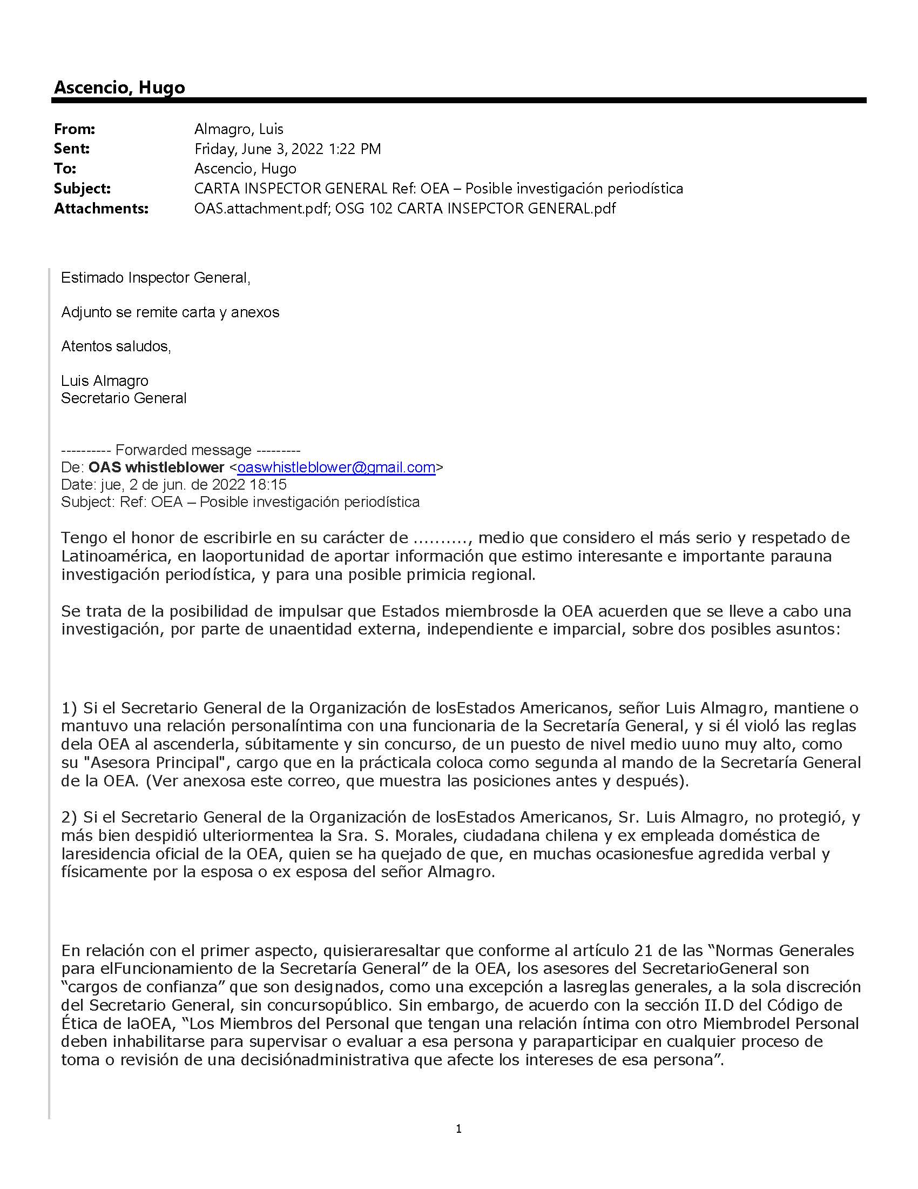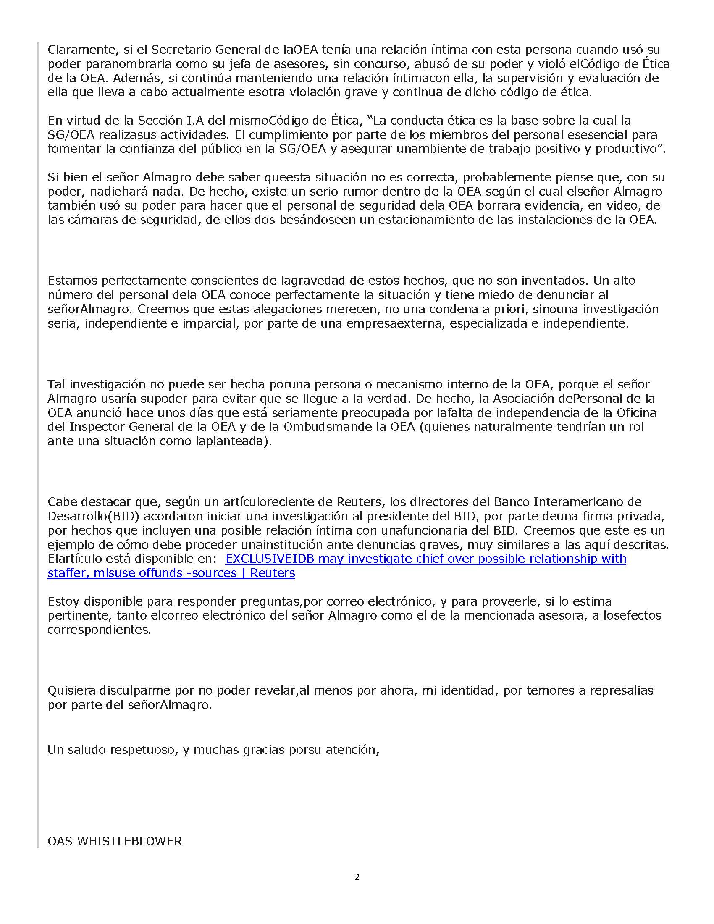
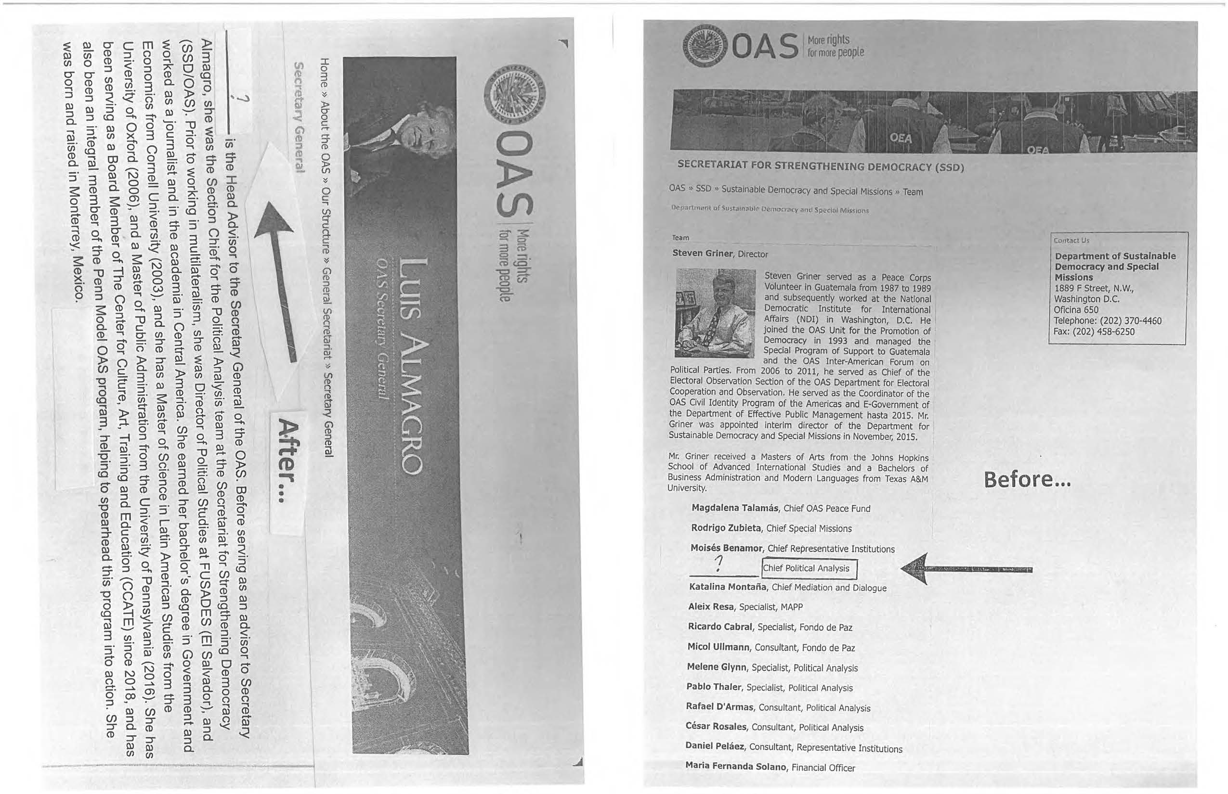
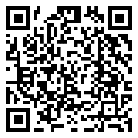
CP46793E01
CP46781E01

. “E. Intimate Relationships Staff Members and Other Service Providers should not allow any intimate relationship with another Staff Member or Other Service Provider to interfere with the performance of their duties or to disadvantage others in the Workplace. Staff Members and Other Service Providers who are involved in an intimate relationship with another Staff Member or Other Service Provider must disqualify themselves from supervising or evaluating that person and from participating in any process of taking or reviewing an administrative decision affecting the interests of that person.”
. “Rule 104.16 Family Relationships (d) Those staff members who become relatives by way of marriage after joining the staff of the General Secretariat or otherwise, a relative of one staff member shall not be assigned to serve in a post which is superior or subordinate in the line of authority to the staff member to whom he/she is related and shall disqualify himself/herself from participating in the process of reaching or reviewing an administrative decision affecting the interests of that staff member.”
. “C. Abuse of Authority All Staff Members and other Service Providers must refrain from inappropriately using a position of influence, power, or authority; from misusing power by creating a hostile or offensive work environment; and from using threats, blackmail, coercion, or intimidation.”
. “4.2 Abuse of Authority: The improper use of a position of influence, power or authority by an individual against a colleague or group of colleagues. This behavior is particularly serious when an individual misuses his/her influence, power or authority to negatively affect the career or employment conditions (including - but not limited to - appointment, assignment, contract renewal, performance evaluation or promotion) of another. It can include a one-off incident or a series of incidents. Abuse of Authority may also include — but is not limited to — misuse of power that creates a hostile or offensive work environment, and the use of intimidation, threats, blackmail or coercion.”
. See footnote 4 above.
. “6.5. Conduct that would not, in itself, be considered Workplace Harassment includes among others: a) A Manager’s or Supervisor’s words or actions taken or used without Malice for the primary purpose of evaluating a person’s performance of official duties; b) The application of disciplinary measures for misconduct, including unsatisfactory performance; c) The decision not to renew a contract together with delivery of the corresponding notice; d) The termination of a Staff Member’s employment or a Non-staff Personnel’s contract together with delivery of the corresponding notice, for any of the reasons stated in the Staff Rules and/or contract; and e) Preferences based on national origin to the extent necessary to obtain geographic distribution as required under Article 120 of the OAS Charter.”

